Possible ways and approaches for sustainable agriculture with special reference to tobacco production

Assoc. prof. dr. Silvana Pashovska, Assis.prof.d-r Katerina Kareska
University St. Kliment Ohridski – Bitola, Scientific tobacco institute - Prilep

Abstract
The sustainable development of agriculture cannot be imagined without its economic ability, environmental protection, social responsibility and ethical focus. Economically powerful agriculture implies the application of new economic methods, which also ensures environmental protection.
Ecologically protected agriculture prefers rational use of natural resources, application of optimal amounts of fertilizers and agrochemical products and special care for the environment. Social responsibility is aimed at hiring agricultural workers, their motivation and commitment to ecologically clean agricultural production.
Eco - ethics is a principle focused on many areas, including how to cultivate the soil, grow crops, treat animals and care for the environment. Tobacco production is an agricultural activity in which about 12% of the population in the Republic of North Macedonia is engaged. Its development must correspond to the guidelines and intentions of the European Union and the global world policy defined by various governmental and non-governmental organizations, which in practice means the production of high-quality tobacco, its application for bioenergy and continuous concern for environmental protection.
This paper determines the trends of the sustainable development of agricultural production, with special reference to the dynamics in the development of tobacco production.
Keywords: agricultural system, environment, eco - management, tobacco, strategy

Introduction
Sustainable development, as a global concept, represents a challenge faced by every person, every country and the world in general, all with the sole aim of ensuring the continuous progress of the quality of life and well-being of the country and ensuring sustainable development for current generations without the possibility of meeting the needs of future generations is threatened.
Unsustainable trends in terms of climate change, energy use, poverty and social exclusion, demographic pressure and aging, threats to public health, use of natural resources, loss of biodiversity, are processes that have an urgent nature. It is the duty of the present generations to preserve the capacity of the planet to support life in all its diversity and to ensure sustainable development.
Achieving this goal means creating an economy with highly qualified employment, quality health care, social and territorial cohesion, as well as environmental protection.
Sustainable development is a globally accepted philosophy of development and progress and sublimates the spiritual ideals of all humanity into a single logical whole. As top advantages, sustainable development puts equality, justice, ethics and responsibility towards current and future generations at the fore. The fact is that Humanity has always faced a number of choices related to the quality of life and the state of the environment. Each choice has an impact on the world that is left to future generations. Some choices will contribute to the creation of a world in which economic and social needs are balanced by the capacity of natural resources and ecosystems, others will lead to a world with a devastated environment, in which poverty and hunger reign.
Through sustainable development, collective responsibility is assumed for the advancement of economic development, social equality and environmental protection at the local, national and global level. It is development that meets the needs of current generations without compromising the ability of future generations to meet their own needs. This concept represents a behavior towards the environment as if we did not inherit it from past generations, but as if we were borrowing it from future ones. In other words, sustainable development represents development that fully meets the needs of today, without negative consequences for the future, that is, the possibility future generations to meet their needs.

Research material and method
Contemporary and relevant domestic and foreign literature in the field of agriculture and agricultural economics, strategic planning and strategic management, data from the Maxstat database of the State Statistics Office of the Republic of North Macedonia, reports from the Ministry of Agriculture, Forestry and Water Management were used in the preparation of the paper. of the Republic of Macedonia, as well as current data from the World Bank database. It will certainly be the starting point for constructing the theoretical part of the paper.
The data analysis will be performed with the method of descriptive explanation of the obtained research results, with mandatory application of the comparative method.
Results and discussion
Sustainable development, as a global concept, is a challenge that every person faces, with the sole purpose of meeting current needs, without jeopardizing the need to meet future generations. Achieving this goal means creating an economy with full and highly qualified employment, quality health care, social and territorial cohesion, as well as environmental protection, all in conditions of a peaceful and safe world.
Europe's determination to actively participate in the global process of sustainable development, highlighted at the conference in Rio de Janeiro in 1992, resulted in the adoption of the first EU Sustainable Development Strategy (SDS), in Gothenburg, 2001 and revised in 2006 by European Commission.
It is the duty of the present generations to preserve the planet's capacity to support life in all its diversity and to ensure sustainable development. The main goal of the revised strategy is the establishment of a set of measures and activities that will enable the continuous improvement of the lives of current and future generations by creating sustainable communities capable of managing and efficiently using natural resources as well as developing environmental and social innovation. potential of the economy, which will ensure economic prosperity, environmental protection and social cohesion.
The revised European Strategy for Sustainable Development (ESRD) points to the global character of sustainable development and the need for global solidarity, involving all, and especially countries with rapid development that have a significant impact on global development. The European strategy is a logical addition to the Lisbon Declaration and largely corresponds to the Millennium Development Goals. The key objectives of the European SOR relate to the protection of the environment, social equality and cohesion, economic prosperity, as well as the fulfillment of international obligations.
This concept represents behavior towards the environment as if we did not inherit it from past generations, but as if we were borrowing it from future ones. In other words, sustainable development is development that fully meets the needs of today, without negative consequences for the future, that is the possibility for future generations to meet their needs.
The field of sustainable development can be divided conceptually into four parts: environmental sustainability (environmental sustainability), economic sustainability, social sustainability and political sustainability. The most widely known model of sustainability has various names such as the "three circles" model, the "three balls" or the "three ring junction" model, illustrated in the attached figure:

Ecology

Economy Society

Picture num. 1. The "Three Circles" Model

The three circle model is a Venn diagram ( with intersecting circles reflecting areas of overlap between different characteristics) that helps decision makers see where their decisions lie. Using this model, the conditions for sustainability coincide when decisions are in the central zone where environmental, social and economic characteristics are also located. This is a very simple communication tool and helps in conveying simple messages in easy to understand ways.
In this context, it can be emphasized that sustainable development is a harmonious relationship between ecology and economy, of natural resources and preservation of our planet for future generations. Sustainable development is a set of methods to create and sustain development that seeks to eliminate poverty, create equal standards of living, meet the basic needs of all people and establish sustainable political practices, while taking all necessary measures to avoid irreversible damage to the natural capital. In that direction, the saying of the famous German botanist Ernest Friedrich is known, who says that the greatest danger to humanity is not threatened by its mistakes, but by its successes. The UN Agenda for Sustainable Development until 2030 is attached.
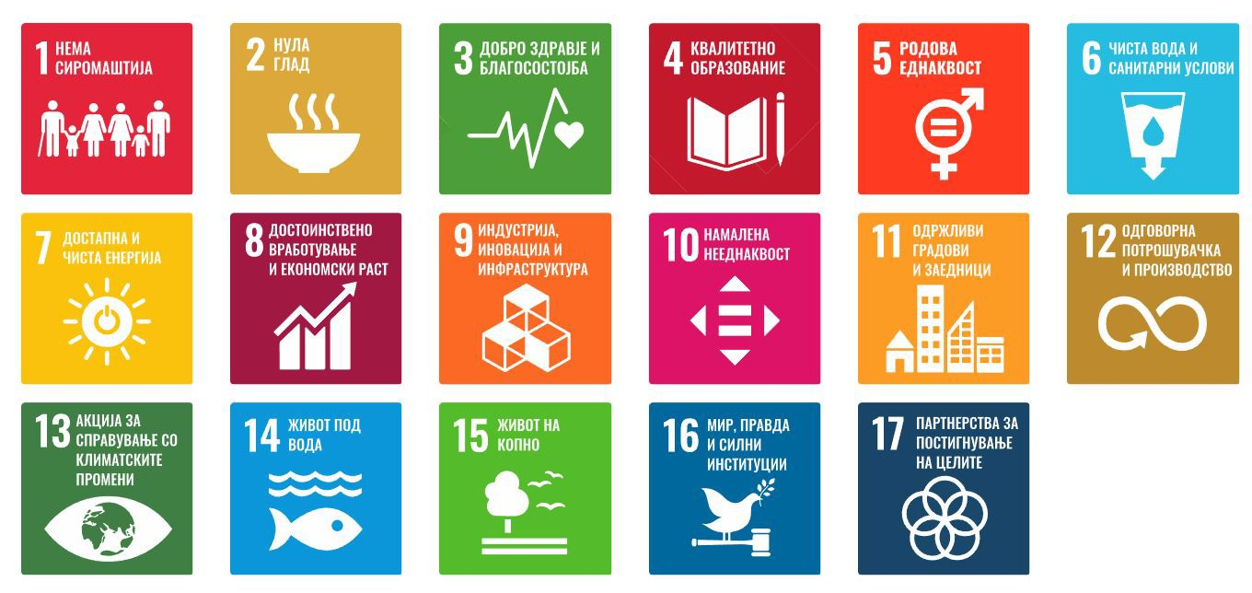
Picture num.2. Agenda for Sustainable Development until 2030
For sustainable agricultural production and sustainable development in all spheres of social life and functioning, adequate management, that is, adequate organization and management, is necessary. In particular, sustainable agricultural production includes: soil management, water and irrigation management, erosion management, available energy management, pasture management, etc., which is graphically presented in Figure 3.

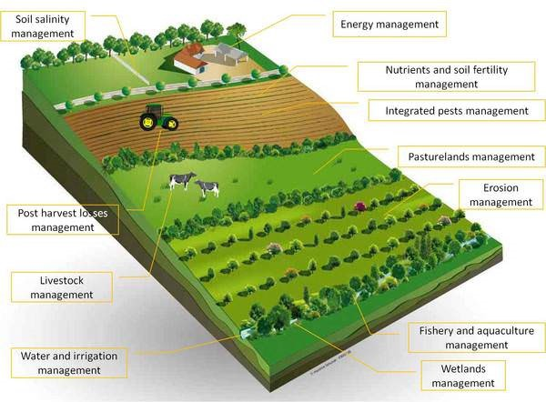
Picture num.3. Sustainable agricultural production
How can man continue his civilization on Earth without destroying nature and himself? Certainly not with ruthless development understood as a simple accumulation of material wealth, followed by mindless wastefulness in the use of natural resources through which all countries compete and only care about their GDP (gross domestic product), on the basis of which countries compare themselves which is more successful and developed, while being blind to the price that nature pays for their progress. The answer to the question lies in the implementation of the concept of sustainable development. Sustainable development means improving the quality of life within the capacity of existing systems. Sustainable development is development that provides essential environmental, social and economic services to all members of the community, while not compromising the vitality of the natural, man-made and social systems on which those services depend.
At the core of the concept of sustainable development is the belief that social, economic and environmental objectives should complement each other and be interdependent throughout the development process. It follows that sustainable development should be treated as an issue based on the integration of economic and social development in the context of high-quality environmental management. In that regard, it is necessary to have a strategy of sustainable development as an important strategic document that defines the optimal directions for the development of the local area, taking into account the characteristics, advantages and limitations of space and environment.
The key objectives of the European Strategy for Sustainable Development (ESDR) relate to environmental protection, social equality and cohesion, economic prosperity, as well as the fulfillment of international obligations.
Hence, the main challenges are:
● Climate change and clean energy - limiting climate change and reducing costs and the negative consequences they have on society and the environment;
● The sustainability of traffic - meeting traffic needs by minimizing unwanted consequences on the economy, society and the environment;
● The sustainable model of production and consumption - separation of economic development from environmental degradation;
● Preservation and management of natural resources - avoiding excessive exploitation of natural resources;
● Public healthcare - equal access to quality healthcare and improved protection against health threats;
● Social inclusion, demography and migrations - improvement of living conditions as a prerequisite for lasting individual well-being;
● Global poverty and facing the challenges of sustainable development - poverty reduction, active promotion of sustainable development and ensuring consistency of internal and external policies with global sustainable development and international commitments.
In the context of the sustainable production and consumption model that will ensure significant economic development, statistical data on planted areas, yield, production in tons and the number of concluded contracts for tobacco production for the period from 1990 to 2022 are attached.
Table num.1. Planted area, yield, tobacco production and number of concluded contracts in the period from 1990 to 2022
Serial num. |  | Year | Planted area | Yield (kg/ha) | Production in tons (t) | Number of contracts concluded
1 |  | 1990 | 20.825 | 790 | 16.452 | 38.809
2 |  | 1991 | 18.324 | 1.375 | 25.195 | 40.750
3 |  | 1992 | 22.497 | 1.178 | 26.502 | 49.348
4 |  | 1993 | 21.373 | 1.123 | 24.002 | 53.809
5 |  | 1994 | 14.864 | 1.269 | 18.862 | 35.416
6 |  | 1995 | 10.891 | 1.440 | 15.683 | 24.752
7 |  | 1996 | 11.738 | 1.313 | 15.412 | 27.110
8 |  | 1997 | 19.290 | 1.312 | 25.308 | 33.050
9 |  | 1998 | 25.016 | 1.309 | 32.746 | 54.661
10 |  | 1999 | 24.700 | 1.189 | 29.368 | 44.822
11 |  | 2000 | 22.790 | 973 | 22.175 | 37.617
12 |  | 2001 | 20.067 | 1.157 | 23.217 | 33.906
13 |  | 2002 | 20.530 | 1.116 | 22.911 | 26.971
14 |  | 2003 | 18.008 | 1.332 | 23.986 | 32.000
15 |  | 2004 | 17.715 | 1.221 | 21.630 | 27.343
16 |  | 2005 | 18.485 | 1.498 | 27.691 | 38.000
17 |  | 2006 | 17.507 | 1.436 | 25.036 | 29.230
18 |  | 2007 | 17.183 | 1.287 | 22.056 | 29.771
19 |  | 2008 | 17.064 | 1.001 | 17.087 | 30.519
20 |  | 2009 | 17.809 | 1.354 | 24.122 | 38.710
21 |  | 2010 | 20.300 | 1.492 | 30.280 | 40.743
22 |  | 2011 | 19.693 | 1.348 | 26.537 | 33.234
23 |  | 2012 | 19.656 | 1.391 | 27.333 | 29.090
24 |  | 2013 | 19.178 | 1.453 | 27.859 | 42.367
25 |  | 2014 | 17.758 | 1.553 | 27.578 | 34.445
26 |  | 2015 | 16.128 | 1.503 | 24.237 | 28.454
27 |  | 2016 | 16.379 | 1.553 | 25.443 | 27.380
28 |  | 2017 | 15.961 | 1.434 | 22.885 | 29.132
29 |  | 2018 | 16.582 | 1.541 | 25.547 | 34.104
30 |  | 2019 | 16.719 | 1.570 | 26.234 | 24.854
 | 31 | 2020 | 16.592 | 1.574 | 26.112 | 29.531
 | 32 | 2021 | 15.457 | 1.574 | 24.329 | 27.650
 | 32 | 2022 | 13.237 | 1.577 | 20.880 | 29.429

The production of oriental fine-leaf aromatic tobaccos has great economic and social importance. The production and trade of tobacco and tobacco products account for 3.8% of the gross domestic product. The tobacco industry participates with about 4.0% in the total industrial production and with 4.1% of employment in the total industry.
Tobacco occupies about 80% of the total area under industrial crops. In the most important exported agricultural products from the Republic of Macedonia, it participates with about 18%, and in the EU-27 with 28.7% of the total export.
In the last five years, in the period from 2018-2022, tobacco is represented on an average area of about 12,996 ha. This data and the data given in the table indicate the fact that although the areas planted with tobacco are decreasing, still the production of tobacco is maintained at a relatively stable level and with satisfactory quality, which guarantees sustainability in the coming period.

Conclusion
The fate of future generations is in the hands of current generations, who have a duty to preserve the planet's capacity to support life in all its diversity and to ensure sustainable development. So, the concern for sustainable development should be covered by science and increasingly by practice.
The current generations should realize that what we inherited from the previous generations should be used sensibly, spent and restored more, in order to leave it to the future generations.
Science, through its scientific researches, debates and creations, should daily aim towards sustainable development in all areas in its own countries and at the level of the planet earth, thus not endangering the stability in the cosmos.
The practice expressed through its practical actions should strive to use limited resources judiciously for the sake of preserving human and overall biological survival.

References
1. http://bidizelen.org/mk/doznaj-poveke/56-sustainable-development.html
2. http://www.stat.gov.mk/OblastOpsto.aspx?id=29
3. http://www.stat.gov.mk/Publikacii/Odrzliv_Razvoj_2014.pdf
4. http://makstat.stat.gov.mk/pxweb2007bazi/Dialog/Saveshow.asp
5. Државен завод за статистика
- http://www.macefdrr.gov.mk/files/dokumenti/NSSD.pdf
- http://www.konkurentnost.mk/Strateski Dokumenti/Nacionalna strategija za odrzliv razvoj.pdf
- http://www.stat.gov.mk/PrikaziPoslednaPublikacija.aspx?id=47
- http://www.stat.gov.mk/Publikacii/PDFSG2015/15-OdrzhlivRaz-SustainableDev.pdf
- http://www.sobranie.mk/WBStorage/Files/Pisarnica/Nacionalna Strategija za Odrzliv Razvoj.pdf
- Национална стратегија за одржлив развој на Р.С.М
- Одржлив развој 2013, 2014, 2015, 2020 година

