|  |
| --- |
| ***XIV International Symposium***  ***"ROAD ACCIDENTS PREVENTION 2018"***  ***Novi Sad, Serbia, 17th and 18th October 2018*** |

***UDK:***

**THE SPEED OF MOVEMENT AS A CAUSE OF A DANGEROUS TRAFFIC SITUATION IN TRAFFIC ACCIDENTS BETWEEN A VEHICLE AND A PEDESTRIAN**

**Zoran Joshevski[1], Z.Sovreski[2], P.Stefanovski[3], Verica Dancevska[4]**

**Abstract**

One of the essential issues that should be answered by this analyses of traffic accidents between a vehicle and a pedestrian is what omissions are made by the participants in the accident, which of them had caused a dangerous traffic situation, or rather made an omission that is connected with generating a dangerous situation. The situation gets more complicated when the driver is moving with exceeding speed, and the accident has happened on a spot where there is no pedestrian crossing, so that imposes the question of whether the driving speed of the vehicle implies as a factor causing the danger, or rather it is the crossing of the road by the pedestrian.

In this paper, two traffic situations will be analyzed, whereas an answer should be brought about, as to in which situations the driving speed imposes as a factor for causing an accident.

**Key words:** dangerous situation, threshold of danger, traffic accident, speed.

**1. INTRODUCTION**

Traffic accidents pose complex negative occurrences in a traffic system, as a result of malfunction of the stakeholders in a traffic system. Commonly traffic accidents happen because of the drivers mistakes and one of the questions that imposes before the traffic forensics is what are the omissions made by the participants of a given traffic accident, in what relation are those omissions with the occurrence of the accident, under what circumstances the accident could have been avoided etc [1].

Traffic accidents with pedestrians call for special approach in solving and determining the causes for the accident. The situation gets more complicated if the driver participant in a traffic accident was driving with disallowed speed, while the pedestrian was crossing the road on a spot where there is no marked pedestrian crossing. In such a traffic accident, the forensic should answer as to which of the participants has caused the dangerous situation. Is it the driver driving with exceeding speed and participated in the traffic accident, or rather it is the pedestrian who has started crossing the road where there is no marked pedestrian crossing in a situation when on his left/right side there was an on-coming vehicle.

In situations when there is no pedestrian crossing on the road within a radius of 100 m, a pedestrian could start crossing the road, but, under the condition that previously he assured himself that he could do the crossing safely. This means that the pedestrian should asses two moments; the approaching speed of the vehicle and the distance of the vehicle. Traffic accidents with pedestrians crossing a road, most often are the result of poor assessment by the pedestrian as to the distance of the vehicle and its driving speed.

When we talk about dangerous traffic situation, it is necessary to know what in fact is a dangerous situation, so having in mind that there is no generally accepted definition of the term “dangerous situation”, what would be the closest to suiting the definition for dangerous situation could be formulated as follows [2]:

“A dangerous situation is every change of circumstances on the road that call for reaction by at least one participant in order to avoid an accident.”

Especially interesting are the situations where the pedestrian has started crossing the road away from a marked pedestrian crossing, while the driver is driving with disallowed speed. In such traffic accidents the answer should bring about which is the crucial omission, or rather, which one of two participants has caused a dangerous situation. Is the reason for the occurrence of the accident, disregarding the right of passage by the pedestrian, or the reason is the exceeding speed of the vehicle.

To answer the previous question, it is necessary to determine the threshold of danger, i.e. the border distance between the two participants, through which who caused the danger could be determined.

1. **DETERMENING THE TRESHOLD OF DANGER**

**IN TRAFFIC ACCIDENTS WITH PEDESTRIANS**

The driving (movement) speed can impose itself as one of the essential factors for causing a dangerous traffic situation. In a specific traffic accident between a vehicle and a pedestrian, where the pedestrian is crossing the road uninterruptedly at a spot where there is no marked pedestrian crossing, while the vehicle is driving with disallowed speed, hens posing the question, what is the border distance between the two participants, to until the reason for the accident will be the crossing of the road by the pedestrian, and what is the distance after which the speed of driving will take over and impose as a generator for creating the danger [3].

Lets consider a case where it came to a contact between a vehicle and a pedestrian that has crossed the road from the left to the right side, observed in direction of the movement of the vehicle (see Figure 1), and the driver is moving with disallowed (exceeding) speed ›. In such a case, the question that imposes itself is, could the driver of the vehicle be the trigger of dangerous traffic situation, i.e. in which case the dangerous traffic situation is caused by the driver of the vehicle, and in which case the danger is caused by the pedestrian. To answer this question we need to determine the threshold of danger ().

The threshold of danger () in a situation when the pedestrian is crossing the road on a spot where there is no marked pedestrian crossing and in a situation when the vehicle is coming on his right side, in fact poses the minimal distance where the vehicle should be regarding the pedestrian, in order for the pedestrian to safely cross the street, without causing the driver of the vehicle (who is driving with maximum allowed speed) to change the actual mode of movement (not to cause him to react by breaking or turning left/right) in the process. If the vehicle that is moving with speed higher than the maximal allowed, was at a further distance of the threshold () then, the dangerous traffic situation is created by the driver of the vehicle that is moving with disallowed speed. In a reverse case, the dangerous situation is created by the pedestrian who has started crossing the road, in a situation where the conditions for safe crossing the road haven’t been fulfilled, i.e. the dangerous situation is a result of disregarding the right of passage by the pedestrian.

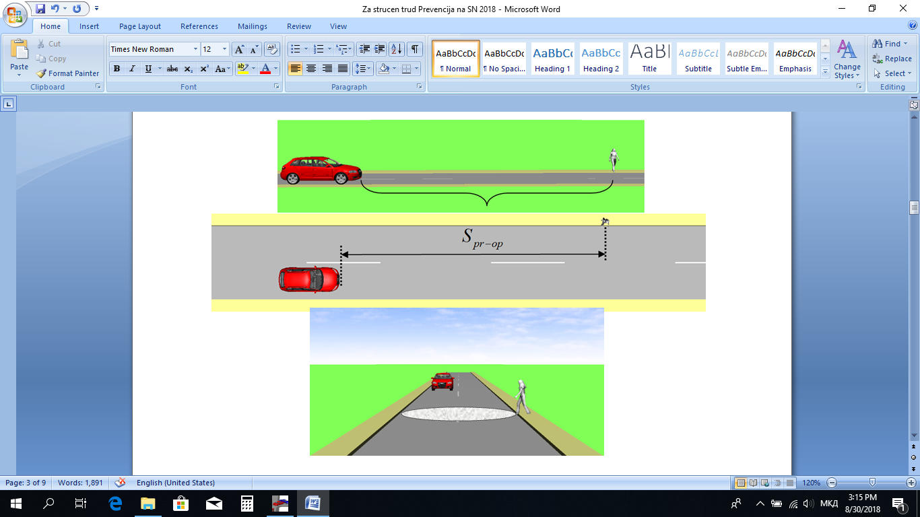

**Fig. 1.** Threshold of danger when a pedestrian crosses the road from left to right side,

observed in direction of movement of the vehicle

In order for the pedestrian not to cause the driver of the vehicle to react by breaking, it is necessary for him to finish the crossing of the road even before the vehicle reaches the potential conflict point. The necessary time for the pedestrian to cross the road completely is a function of the road width and the movement speed of the pedestrian.

The threshold of danger, in a situation when the pedestrian is crossing the road from the left to the right side, observed in direction of the vehicle movement, will be:



Where as:

 - necessary time for the pedestrian to cross the road

 road width

 speed of the pedestrian

**Table 1**. Layout of threshold of danger values at different conditions

|  |  |  |  |  |
| --- | --- | --- | --- | --- |
| Ordinal number | Maximum allowed speed  () | Speed of movement of the pedestrian | Road width | Threshold of danger  () |
| 1 | 30 km/h | 1,0 m/s | 6,0 m | 50,0 m |
| 2,0 m/s | 25,0 m |
| 2,5 m/s | 20,0 m |
| 2 | 40 km/h | 1,0 m/s | 6,0 m | 66,7 m |
| 2,0 m/s | 33,3 m |
| 2,5 m/s | 26,6 m |
| 3 | 50 km/h | 1,0 m/s | 6,0 m | 83,3 m |
| 2,0 m/s | 41,7 m |
| 2,5 m/s | 33,3 m |
| 4 | 60 km/h | 1,0 m/s | 6,0 m | 100,0 m |
| 2,0 m/s | 50,0 m |
| 2,5 m/s | 40,0 m |
| 5 | 80 km/h | 1,0 m/s | 6,0 m | 133,3 m |
| 2,0 m/s | 66,7 m |
| 2,5 m/s | 53,3 m |

In Table 1. values of threshold of danger are laid out () for various values of the maximum allowed speed of movement (driving) () and various values of the speed of movement of the pedestrian, who crosses a road 6,0 m wide.

Lets consider a case where it came to contact between a vehicle and a pedestrian who has crossed the road from the right to the left side, observed in direction of the vehicle movement (see Figure 2), and the driver is moving with disallowed speed › . In such a case, the distance passed by the pedestrian until the conflict point with the vehicle is significantly shorter, hens the time of occurrence of danger for the driver is shorter as well, i.e. the driver has less possibility to avoid contact with the pedestrian. And again, the imposed question here is, in which case the dangerous traffic situation is caused by the pedestrian, and in which by the driver of the vehicle driving with disallowed speed is in fact the participant that has created the dangerous traffic situation.

The threshold of danger, in a situation when the pedestrian crosses the road from the right to the left side, observed in direction of vehicle movement, will be:



Where as:

 - needed time for the pedestrian to pass the conflict zone with the vehicle

road width

 speed of movement of the pedestrian

 - safe distance that the pedestrian has to pass after passing on the right half of the road.

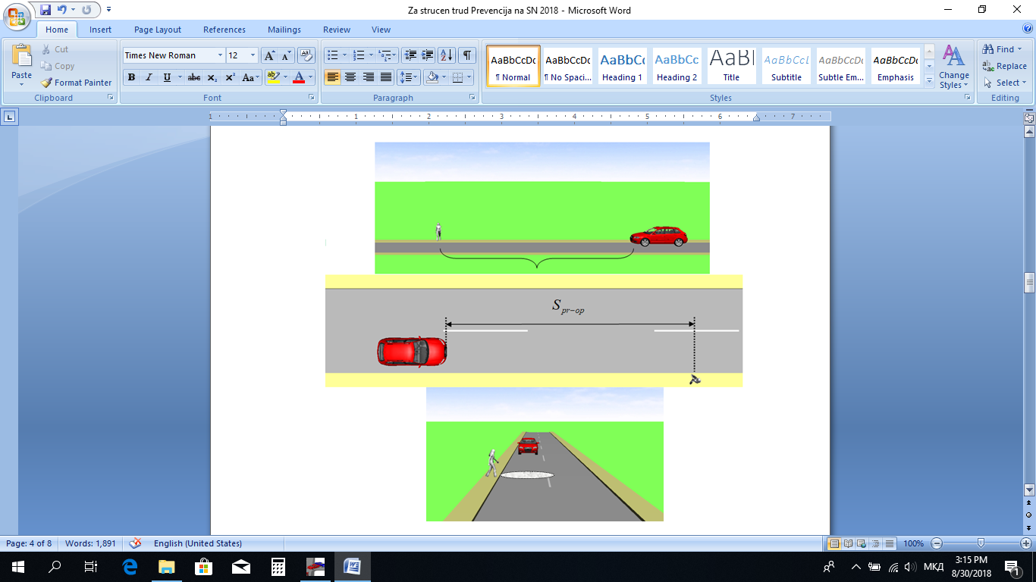

**Fig. 2.** Threshold of danger when a pedestrian crosses from left to right side,

observed in direction of vehicle movement

In table 2 threshold of danger values are given () for various values of the maximum allowed speed of driving () and various values of the speed of movement of the pedestrian, who crosses a road 6,0 m wide.

**Table 2.** Layout of the threshold of danger values for various conditions

|  |  |  |  |  |
| --- | --- | --- | --- | --- |
| Ordinal number | Maximum allowed speed  () | Speed of movement of the pedestrian | Road width | Threshold of danger  () |
| 1 | 30 km/h | 1,0 m/s | 6,0 m | 33,3 m |
| 2,0 m/s | 16,7 m |
| 2,5 m/s | 13,3 m |
| 2 | 40 km/h | 1,0 m/s | 6,0 m | 44,4 m |
| 2,0 m/s | 22,2 m |
| 2,5 m/s | 17,8 m |
| 3 | 50 km/h | 1,0 m/s | 6,0 m | 55,6 m |
| 2,0 m/s | 27,8 m |
| 2,5 m/s | 22,2 m |
| 4 | 60 km/h | 1,0 m/s | 6,0 m | 66,7 m |
| 2,0 m/s | 33,3 m |
| 2,5 m/s | 26,7 m |
| 5 | 80 km/h | 1,0 m/s | 6,0 m | 88,9 m |
| 2,0 m/s | 44,4 m |
| 2,5 m/s | 35,6 m |

1. **CONCLUSION**

In a situation when the question of whether the speed of movement (driving) could be a generator of a dangerous traffic situation, should be answered, it is necessary to carefully create a time-space analyses, therefore correctly determining the disposition of the participants in certain featured moments before the occurrence of the contact.

Through comparison of these calculated distances with the threshold of danger, mentioned above, the correct conclusion can be derived as to which of the two participants has created the danger.

Having taken in to consideration the determination of the threshold of danger, it is necessary to point out that there is a whole lot of other situations where it could be applied, such as in cases of changing of traffic lane, half-round turn, approaching of a vehicle from a side road, etc.

1. **REFERENCES**

[1] Joshevski Z., Zlatkovski S.: Ekspertiza na soobrakajni nezgodi. Tehnicki fakultet Bitola. Bitola. 2013.

[2] Joshevski Z., Stefanovski P., Stojmenov M.: Speed of movement as a cause of a dangerous traffic situation. XVII Simpozijum “Vjestacenje saobracajnih nezgoda i prevare u osiguranju”. Banja Luka. 2018.

[3] Joshevski Z., Zlatkovski S.: Teorija na sopiranje. Tehnicki fakultet Bitola. Bitola. 2008.

1. Associate Proffesor, Tehnicki Fakultet Bitola, Bitola, zoran.josevski@tfb.uklo.edu.mk
2. Associate Proffesor , Tehnicki Fakultet Bitola, Bitola, zlatkosovre@yahoo.com
3. Associate Proffesor, Triglav osiguruvanje / University American College Skopje, Skopje, stefanovski.pero@gmail.com
4. Proffesor, Tehnicki Fakultet Bitola, Bitola, verica.dancevska@tfb.uklo.edu.mk