COUNTERING CORRUPTION IN CUSTOMS - THE CASE OF THE REPUBLIC OF MACEDONIA

DanijelaMiloshoska,
University “St. Kliment Ohridski”-Bitola
Faculty of Tourism and Hospitality-Ohrid
Republic of Macedonia, dancesmilevska@yahoo.com
Risto Reckoski,
University “St. Kliment Ohridski”-Bitola
Faculty of Tourism and Hospitality-Ohrid
Republic of Macedonia, reckoice@t-home.mk

ABSTRACT
Customs Administrations play a key role in trade facilitation, revenue collection, community protection and national security. The issue of corruption is a critical issue for all nations and for all Customs Administrations. It is evident that this problem is far more prevalent in developing countries. In developing countries, Customs are usually among those administrations where corruption is most entrenched. The presence of corruption limits Customs capacity to effectively accomplish its goals.
The economy of the Republic of Macedonia is highly depended on international trade, especially imports. That results in a very big percent of businesses having direct encounters with customs officers, which gives the opportunity for corruption. Effectively preventing and combating corruption in customs is essential to an enabling business environment and investment climate. The aim of this paper is to analyze corruption in customs sector and to provide useful conclusions and recommendations in the fight against corruption.

KEY WORDS: Customs, Customs Administration, Corruption, Republic of Macedonia

INTRODUCTION
Corruption occurs in many situations and it includes different actions. The World Bank and the WCO define corruption simply as “the misuse of public power for private benefit” (World Bank, 1997). In some countries the practice of corruption is so widespread in the working relationship between customs officials and members of the business community that it has become an accepted practice. Corruption includes any action that the employee will perform while on his duty, and for what he requires return or accepts some benefit, convenience or interest, as well as overdraft and violation of standard procedures, misuse of the official duty or overstepping of legal authorizations.
A useful analytical framework to analyze corruption is proposed by Robert Klitgaard (1998). Klitgaard suggests that corruption is most likely to occur when agents (individuals or groups) enjoy monopoly power over clients, when agents enjoy discretionary power over the provision of goods or services, and when the level of accountability is low. According to this framework, the probability of corruption occurring follows a simple equation:
Corruption =Monopoly +Discretion-Accountability (C =M +D -A)
Klitgaard’s conclusions accord closely with those of Irene Hors of the OECD Development Centre. Hors (2001), drawing on the lessons learned from the anticorruption and modernization efforts in the customs administrations of three countries, concluded that the customs working environment is vulnerable to corruption because there is (a) a discretionary interface between customs officials and private sector operators, (b) a possibility for customs officials to operate within a network of accomplices, and (c) a lack of official controls.
Deriving from the Klitgaard (1998) theoretical framework, Ferreira, Carlos, Michael Engelschalk, and William Mayville (2007) develop a corruption risk map related to combating illicit trade, weakness of the legal and regulatory system, inefficient human resource system and lack of an appropriate accountability system. They support and further develop the argument of Le, Tuan Minh (2007) on the correlation between corruption and size of the shadow market. Having identified the risks of corruption, the authors give an overview of strategies to reduce it.
Klemencic, Goran and Janez Stusek (2007) in their OECD report analyze different models of specialised anti-corruption agencies. Based on a number of criteria, the authors have identified three general models: multi-purpose agencies with law enforcement powers; law enforcement agencies, departments and units; and preventive, policy development and coordination institutions.
Michael, Bryane and Mariya Polner (2008) analyze the problems of the legislation in place and action planning as well as refer to the issue of the best organizational model to combat corruption. The authors concluded that implementation of a risk management system and introduction of investigation and prosecution mechanisms can be effective in reducing corruption.
Sequeira, Djankov (2013) investigates how corruption affects firm behaviour. Firms can engage in two types of corruption when seeking a public service: cost-reducing “collusive" corruption and cost-increasing “coercive" corruption.

The current environment in Macedonia

Over the past few years, Macedonian customs has seen significant progress, particularly with the introduction of the integrated border management and a separate functional central system of video surveillance at the border crossings and customs checkpoints, which operates continuously. New bylaws were adopted that lay down the standards for conduct of customs officials in different circumstances and a mobile system of internal control was also introduced.
But still there are figures that indicate that the customs remains a high risk area in terms of corruption (the European Commission report on the progress of the Republic of Macedonia of 12 October 2011; Business, corruption and crime in the Western Balkans: The impact of bribery and other crime on private enterprise 2013; Corruption Assessment Report for Macedonia 2014; Corruption Assessment Report for Macedonia 2016).
The analyzes presented in the Corruption Assessment Report 2016 show various trends in the indicators of corruption analyzed over the years. Susceptibility to corruption has decreased slightly and corruption pressure and involvement in corruption has increased marginally. Citizen perceptions of corruption have improved significantly compared to 2002. The practical efficiency of corruption goes below the levels of 2001, which implies it has become more uncertain to get involved in corruption (Corruption Assessment Report, 2016).
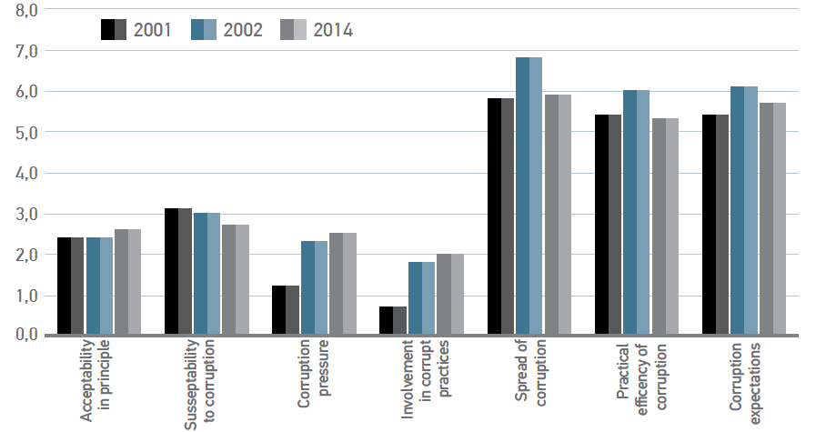 Figure 1: Comparison of Corruption Monitoring System indexes for Macedonia between 2001, 2002 and 2014 (Source: Corruption Assessment Report for Macedonia 2016, based on Corruption Monitoring System (CMS) 2014)

The Corruption Assessment Report shows that according to the respondents’ perceptions, corruption is most prevalent in the Customs, Courts and Police. Following those is the Ministry of Health and the Ministry of Transport. Close to the top ranking is also the Government, local governments, and the tax office. Similarly, when asked about professions and holders of specific public positions, citizens put on top customs officers, judges, ministers, public prosecutors, tax officers, and political party leaders (Corruption Assessment Report 2016).

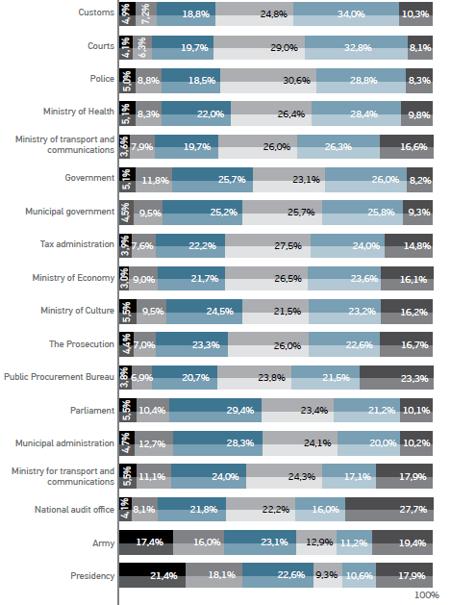
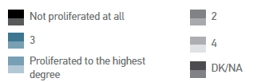
Figure 2: Corruption in state institutions (Source: Corruption Assessment Report for Macedonia 2016, based on Corruption Monitoring System (CMS) 2014)

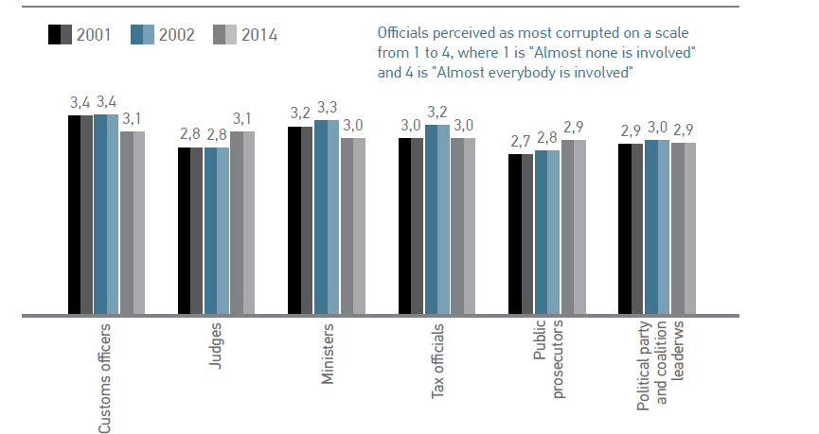

Figure 3: Perception of corruptness according to profession – most corrupted (Source: Corruption Assessment Report for Macedonia 2016, based on Corruption Monitoring System (CMS) 2014)
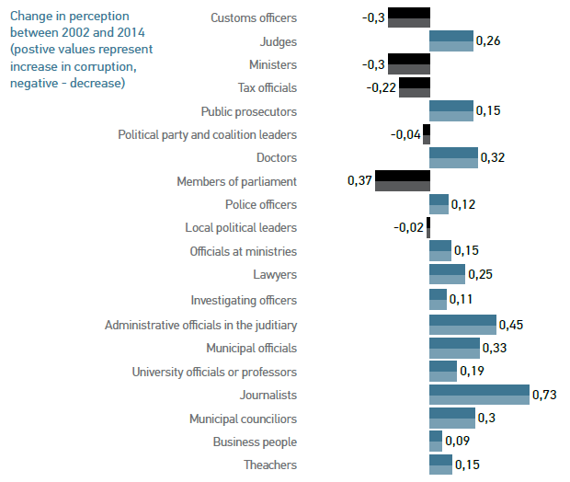Figure 4: Perceptions of corruptness of public officials – change in perception between 2002 and 2014. (Source: Corruption Assessment Report for Macedonia 2016, based on Corruption Monitoring System (CMS))

Causes and effects of corruption in customs

Analyzes suggest that there are a number of reasons that make customs corruption happen on an everyday basis. As the main causes of customs corruption, we will list the following:
- It happens during the contacts with the customs officers;
- The more direct contacts imposed by the regulation and the system - the greater the scope for corruption and abuse it is;
- Complex and imprecise regulation with discretion of the customs officers as a cause of corruption;
- Missing of low transparency – as a cause of corruption;
- Cash payment - more room for corruption;
- The Macedonian economy is still highly import dependent - 80% of businesses have to work with the Customs Administration.
The effects of corruption in customs are various:
- Illegal trade in narcotics, weapons and dual-use goods;
- Production and distribution of counterfeited goods and piracy;
- Cash payments;
- Money laundering;
- Tax evasion;
- Economic crime;
- Financing terrorism;
- Less finance to fulfill public needs;
- Reduced protection of human life and health and the environment;
- Higher costs for legal trade;
- Unfair competition and unfavorable business environment.

Measures and activities of Macedonian customs countering corruption

The extensive problem of corruption in customs needs a comprehensive and sustainable approach that addresses the causes and effects of it, covering the needed measures and activities countering corruption. The Arusha Declaration drafted by the World Customs Organization (WCO 1993), the International Monetary Fund Integrity Paper (IMF 1997) and the conclusions of the Working Group on Customs Ethics in Central and Eastern European Countries (Working Group on Customs Ethics 2000) recommend the following changes in customs administration in order to fight against corruption:
Organization of Customs Operations: define targets and standards of service quality; segregate functions strategically and build checks and balances; frame customs procedures so as to reduce to a minimum the inappropriate exercise of discretion; computerize customs operations; minimize the requirements of information and documentation from traders.
Staff Rules: develop a code of conduct and explain its implications to customs officers; define corruption and related offences in legal texts and in the customs internal rules; set corresponding sanctions at a reasonably dissuasive level (including in internal disciplinary measures the possibility of dismissal).
Internal Culture: promote customs service standards and ideals; develop behavior, based on a sense of loyalty and pride in the customs service.
Obtaining Information and Investigation: give managers the prime responsibility for identifying weaknesses in working methods and in the integrity of the staff; set up internal audit mechanisms; conduct regular external audits; set up an internal affairs unit with the specific task of investigating all cases of suspected malpractice, in complement to internal audit; allocate examinations of customs officers randomly; take measures to allow feedback from private operators; follow the employees' assets, by organizing disclosure.
Human Resource Management: adopt an objective recruitment process, immune from interference, based on knowledge and standards of personal ethics; adopt an objective promotion process, immune from interference, merit-based and jeopardized by inappropriate behavior; relocate regularly the staff; provide professional training to customs officers throughout their careers, including on ethics and integrity issues. provide a remuneration sufficient to afford a decent standard of living, including, in certain circumstances social benefits such as the health care and housing facilities; set up incentive payments.
Relations with Customs Brokers and the Business Community: facilitate access of private operators to information on regulations and procedures; organize liaison committees with the business community; make appealing against customs decisions, with, in the final instance, recourse to independent adjudication, possible.
In addition, all three study papers, mentioned above, link the reduction of corruption with broader policy measures, at the national level. The Arusha Declaration and the IMF Paper identify several essential conditions for successful reform. Both stress the importance of “a firm commitment at the highest political and administrative levels” (Arusha Declaration) or in the terms of the IMF Paper “a clear and unequivocal commitment from the Government”. The IMF paper goes further and points out three supplementary conditions:” an atmosphere where importers and exporters will come forward and discuss the decisions that are being made and the existence of an independent judiciary and a free press”.
Analysis of the Macedonian customs operating environment complements these assertions. In the light of the identified problems and risk factors of corruption there are several activities and measures (Recognized by the State programme for prevention and reduction of corruption and conflict of interests 2011-2015, State Commission for Preventing Corruption) to be taken:
- Strengthening the capacities of the internal control and creating a system of regular and extraordinary controls over the work of the customs officers in order to ensure that the standard operating procedures are consistently respected and implemented;
Improving the capacities of the internal control unit, together with the measures to strengthen the individual integrity, are the main drivers for consistent compliance with the standard procedures and the established deadlines. Therefore, it is necessary to strengthen the controls at border crossings and customs checkpoints; implement continuous training for effective implementation of the Code of Conduct for the Customs Officials and undertake all the legal measures to detect and punish the cases of corruption.
- Implementing a system for corruption risk assessment in the customs services, with measures to strengthen the individual and institutional integrity;
Customs Administration should assess the risk of corruption in all aspects of the customs operations, with measures to strengthen the individual and institutional integrity. That will contribute to preventing the possible forms of corruption, while helping to improve the organization of work and the utilization of the existing resources.
- Introducing a more efficient system for communication with the public.
The introduction of a more efficient system of communication with the public will allow for the institutions to open for the citizens and publicize all the necessary documents for all customs services. In this manner, conditions will be created for more efficient service delivery to the citizens, improved cooperation in identifying the bottlenecks in the work of the customs services as a source of corruption, as well as more active cooperation by the citizens in recognizing and preventing corrupt behavior.
The Macedonian Customs aims at achieving a high level of trust in the public and maintaining and developing the organizational culture based on the following principles: Rule of law, equality and fairness; Leadership, professionalism, accountability, honesty and transparency; Efficiency, effectiveness, availability and confidentiality.
In implementing laws and regulations, the Customs Administration must apply high standards of integrity, behaviour and core values, especially with regard to quality service, honesty and trust, motivation and development of human potential and teamwork and corporate spirit. The above mentioned principles will be ensured through the application of the ethical code of conduct, annual priorities and plans, financial management and control, information security management, control of operations and assessment, internal audit and disciplinary and other procedures.
According to the Strategic Plan of the Customs Administration of the Republic of Macedonia 2018-2020, Macedonian customs is obliged to: Implementation of the Programmes of the Government of the Republic of Macedonia for Prevention of Corruption and Conflict of Interest; Promoting the cooperation with the State Commission for Prevention of Corruption and other institutions involved in the fight against corruption; Improving the mechanism of professional accountability and integrity by using the best international practices by promoting the established systems of professional, legal and ethical conduct; Introducing measures for strengthening the integrity and affirmation of the positive conduct of the employees that promotes honest and ethical behavior in the performance of their official duties; Raising public awareness for reporting corruption cases by organizing and conducting anti-corruption campaigns and conflicts of interest; Improving the research of the opinion and attitudes of the business community, citizens and employees regarding the level of exposure to misuse of office and the occurrence of corrupt activities. In order to fulfill its obligation in the fight against corruption Macedonian Customs has adopted several anti-corruption activities: Strategy for integrity and fight against corruption in the Customs Administration of the Republic of Macedonia 2015-2018 (aims at defining the directions for strengthening the integrity and developing a concept of proactive measures for reducing corruption and conflict of interest.); Ratified United Nations Convention against Corruption; Protocol on Cooperation for the Prevention and Repression of Corruption and Conflict of Interest; Revised Arusha declaration; Code of Conduct of Customs Officers; Rules of Order and Discipline at the Customs Administration.

Conclusions

Macedonian Customs is constantly taking measures and corruption reduction activities, but the corruption is still present. Corruption discredits Macedonian Customs and destructively affects its overall operations, which in turn leads to a reduction in public confidence. The implications of corruption in customs on a nation's capacity to benefit from the expansion of the global economy are obvious. The employees of the Customs Administration are obliged to respect and enforce legal regulations and bylaws responsibly and professionally.
The analyses of the Macedonian customs underlined several activities and measures to prevent corruption:
- Strengthening the capacities of the internal control and creating a system of regular and extraordinary controls over the work of the customs officers in order to ensure that the standard operating procedures are consistently respected and implemented;
- Implementing a system for corruption risk assessment in the customs services, with measures to strengthen the individual and institutional integrity;
- Introducing a more efficient system for communication with the public.

REFERENCE:

1. Crotty J, Practical Measures to Promote Integrity in Customs Administrations, Washington, D.C.: International Monetary Found, 1997
2. Customs Administration of Republic of Macedonia, Annual Reports of the Customs Administration of the Republic of Macedonia 2010-2016. Available at: www.customs.gov.mk (accessed 30.06. 2018)
3. Ferreira, Carlos, Michael Engelschalk, and William Mayville , The Challenge of Combating Corruption in Customs Administrations, in J. Edgardo Campos and Sanjav Pradhan, The Many Faces of Corruption: Tracking Vulnerabilities at the Sector Level, The World Bank, pp. 367-386, 2007
4. European Commission, Report on the progress of the Republic of Macedonia, Skopje, 2011
5. Hors Irene, Fighting Corruption in Customs Administration: What Can We Learn from Recent Experiences? , OECD Development Centre Technical Paper No. 175. Paris, 2001
6. International Express Carrier’s Conference, Customs Reform — Integrity Through Efficiency, IECC Occasional Paper No. 1, Brussels, Belgium, 1998
7. Klitgaard, R., Controlling Corruption, University of California Press, Berkeley, 1998
8. Klemencic, Goran and Janez Stusek, Specialised Anti-Corruption Institutions, Review of Models, OECD, 2007
9. Lambsdorff J., Corruption in Empirical Research — A Review, Transparency International Working Paper, 1999
10. Leonid, Lozbenko, Customs Integrity Issues, 9 th International Anti Corruption Conference, Durban, South Africa, 1999
11.Le, Tuan Minh, Combating Corruption in Revenue Administration: an Overview, in J. Edgardo Campos and Sanjav Pradhan, The Many Faces of Corruption: Tracking Vulnerabilities at the Sector Level, The World Bank, pp. 335-338, 2007
12. Michael, Bryane and Mariya Polner, Fighting Corruption on the Transdnistrian Border: Lessons from Failed and New Successful Anti-Corruption Programmes,Transition Studies Review 15:3, Springer, pp.524-541, 2008

13. Organization for Economic Co-operation and Development, Working Paper No.175, Fighting Corruption in Customs Administration: What Can We Learn From Recent Experiences?, 2001
14. Robert, Holler L., Customs modernization handbook, Establishing and Implementing a Customs Integrity Program, United States Agency for International Development, 2005
15. Sequeira, S., and Djankov, S., Corruption and firm behaviour: Evidence from African ports, London School of Economics, 2013
16. State Commission for Preventing Corruption, State progamme for prevention and reduction of corruption and conflict of interests 2011-2015, Skopje, 2011
17. State Commission for Preventing Corruption, State progamme for prevention and reduction of corruption and conflict of interests 2016-2019, Skopje, 2015
18. United Nations Office on Drugs and Crimes, Business, Corruption and Crime in the Western Balkans: The impact of bribery and other crime on private enterprise, 2013
19. United States Agency International Development , Corruption Assessment Report for Macedonia, 2014
20. United States Agency International Development, Corruption Assessment Report for Macedonia, 2016
21. World Customs Organization, The Arusha Declaration — Declaration of the Customs Co-operation Council Concerning Integrity in Customs, 1993
22. Working Group on Customs Ethics, Conclusions of the Workshop on Customs Ethics. Budapest: Unpublished document, 2000
23. World Bank, New Frontiers in Diagnosing and Combating Corruption., PREM Notes, World Bank, 1998 Available at: www.worldbank.org, (accessed January 2018)
24. World Bank, Helping Countries Combat Corruption: The Role of the World Bank, Washington, DC: World Bank Group, 1997

