SYNTHESIS AND SPECTROPHOTOMETRIC ANALYSIS OF
3,5-BIS(ARYLIDENE)-4-PIPERIDONES

Zlatko Lozanovski¹[^{0009-0009-9228-893X}] and Valentina Velkovski^{2[}0000-0003-4978-5710]

¹ Higher Medical School – Bitola, University “St. Kliment Ohridski” – Bitola, N. Macedonia
² Faculty of Technology and Technical Sciences – Veles, University “St. Kliment Ohridski” – Bitola, N. Macedonia
e-mail: zlatko.lozanovski@uklo.edu.mk

Abstract

3,5-Bis(arylidene)-4-piperidones represent a class of synthetically accessible scaffolds with notable pharmacological potential, including anticancer, antimicrobial, and anti-inflammatory properties. In this study, three derivatives (3E,5E)-3,5-bis(2-fluorobenzylidene)-piperidin-4-one (IIIa), (3E,5E)-3,5-bis(2-bromobenzylidene)-piperidin-4-one (IIIb) and (3E,5E)-3,5-bis(2-trifluoromethylbenzylidene)-piperidin-4-one (IIIc) were synthesized via Claisen–Schmidt condensation of ortho-substituted aromatic aldehydes with 4-piperidone in methanol under basic conditions. Compounds were isolated as crystalline solids in good yields and characterized by melting-point analysis, UV-Vis, FTIR, ESI-MS, HPLC, and GC-MS.
FT-IR spectra confirmed conjugated carbonyl absorptions in the 1661–1676 cm⁻¹ range together with substituent-specific signals such as C–F, C–Br, and CF₃. Additional features, including aromatic C=C bands and a diagnostic trans =C–H vibration at ~965 cm⁻¹, supported their structural configuration. UV-Vis spectra displayed characteristic π→π* and n→π* transitions in the 228–370 nm region. The position of these bands reflected the electronic effects of the substituents, with CF₃ causing hypsochromic shifts and Br producing pronounced bathochromic shifts. These spectroscopic results confirm the successful synthesis and structural integrity of IIIa,IIIb and IIIc, highlighting their potential for further biological evaluation.
Given the electrophilic nature of their α,β-unsaturated carbonyl groups, these compounds also present opportunities for thiol-reactivity studies relevant to redox signaling, enzyme inhibition, and cellular stress response mechanisms.

Keywords: 4-piperidones, Claisen–Schmidt condensation, UV-Vis, FTIR, HPLC, GC-MS.

1. Introduction

3,5-Bis(arylidene)-4-piperidones represent a structurally versatile class of curcumin analogues that have attracted considerable scientific attention for their pharmacological potential. Unlike natural curcumin, which suffers from poor bioavailability, instability, and rapid metabolism, bis(arylidene)-4-piperidones exhibit improved chemical stability and tunability of their core scaffold, enabling more potent and selective biological effects (Razali et al., 2022; Shmitt et al. 2018; Razali et al., 2024). The central piperidone ring, substituted at the 3,5-positions with conjugated arylidene groups, confers strong electrophilicity due to its α,β-unsaturated carbonyl system, figure 1. This feature allows interaction with cellular nucleophiles such as cysteine thiols, thereby modulating redox signaling pathways, enzyme activity, and cell survival mechanisms.
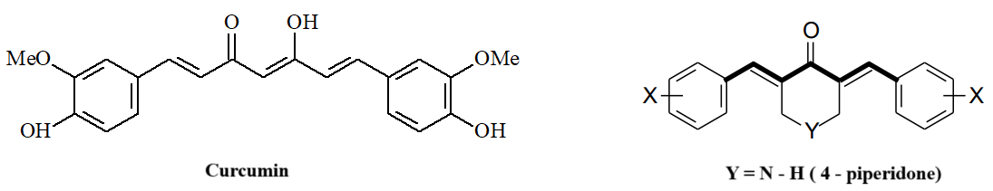
Figure 1: Curcumin structural formula (left), 4 – piperidones general structural formula (right)

From a synthetic perspective, bis(arylidene)-4-piperidones are typically obtained through Claisen–Schmidt condensation between substituted aromatic aldehydes and 4-piperidone under basic or acidic catalysis. This study examines (3E,5E)-3,5-bis(2-fluorobenzylidene)-piperidin-4-one (IIIa), (3E,5E)-3,5-bis(2-bromobenzylidene)-piperidin-4-one (IIIb), and (3E,5E)-3,5-bis(2-trifluorobenzylidene)-piperidin-4-one (IIIc), using reliable synthetic methods and detailed analytical characterization to provide a foundation for future biological studies.

2. Literature Review

In bis(arylidene)-4-piperidones with a C-5 chain, the modifications are directed towards acylation of the –NH group of the 4-piperidone ring in order to obtain analogues with improved antitumor properties (Das et al., 2008; Lagisetty et al., 2010; Jha et al., 2007; Makarov et al., 2010; Dimmock et al., 2001). The presence of amido-ether groups is responsible for numerous polar and non-polar interactions, rendering the molecule highly reactive and capable of forming hydrogen bonds, van der Waals forces, as well as π–π stacking interactions, all of which are exploited in targeted cancer therapy (Liang et al., 2008).
Anthwal and colleagues succeeded in synthesizing derivatives with a piperidone core (analogues 1–3) through an aldol condensation reaction between 4-piperidone hydrochloride and the corresponding aldehyde in the presence of methanol and NaOH, as shown in Figure 2 (Anthwal et al., 2016).
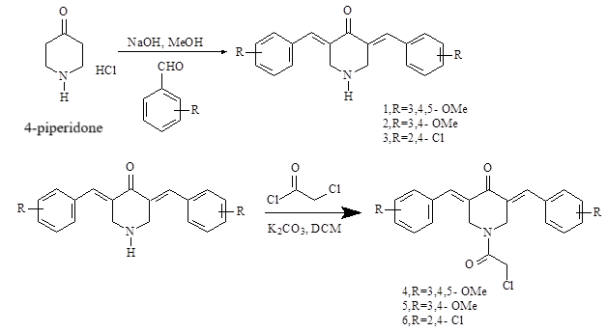
Figure 2. Modification of the curcumin molecule and synthesis of cyclic analogues with a piperidone core (Anthwal et al., 2016).

Singaram and colleagues synthesized three series of heteroaromatic analogues (27 derivatives) and evaluated them for potential antimicrobial activities against six microbial strains: Salmonella enterica subsp. enterica serovar Typhi, Vibrio cholerae, Escherichia coli, Staphylococcus aureus subsp. aureus, Aspergillus niger, and Aspergillus fumigatus (Singaram et al., 2016). It was observed that 3,5-dibenzylidene-1-[(3,5-dichloro-2-hydroxyphenyl)-sulfonyl]-piperidin-4-one (compound 5e) exhibited the strongest antifungal properties against A. niger and A. fumigatus, while derivatives 3a–f displayed moderate antimicrobial activity across the six microbial strains, particularly compounds 3a, 3b, 3d, and 3f. The synthesis of the 3a–f series was carried out through condensation of 4-piperidone hydrochloride with appropriately substituted aromatic aldehydes (Singaram et al., 2016).
Wang and co-workers designed 30 monocarbonyl analogues of curcumin incorporating electron-donating and electron-withdrawing substituents (hydroxy, methoxy, fluoro, trifluoromethyl, and trifluoromethoxy groups) at the ortho position of the aromatic ring, combined with acetone, cyclohexanone, cyclopentanone, and 4-piperidone (N–H, N-methyl, and N-acrylyl) moieties, respectively figure 3. Their focus was on evaluating the anti-inflammatory properties of these analogues in lipopolysaccharide (LPS)-stimulated Raw264.7 macrophages and in a dextran sulfate sodium (DSS)-induced colitis mouse model, aiming to identify potent anti-inflammatory agents in vivo (Wang et al., 2021).

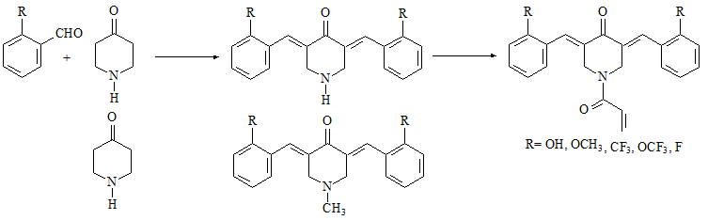
Figure 3. Synthesis of 4-piperidone MACs and the corresponding acryloyl derivatives, (Wang et al., 2021).

In addition, there are reports describing the synthesis of a series of analogues belonging to the class of N-[4-(3-aryl-3-oxo-1-propenyl) phenylcarbonyl]-3,5-bis(phenylmethylene)-4-piperidones (analogues 125–130). These synthesized compounds were shown to exhibit pronounced cytotoxicity and selective toxicity against different tumor cell lines, which is of considerable significance in oncology, figure 4 (Dimmock et al., 2002).

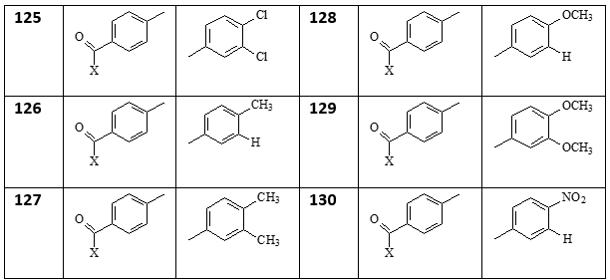

Figure 4. Structure of 3,5-bis(phenylmethylene)-4-piperidones (analogues 125–130), (Dimmock et al., 2002).

3. Methods and Materials

The following materials and reagents were used: 2-bromobenzaldehyde, 2-(trifluoromethyl)-benzaldehyde, 2-fluorobenzaldehyde, CH₃CN (HPLC grade), 4-piperidone hydrochloride, ammonium chloride, chloroform, and sodium hydroxide, all obtained from Sigma-Aldrich. Ethyl acetate was purchased from VWR Chemicals, n-hexane from Carlo Erba, dichloromethane and acetone from Fisher Chemical, while methanol and ethanol were obtained from Alkaloid AD Skopje. All chemicals were used without further purification.
Melting points were determined in open capillaries using a Mel-Temp apparatus and are uncorrected. Infrared spectra were recorded on a Varian Excalibur 3100 FT-IR spectrometer using KBr pellets. Mass spectra were acquired using an Agilent 1100 HPLC system equipped with an ESI interface and an ion trap mass analyzer (G2445A spectrometer), operated with LCMSD software (Agilent, v.4.1). Measurements were performed in APCI positive ion mode.

3.1. UV-Vis Spectroscopy

UV-Vis spectra were recorded on a Cary 50 spectrophotometer using quartz cuvettes over the wavelength range of 200–800 nm. Samples of 3,5-bis(arylidene)-4-piperidones were weighed to obtain a final concentration of 0.2–0.4 mg/mL and dissolved in spectrophotometric grade CH₃CN in separate flasks. Appropriate aliquots of these stock solutions were then taken to prepare working solutions with a concentration of 10⁻⁵ M in pure CH₃CN or in 80/20 CH₃CN/water. A blank probe was recorded in CH₃CN or 80/20 CH₃CN/H₂O. The UV-Vis spectra of the compounds of interest were measured in 80/20 CH₃CN/dH₂O, and throughout all measurements the samples were protected from light.

3.2. Synthesis of 3,5-Bis(arylidene)-4-piperidones

The synthesis of 3,5-bis(arylidene)-4-piperidones was carried out according to the method reported by Liu (Liu et al., 2018). Piperid-4-one (25 mmol), the appropriate benzaldehyde (51 mmol), and ethanol (8 mL) were added to a round-bottom flask. The reaction mixture was stirred at room temperature, after which a 20% (w/v) aqueous sodium hydroxide solution (5 mL) was added dropwise. The mixture was further stirred for 24 h with a magnetic stirrer at room temperature, followed by the addition of dH₂O (40 mmol) and neutralization with hydrochloric acid solution, resulting in the formation of a yellow precipitate.
The reaction mixture was cooled in an ice bath for 10 min and filtered through a Büchner funnel. The obtained precipitate was washed with distilled water and ice-cold methanol, and subsequently dried under vacuum (Liu et al., 2018). The final product was recrystallized from the appropriate solvent, with care taken to avoid exposure of the solution to light.

(3E,5E)-3,5-Bis(2-fluorobenzylidene)-4-piperidone (PIP IIIa): yield: 47%, recrystallized from 96% ethanol to yield yellow crystals; m.p. 134-136 °C (lit. 138-142 °С (Liu et al., 2018); FT-IR (KBr): 3304 cm⁻¹ (NH), 1661 (C = O); FT -IR-ATR (safir): 3303 cm⁻¹ (NH), 1660 (C = O) ; UV-Vis : λ _{max} (80/20 CH₃CN: H₂O) = 324 nm ( ε = 26688 L· mol⁻¹ ·cm⁻¹ ), HPLC-DAD-MS , tR = 2,9 min, MS-APCI ( m/z ) = 312 (MH⁺).

(3E, 5E)-3,5-bis(2-bromobenzylidene)-4-piperidone (PIP IIIb): yield: 56%, yellow needles, rec. solvent 4:1 96% EtOH/ EtOAc, m.p. 162–163 ◦C; FTIR bands: ν(C=O) 1669 cm⁻¹ , ν(N-H) 3312 cm⁻¹ , ν(C-Br) 1075–1030 cm⁻¹ , ν(C-N) 1194 cm⁻¹ ; ATR-FTIR bands: ν(C=O) 1667 cm⁻¹ , ν(N-H) 3313 cm⁻¹ , ν(C-Br) 1075–1030 cm⁻¹ , ν(C-N) 1192 cm⁻¹ ; UV-Vis (80/20 CH₃CN: H₂O) = 370 nm), GC-MS , tR = 24,77 min, EI-MS ( m/z ) = M⁺+4 (435), M⁺+2 (433), M⁺(431)+.

(3E, 5E)-3,5-bis(2-trifluorobenzylidene)-4-piperidone(PIP IIIc): yield: 62%, yellow needles, rec. solvent 96% EtOH, m.p. 167–168 ◦C; FTIR bands: ν(C=O) 1676 cm⁻¹ , ν(N-H) 3272 cm⁻¹ , ν(C-F) 1350–1100 cm⁻¹ , ν(C-N) 1100 cm⁻¹ ; ATR-FT-IR bands: ν(C=O) 1661 cm⁻¹ , ν(N-H) 3302 cm⁻¹ , ν(C-F) 1350–1100 cm⁻¹ , ν(C-N) 1095 cm⁻¹ ; UV-Vis (CH₃CN): λ = 228 nm (π→π*), λ = 304 nm (n→π*).
4. Results and Discussion

The synthesis of 3,5-bis(arylidene)-4-piperidones was performed according to the method of Liu (Liu et al., 2018) namely via a classical Claisen–Schmidt condensation between piperid-4-one and the corresponding benzaldehyde (2-bromobenzaldehyde, 2-(trifluoromethyl)-benzaldehyde and 2-fluorobenzaldehyde), yielding needle-like crystalline products designated as PIP IIIa, PIP IIIb, and PIP IIIc. Through this condensation, the synthesized compounds acquire a single keto group, which contributes to enhanced stabilization and greater cytotoxic potential of the piperidone scaffold compared with its natural precursor, curcumin, figure 5.
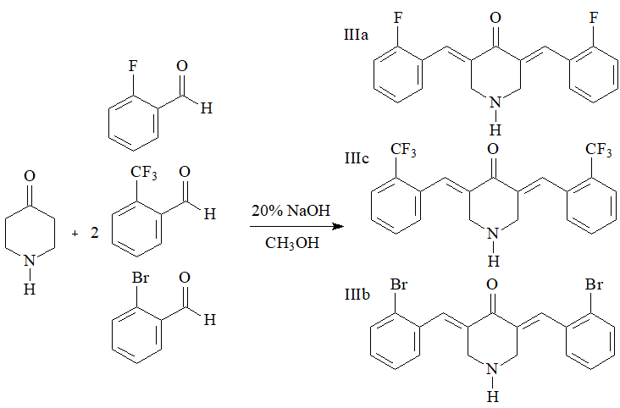
Figure 5: Synthesis of (3E,5E)-3,5-bis(2-fluorobenzylidene)-piperidin-4-one (IIIa), (3E,5E)-3,5-bis(2-bromobenzylidene)-piperidin-4-one (IIIb), and (3E,5E)-3,5-bis(2-trifluorobenzylidene)-piperidin-4-one (IIIc).

The obtained piperidones were recrystallized from the appropriate solvent, and their melting points were determined and compared with literature data (Table 1).

Table 1: Significant physicochemical and spectroscopic characteristics of the synthesized 3,5-bis(arylidene)-4-piperidones.

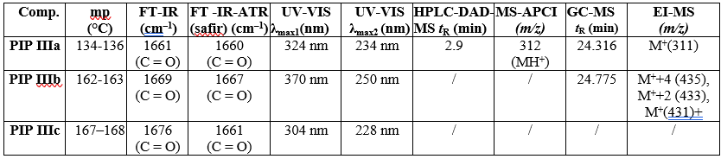

The FT-IR spectra of the synthesized 3,5-bis(arylidene)-4-piperidone derivatives provide clear diagnostic features that confirm their conjugated enone framework, substituent effects, and stereochemical configuration. Across all three compounds: IIIa, IIIb and IIIc a strong conjugated carbonyl stretch is consistently observed in the 1661–1675 cm⁻¹ region which is consistent with the literature (McMurry, 2004), figure 6. Substituent-specific signals allow clear differentiation between the derivatives. In the fluorinated compound, strong C–F stretching bands are evident in the 1206–1270 and 1000–1100 cm⁻¹ regions, consistent with ortho-fluoro substitution on the aromatic rings, figure 6.

`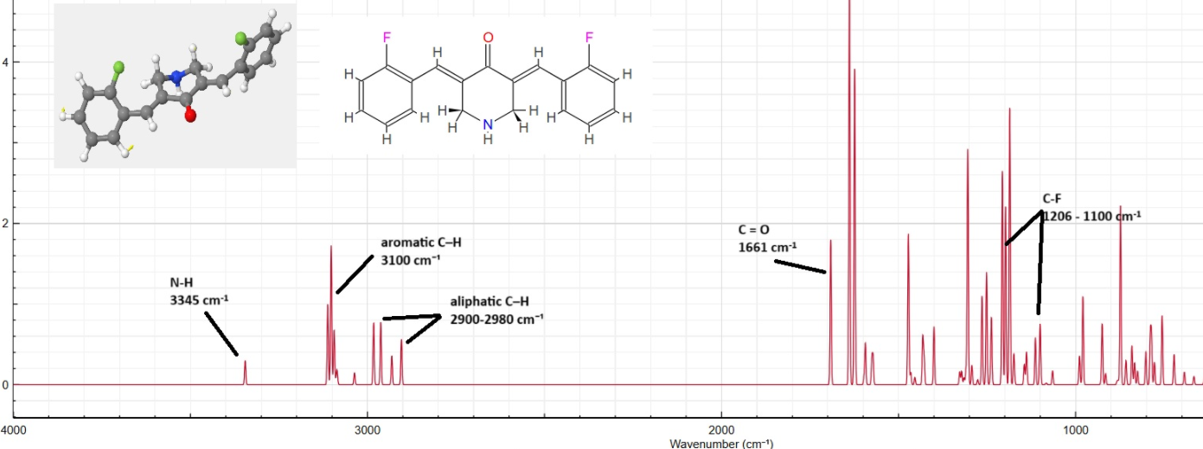
Figure 6: FT-IR spectra of (3E,5E)-3,5-bis(2-fluorobenzylidene)-4-piperidone (IIIa)

In the brominated analogue, the presence of bromine is marked by distinctive C–Br absorptions at 1075–1030 cm⁻¹, absent in the other derivatives. The trifluoromethyl derivative exhibits the most intense fingerprint region, with characteristic CF₃ absorptions near 1330 cm⁻¹ and additional strong bands in the 1250–1120 cm⁻¹ range, reflecting the highly electronegative and bulky substituents.
Additional recurring features across the series include aliphatic C–H stretches (2850–2960 cm⁻¹), aromatic C–H stretches (~3020–3100 cm⁻¹), and in some cases a weak to medium N–H stretching band around 3300–3350 cm⁻¹, present only if the piperidone nitrogen remains unsubstituted, figure 7. Importantly, all three derivatives display a sharp out-of-plane trans =C–H bending vibration near 965 cm⁻¹, which is diagnostic for the (E,E) geometry of the exocyclic double bonds. Aromatic C–H out-of-plane bends in the 700–800 cm⁻¹ region further confirm ortho-substitution patterns.
The UV-Vis spectra of the three derivatives: IIIa, IIIb and IIIc demonstrate spectral features that are typical for conjugated enone–aryl systems while also reflecting the influence of different substituents on the benzylidene rings. For the fluoro-substituted derivative, two major absorption bands are observed: one at 234 nm, assignable to a π→π* transition of the aromatic and conjugated alkene system, and another at 324 nm, attributed to the n→π* transition of the conjugated carbonyl group. The modest bathochromic shift of the n→π* band relative to simple arylidene ketones suggests an extended conjugation pathway stabilized by the ortho-fluoro substituents, figure 7- left.

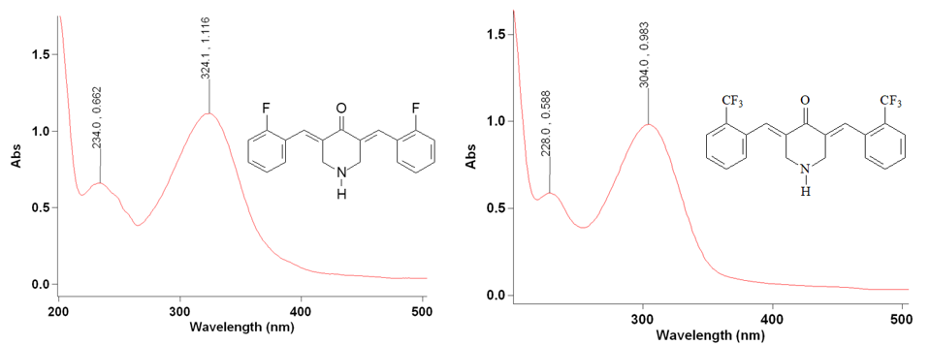
Figure 7: IIIa dissolved in 80/20(v/v)CH₃CN/H₂O quartz cuvette- left, IIIc dissolved in 80/20(v/v)CH₃CN/H₂O quartz cuvette- right

The trifluoromethyl derivative exhibits absorptions at 228 nm (π→π)* and 304 nm (n→π)**. Compared with the fluoro compound, the π→π band is slightly hypsochromically shifted, while the n→π* band appears at lower wavelength (304 vs. 324 nm), reflecting the strong electron-withdrawing effect of the CF₃ groups. These substituents reduce the electron density on the conjugated system, leading to diminished delocalization and therefore a blue shift of the n→π* transition, figure 7- right.
The bromo-substituted analogue shows the most pronounced red-shift, with absorptions at 250 nm (π→π)* and 370 nm (n→π)**. The extended bathochromic shift of the n→π transition indicates that heavy atom substitution and the polarizability of bromine enhance conjugation and lower the energy gap for this transition. This effect is consistent with literature (McMurry, 2004), that heavier halogens increase orbital overlap and promote stabilization of the excited state, leading to longer wavelength absorption, figure 8.

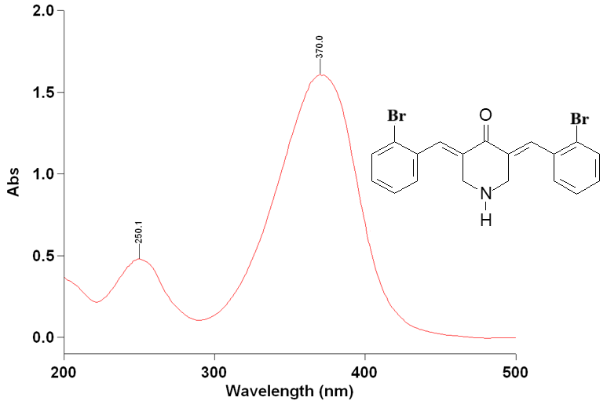

Figure 8: IIIb dissolved in 80/20(v/v)CH₃CN/H₂O quartz cuvette

UV-Vis spectra of these derivatives provide direct evidence of the interplay between substitution pattern and electronic structure. The π→π* bands in the 228–250 nm range are relatively invariant, corresponding to aromatic and alkene chromophores, whereas the n→π bands (304–370 nm) are sensitive to the electronic nature of the substituents. Electron-withdrawing fluorine and CF₃ groups induce hypsochromic shifts, while the more polarizable bromine substituents produce significant bathochromic shifts.

5. Conclusion

The present study highlights the importance of 3,5-bis(arylidene)-4-piperidones as synthetically accessible analogues with promising pharmacological potential. Comprehensive characterization by FT-IR confirmed the presence of conjugated carbonyl and substituent-specific vibrations, while UV-Vis spectroscopy revealed distinct π→π* and n→π* transitions sensitive to electronic effects of halogen and CF₃ groups. These spectral features not only validated the successful synthesis and structural integrity of the derivatives but also provided insight into their electronic properties. The combined physicochemical and spectroscopic data establish a robust framework for future biological evaluation and rational design of novel piperidone-based therapeutics.

References

Anthwal, A., Singh, K., Rawat, M. S. M., Tyagi, A. K., Haque, A., Ali, I., & Rawat, D. S. (2016). Synthesis of 4-piperidone based curcuminoids with anti-inflammatory and anti-proliferation potential in human cancer cell lines. Anti-Cancer Agents in Medicinal Chemistry, 16(7), 841–851. https://doi.org/10.2174/1871520616666160201151206
Das, S., Das, U., Bandy, B., Gorecki, D. K. J., & Dimmock, J. R. (2008). The effect of some1-[4-(2-diethylaminoethoxy)-phenylcarbonyl]-3,5-bis(benzylidene)-4-piperidone methiodides and related compounds on respiration and swelling of rat liver mitochondria. Pharmazie, 63(11), 827–829. https://doi.org/10.1691/ph.2008.8589
Dimmock, J. R., Jha, A., Zello, G. A., Quail, J. W., Oloo, E. O., Nienaber, K. H., Kowalczyk, E. S., Allen, T. M., Santos, C. L., De Clercq, E., Balzarini, J., Manavathu, E. K., & Stables, J. P. (2002). Cytotoxic N-[4-(3-aryl-3-oxo-1-propenyl)phenylcarbonyl]-3,5-bis(phenylmethylene)-4-piperidones and related compounds. European Journal of Medicinal Chemistry, 37(12), 961–972. https://doi.org/10.1016/S0223-5234(02)01414-9
Dimmock, J. R., Maniyan, P., Padmanilayam, R. N., Puthucode, A. J., Motaganahalli, N. L., Zello, G. A., & Quail, J. W. (2001). A conformational and structure–activity relationship study of cytotoxic 3,5-bis(arylidene)-4-piperidones and related N-acryloyl analogues. Journal of Medicinal Chemistry, 44(4), 586–593. https://doi.org/10.1021/jm0002580
Jha, Amitabh, and Katherine M. Duffield. 2007. “3,5-Bis(Arylmethylene)-4-Piperidone Derivatives as Novel Anticancer Agents.” ChemInform 38 (1). https://doi.org/10.1002/chin.200701248
Lagisetty, P., Vilekar, P., Sahoo, K., Anant, S., & Awasthi, V. (2010). CLEFMA—An anti-proliferative curcuminoid from structure–activity relationship studies on 3,5-bis(benzylidene)-4-piperidones. Bioorganic & Medicinal Chemistry, 18(16), 6109–6120. https://doi.org/10.1016/j.bmc.2010.06.055
Liang, G., Yang, S., Jiang, L., Zhao, Y., Shao, L., Xiao, J., Ye, F., Li, Y., & Li, X. (2008). Synthesis and anti-bacterial properties of mono-carbonyl analogues of curcumin. Chemical & Pharmaceutical Bulletin, 56(2), 162–167. https://doi.org/10.1248/cpb.56.162
Liu, G.-Y., Jia, C.-C., Han, P.-R., & Yang, J. (2018). 3,5-Bis(2-fluorobenzylidene)-4-piperidone induces reactive oxygen species-mediated apoptosis in A549 cells. Medicinal Chemistry Research, 27(1), 128–136. https://doi.org/10.1007/s00044-017-2056-x
Makarov, M. V., Leonova, E. S., Rybalkina, E. Yu., Tongwa, P., Khrustalev, V. N., Timofeeva, T. V., & Odinets, I. L. (2010). Synthesis, characterization and structure-activity relationship of novel N-phosphorylated E,E-3,5-bis(thienylidene)piperid-4-ones. European Journal of Medicinal Chemistry, 45(3), 992–1000. https://doi.org/10.1016/j.ejmech.2009.11.041
McMurry, J. (2004). Organic Chemistry (6th ed.). Belmont, CA: Thomson-Brooks/Cole
Razali, N. S. C., Lam, K. W., Rajab, N. F., Rahman, A. J. A., Kamaluddin, N. F., & Chan, K. M. (2022). Curcumin piperidone derivatives induce anti-proliferative and anti-migratory effects in LN-18 human glioblastoma cells. Scientific Reports, 12, 13131. https://doi.org/10.1038/s41598-022-16274-4
Razali, N.C., Lam, K.W., Rajab, N.F. et al. Curcumin piperidone derivatives induce caspase-dependent apoptosis and suppress miRNA-21 expression in LN-18 human glioblastoma cells. Genes and Environ 46, 4 (2024). https://doi.org/10.1186/s41021-023-00297-y
Schmitt, F., Subramaniam, D., Anant, S., Padhye, S., Begemann, G., Schobert, R., & Biersack, B. (2018). Halogenated bis(methoxybenzylidene)-4-piperidone curcuminoids with improved anticancer activity. ChemMedChem, 13(11), 1115–1124. https://doi.org/10.1002/cmdc.201800135
Singaram, K., Marimuthu, D., Baskaran, S., & Ramaswamy, V. (2016). Synthesis and antimicrobial activity of new 3,5-diarylidene-4-piperidone derivatives. Journal of the Serbian Chemical Society, 81(8), 859–870. https://doi.org/10.2298/JSC151112043S
Wang, Z., Mu, W., Li, P., Liu, G., & Yang, J. (2021). Anti-inflammatory activity of ortho-trifluoromethoxy-substituted 4-piperidione-containing mono-carbonyl curcumin derivatives in vitro and in vivo. European Journal of Pharmaceutical Sciences, 160, Article 105756. https://doi.org/10.1016/j.ejps.2021.105756

