QUANTIFICATION OF DAILY GLYCEMIC OSCILLATIONS IN HOSPITALIZED PATIENTS TREATED WITH INSULIN: BIOCHEMICAL PARAMETERS AND NUTRITIONAL INTERFERENCE

Zlatko Lozanovski¹[^{0009-0009-9228-893X}], Valentina Velkovski^{2[}0000-0003-4978-5710], Angelka Jankulovska ^{1[0000-0002-4840-0308]} and Erzindzan Bajramoska ^{1[0000-0000-0000-0000]}

¹ Higher Medical School – Bitola, University “St. Kliment Ohridski” – Bitola, N. Macedonia
² Faculty of Technology and Technical Sciences – Veles, University “St. Kliment Ohridski” – Bitola, N. Macedonia
e-mail: zlatko.lozanovski@uklo.edu.mk

Abstract

Effective management of diabetes mellitus in hospitalized patients requires close monitoring of glycemic variability, particularly in relation to nutritional intake. This study aimed to assess the impact of meal type and quantity on glycemic response in hospitalized diabetic patients.
In this prospective study conducted at the Internal Medicine Department of the Clinical Hospital in Bitola (June–July 2025), 20 patients (11 females, 9 males; mean age 68.4 years) were monitored. Capillary blood glucose was measured at three time points: fasting (06:00 h), two hours post-breakfast (12:00 h), and two hours post-lunch (17:00 h). Measurements were performed every other day, corresponding to three times per week, over a period of four weeks. Glucose concentrations were determined using an electrochemical glucose sensor based on glucose oxidase activity. Patient data on dietary intake, HbA1c, BMI, and comorbidities were also recorded.
Mean glucose levels were 10.37 mmol/L (fasting), 13.8 mmol/L (post-breakfast), and 12.26 mmol/L (post-lunch). The average HbA1c was 9.03%, and the mean BMI was 28 kg/m², indicating a predominance of overweight/obese status. Only 35% of patients consumed their full prescribed hospital meals, 30% partial meal and 35% consumed additional non-prescribed food. Common comorbidities included dyslipidemia (35%), thyroid dysfunction (15%), and renal insufficiency (15%).
Glycemic instability was most pronounced in the postprandial period, particularly among patients with irregular or excessive food intake. These findings emphasize the need for individualized insulin dosing based on actual dietary consumption and highlight the importance of standardized nutritional protocols in the inpatient setting.

Keywords: Postprandial Glucose, Insulin Therapy, Electrochemical Glucose Sensor, Nutrition.

1. Introduction

Effective management of diabetes mellitus in hospitalized patients largely depends on the precise control of glycemic variability (GV). GV refers to the rapid fluctuations in blood glucose levels that are not fully captured by HbA1c, which only reflects average long-term glucose exposure. Elevated GV substantially contributes to oxidative stress, endothelial dysfunction, and an increased risk of both micro and macrovascular complications, rendering it particularly hazardous in the inpatient setting (Mo et al., 2024; Zhou et al., 2021).
In hospitalized patients, several factors exacerbate GV: acute illness, stress hormones, pharmacologic interventions (e.g., corticosteroids), and, critically, inconsistent meal intake. Discrepancies between the prescribed nutritional regimen and the actual food consumed whether due to skipped meals, partial intake, or additional snacking can result in unpredictable postprandial glucose excursions. This underscores the complex interplay between nutrition, insulin therapy, and metabolic stability (Kapłan et al., 2022; Marino et al., 2025).
Moreover, both the nutrient composition and method of meal preparation markedly influence glycemic responses. Dietary strategies such as adjusting the macronutrient ratio by increasing protein or dietary fiber intake, or adding fats or acids (e.g., vinegar) can attenuate postprandial glycemic peaks by modulating gastric emptying and nutrient absorption (Murillo et al., 2022; Ryan et al., 2014). These interventions highlight the role of diet not merely as supportive care but as an active modulator of GV.
Nevertheless, despite such insights, there remains a notable paucity of studies investigating how meal type and quantity affect glycemic responses in hospitalized patients with diabetes, and a pressing need to better understand these dynamics within real-world inpatient environments, where adherence to prescribed diets often varies and institutional protocols may not align with actual patient behavior.
The present study seeks to address this gap by quantifying daily glycemic oscillations in insulin-treated inpatients, with particular attention to how meal-related behaviors such as incomplete consumption of hospital meals or the intake of unprescribed food affect glycemic outcomes. Conducted at the Department of Internal Medicine, Clinical Hospital Bitola (June–July 2025), this investigation examines biochemical parameters alongside nutritional interference. By linking dietary behavior to specific glycemic outcomes, our study aims to generate actionable recommendations for more precise insulin titration and the standardization of nutritional protocols in hospital settings. Ultimately, this research seeks to provide practical evidence to optimize both metabolic control and patient safety in the inpatient context.

2. Literature Review

A literature review clearly indicates that glycemic variability (GV) represents a key component in the management of diabetes, with significant implications for the occurrence of complications, mortality, and patient quality of life. Chun et al. (2022) analyzed 2,617 patients with acute heart failure and found that high GV, measured by the coefficient of variation (CoV > 21%), significantly increased one-year mortality. The effect was more pronounced in non-diabetic patients, suggesting that GV is an independent prognostic factor for survival in critically ill patients.
Ohara et al. (2016) demonstrated that both intraday and interday glycemic variability are strongly associated with oxidative stress in patients with T2DM. Parameters such as MAGE (Mean Amplitude of Glycemic Excursions) and MODD (Mean of Daily Differences) showed the strongest correlation with oxidative stress biomarkers (d-ROMs), independently of HbA1c.
Krishna et al. (2013) conducted a review and emphasized that GV is as important a parameter as HbA1c, particularly in predicting cardiovascular complications. The authors highlighted that both postprandial hyperglycemia and hypoglycemic episodes increase the risk of cardiovascular disease. Modern therapies, such as GLP-1 receptor agonists and newer basal insulins, have been shown to be effective in reducing GV.
Pantanetti et al. (2024), in a case-series study, demonstrated that the use of a diabetes-specific enteral formula (DSF) led to improved glycemic control, reduced variability, and lower insulin requirements. Additionally, DSF exerted a positive effect on the lipid profile without significant adverse gastrointestinal effects.
Islami et al. (2023) documented the status of diabetes in the Skopje region for the year 2020, reporting 14,132 registered patients, with the highest prevalence in the 65–69 age group. The most common comorbidity was hypertension (85%), and the most frequent complications were peripheral circulatory disorders (40%). This study provides important local context on the burden of diabetes and its consequences for the Macedonian population.

3. Methods and Materials
3.1. Study design and protocol
This prospective study was conducted at the Department of Internal Medicine, Clinical Hospital Bitola, during June–July 2025. A total of 20 patients with diabetes mellitus (11 females and 9 males; mean age 68.4 years) were enrolled.
Patients were monitored under inpatient conditions with the aim of assessing glycemic variability (GV) in relation to food intake. Hospital meals were prepared in accordance with standardized dietary protocols for patients with diabetes mellitus. Capillary blood glucose was measured at three time points: fasting (06:00 h), two hours after breakfast (12:00 h), and two hours after lunch (17:00 h). Measurements were performed every other day, corresponding to three times per week, over a period of four weeks.

3.2. Method of glucose measurement
Blood glucose concentrations were determined using an electrochemical glucometer based on enzyme-catalyzed electrochemical transduction. Each disposable test strip contained a thin layer of dried enzyme (most commonly glucose oxidase [GOx] or pyrroloquinoline-dependent glucose dehydrogenase [PQQ-GDH]) together with a redox mediator (ferricyanide, ferrocene derivatives, or osmium complexes) that shuttles electrons from the reduced enzyme to the working electrode (Heller et al., 2008). When a small blood drop (≈0.3–5 μL) came into contact with the test strip, glucose was oxidized by the enzyme to gluconolactone, with the enzyme cofactor (FAD in GOx) reduced to FADH₂. This reduced cofactor was subsequently re-oxidized by the mediator, which itself became oxidized at the electrode, generating an electrical current proportional to the glucose concentration (Heller et al., 2008).
In some test strips, an O₂-dependent mechanism was also employed: GOx reduces oxygen to hydrogen peroxide (H₂O₂), and either the decline in O₂ partial pressure or the oxidation of the produced H₂O₂ is measured amperometrically. In all cases, the electrical signal is processed through factory calibration, which aligns the measured current with plasma glucose concentrations, often via plasma-equivalent algorithms. This ensures that glucometer readings are standardized against laboratory plasma glucose measurements (Heller et al., 2008).

3.3. Biochemical and clinical parameters
In addition to glycemic values, the following parameters were collected from hospital medical records: sex, age, HbA1c, body mass index (BMI), and information about comorbidities (dyslipidemia, thyroid disorders, chronic renal insufficiency, etc.). Through direct patient interviews, data were also obtained on adherence to hospital nutrition—whether the prescribed meal was consumed fully, partially, or supplemented with additional non-prescribed food.

3.4. Statistical analysis
All data were analyzed using descriptive statistics. Results are presented as arithmetic means ± standard deviation (SD) with 95% confidence intervals (CI). Special emphasis was placed on postprandial glucose values and their dependence on actual food intake, cross-analyzed with biochemical and clinical parameters.

4. Results and Discussion

In this study, 20 patients (11 females and 9 males) were enrolled, and daily glycemic oscillations were monitored three times per day—fasting (06:00 h), two hours after breakfast (12:00 h), and two hours after lunch (17:00 h). Measurements were performed alternately every other day, corresponding to three times per week, over a period of four weeks, and their mean values are presented in Figure 1. This design resulted in approximately 36 measurements per patient, yielding more than 700 total glucose determinations for the entire group.

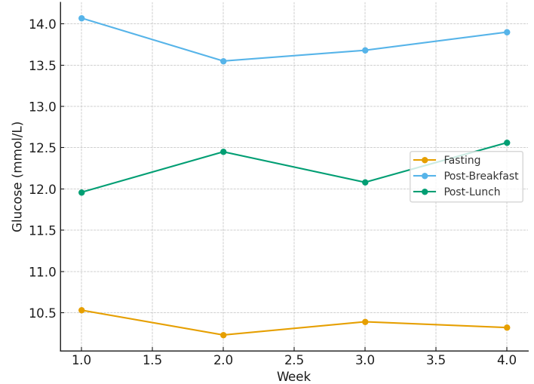
Figure 1: Weekly mean blood glucose values for fasting, post-breakfast, and post-lunch measurements

The mean monthly capillary glucose values, as presented in Table 1, were 10.37 mmol/L for fasting, 13.80 mmol/L post-breakfast, and 12.26 mmol/L post-lunch.

Table 1: Summary Statistics with 95% Confidence Intervals
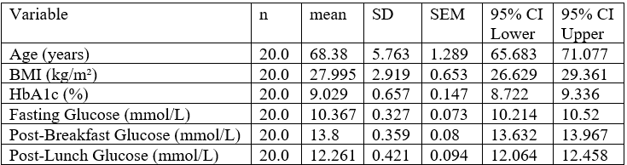

The analysis of the parameters presented in Table 1 showed that the mean age of the group was 68.4 years, with a predominance of elderly patients. According to the literature, this age group is characterized by reduced β-cell function and increased insulin resistance (Huang et al., 2023). In parallel, the mean BMI of 28.0 kg/m² confirmed the tendency toward overweight/obesity, a condition closely associated with a higher risk of glycemic variability due to insulin resistance. The mean HbA1c value of 9.03% indicated long-term poor glycemic control, which correlated with the elevated fasting and postprandial values. This combination of chronic hyperglycemia and increased BMI further exacerbates insulin resistance and aggravates postprandial fluctuations.
The observed glycemic profiles (10.37 mmol/L fasting, 13.80 mmol/L post-breakfast, and 12.26 mmol/L post-lunch) demonstrated a pronounced postprandial dominance of hyperglycemia, particularly after the first meal of the day, which is generally recognized as a key clinical problem. This observation is consistent with contemporary literature emphasizing the role of postprandial excursions as a major predictor of complications in patients with diabetes mellitus (Shibib et al., 2024). Standard deviation (SD) and 95% confidence intervals (CI) further confirmed the variability of these parameters, underscoring the heterogeneity of individual responses to meals and insulin therapy. This highlights the importance of individualized insulin regimens tailored to patient-specific needs.
Nutritional behavior analysis revealed that approximately one-third of the patients (35%) consumed their hospital meals in full, 30% consumed only part of the meals, while the remaining 35% ingested additional non-prescribed food obtained either from outside the hospital or brought from home (Table 2).

Table 2: Distribution of categorical variables
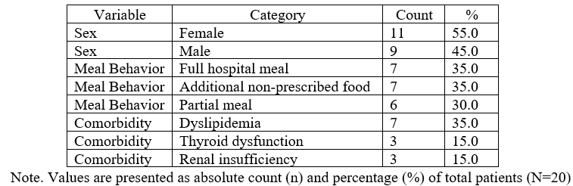

According to the data presented in Table 2, the most frequently recorded comorbidities were dyslipidemia (35%), thyroid dysfunction (15%), and renal insufficiency (15%). The presence of dyslipidemia underscores the need for a holistic management approach, since the combination of uncontrolled glycemia and an altered lipid profile dramatically increases cardiovascular risk (Kalra et al., 2024). Renal insufficiency may affect insulin clearance, while thyroid disorders can influence both metabolism and insulin sensitivity (Parvathareddy et al., 2023; Eom et al., 2022). The subgroup of patients who consumed additional non-prescribed food (purchased outside or brought from home) demonstrated the highest average glucose levels, particularly two hours post-breakfast (13.890 mmol/L), Table 3.

Table 3: Meal behavior vs glucose values mmol/L
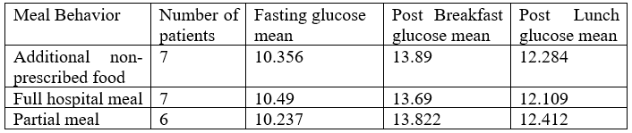

Nevertheless, the differences among the three groups (according to dietary behavior) did not reach statistical significance with the present sample size (n=20). Although variability can be observed, the possibility of demonstrating a meaningful difference is limited by the small group. This aligns with clinical experience, which suggests that actual intake (particularly the consumption of “additional food”) can influence postprandial values; however, larger sample sizes and/or repeated assessments are required to establish statistical significance.
With respect to comorbidities in hospitalized patients, as shown in Table 4, dyslipidemia exhibited a moderate effect toward higher fasting glucose values compared to renal insufficiency, but this difference did not reach statistical significance.

Table 4: Comparison of glucose levels (fasting and post-lunch, mmol/L) by comorbidity status
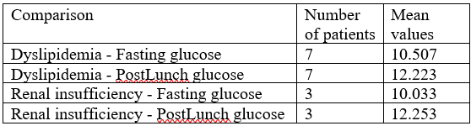

For a valid assessment, larger patient groups and/or modeling approaches that account for factors such as insulin clearance, concomitant therapy, and nutritional intake would be required.

5. Conclusion

Glycemic variability was most pronounced in the postprandial period, with nutritional behavior emerging as a key modulator of these oscillations. Chronically elevated HbA1c values (>9%) and a BMI of 28.0 kg/m² were associated with higher fasting and postprandial glucose levels, while age contributed to broader variability, consistent with known metabolic changes. Patients who consumed non-prescribed food tended to exhibit higher postprandial glycemia, whereas comorbidities further complicated metabolic regulation and increased the risk of complications.
These findings underscore that successful inpatient diabetes management requires a multidisciplinary approach and dynamic insulin titration based on actual food intake and individual patient characteristics. Importantly, patients should adhere strictly to hospital diets, recommendations, and protocols rather than consuming additional non-prescribed food.
Furthermore, the implementation of continuous glucose monitoring (CGM) in hospitalized patients could provide a more precise and dynamic representation of glycemic excursions throughout the day. Such real-time data would allow clinicians to personalize insulin or oral therapy adjustments in close relation to actual dietary intake and individual metabolic responses. Integrating CGM into routine inpatient care not only enhances the accuracy of therapeutic decision-making but also offers a pathway toward truly individualized nutritional and pharmacological strategies, thereby improving both metabolic control and patient safety in hospital settings.

References

Chun, K.-H., Oh, J., Lee, C. J., Park, J. J., Lee, S. E., Kim, M.-S., Cho, H.-J., Choi, J.-O., Lee, H.-Y., Hwang, K.-K., Kim, K. H., Yoo, B.-S., Choi, D.-J., Baek, S. H., Jeon, E.-S., Kim, J.-J., Cho, M.-C., Chae, S. C., Oh, B.-H., & Kang, S.-M. (2022). In-hospital glycemic variability and all-cause mortality among patients hospitalized for acute heart failure. Cardiovascular Diabetology, 21(1), 291. https://doi.org/10.1186/s12933-022-01720-4
Eom, Y. S., Wilson, J. R., Bernet, V. J. (2022). Links between Thyroid Disorders and Glucose Homeostasis. Diabetes & Metabolism Journal, 46(2), 239–256. https://doi.org/10.4093/dmj.2022.0013
Heller, A., & Feldman, B. (2008). Electrochemical glucose sensors and their applications in diabetes management. Chemical Reviews, 108(7), 2482–2505. https://doi.org/10.1021/cr068069y
Huang, L. Y., Liu, C. H., Chen, F. Y., Kuo, C. H., Pitrone, P., & Liu, J. S. (2023). Aging Affects Insulin Resistance, Insulin Secretion, and Glucose Effectiveness in Subjects with Normal Blood Glucose and Body Weight. Diagnostics (Basel, Switzerland), 13(13), 2158. https://doi.org/10.3390/diagnostics13132158
Islami, N., Jankoska, A., & Simonovska, V. (2023). The state of diabetes in the population of the Skopje region during 2020. Acta Medica Balkanica, 8(3), 269–274.
Kalra, S. (2024). Review article: Dyslipidemia in diabetes. Indian Heart Journal. Advance online publication. https://doi.org/10.1016/j.ihj.2023.11.002
Kapłan, C., Kalemba, A., Krok, M., & Krzych, Ł. (2022). Effect of treatment and nutrition on glycemic variability in critically ill patients. International Journal of Environmental Research and Public Health, 19(8), 4717. https://doi.org/10.3390/ijerph19084717
Marino, E. C., Momesso, D., Toyoshima, M. T. K., de Almeida, M. F. O., Schaan, B. D., Negretto, L. A. F., Santomauro Junior, A. C., Cukier, P., Genestreti, P. R. R., Feitosa, A. C. R., da Silva Soares Pinto, J. E., Ribeiro, R. S., Lamounier, R. N., Lyra, R., & Bertoluci, M. C. (2025). Screening and management of hospital hyperglycemia in non-critical patients: a position statement from the Brazilian Diabetes Society (SBD). Diabetology & metabolic syndrome, 17(1), 54. https://doi.org/10.1186/s13098-025-01585-z
Mo, Y., Lu, J., & Zhou, J. (2024). Glycemic variability: Measurement, target, impact on complications of diabetes and does it really matter? Journal of Diabetes Investigation, 15(1), 5–14. https://doi.org/10.1111/jdi.14112
Murillo, S., Mallol, A., Adot, A., Juárez, F., Coll, A., Gastaldo, I., & Roura, E. (2022). Culinary strategies to manage glycemic response in people with type 2 diabetes: A narrative review. Frontiers in Nutrition, 9, Article 1025993. https://doi.org/10.3389/fnut.2022.1025993
Ohara, M., Fukui, T., Ouchi, M., Watanabe, K., Suzuki, T., Yamamoto, S., Yamamoto, T., Hayashi, T., Oba, K., & Hirano, T. (2016). Relationship between daily and day-to-day glycemic variability and increased oxidative stress in type 2 diabetes. Diabetes Research and Clinical Practice, 122, 62–70. https://doi.org/10.1016/j.diabres.2016.09.025
Pantanetti, P., Cangelosi, G., Sguanci, M., Morales Palomares, S., Nguyen, C. T. T., Morresi, G., Mancin, S., & Petrelli, F. (2024). Glycemic control in diabetic patients receiving a diabetes-specific nutritional enteral formula: A case series in home care settings. Nutrients, 16(16), 2602. https://doi.org/10.3390/nu16162602
Parvathareddy, V. P., Wu, J., & Thomas, S. S. (2023). Insulin Resistance and Insulin Handling in Chronic Kidney Disease. Comprehensive Physiology, 13(4), 5069–5076. https://doi.org/10.1002/cphy.c220019
Ryan, D. B., & Swift, C. S. (2014). The Mealtime Challenge: Nutrition and Glycemic Control in the Hospital. Diabetes Spectrum, 27(3), 163–168. https://doi.org/10.2337/diaspect.27.3.163
Shibib, L., Al-Qaisi, M., Guess, N., Miras, A. D., Greenwald, S. E., Pelling, M., & Ahmed, A. (2024). Manipulation of Post-Prandial Hyperglycaemia in Type 2 Diabetes: An Update for Practitioners. Diabetes, metabolic syndrome and obesity : targets and therapy, 17, 3111–3130. https://doi.org/10.2147/DMSO.S458894
Zhou, Z., Sun, B., Huang, S., Zhu, C., & Bian, M. (2020). Glycemic variability: adverse clinical outcomes and how to improve it? Cardiovascular Diabetology, 19(1), 102. https://doi.org/10.1186/s12933-020-01085-6
Кrishna, S. V. S., Kota, S. K., & Modi, K. D. (2013). Glycemic variability: Clinical implications. Indian Journal of Endocrinology and Metabolism, 17(4), 611–619. https://doi.org/10.4103/2230-8210.113751

