University “St. Kliment Ohridski” Bitola, Republic of Macedonia

Sasho Korunovski PhD, NaumeMarinoski PhD, Zlatko Zhoglev PhD, Pere Aslimoski PhD
Plan for local Inclusive Development in Tourism: Case Study of Municipality of Krushevo, Republic of Macedonia

I. EXECUTIVE SUMMARY
Krushevo is one of the most specific urban settlement in Republic of Macedonia. It is a town of dense type, with specific architecture. It is a town that historically speaking, determines the Macedonia independence and statehood. The municipality has in total 9.684 inhabitants (according the Census in Macedonia from 2002), of which 60% are urban population. Krushevo belongs to the group of towns of mountain area, and also is town with the biggest elevation on the Balkans. The elevation enables the town to be especially attractive during the winter period. The municipality is active in the Pelagonia region, together with themunicipalities of Prilep and Bitola,and has good cooperation with ZELS (Association of Local Selfgovernments in Macedonia).
The feature of the municipality is high unemployment and occurrence of depopulation and immigration. The trend of economic stagnation is not in accordance with the resources that Krushevo has, especially with tourist resources, of which more important are the following:
-Mountain sides with significant skiing inclination
-Pathways for mountaineering, hiking and biking
-Artificial lake
-Mountain sections for paragliding and kiting
-Richness of flora
-Cultural resources
-Developed horse breeding
-Traditional crafts work
The business sector is very fragmented, and the most enterprises are small, with one employee. Development potential present economic entities “Montana Palas” and “Inen dekor”, that could be triggers for other economic entities to be included in economic and social activities. The NGO sector is relatively active and has positive views for the development of the municipality. They express their interest for participation in social and public-private partnership in the municipality.
The municipality is significant tourist center in Republic of Macedonia. In the strategic documents the tourism has its priority. In this regard, it is necessary to enrich developing contents and beside winter-sport activities also, other alternative forms of tourism to find their place.
The potentials that the municipality has enable creation of extraordinary touristic offer. Paragliding and horse breeding are forms that respect natural and cultural potentials.
The researches discover few segments that can be in context of acceleration of the municipal development. These are shaped as project proposals , with clear structure for realization, meaning:
-Designing of paragliding center
-Creating of visitors center of Krushevo's Republic
-Cavalry tourist pathways
-Arranging of space for souvenir's locations
II. INTRODUCTION AND METHODOLOGY
Krushevo is one of the municipalities that has significant resources in different areas. It is a municipality that succeeds to impose itself as an area that accepts modern approaches in creation of policies and modern activities. The municipality is active in the following areas:
-Infrastructural projects are being performed;
-There is consistency in the education;
-Social protection is treated as an important factor in the development of themunicipality;
-Special attention is being paid to protection of the environment;
-In the area of culture the municipality has comparaitive potentials at national and regional level, that presents the most respective determinant for the development of the municipality;
-In the municipality there is large interest for sport development.
Also, it is typical that an international cooperation of the municipality should be improved for which there are implemented and current projects, such as the Project for development of the religious tourism as a part of IPA programs. But, it should be concluded that the transition process has affected this area as well, so Krushevo is in relatively unfavorable economical and social condition. Around 2.000 inhabitants are unemployed, beside the fact there are 267 business entities, main part of them employ only one person. The percentage of unemployment that is above the State average impose need of urgent action for accelerating of economical development and using of all possibilities for stimulation of social and other forms of public-private partnerships, that will enable using of certain resources in a sustainable way at the municipality. Key actors in realization of this possibilities is the municipality through the sector for economic development, NGO sector and exposed economic entities.
-The methodological approach in determination of the development possibilities of the municipality relies on five relevant operational activities:
-Review of the adopted strategies, plans and development programs, in accordance with development possibilities;
-Analysis of the study on the satisfaction of the citizens of the municipal services within the project for strengthening of the public policies process, based on empirical data;
-Conducted interviews with relevant stakeholders i.e. officials fromlocal administration, persons from the business community and representatives from NGO sector;
-Field research of the development possibilities in the municipality;
-Adjustment of the preliminary findings and initiatives of the expert's team, with the actors in the local social and economic development of the municipality.
1.Review of the adopted strategies, plans and development programs in accordance with development possibilities
We could conclude that the municipality has adopted Revised Strategy for local economic development, but in this Strategy there is no Action Plan with financial construction, time frame, as well as, clearly defined actors and executives of the activities. Also, we havedetected that there is no Strategy for social development, which means that there is no Action Plan. Municipality has General and Detailed Urban plan and initiative has been set for review of these 2 documents.
The municipality adopted other strategic project plans and programs and in this context, the following can be pointed out:
-Local environmental action plan
-Local plan for reduction of unemployment in the municipality
The existing strategic plans and programs partly have adopted action activities, but very little of the planned has been realized. The basic reasons are lack of economic activity and stronger economic entities in the municipality, insufficient support by the investment funds, as well as, disinterest of the population and poor inventiveness of the few economic entities, in relation of long term implementation of these efforts.
2. Analysis of the satisfaction of the citizens of the municipal services within the project for strengthening of the public policies process, based on empirical data
The study was focused on citizen's satisfaction by the municipal services within the project for strengthening of the process of public policies, based on empirical indicators recommends screening of the relevant local/regional/national private sector and the civil society, that have wide network, good reputation and are capable to mobilize young people and other specific vulnerable groups. The aim of the study was to find potentials that are able to generate establishment of social partnerships for inclusive service delivery, as well as, for establishing of cooperation for inclusive local development, mapping of the (existent and potential) models for social entrepreneurship – social responsible economic initiatives that can attract investment funds in local context, support for development of the Municipality through culture and tourism.
3.Conducted interviews with officials from municipal administration and relevant persons in the business communityand representatives from NGO’s
In the municipality we have performed survey with the relevant stakeholdes in order closer to identify the significant advantages and lacks in the development of the municipality.
4.Field research of the development possibilities in the municipality
In order to be able to record the possibilities and to perform the valuation of certain segments of development, we have approached to field research that exposedthe exact locations and facilities that can be in function of development of the municipality.
5. Adjustment of the preliminary findings and initiatives of the expert's team, with the actors in the local social and economic development of the municipality.
Within the mutual relations of the research team and the actors of development was necessary to comply the adopted research results with the planned development documents and visions of the stakeholders on the local economic development.
III. DETECTING OF THE IMPORTANT AND THE RELEVANT LOCAL/ REGIONAL ACTORS OF THE PRIVATE SECTOR, PUBLIC SECTOR AND NONGOVERNMENTAL ORGANIZATIONS
In order to perceive the levels of influence of certain entities in the development of the municipality, we have categorized them into 3 groups:
- the local self government,
- the business community and
- non governmental organizations.
The answers on these questions ranked according their meaning were the following:
In the local self government these are departments for:Local economic development and departments for Urban planning and spatial planning. In general, the problem in the local administration is the overload with administrative competencies, so one department at the same time covers competencies of more departments and within the department one person is presented in more sectors, which are not defined according the competencies. This is consequence of symmetrical decentralization of the competencies of all municipalities, regardless their size.
Regarding the question that refers to the most important activities with which the local self government stimulates the development activities, it is pointed out that there is a project for two weekend zones by the Artificial lake “Gumenje” and according this project weekend houses should be build. One area is almost realized and the other is in phase of realization and is development priority. Dominant position in the development of the municipality has the state through its funds and projects. According to the answers it can be concluded that there is no association and organization of economic character that stimulates economic development in the municipality. Meaning, there is only association for hospitality and tourism that does not function and it is only informally established.
Regarding the relevant actors of the business community, the respondents gave different opinions. According some of them, there is fragmentation in the business community, poor coherence and cooperation and the domination is by very small entities of type “one man – one company”. That does not give possibility for acting of the business community in cluster sense and other forms of organization. Still, as more significant factor for development can be detected in the managing team of hotel “Montana palas”, that shows noticeable interest for social and public-private partnerships. Directions are being given by some of the sub sectors that could be interesting for connecting through social and public-private partnership. Those are: hooper smith and cooperage handcraft.
From the selective research that we have performed on the field, we concluded that in the local community Krushevo there are possibilities for activating of some segments of the local economic development. Those are the following: -The management team of hotel “Montana palas” -Krushevo, -„Inen dekor” -enterprise for production of woodencarpentry -Bakery “Spiki” -Individuals that participate in activities on mountain and in extreme conditions, -The researches showed that there are approximately 150 breaded, able fitted horses,that enables their using in activities related to tourism, beside the primary function transportation of woods.
In the sector of NGO it is evident that there is big number of registered NGO's and associations, but only 4 to 5 are active. That shows on their relatively low functionality and disinterest of the citizens for permanent activities.Although the number of NGO’s is relatively small, significant is the interest for inclusion in the partnership. The association of women “Cvet” shows high interest for promotion and distribution of the cuisine specialties that are specific for krushevo's region. In the performed interviews they have supported the idea of locating of restaurant capacities, in the frames of projected Center for paragliding. This association is prepared to participate in production and distribution of domestic handcrafts in the souvenir shops planed on the locality Gumenje.
As a result of our direct contacts with the interested entities and actors, the establishment of association of horse breeders and mountain rescuers was initiated, that based on the proposals of the experts team were already in establishment during our next meeting. These associations will give new impulse in the development of the tourism in Krushevo.
IV. EXISTENCE OF PARTNERSHIPS AND NETWORKS BETWEEN STEKEHOLDERS
In the municipality are registered 76 non governmental organizations, but their function is marginal. Their influence is very small. In the last 5 years in the municipality are realized only 2 projects of an international character, there are no projects of state and inter-municipal character, so NGO is not a corrective for functioning of the municipal management. There is no network between the relevant actors in the municipality, as for example NGO sector and business entities, because the basic problem is fragmentation of the economic sector.
As an initial form of connecting and networking can be use the initiative for creation of separate web portal, with categorized rooms for private renters, that at the moment offer 267 beds.
According the fragmentation and poor capacity of the citizen's sector and the economic sphere we consider there is poor basis for establishment of functional networks of the economic entities, as in cluster sense, as well as in concession and establishment of social and public-private partnerships. In order to overcome this condition it will be necessary to conduct more comprehensive trainings of the main actors and especially in relation of preparation and conducting of projects, that are characteristic for rural municipalities.
V. MAPPING OF POTENTIALS FOR INTER-MUNICIPAL COOPERATION
In relation of mapping the inter-municipal cooperation and other cooperation, we concluded the following:
On the basis of this cooperation the Agency for development of Prespa -Pelagonia region is being established, where the municipality has active participation. At the moment there are no specific bilateral forms of cooperation with the neighboring municipalities. The respondents consider that the best solution for inter municipal cooperation with neighboring municipalities are the tourist routes of thematic character. In that sense it is necessary to prepare a Management plan for tourism and protection of the nature. The respondents consider that the tourism is priority option of inter-municipal cooperation, aimed towards municipality Prilep and Pelagonija Planning region.
VI. POSSIBILITIES FOR SOCIAL AND PUBLIC-PRIVATE PARTNERSHIP
Regarding managing of protected areas, it is necessary to perform previous valuation and to suggest appropriate protected categories in accordance with provisions of the Law on nature, the Natural surrounding of town Krushevo and settlements in the municipality. In combination with specific spatial features of the settlements and original architecture it is unique possibility for declaration of the part of municipal territory as characteristic area, meaning that these resources would be put into function of local economic development. The valuation and management with natural and cultural heritage is inseparably related with the development of the municipality, through appropriate forms of tourism. Thus, even the tourism is already identified as priority business in the strategies, the plans and programs of the municipality, still the existing infrastructure is not appropriate with the possibilities for accelerated touristic development. Based on tourist fee for the year 2011th , the total collection was modest 4.500euro. At this moment, in the municipality of Krushevo there is no tourist information center. Negative experience was pointed out with the former center that was created with TA “Arbo – Travel”, which was in function for one year and had negative implications on the development of tourism in this area.
In relation of establishing of social and public-private partnerships almost all of the respondents pointed out that are familiarized with this tool, but in order to be implemented it is necessary to have trainings and other forms of training, that will contribute to increase the awareness of all potential partners. The municipality is prepared into this direction and has legal acts that enable concession of localities and facilities in this area. But, problem is that there are no interested entities that would invest in those opportunities. Only, hotel “Montana Palas” shows proactive attitude in relation to this issue. Even the NGO sector is not financial sustainable still, it shows significantly higher interest for inclusion in these activities, comparing to the private sector. In this context, interesting is the initiative for establishment of Association of mountain rescuers, that are already devoted enthusiasts and the procedure for establishment of this association is in progress.
Also, interest has been noticed by two associations that are relatively more passive, such as “Akademik” and “Vision for future” through its members to intensify the preparation of local handcrafts and souvenirs suggesting adjustment of current or, building of minimum number of facilities for production and especially for distribution of souvenirs. Beside this, their effort for creative ideas should be respected, such as structuring of urban and architectural arrangement of entering gate for Krushevo, in direction of road Krushevo – Prilep. Also, we consider as noble the idea for arranging and shaping of the town public water taps (fountains), with different content in Krushevo.
We consider that the association “Cvet” is affirmed association and it has positive ideas in context of the planned projects by the experts team, towards the inclusive development of municipality of Krushevo. We think that especially positive are the activities such as, publication of the Local guide – Cookbook with guidelines for preparation of local specialties, as a part of the existing offer of restaurant services. Also, we think that this association gives constructive approach in possibility of distributing handcrafts through souvenirs shops, planned in the project for arranged areas for souvenirs shops.
VII. DETECTED SPECIFIC POSSIBILITIES FOR DEVELOPMENT OF SOCIAL AND PUBLIC-PRIVATE PARTNERSHIPS IN THE MUNICIPALITY
On the basis of researching activities we detected the following opportunities for establishment of social and public-private partnership in the area of tourism in order to improve the local economic development.
-In the municipality we detected notable presence (around 100 paragliders) in the area, on location that can be marked as paragliding starting point. Also, were detected organized forms and paragliding competitions in municipality of Krushevo, and some of them have an international character. According spatial technical norms for these activities, the area is extraordinary suitable, so that paragliding is activity that can inspire sustainable forms of social and public-private partnerships. In that sense, the municipality will revise GUP (General urban plan) and DUP (Detail urban plan) in which paragliding starting point will be determined as an area with touristic and hospitality purpose. In this complex, Center for paragliding will be located and will be managed by the Association of paragliding from Prilep. An interest for such activity is presented by the president of this association. Also, at the Center, the Association for mountain rescuers should have their offices. In the hospitality business an interest showed the Association for tourism and hospitality and the owner of hotel “Montana Palas”. The municipality will manage the parking area. The collection of parking fee can be performed by the members of the vulnerable groups.
-Krushevo as a symbol of creation for Macedonian statehood expressed through several monuments dedicated to this period has extraordinary opportunities for additional activities that are in favor of partnership, through increasing the number of visitors and changing the way of presenting of the monuments from this period. Transforming an old-fashioned monument of Macedonium into a modern visitor center has been detected as an opportunity for tourist development. With the increased visits, selling of souvenirs will be improved that is planned in one of the projects.
-According the conversations with the respondents and interviewed was detected the potential related with the existence of breaded horses that can be put into function of development of tourism. This goes in favor of increasing the content of overnights in Krushevo, as well as, creating conditions for additional consumption and longer stay. Horse breeders through their association will be able to rent horses to the tourist agencies for individuals and groups of tourists. The municipality will find its benefit in engagement of this social-vulnerable group. This results from the fact that the primary activity of the horse breeders is related with transportation of woods.
-Regarding arranging of space for authentic souvenirs of Krushevo, inadequacy of sale of souvenirs and other goods for tourists and visitors of memorial area “Gumenje” for Toshe Proeski was detected. There is a need for more dignified and organized exposure and sell of authentic Krushevo souvenirs, through forms of social and public-private partnership. Public-private partnership in this direction is viewed in benefits that the municipality will have from the location under concession. The benefit realized by the non governmental organizations will be in the engagement and benefits of the vulnerable categories in preparation of authentic souvenirs. The association of craftsmen will allow to its membership a part of income of the sold souvenirs. The contractor of the concession will be able to earn, to employ and to contribute to the development of the municipality.
VIII. CONCLUSIONS
As conclusion resulted that we should structure several specific projects with clearly determined participants in the social and public-private partnership, time frame and the funding possibilities. They will serve as a guide for all stakeholders in the municipality to adjust their development plans and strategies. Since all the projects were accepted with consensus, the mutual vision was created, that in the future will articulate strong interest among stakeholders to put their resources into it, but also it will help to the municipality of Krushevo to apply on international calls for regional development.

IX. BYBLIOGAPHY
- Bramwell, B. and Sharman, A. (1999), “Collaboration in local tourism policymaking”, Annals of Tourism Research, 26(2), 392-415.
- Cravens, D.W. and Piercy, N.F. (2006), Strategic Marketing, McGraw-Hill, New York, NY.
- Garrod, B. (2005), “Managing visitor impacts”, in Fyall, A., Garood, B. and Leask, A. (Ed.), Managing Visitor Attractions, Elsevier, Oxford, UK, 124 – 139.
- Korunovski, S. (2006), Cultural Heritage, FTU, Ohrid, MK.
- Marinoski, N. (2009), Tourism Geography, FTU, Ohrid, MK.
- Marinoski, N. (2010), Basics of Tourism Theory and Practice, FTU, Ohrid, MK.
- Marinoski, N. and Korunovski, S. (2008), Macedonia: Land of Tourism, INA Commerce, Skopje, MK.
- Papathanasiou-Zuhrt, D. and Sakellaridis, O. (2006), “Destination information, marketing and management systems and sustainable heritage tourism development”, in Sigala, M. and Leslie, D, (Ed.), International Cultural Tourism: management, implications and cases, Elsevier, Oxford, UK, 217-233.
- Pedersen, A. (2002),Managing Tourism at World Heritage Sites:a Practical Manual for World Heritage Managers, UNESCO World Heritage Centre, Paris, FR.
- “Spatial Plan of the Republic of Macedonia” (2004), Ministry of Environment and Spatial Planinng – legaldocument for development – Official Journal of the Republic of Macedonia no. 4/96, 28/97, 53/01, 45/02, Skopje, MK.
- Watson, S. and McCracken, M. (2005), “Visitor attractions and human resources management”, in Fyall, A., Garood, B. and Leask, A. (Ed.), Managing Visitor Attractions, Elsevier, Oxford, UK, 171-184.

IX. ANNEXES
Krushevo, Republic of Macedonia
Panoramic view
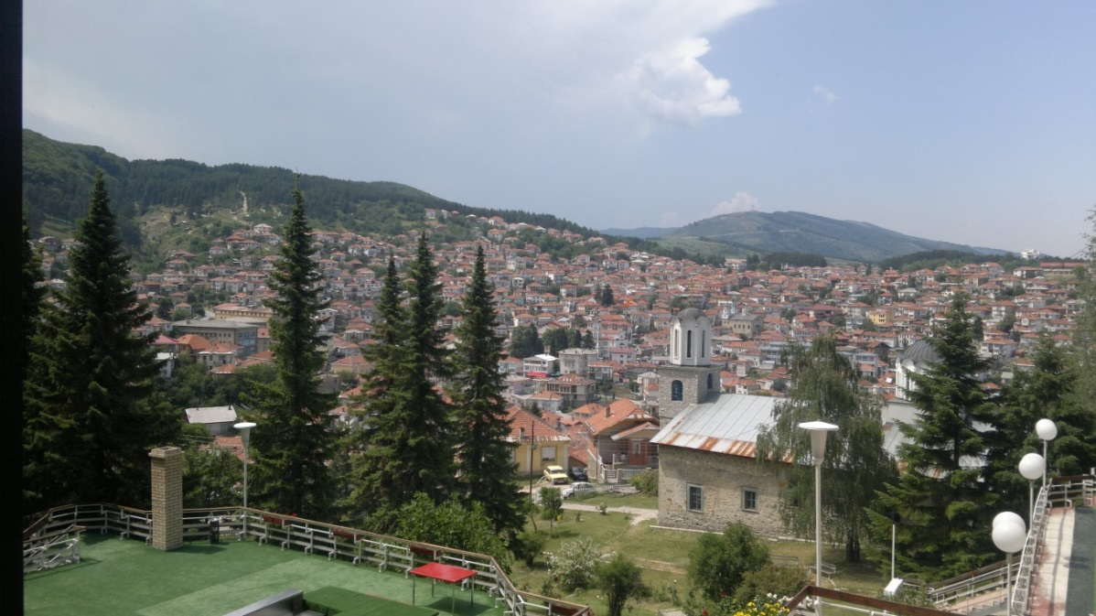
-Designing the center for paragliding and kiting;
LOCATION: Krushevo – Mechkin Kamen (paragliding starting point)

-Building of visitors center of Republic of Krushevo
LOCATION: Krushevo – „Gumenje“ – Monument „Makedonium“
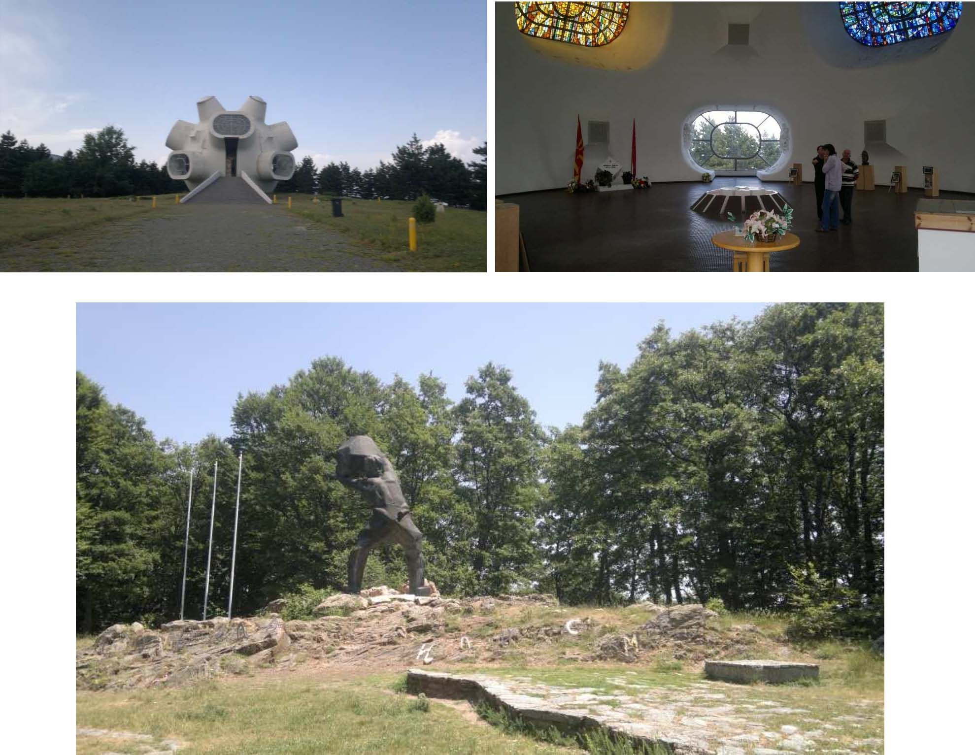

-Cavalry tourist pathways;
LOCATION: Krushevo – Busheva mountain
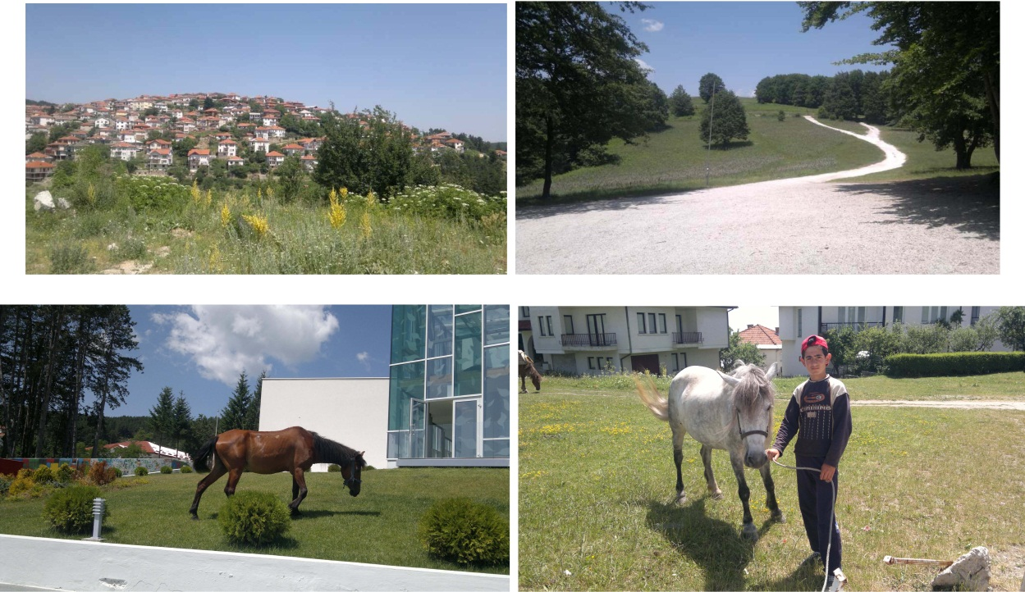
-Arranging of space for location of souvenirs shops.
LOCATION: Krushevo
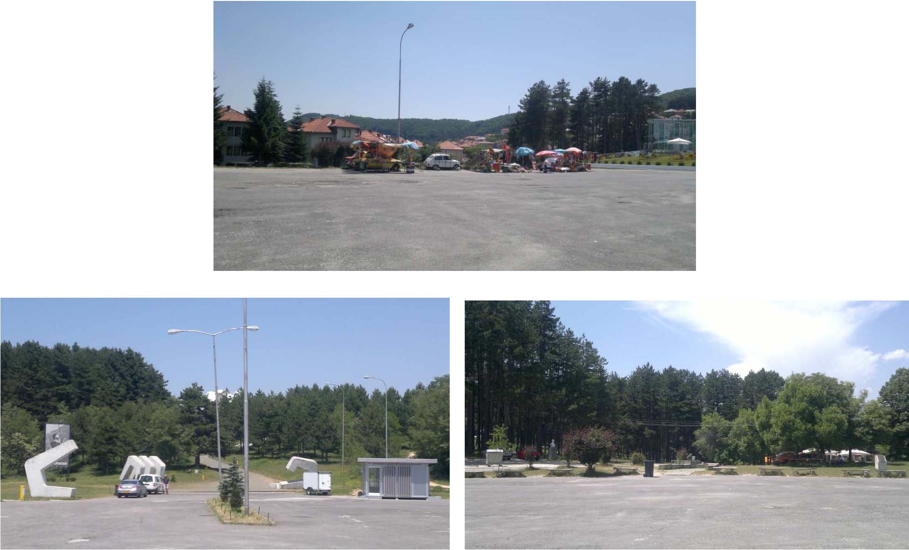

Proposed activities – projects:
 |  | Project – Designing the center for paragliding and kiting
Goal | Contents | Activities | Approximative budxet (in euros) | Time frames | Main contractor | Partners | Model for realization | Criteria/  success indicators
Development of | •Space for | •Urban | 25.000 | 2 years | •The local self | •Paragliding club | Social and public | •RevisedGeneral
paragliding and | restaurants and | planning of |  | (2012-2014) | government in | “Delta” Prilep | private | urban plan with
kiting in | bars | the space |  |  | cooperation with | •Hotel “Montana | partnership
Republic of | •Public toilets | •Building of a |  |  | the Ministry for | Palas”
Macedonia | •Location for | restaurant, | 65.000 |  | transport and | •PE “Inen dekor”
Revitalization of | recreation and | bar and space |  |  | communications | •Association of |  | •Announced call for
the area in | picnic activities | for trainers |  |  |  | mountain |  | public procurement
function of | •Mini Observatory | •Designing of |  |  |  | rescuers – |  | •Expressed
development of |  | the space for | 25.000 |  |  | Krushevo |  | preparedness of the
tourism and |  | picnic |  |  |  | •NGO “Cvet” |  | tourist business
hospitality | •Location for trainers and | •Building of |  |  |  | •NGO “Akademik” |  | representatives for concession
 | service for control and | parking lot •Building of | 10.000  20.000 |  |  | •NGO “Svetla zvezda” |  | •Realized concluded contractors for public-
 | rescuing •Parking lot •Space for renting of equipment | public toilets •Ground floor arranging of the space | 30.000 |  |  |  |  | private partnership
Total
175.000

 |  | Project – Creating of visitor center of the Krushevo's Republic
Goal | Contents | Activities | Approximative budxet (in euros) | Time frames | Main contractor | Partners | Model for realization | Criteria/success indicators
Establishing an | Interactive | •Preparation of | 25.000 | 4 years | •Ministry of | •The local self | Social and | •Adopted feasibility
innovative | presentation of | feasibility study |  | (2012 | culture of Re | government | Public-private | study by the Ministry of
animation show | the events | • Set up the |  | 2016) | public of | •NGO “Cvet” | partnership | culture
of the battles for | related with | space around | 25.000 |  | Macedonia | •NGO “Vision |  | •Equiped interior
Krushevo's | Krushevo's | the monument |  |  | Institute for | for future” |  | for multifunctional
Republic | Republic | “Makedonium” •Arranging of ground floor of the monument “Makedonium”for this purpose | 200.000  Total  250.000 |  | protection of monuments and Museum of Prilep -Organizational unit monument “Makedonium” | •NGO “Akademik” •PE “Inen dekor” •Hotel “Montana Palas” |  | purpose in the facility “Makedonium” •Arranged exterior part with shaped thematic setting in the monument complex

 |  | Project – Cavalry tourist pathways
Goal | Activities | Approximat | Time frames | Main contractor | Partners | Model for | Criteria/success
 |  | ive budget |  |  |  | realization | indicators
 |  | (in euros)
Animation | •Establishment of association of | 1.000 | 1 year (2012-2013) | •Local self | •Association of | •Social and | •Established association
activities in the | horse breeders |  |  | government | the horse | Public-private | of horse breeders
tourist offer | •Establishment of registry of |  |  |  | breeders in | partnership | •Number of realized
 | available potentials (horse and | 5.000 |  |  | Krushevo |  | arrangements
 | donkeys)  •Tourist evaluation of the area in | 5.000 |  |  | •Tourist agency VIS-POJ Ohrid
 | In order to definethe pathways |  |  |  | •Hotel „Montana Palas“
 | •Training of the involved entities | 5.000 |  |  | •NGO „Cvet“
 | •Promotion of cavalry routes |  |  |  | •NGO „Vision for
 | to tourist agencies |  |  |  | future“
 |  |  |  |  | •NGO
 |  |  |  |  | “Akademik”
 |  | Total: |  |  | •Association of
 |  | 16.000 |  |  | hunters “Elen”
 |  |  |  |  | •Association of
 |  |  |  |  | fisherman
 |  |  |  |  | “Mrena”

 |  |  | Project – Arranging of space for souvenirs locations
Goal | Contents | Activities |  | Approximative budxet (in euros) | Time frame | Main contractor | Partners | Model for realization | Criteria/success indicators
Enabling of sell | Establishment | •Urban |  |  | 1 year | •Local self | •NGO “Cvet” | Concession | •Adopted urban
of indigenous | of system for | arrangement |  | 10.000 | (2012-2013) | government | •NGO “Vision |  | locations
souvenirs | production, | of the space |  |  |  |  | for future” |  | •Announced call for
 | verification and | •Architectural |  |  |  |  | •NGO |  | concession
 | distribution of | design of |  |  |  |  | “Akademik” |  | •Prepared architectural
 | indigenous | facilities for |  | 3.500 |  |  | •PE “Inen |  | design for facilities
 | souvenirs | selling |  |  |  |  | dekor” |  | •Signed contracts
 |  | souvenirs |  |  |  |  |  |  | for concession
 |  |  |  | Total
 |  |  |  | 13.500

The preparation of this Plan was requested by UNDP and it had been produced within the project of UNDP and the Ministry of finance titled “Social services in support of social development and social cohesion”.

