Prof. Margarita Janeska, Ph.D.
Faculty of Economics – Prilep / “St. Kliment Ohridski” University – Bitola
Postal address: Prilepski Braniteli St. 143, MK-7500 Prilep, North Macedonia
Phone: +389 48 427 020 Fax: +389 48 427 021
E-mail address: margarita.janeska@uklo.edu.mk

Prof. Emilija Gjorgjioska, Ph.D.
Faculty of Economics – Prilep / “St. Kliment Ohridski” University – Bitola
Postal address: Prilepski Braniteli St. 143, MK-7500 Prilep, North Macedonia
Phone: +389 48 427 020 Fax: +389 48 427 021
E-mail address: emilija.mateska@uklo.edu.mk

Prof. Monika Angeloska Dichovska, Ph.D.
Faculty of Economics – Prilep / “St. Kliment Ohridski” University – Bitola
Postal address: Prilepski Braniteli St. 143, MK-7500 Prilep, North Macedonia
Phone: +389 48 427 020 Fax: +389 48 427 021
E-mail address: monika.angeloska@uklo.edu.mk

Prof. Aneta Risteska Jankuloska, Ph.D.
Faculty of Economics – Prilep / “St. Kliment Ohridski” University – Bitola
Postal address: Prilepski Braniteli St. 143, MK-7500 Prilep, North Macedonia
Phone: +389 48 427 020 Fax: +389 48 427 021
E-mail address: aneta.risteska@uklo.edu.mk

THE PUBLIC PROCUREMENT REPORTS IN THE REPUBLIC OF NORTH MACEDONIA THROUGH THE PRISM OF BENFORD’S LAW
ИЗВЕШТАЈИ О ЈАВНИМ НАБАВКАМА У РЕПУБЛИЦИ СЕВЕРНОЈ МАКЕДОНИЈЕ КРОЗ ПРИЗМУ БЕНФОРДОВОГ ЗАКОНА

ABSTRACT
Public procurement contracts have a great value for every national economy. Due to the fact that public procurement contracts are one of the greatest expenditures in national budgets, these procedures may be a huge trap for favoritism, irregularities, violation or other forms of corruption. The possibilities for corruption risks are constantly increasing by the complexity of the process, closer interaction between public officials, and entrepreneurs and businessmen on the other side. These risks for manipulations and corruptive actions are present in all the phases of the procedure, until the final realization of the particular procurement.
One of the possible ways to discover the anomalies and possible manipulations in public procurements is by analyzing the reality of the data published in the yearly reports of the public procurement bureau of the Republic of North Macedonia issued in the last five years, by applying the Benford’s law. The Benford’s Law is an important control mechanism that can contribute to increasing of data integrity and information quality of the public procurement statistics reports.
The main objective of this paper is, by applying the Benford’s law to recognize the precision and exactness of the published data, to identify some anomalies and manipulations in the monetary value of concluded contracts, as well as some suspicious parameters that are leading to higher risk level.
The existence of anomalies in the reports from the Public procurement bureau of the Republic of North Macedonia will be identified through five tests: z-statistics, MAD-Mean absolute deviation test, 2 χ - test, Kolmogorov-Smirnov test and Kuiper test. Microsoft Excel will be used to analyze the data.

Key words: public procurement, Benford’s Law, first digit test, anomalies, public procurement contracts, statistical tests.
JEL: C80, К13, M42, H57, C43.
SAŽETAK
Уговори о јавним набавкама имају голем значај за сваку националну економију. С обзиром на чињеницу да уговори о јавним набавкама претстављају једaн од највечих расхода у сваком националном буџету, ови поступци могу бити велика замка за фаворизовање, нерегуларности, прекршаје или друге облике корупције.
Могућност ризика од корупције расте са сложеношћу процеса, блиском интеракцијом између јавне службенике, и привредника и предузетника, са друге стране. Ризик о манипулацији и коруптивним радњама присутан је у свим фазама поступка, све до крајне реализације конкретне набавке.
Један од начина за откривање аномалија и могућих манипулација у јавним набавкама је сагледавање реалности података у годишњим извештајима о јавним набавкама, које су јавно објављени од стране Биро за јавне набавке у Републици Северна Македонија за последњих пет година, применом Бенфордовим законом. Бенфордов закон је важан контролни механизам који може допринети повећању интегритета података и квалитета информације у статистичким извештајима о јавним набавкама.
Циљ овог труда је да се применом Бенфордовим законом уоче прецизност и тачност података и идентификује постојање могућих аномалијама и манипулацијама у вредности закљуђених уговора, као и сумњивих параметара који носе виши нивоа ризика.
Постојање аномалије у извештајима Биро за јавне набавке биђе идентификовани кроз пет тестова: z- статистика, тест просеђног апсолутног отступања (MAD-Mean absolute deviation), $χ^{2}$- тест, Колмогоров – Смирнов тест и Куиперов (Kuiper) тест. За анализи података користиђе се Microsoft Excel.

Кључне речи: јавне набавке, Бенфордов закон, тест прве цифре, аномалије, закључени уговори, статистичке тестове.

JEL: C80, К13, M42, H57, C43.

1. INTRODUCTION

The Bureau of Public Procurement is a central body in the Republic of North Macedonia where all data related to the procedures for awarding contracts for public procurement at the state level are collected. With this competence, the Bureau directly encourages competition and transparency, as it makes data available to all interested parties. All plans, announcements and notifications about concluded contracts for public procurement are published on the electronic system for public procurement. These data represent the basis for the preparation of detailed annual statistical reports, which are used for further analysis and taking measures for improving the public procurement system. The accuracy and reliability of the data on concluded contracts in the annual public procurement reports should be one of the basic principles for Public Procurement Bureau operating. These attributes are achieved by using proven data collection and processing methods, attested procedures and balanced calculations using all available sources of information. The importance of public procurement market is stress out by the fact that this market amounted to 11% of the country’s GDP in 2022 (European Commission, 2022, p.57).
According to European Commission (2022, p.58-60) the electronic system for public procurement is functioning efficiently, but North Macedonia is moderately prepared in area of public procurement. One of the main remarks and so further recommendation is improving control of public procurement procedures through the efficient follow-up and reporting of irregularities, case of conflict of interest and fraudulent practices.
The Benford's law is used to detect anomalies, i.e., the existence of the real data on numerous data sets. The basic assumption is that when the distribution of the leading digits in the data set for the number and value of concluded contracts differs significantly from that expected by Benford's law, this anomaly may be an indication of fraud or manipulation. Thus, Benford's law is an important control mechanism that can contribute to increasing the integrity of data and the quality of information regarding to the various parameters of concluded public procurement contracts, as well as to greater transparency with the users of these reports. Hence, Benford's law is usually called the law of anomaly detection.
Through the application of Benford's law in identifying anomalies over the data of concluded contracts for public procurement, especially through the first digit of the value of the concluded contracts in relation to various parameters, the degree of intensity of competition and the level of corruption risk can be perceived. Namely, a greater distortion of the value is expected on public procurements with high corruption risks and a low degree of intensity of competition.

2. THEORETICAL ASPECTS OF BENFORD'S LAW AND PREVIOUS RESEARCH

Benford's Law (Law of the First Digit) can be used as a screening tool to detect fraud when is applied to a data set. This law describes the frequency distribution of the first digit in a data set and compares the expected and observed distributions. Since the digit 1 appears most often as the first digit in the data progression, and subsequent digits less often, strong deviations from expected frequencies or anomalies may indicate that the data is suspect. Namely, according to Benford's law in numerical lists, i.e. statistical data, the number 1 (one), as the starting number of a numerical value, appears with a probability of approximately 30%, which is much more than the expected 11.1% (calculated according to the theory of probability, according to which the probability of occurrence of each digit from 1 to 9 is the same). Benford's law reversed the usual assumption that every digit in every position could be equally likely. The most famous version of Benford's law is related to the distribution of first leading digits, which states that (Berger, 2011):
$P(D)=\text{log}(1+\frac{1}{D})$ $D∈\left\{1,2,\text{.}\text{.}\text{.},9\right\}$,
where $D$ is a random variable; $D:R→\left\{1,2,\text{.}\text{.}\text{.},9\right\}$ and denotes the first significant digit of the randomly selected real number.

The following graph shows the distribution of the relative frequencies of the first significant digits according to Benford's law.
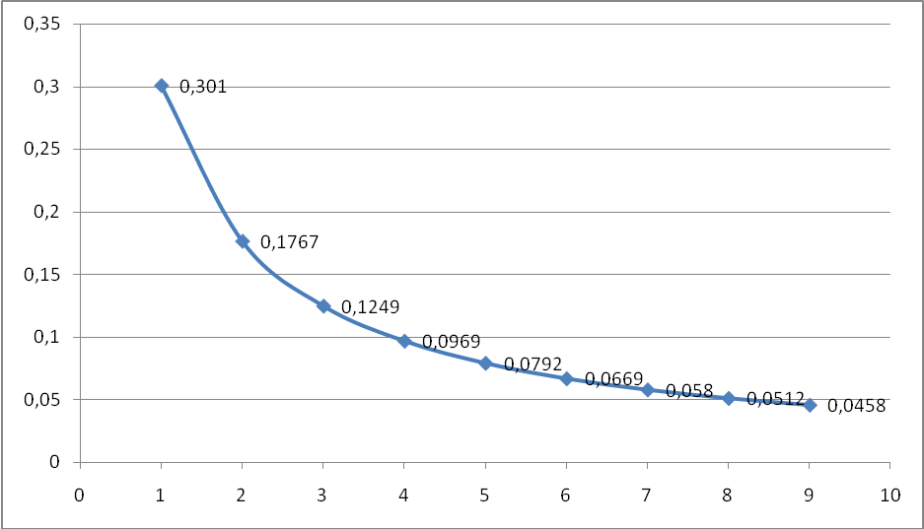
Fig. 1: The distribution of relative frequencies in the first significant figures according to Benfordʻs law
Benfordʻs law applies in many areas, such as: macroeconomic reports; (Rauch et al, 2011); elections; information technologies; the judiciary; lightning strikes (Pooyan, 2010); Earthquakes (Díaz et al, 2007); nuclear science (Wells et al, 2007); medicine (Sanches and Jorge S. 2006, Zdraveski, et al, 2022); detecting modifications in JPEG images (Kumar et al, 2015); irregularities in financial data (Zdraveski & Janeska, 2021); abnormalities in public statistics data (Matakovic, 2021) etc.
Benford’s law is used as analytic tools to examine the phenomenon of corruption in public procurement in terms of intensity of competition, corruption risks, and price distortion. Tóth & Hajdu, (2017) in their report are illustrating the use of the Benford's law through the empirical analysis of the Hungarian public procurement data in the period of 2009-2016. Sampaio, Figueiredo and Loiola (2022) analyzed the values of Electronic Bidding Processes that occurred in the Purchasing Portal of the Brazilian Federal Government in period between 2014-2018 by using the Newcomb-Benford law aiming to verify anomalies, which represent signs of fraud.

3. RESEARCH METHODOLOGY

In this paper Benford's analysis is carried out on the data from the reports on public procurement in North Macedonia, actually the data relating to the concluded contracts for public procurement. Namely, the research covert the data related to: number and value of concluded contracts according to the type of procedure (simplified competitive procedure, simplified open procedure, open procedure, qualification system, negotiated procedure with prior publication of an announcement, negotiated procedure without prior publication of an announcement, procedures for procurement of social or special services), number and value of concluded contracts according to the type of public procurement contract (goods, services and works), number and value of concluded contracts based on the criterion (these data are available only for the last 2 years), number and value of concluded contracts according to the category of contracting authority and data on concluded public procurement contracts according to other parameters (number and value of framework agreements and number and value of concluded contracts according to the type of procedure and the justification for choosing the procedure.
The total amount of data from year to year is different, depending on the items by individual indicators. The analysis was performed over 628 data in total for the last 5 years (2017-136, 2018-126, 2019-132, 2020-114 and 2021-120 data). For the purpose of the paper, we used the data published in official state reports issued by the Public Procurement Bureau of Republic of North Macedonia. The number of positions from the reports is not the most suitable for one-year testing (due to the small amount of data), so we used the data from the reports for the last 5 years. Analysis of data in the reports for more than one year can be useful in terms of determining the propensity for malpractices in the publication of data. The existence of anomalies in reports from the Bureau of Public Procurement will be identified through five tests: z-statistics, test of average absolute deviation (MAD-Mean absolute deviation), $χ^{2}$- test, Kolmogorov-Smirnov test and Kuiper test, through the test on the first digit of Benford's law.
Microsoft Excel was used for data analysis. To count how many time the digits from 1 to 9 occur, first we extract the first digits of the column from the sorted data using the function: LEFT. After that, the numbers 1 to 9 are inserted into the First column. In the Count column, the CountIF function is used in order to calculate exactly how many digits 1 to 9 exist in the total sample. In the column Actual, the relative actual frequencies are calculated. The next column is Benford' Law which shows the expected frequencies. According to the mathematical formulas for the separate tests and their corresponding critical values, it is ascertained whether or not there are anomalies in the publicly presented data in the reports by the public procurement bureau in North Macedonia.

4. ANALYSIS OF THE DATA ON CONCLUDED CONTRACTS IN THE REPORTS OF PUBLIC PROCUREMENT IN NORTH MACEDONIA

In order to identify anomalies in public procurement reports, first are used so-called z-statistics. The z-statistic is a statistical measure of how many standard deviations are from the mean value and how it allows to auditors (supervisors) to empirically determine whether deviations from the model are statistically significant. The following mathematical formula is used when using this test: (Pike, 2018, p.15):
$$Z=\frac{\left|A_{i}−B_{i}\right|}{\sqrt{\frac{B_{i}⋅(1−B_{i})}{n}}}$$
where:
$A_{i}$- is a frequency of occurrence of the digit $i$ determined by examination of the sample;
$B_{i}$- theoretical frequency of occurrence of the digit $i$ expected by Benford's law;
$n$-total number of data.
The critical value for the z-statistic for the 5% confidence level is 1.96.(Nigrini, 2012, p.82)
Any z-result that exceeds the maximum allowable z-result can indicate the possibility that a manipulation has been made, actually anomaly, and should be investigated further. The z-statistic analysis is presented in the following tablе:

Table 1: Analysis of data from public procurement reports relating to concluded contracts with z-statistics

First | Count | Actual | Benford'Law | Difference | AbsDiff | Z-stat
1 | 196 | 0.3121 | 0.30103 | 0.011071911 | 0.011071911 | 0.604878633
2 | 109 | 0.17357 | 0.17609 | -0.002523121 | 0.002523121 | 0.166000987
3 | 60 | 0.09554 | 0.12494 | -0.029398599 | 0.029398599 | 2.228110808
4 | 62 | 0.09873 | 0.09691 | 0.001816115 | 0.001816115 | 0.153841417
5 | 47 | 0.07484 | 0.07918 | -0.004339236 | 0.004339236 | 0.402715123
6 | 33 | 0.05255 | 0.06695 | -0.014402229 | 0.014402229 | 1.444048546
7 | 46 | 0.07325 | 0.05799 | 0.015258408 | 0.015258408 | 1.636005368
8 | 44 | 0.07006 | 0.05115 | 0.018913694 | 0.018913694 | 2.151466491
9 | 31 | 0.04936 | 0.04576 | 0.003603057 | 0.003603057 | 0.432094937
Sum | 628 | 1 |  |  | 0.011258485
Source: Authors' own calculations

From the z-stat column. from the table it can be concluded that there is a statistical deviation in digits 3 and 8, because the corresponding value of z is greater (insignificantly) than 1.96. Therefore, the rows of numbers 3 and 8 are marked in red. This means that according to this test the distribution of the first digit of the data on concluded public procurement contracts doesn’t follow the Benford distribution. Namely, at the data starting with the digits 3 and 8, more caution is needed, in fact they can indicate some kind of manipulation. In other words, these data open directions for questioning their reliability and accuracy.
The following diagram shows the actual occurrences of the digits in relation to Benford's law, which will also give an overview of the deviations:
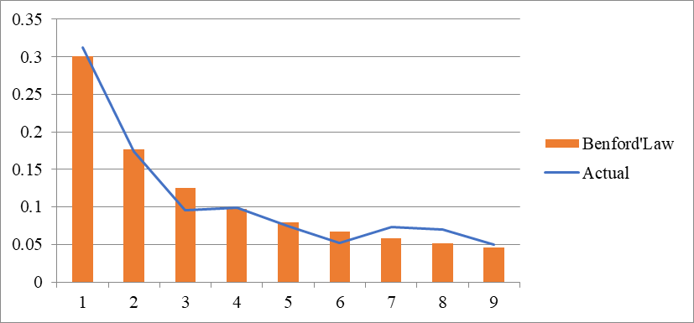
Fig. 2: Comparison of the appearance of the digits in the public procurement reports from 2017-2021 (in the first position are those according to Benford's law)

Further tests of Benford's law on data from public procurement reports are conducted by using the $χ^{2}$- test and the mean absolute deviation (MAD) test. The $χ^{2}$- the test, similar to the z-test, is very sensitive to the sample size and is based exclusively on the analysis of absolute frequencies and can give an answer as to how many of the obtained frequencies deviate from the expected frequencies. The following formula is used to conduct this test:

$$χ^{2}=\sum_{i=1}^{9}{\frac{(A_{i}−B_{i})^{2}}{B_{i}}}$$
where:
$A_{i}$- is an absolute frequency of occurrence of the digit $i$ determined by examination of the data;
$B_{i}$- is a theoretical absolute frequency of occurrence of the digit $i$ expected from Benford's law.
The limit value of this test for the first digit is 15.507. If the obtained value is greater than the same, the null hypothesis that the distribution of the first digit corresponds to the expected distribution according to Benford's law is rejected. We compare the obtained value of the $χ^{2}$- -test for 8 degrees of freedom with the critical $p$-value depending on the desired degree of confidence.
While, on the other hand, the MAD test is defined as the sum of the absolute values of the differences between the frequencies of occurrence of each of the digits and the expected frequencies of occurrence according to Branford's law. Then this sum is divided by the number of digits considered in the leading position. It is actually represented by the following mathematical formula (Nigrini, 2011, p.114):
$$\text{MAD}={\left(\sum_{i=1}^{n}{\left|A_{i}−B_{i}\right|}\right)}/D$$
where:
$A_{i}$- frequency of occurrence of the digit $i$ determined by examination of the data;
$B_{i}$- theoretical frequencies of occurrence of the digit $i$ expected from Benford's law.
$D$- number of leading digits taken into consideration.
The critical value for MAD for the first digit is 0,015. (Nigrini, 2012, p.160)
Because the MAD statistic does not depend on the size of the set being tested, it is considered a useful tool for examining data sets of varying size.
The analysis of the data according to the $χ^{2}$ -test and the MAD test is given in the following table:

Table 2: Analysis of the data according to $χ^{2}$ and MAD test – calculations by the authors
First digit | Benford'Law | Actual relative f | Actual absolute f | Expected absolute f | Difference | Abs. Difference | Hi-square
1 | 0.30103 | 0.312101911 | 196 | 189.04684 | 1.107191083 | 1.107191083 | 0.255737858
2 | 0.17609 | 0.173566879 | 109 | 110.58452 | -0.252312102 | 0.252312102 | 0.022703934
3 | 0.12494 | 0.095541401 | 60 | 78.46232 | -2.939859873 | 2.939859873 | 4.344215922
4 | 0.09691 | 0.098726115 | 62 | 60.85948 | 0.181611465 | 0.181611465 | 0.021373595
5 | 0.07918 | 0.074840764 | 47 | 49.72504 | -0.433923567 | 0.433923567 | 0.1493381
6 | 0.06695 | 0.052547771 | 33 | 42.0446 | -1.44022293 | 1.44022293 | 1.945666962
7 | 0.05799 | 0.073248408 | 46 | 36.41772 | 1.525840764 | 1.525840764 | 2.521302542
8 | 0.05115 | 0.070063694 | 44 | 32.1222 | 1.891369427 | 1.891369427 | 4.392044531
9 | 0.04576 | 0.049363057 | 31 | 28.73728 | 0.360305732 | 0.360305732 | 0.178162366
 | 1 | 1 | 628 |  |  | 1.125848549 | 13.83054581
Source: Authors' own calculations

As can be seen from the table, the average absolute deviation is 1.13 and belongs to the category of large deviation (over 0.015 is a large deviation from the limit values for this test), which means that according to this test the distribution of the first digit from the data on concluded public procurement contracts does not follow the Benfordʻs distribution. The value of the $χ^{2}$ - test is 13.83 (which is lower than the limit value for this test (15.507), which indicate a good match between actual and expected distributions.

The dispersion of the $χ^{2}$- test is presented in the following graph:
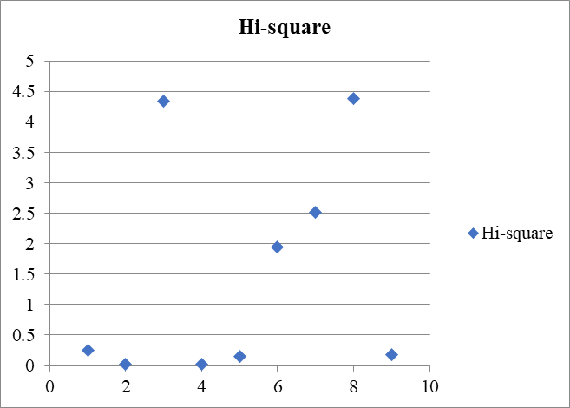
Fig. 3: $χ^{2}$- test

The Kolmogorov-Smirnov test is based on a statistic that represents the maximum value of the deviation from Benford's law, thus summing the differences between the frequencies of the digits 1 to 9 obtained by testing the sample data and the frequencies expected theoretically. It is a non-parametric statistical test. The mathematical model used for this test is as follows:
$$\text{KS}=\text{max}\left\{\left|C_{1}−O_{1}\right|,\left|(C_{1}+C_{2})−(O_{1}−O_{2})\right|,\text{.}\text{.}\text{.},\left|(C_{1}+C_{2}+\text{.}\text{.}\text{.}+C_{9})−(O_{1}+O_{2}+\text{.}\text{.}\text{.}+O_{9})\right|\right\}$$
where:
$C_{i}$ - is a frequency of occurrence of the digit $i$ determined by examination of the data;
$O_{i}$ - shows theoretical frequencies of occurrence of the digit $i$ expected from Benford's law
The critical value of this test is expressed through the following mathematical formula: (Morrow, 2010, p 5).
$$\text{KS}=\frac{1,\text{148}}{\sqrt{n}}$$
Where
where 1.148 is a constant specific to the Benfordʻs distribution for a significance level of 0.05 and n number of data.
While Kolmogorov's Smirnov test is applied to find shifts in the probability distribution, with the greatest sensitivity around the mean, the Kuiper test considers all distributions. And this test is a statistical non-parametric test. The Kuiper test can provide a reliable score in this research given the fact that it is applied to smaller data sets. This test uses the following mathematical formulas (Aslan, 2002, p. 169):
$$V_{n}=D_{n}^{+}+D_{n}^{−}$$
where :
$$D_{n}^{+}=\text{max}\left[F_{n}(x)−F_{0}(x)\right]$$
$$D_{n}^{−}=\text{max}\left[F_{0}(x)−F_{n}(x)\right]$$
The critical value for this test is calculated as follow: (Morrow, 2010, p.5)
$$K=\frac{1,\text{321}}{\sqrt{n}}$$
Where 1,321 is constantly specific to Benford's distribution for a level of significancy of 0.05 and n number of data.
The following table shows the critical values and conclusions for the Kolmogorov-Smirnov and Kuiper test: (Morrow, 2010, p.5)

Table 3: Critical values and conclusions for the Kolmogorov-Smirnov and Kuiper test

Analysis of data according to Kolmogorov-Smirnov and Kuiper test is given in the following table:
Table 4: Analysis of data according to Kolmogorov-Smirnov and Kuiper test
First | Count | Tested | Benford'Law | Cumulative Actual | Cumulative Benford'Law | Abs Difference | Dn+ | Dn- | Kuiper's test
1 | 196 | 0.312101911 | 0.30103 | 0.312101911 | 0.30103 | 0.011071911 | -0.01107 | 0.011072
2 | 109 | 0.173566879 | 0.17609 | 0.48566879 | 0.47712 | 0.00854879 | 0.002523 | -0.00252
3 | 60 | 0.095541401 | 0.12494 | 0.581210191 | 0.60206 | 0.020849809 | 0.029399 | -0.0294
4 | 62 | 0.098726115 | 0.09691 | 0.679936306 | 0.69897 | 0.019033694 | -0.00182 | 0.001816
5 | 47 | 0.074840764 | 0.07918 | 0.75477707 | 0.77815 | 0.02337293 | 0.004339 | -0.00434
6 | 33 | 0.052547771 | 0.06695 | 0.807324841 | 0.8451 | 0.037775159 | 0.014402 | -0.0144
7 | 46 | 0.073248408 | 0.05799 | 0.880573248 | 0.90309 | 0.022516752 | -0.01526 | 0.015258
8 | 44 | 0.070063694 | 0.05115 | 0.950636943 | 0.95424 | 0.003603057 | -0.01891 | 0.018914
9 | 31 | 0.049363057 | 0.04576 | 1 | 1 | 0 | -0.0036 | 0.003603
 | 628 | 1 | 1 |  |  | 0.037775159 | 0.029399 | 0.018914 | 0.048312293
Source: Authors' own calculations

The following figure presents the cumulative relative frequencies:
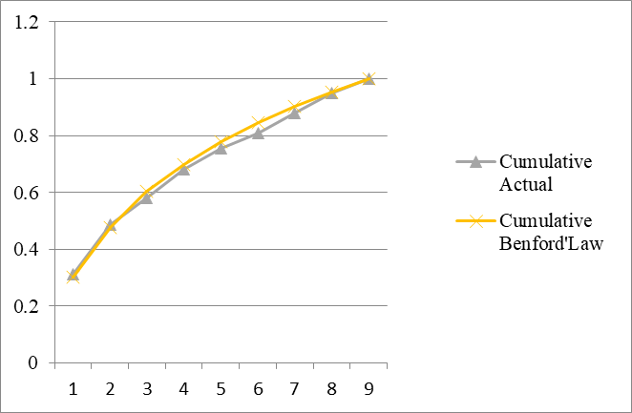

Fig. 4: Cumulative relative frequencies

The critical value for the Kolmogorov-Smirnov test is:
$$\text{KS}=\frac{1,\text{148}}{\sqrt{n}}=\frac{1,\text{148}}{\sqrt{\text{628}}}=0,\text{046}$$
Considering the fаct that the calculated value 0.038 is less than the critical value, the actual and expected data values of concluded public procurement contracts are matching.

Тhe calculated value 0.038 is less than the critical value, which means that the actual and expected data values of concluded public procurement contract are matching.
The critical value for the Kuiper test is
$$K=\frac{1,\text{321}}{\sqrt{n}}=\frac{1,\text{321}}{\sqrt{\text{628}}}=0,\text{053}$$
Since the calculated value 0.048 is lower than the critical value, according to this test, as well as the previous one, the actual and expected values of the data on concluded public procurement contracts coincide.
From the results of all tests ($χ^{2}$- the test, the Kolmogorov-Smirnov test and the Kuiper test) it can be concluded that there is no difference in the actual and expected values of the data for concluded public procurement contracts, while according to the z-test there is an insignificant discrepancy and in the MAD test there is a large deviation between the actual and expected values.
However, taking into account that in the z-test for a smaller set of data, larger deviations (in this case, the deviations are small, and only for 2 digits) will not be significant (because the research was carried out over a small set of data ( $n<\text{1000}$) (Campanelli, 2022, p.1) and taking into account that with the MAD test, although it doesn’t depend on the size of the data set, there are no objective critical values (Nigrini, 2012,p.159) the general finding is that there are no anomalies in the data relating to concluded contracts, presented in the reports from the Bureau of Public Procurement in Republic of North Macedonia.

CONCLUSION

Considering the fact that public procurement in the Republic of North Macedonia has a significant contribution in the gross domestic product, the neccessity of precise, reliable and accurate data presented in the annual statistical reports prepared by the Public Procurement Bureau in North Macedonia is more than obvious. Today, data can be sorted and processed in a variety of ways through the information technology and on that way arises the possibility of displaying distorted data (intentionally or unintentionally). The purpose of the conducted research was, to identify anomalies in the presented data of concluded contracts according to different parameters by using various tests based on Benford's law (law of the first digit).
The analysis showed that the number and value of concluded public procurement contracts according to various parameters correspond to the Benfordʻs distribution for the period of 2017-2021 as a whole, which means they are accurate and reliable.
The paper represents an initial step to detect possible manipulations in the public procurement reports by using Benford's law, because in North Macedonia no tools and techniques are used to detect data anomalies in annual public procurement reports.
The further research will be focused on analyzing the reliability of the data separately for each year, because many cases shows that by using analysis of data for a longer period, many data anomalies in individual report items are masked. Also, the analysis can be carried out on the other parameters, which are an integral part of the public procurement reports, such as: data from the notices for annulment of the procedures, data on participation in the procedures, data on electronic auctions, data on established red flags etc.
When analyzing this data, it should be taken into account that Benford's law is "not a lie detector", but only an indicator of an increased risk of fraud or error, since deviations from Benford's law indicate that the digits in a particular set of numbers are being manipulated in any way but according to Benford's law it cannot be determined whether data manipulations are accidental or intentional. An inadvertent error may occur for technical reasons during the physical collection and processing of data. In any case, supervisory institutions and bodies should apply this tool, with the main aim to increase the quality of annual reports on public procurement.

REFERENCES

Aslan B., Zеch G. (2002), Comparison of Different Goodness-of-fit test [Online]. Available from: https://www.ippp.dur.ac.uk/Workshops/02/statistics/proceedings/aslan.pdf,[Accessed:10 July 2023]

Berger, A., Hill Theodore P. (2011) A basic theory of Benford’s Law. Probability surveys, 8: pp.1–126.

Campanelli L. (2022) Testing Benford’s law: from small to very large data sets, Spanish Journal of Statistic, 4 (1) pp.41-54.

Díaz Cusi, J. et al. (2015) On the Ability of the Benford’s Law to Detect Earthquakes and Discrimina te Seismic Signals. Seismological research Letters, 86 (1)

Rauch B., Goettsche M., Max and Braehler, G. and Engel, S. (2011) Fact and Fiction in EU-Governmental Economic Data. GERMAN ECONOMIC REVIEW, 12 (3). pp. 243-255.

European Commission, (2022), Communication from the Commission to the European Parliament, the Council, the European Economic and Social Committee and the Committee of the Regions 2022 Communication on EU Enlargement policy [Online]. Available from: North Macedonia Report 2022 (europa.eu) [Accessed: 1 August 2023]

Kumar A., Agarwal A., Singh A., (2015) Analysis of Benford’s Law in Digital Image Forensics [Online]. Available from: https://abhayk1201.github.io/files/EE604_tp.pdf [Accessed: July 2023.]

Manoochehrnia, Pooyan et al. (2010) Benford’s Law and Its Application to Lightning Data. 30th International Conference on Lightning Protection - ICLP 2010, 52 (4), 1286(1-3).

Matakovic H. (2021) Tourism Data in Croatia Assessed by Benford’s Law, Journal of Public Administration, Finance and Law, 19/2021, pp. 166-184.

Morrow, J. (2010) Benford’s Law, Families of Distribution and a Test [Online]. Available from: http://www.johnmorrow.info/projects/benford/benfordMain.pdf [Aaccessed: 10 July 2023]

Nigrini M.J. (2012) Benford's Law: Applications for Forensic Accounting, Auditing and Fraud Detection, New Jersey: John Wiley & Sons.

Nigrini, M. J. (2011) Forensic Analytics: Methods and Techniques for Forensic Accounting Investigations, New Jersey: John Wiley & Sons.

Pike P. D, (2018) Testing for the Benford Property, Rochester Institute of Tecnology [Online]. Available from: https://evoqeval.siam.org/Portals/0/Publications/SIURO/Vol1_Issue1/ Testing_for_the_Benford_Property.pdf?ver=2018-03-30-130233-050 [Accesed: 20 June 2023]

Public Procurement Bureau of North Macedonia (-) Annual Reports of the Activities of the Public Procurement Bureau in the functioning the Public Procurement System [Online]. Available from https://www.bjn.gov.mk/en/category/annual-reports/ [Accessed: 1 August, 2023]

Sampaio A de H., Figueiredo P. S. and Loiola E. (2022) PUBLIC PROCUREMENT IN BRAZIL: EVIDENCE OF FRAUDS USING THE NEWCOMB-BENFORD LAW, Cadernos Gestão Pública e Cidadania, 27 (86), p.1-19.

Sanches, João M. i Marques, Jorge S (2006) Image Reconstruction Using the Benford Law. Proceedings International Conference on image Processing.

Tóth I.J.,Hajdu M. (2017) Intensity of Competition, Corruption Risks and Price Distortion in the Hungarian Public Procurement – 2009-2016. Budapest: Corruption Research Center [Online]. Available from: https://www.crcb.eu/wp-content/uploads/2017/12/eu_hpp_2016_report_170616 _.pdf [Accessed: 15.July 2023]

Wells, Kevin et al. (2007) Quantifying the Partial Volume Effectin PET Using Benford’s Law. IEEE Transactions on Nuclear science, 54 (5).

Zdraveski D., Janeska M. (2021) Application of Benford'S Law for Detecting Manipulation in The Financial Statements in Macedonian Companies, Annals of the „Constantin Brâncuşi” University of Târgu Jiu, Economy Series, 6/2021, pp 4-13.

Zdraveski D., Janeska M., Avramovski P., (2022) Determination of the Reliability of Covid-19 Data in the Republic of North Macedonia Using Benford’s law, Research Article, Ec Pulmology and respiratory medicine, ECronicon open access, 11(1), pp. 31-46.

