THE SITUATION WITH ORIENTAL TOBACCO IN MACEDONIA AND THE COUNRTRIES OF THE REGION
Silvana Pashovska
" St.Kliment Ohridski " University, Bitola, Scientific Tobacco Institute, Prilep, Republic of North Macedonia
e-mail: silvana.pasoska@uklo.edu.mk

ABSTRACT

The long-term future of tobacco production in Macedonia will be ensured only through a quality production policy, proper investment, employee encouragement and motivation, capital increase, proper pricing policy, subsidy stimulation, education and advice from experts and proper market policy. In this context, it is inevitable to emphasize that the traditional method of tobacco production, favorable natural-climatic conditions, state interest, socio-economic aspects and export policy on a global scale are springboard for the continuation of the century-old tradition of tobacco production in our country. This paper analyzes the state of the tobacco production sector in the Republic of Macedonia compared to tobacco production in the countries of the region, with the aim of aligning the facts about future perspectives and trends in this industry.

Keywords: tobacco production, strategy, perspectives, trends, areas, yield

СОСТОЈБАТА НА ОРИЕНТАЛСКИОТ ТУТУН ВО МАКЕДОНИЈА И ЗЕМЈИТЕ ОД РЕГИОНОТ

Долгорочна иднина на тутунопроизводството во Македонија ќе се обезбеди само со квалитетна производствена политика, правилно инвестирање, поттикнување на вработеноста, на мотивираноста, зголемување на капиталот, правилна политика на цени, стимулирачка субвенциска политика, едукација и совети од стручни лица и правилна пазарна политика. Во овој контекст, неизбежно е да се нагласи дека традиционалниот начин на производство на тутун, поволните природноклиматски услови, државниот интерес, социјално-економскиот аспект и извозната политика во светски рамки, претставуваат отскочна даска за продолжување на векот на тутунопроизводството кај нас. Во овој труд направена е анализа на состојба во сферата на тутунопроизводството во Р.С.Македонија во споредба со тутунопроизводството во земјите од регионот, со цел да се соглада фактот за идните перспективи и трендови во оваа дејност.

Клучни зборови: тутунопроизводство, стратегија, перспективи, трендови, површини, принос

INTRODUCTION

Macedonia has a long tradition in tobacco production, which represents a significant agricultural activity and occupies a prominent place in the agro-industrial complex and the entire economy. Tobacco cultivation began to expand in the 18th century in the territory of present-day Macedonia. The beginnings of industrial tobacco production date back to the second half of the 19th century. Macedonian tobacco is one of the most sought after globally. Great part of the domestic production is exported abroad, placing the country among the top 20 world producers.
Tobacco is one of the most prevalent agricultural crops on industrial agricultural areas, cultivated by over 25,000 Macedonian families and it is considered one of the traditional branches. Annually, Macedonia produces an average of 20,000-25,000 tons or about 0.5% of the total world production and 15% of European tobacco production. Regarding the agricultural area planted with tobacco, 58.4% is privately owned, 27.9% is leased from private individuals and only 6.8% is state-owned land. Although it involves labor-intensive processing, tobacco continues to dominate Macedonian fields because it is the only crop with guaranteed purchase. Also, the subsidies provided by the state are guaranteed every year.
It is necessary to emphasize the fact that, in terms of subsidies, there are certain criticisms that they are seen more as a social measure and transfer of funds to vulnerable agricultural families, rather than achieving the primary purpose of investing in mechanization, infrastructure, workforce education, etc.
Our country is well recognized by international tobacco companies as a land with favorable soil, climatic and economic conditions for the production of quality tobacco and tobacco products. In the context of modern management, tobacco will realize its maximum biological potential only if there is healthy seed material, adequate protection and application of modern agrotechnical measures, i.e., with the appropriate implementation of good agricultural practices.
The rules of good agricultural practice also serve as a guide for tobacco producers to avoid harmful effects on the environment (soil, water and air) during tobacco production. Some of the practices outlined in the Code of good agricultural practice are in accordance with European regulations and are not binding on tobacco producers. Unlike them, the recommendations and practices stemming from domestic legislation are binding.
In fact, tobacco production in Macedonia fulfills its obligations towards the European Union and the commitments arising from signed and ratified international documents, such as the Framework Convention on Tobacco Control. Although the Convention's goal is not to prohibit tobacco production but to introduce indirect measures to reduce production, its implementation is challenging worldwide, especially in developing countries. Even some highly developed countries (USA, Switzerland, Argentina) have not ratified this Convention, and many of the countries that have ratified it do not fully implement the measures and obligations arising from it.
Considering the demands of the global market, scientific and technological achievements worldwide and the available natural, production and human potentials, it can be noted that today and even more in the future, there will be a pronounced need to elevate the quality of tobacco production to a much higher level. This includes taking into account buyer requirements, the need for efficient and effective production, easier identification of occurring and potential problems, boosting motivation and satisfaction among employees, ensuring the quality of tobacco production and tobacco products, secure placement in the market, as well as the continuous development of research, educational and advisory activities to raise awareness about the proper implementation of Good Agricultural Practices (GAP).
MATERIAL AND METHODS

The development of this study employs a scientific and analytical approach, with the obligatory use of statistical data from relevant sources such as the State Statistical Office of the Republic of North Macedonia, the Ministry of Agriculture, Forestry and Water Economy of the Republic of North Macedonia, Economic Chamber, AMIS (Agricultural Market Information System), data from the EUROSTAT database, data from the Food and Agriculture Organization of the United Nations (FAO), data from the World Health Organization, etc. In the empirical part, the scientific method - statistical analysis conducted on obtained data for a specific time period will be utilized, along with the method of descriptively explaining the obtained results of the research, with the mandatory application of the comparative method.
The work plan for the specific topic will encompass significant aspects and opportunities through which the final expected results will be achieved. These aspects and opportunities relate to the following:
Acquisition of scientific knowledge about the trends and developmental perspectives of tobacco production in Macedonia, taking into account the intentions and needs at the global level.
- Highlighting the advantages and benefits for the production of quality tobacco in Macedonia, especially considering tradition and years of experience, favorable natural-climatic conditions, state interest from a financial perspective, socio-economic aspects and export policy on a global scale, representing an opportunity to continue the century-long tradition of tobacco production in our country.
- Emphasizing the importance of the tobacco industry in our country, which plays a particularly significant economic and financial role, as tobacco is an export product contributing to a net foreign exchange inflow for the state budget.
- Making comparisons regarding the situation of tobacco production in Macedonia and neighboring countries.
- Pointing out the fact that tobacco production in Macedonia must adapt to global trends, with special consideration given to the indications provided by relevant factors and institutions in this domain.
A developmental strategy is inevitably needed for tobacco production as a framework for advancing the industry. This strategy should ensure developmental interest in increasing cultivated areas by motivating the government to enhance subsidies. Additionally, it should underscore the importance of considering tobacco as a high-ranking factor in calculations and projections for the economic and financial development of our country.

RESULTS AND DISCUSSION

Oriental tobacco, as a plant compatible with soil conditions that may not be suitable or profitable for cultivating other types of agricultural products, is traditionally grown in more than 15 countries worldwide. It is particularly prominent in Macedonia, Turkey, Greece and Bulgaria, which are the focus of analysis in this study.
Although its productive cultivation requires favorable soil and climatic conditions and a tradition of cultivation, it thrives even in poorer soils and areas with greater aridity. In the tobacco industry, it holds significance as an export-oriented high-quality product that generates substantial revenues for the overall economy. Oriental tobacco imparts a spiciness to tobacco blends, lending the flavor profile an extra dimension. It is especially valued for its spicy note, making it a crucial component in developing new blends.
Out of respect for this culture, we will first provide a brief overview of the quantities of Oriental tobacco produced in Macedonia and neighboring countries, which are similar producers (Table 1).

Table 1. Production of oriental tobacco types in Balkan countries (2010-2022)
Year | Turkey | Macedonia | Greece | Bulgaria
2010 | 50.400 | 30.280 | 25.676 | 28.906
2011 | 41.498 | 26.537 | 23.211 | 25.846
2012 | 70.150 | 27.333 | 24660 | 16.212
2013 | 89.109 | 27.859 | 31.486 | 23.562
2014 | 71.729 | 27.578 | 30.881 | 17.207
2015 | 65.230 | 24.237 | 26.103 | 11.982
2016 | 73.659 | 25.443 | 26.352 | 7.663
2017 | 91.107 | 22.885 | 24.830 | 6.690
2018 | 72.114 | 25.547 | 15.550 | 4.862
2019 | 82.212 | 26.234 | 15.185 | 4.246
2020 | 72.850 | 26.112 | 14.290 | 4.824
2021 | 69.430 | 24.329 | 11.500 | 5.400
2022 | 41.150 | 20.880 | 8.500 | 4.500
Total | 890.638 | 335.254 | 278.224 | 161.900
Average production for the analyzed period | 68.511 | 25.789 | 21.402 | 12.454
Source: Database of Philip Morris International (https://www.pmi.com/tobacco- economics/tobacco database)

For better clarity of the data on Oriental tobacco production in the mentioned countries, they are presented in the following Chart 1.

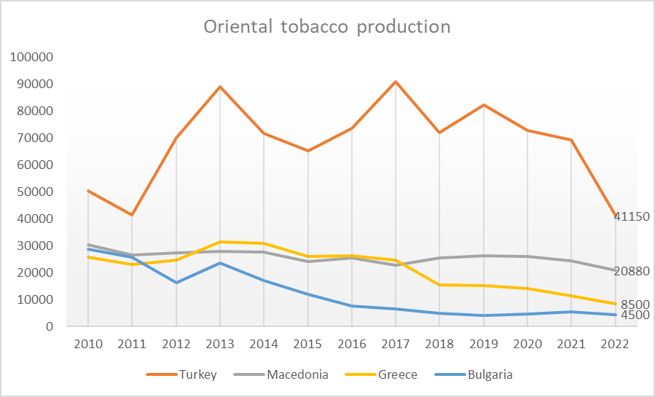
Chart 1. Production of Oriental types of tobacco in Balkan countries (2010-2022)

Presented data in table 1 and chart 1 indicate that the production of Oriental tobacco shows fluctuations with a decreasing trend from year to year. The main reason for the decline in tobacco production and consequently in the production of Oriental types of tobacco, is the discontinuation of direct subsidies in Greece, shifting towards olive cultivation as a less labor-intensive crop. In Turkey, the decrease is attributed to the development of tourism, especially in the Aegean region, which represents the largest tobacco production area in terms of volume. In Bulgaria, the reduction is linked to obtaining production quotas after its accession to the European Union, aligning the Common Agricultural Policy with Union regulations, which eliminates direct subsidy payments to tobacco producers and replaces them with area-based payments. Additionally, a significant portion of the population in Bulgaria, especially the younger demographic, has been migrating to Western European countries after joining the European Union.
To sustain production in North Macedonia, it is crucial to continue the state's policy of subsidizing and stimulating this industry. Supported by the government's subsidy policy, Macedonia should aim to increase the production of Oriental tobacco, considering the continued decline in production in Greece, Bulgaria and Turkey. The trend in the production of this type of tobacco in Balkan countries shows a continued linear decline. Albania and Serbia have very small and almost negligible quantities of Oriental tobacco. Chart 2 shows the average production for the analyzed period in the mentioned countries.

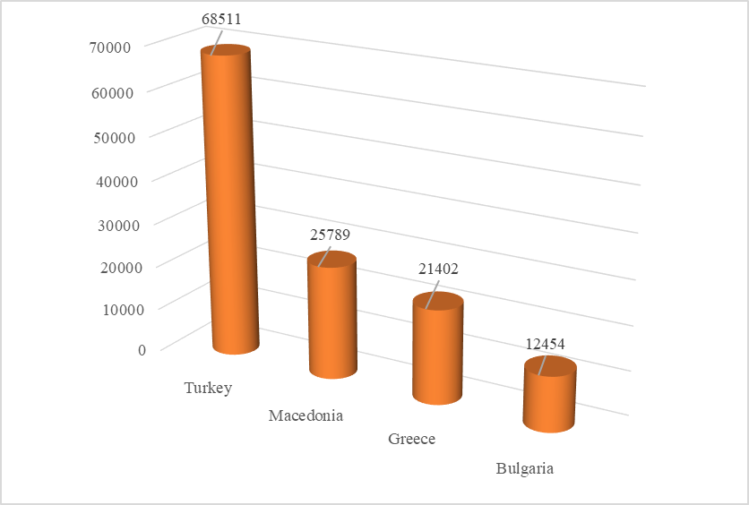
Chart 2. Average production of Oriental tobacco in Turkey, North Macedonia, Greece and Bulgaria (2010-2022)

The production and trade of Oriental tobacco and tobacco products have significant economic and social importance for the Republic of North Macedonia, contributing to 3.8% of the gross domestic product (GDP). The tobacco industry accounts for approximately 4.0% of the total industrial production and 4.1% of employment in the overall industry.
In recent years, tobacco production has shown a relatively stable trend, ranging from 20,000 to 25,000 tons on an area of about 13,500 hectares. However, as this production is directly influenced by climatic conditions, a decrease is expected in the upcoming harvest of 2023. This reduction is attributed to excessive rains during the spring, leading to diseases in tobacco plants and causing significant thinning. Subsequently, a dry period followed, further impacting the yield. Although the quality of the produced and harvested tobacco is expected to be good, the quantity is expected to be significantly lower compared to the 2022 harvest.
Table 2 contains data on the number of concluded contracts, cultivated tobacco area, production in tons and yield in kg/ha (2010-2022).

Table 2. Number of concluded contracts, tobacco planted area, production in tons, yield kg/ha (2010-2022)
Year | Number of concluded contracts | Tobacco planted area | Production in tons (t) | Yield (kg/ha)
2010 | 40.743 | 20.300 | 30.280 | 1.492
2011 | 33.234 | 19.693 | 26.537 | 1.348
2012 | 29.090 | 19.656 | 27.333 | 1.391
2013 | 42.367 | 19.178 | 27.859 | 1.453
2014 | 34.445 | 17.758 | 27.578 | 1.553
2015 | 28.454 | 16.128 | 24.237 | 1.503
2016 | 27.380 | 16.379 | 25.443 | 1.553
2017 | 29.132 | 15.961 | 22.885 | 1.434
2018 | 34.104 | 16.582 | 25.547 | 1.541
2019 | 24.854 | 16.719 | 26.234 | 1.569
2020 | 29.531 | 16.592 | 26.112 | 1.574
2021 | 27.712 | 15.457 | 24.329 | 1.574
2022 | 29.653 | 13.237 | 20.880 | 1.577
Source: State Statistical Office of the Republic of North Macedonia (https://www.stat.gov.mk/)

Data from the table clearly indicate the fact that the number of individual tobacco producers (concluded contracts) and the cultivated areas have been decreasing over the years. However, produced quantities remain relatively stable as a result of using healthy seed material, modern mechanization, proper managerial approach in organization and implementation of the production process, and the application of Good Agricultural Practices (GAP). This contributes to a constant increase in the achieved yield per kg/ha, which serves as a special incentive for tobacco producers.
In fact, with a proper policy of subsidizing and stimulating, along with maintaining relatively acceptable prices at purchase, the production of tobacco is expected to continue at a stable level with good prospects for future growth. This is particularly important because previous analyzes indicate that there is no alternative crop that would absorb as much labor and have such an economic impact as tobacco, both from the perspective of tobacco producers and the state.
For a clearer understanding and analysis of the state of tobacco production in Macedonia during the period 2010-2022, following graphical representations illustrate the trends of all individual parameters included in Table 2.
Chart 3 depicts the mentioned trend of decreasing numbers of individual tobacco producers, i.e., concluded contracts.

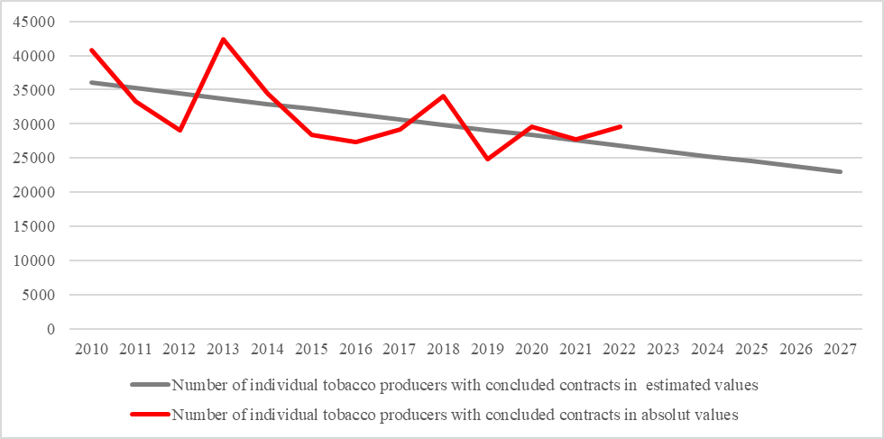
Chart 3. Number of individual tobacco producers with concluded contracts in absolute and estimated values

It is evident that the number of tobacco production entities fluctuates from year to year with a declining trend. Specifically, the number has decreased from 40,743 entities in 2010 to 29,653 entities in 2022. The same trend is observed in tobacco planted areas, which have decreased from 20,300 hectares in 2010 to 13,237 hectares in 2022, with an estimated and continued declining trend . This situation is depicted in Chart 4.

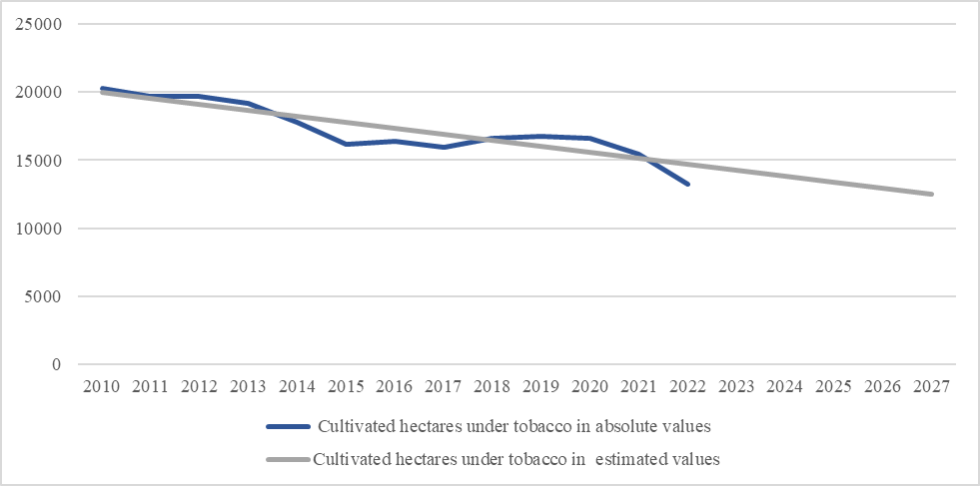
Chart 4. Cultivated hectares under tobacco in absolute and estimated values

Declining trend with a certain decrease is also present in tobacco production. However, it is maintained at a relatively stable level as a result of experience and tradition in the work process, the use of modern mechanization, proper management and of course, the involvement of family members in a successful family business. This situation is depicted in Chart 5.
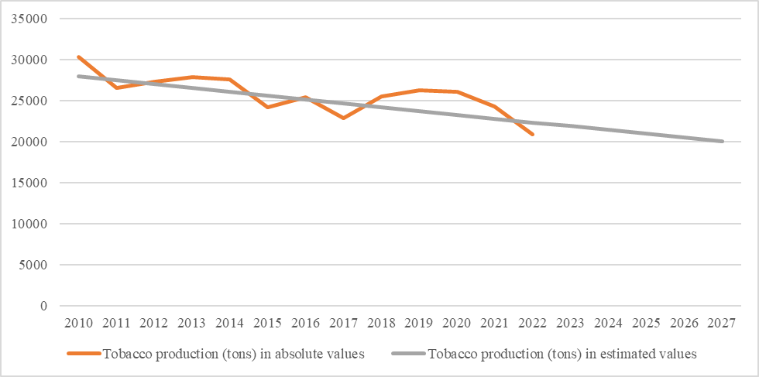
Chart 5. Tobacco production (tons) in absolute and estimated values

In contrast to the previously analyzed parameters from Table 1, which show declining trends, there is a trend of gradual increase in yield per kg/ha. This is particularly significant for tobacco producers to consider in planning their future in this industry. This situation is depicted in Chart 6.

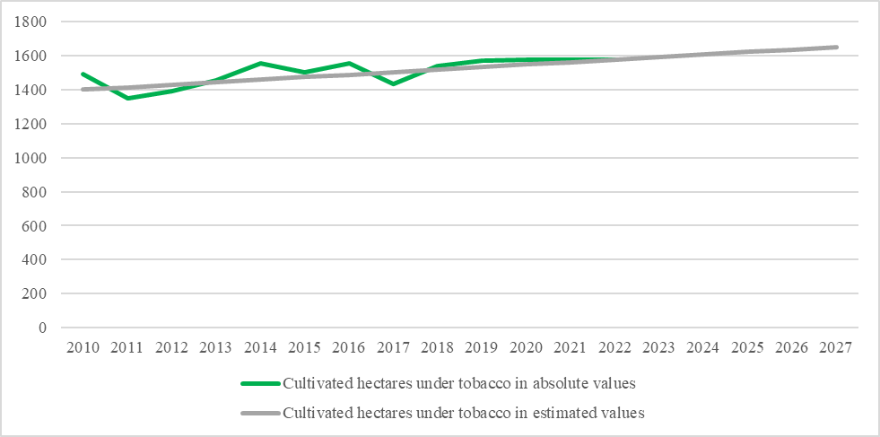Chart 6. Yield of tobacco (kg/ha) in absolute and estimated values
In such circumstances, the question arises: How profitable is the Macedonian tobacco production, which brings in a significant foreign exchange inflow of around 120 million euros? In the period from 2010 to 2022, the annual production is about 25,000 tons of tobacco, stabilized at 22,000 to 23,000 tons annually, achieving continuity in tobacco production unlike neighboring countries where a decrease is observed and this trend should be utilized in the coming years . In fact, the reduced production in neighboring countries such as Greece, Bulgaria and Turkey should be leveraged by our country to protect the production of Oriental tobacco, as we have competitive and renowned varieties on the world market, with valued tobacco raw material. The "Prilep" type, alongside the "Izmir" type, is second in the world in terms of placement as a type of tobacco.
Macedonian Oriental tobacco is sought after on the world market, especially when global production stagnates, particularly for Oriental types, which are mostly produced in our country.
Thus, in recent years, there has been a stagnation in the production of raw tobacco in the world, at around six million tons, across all types. The "Virginia" and "Burley" types, among others, have the largest share in global production, along with Oriental types. Of all types, the Oriental type has experienced the greatest decline, dropping from the former 300,000 tons to the current 120,000 tons in global production. For now, Macedonian production is not endangered because we have had standard production for several years, with the exception of this year. This does not currently pose a threat as there is a more significant decrease in other countries, such as Bulgaria, Greece and Turkey. This means that there is still a place for our tobacco in the global market.
Macedonian tobacco producers are primarily concerned about the purchasing price, which they consider low when viewed from the perspective of expenses such as fuel, artificial fertilizers, protective measures and labor, all of which have become increasingly expensive. From this standpoint, there is a possibility of stagnation in Macedonian tobacco production, which could be addressed through higher purchase prices that follow inflation in this period.
One of the main opportunities that needs intensive focus, especially in the upcoming period, is the utilization of uncultivated agricultural land owned by the state. Another opportunity that should be addressed is the reduction of fragmentation among existing tobacco production entities, aiming to improve their efficiency and effectiveness. Education of tobacco producers, encouraging both tobacco production and elevating it to the level of a family business, is a third opportunity that should be explored, especially through participation in seminars, training, debates and greater involvement of expert public opinion, bringing it closer to on-the-ground issues. Introduction of production quotas for tobacco in the European Union member states, as well as the decrease in production in these countries due to the lack of interest among producers in this type of business, presents new opportunities for expansion of production in Macedonia, particularly during a period of stagnation in the production of oriental tobacco types, not only in our immediate neighborhood but globally as well.
As a future prospect for current and potential tobacco producers, the development of ideas and plans for additional production is crucial, aiming for better utilization of production factors. To improve and increase tobacco production, it is essential to provide affordable credit lines, facilitating easy access to fresh capital for both modernizing outdated equipment and expanding production capacities, i.e., cultivating larger areas.
The long-term future of tobacco production can only be ensured through quality production policies, proper investment, employment encouragement, motivation, capital increase, proper pricing policies, stimulating subsidy policies, education, advice from experts and proper market policies. In this context, it is inevitable to emphasize that the traditional method of tobacco production, favorable natural climate conditions, state interests, socio-economic aspects and export policies within global frameworks are primary factors for the continuation of the century-old tradition of tobacco production in Macedonia.

CONCLUSIONS

Viewed in perspective, tobacco production exhibits a stable trend with certain fluctuations, showing slight upward trends in global production. Our country must track and adapt to these trends. The future of tobacco production will heavily depend on a sound agricultural and export policy, as well as a well-implemented state subsidy policy. It is crucial to encourage and direct the young population towards tobacco production, presenting not only an opportunity for existence but also space for development, expansion and, of course, profit. In this regard, motivation and leadership play an essential role among various related activities to foster an entrepreneurial spirit among the youth, who represent the future of our country.
If all measures continuously offered by European commissions for the protection and improvement of agriculture, including IPARD funds, are utilized, the developmental course of tobacco production in our country will significantly progress.
From the perspective of quantities of Macedonian oriental tobacco types concerning the total production of oriental tobacco globally, we observe that our role in this domain is relatively small, but our priority should be quality. We must not allow any compromises in either the quality or the typical and varietal purity of our tobacco types. The tobacco production sector in Macedonia is characterized by enviable quality and global renown. Therefore, efforts are needed to enhance production and economic policies through the implementation of a development strategy, where pricing policy should serve as a necessary stimulus for tobacco production. In this context, maintaining the status of a traditional producer of oriental tobacco, with consistently stable production compared to surrounding countries – producers of oriental tobacco types (Bulgaria, Turkey, and Greece), is essential. Macedonia possesses outstanding opportunities for producing high-quality small-leaf aromatic tobacco types. Oriental tobacco types are an industrial culture with a high degree of globalization and represent a unique alternative unto themselves.

REFERENCES

- Miceski T., Pashovska S., 2008. Development of family business in tobacco production, Acetoni-Prilep.
- Miceski T., Pashovska S., Reengineering as a method and approach for adapting to organizational changes, Yearbook -Faculty of Economics: Vol. 5 No. 1 (2013): Yearbook 2013
- Pashovska S., Miceski T., The Global Environment as a challenge to Corporate Competitiveness, Journal of Economics: Vol. 1 No. 1 (2016)
- State Statistical Office of the Republic of North Macedonia (https://www.stat.gov.mk/ )
- https://www.pmi.com/tobacco-economics/tobacco-database
- https://www.semanticscholar.org/paper/The-tobacco-sector-in-the-Republic-of-Macedonia Tuna/387e1ec0bf0378713e261aadc3f1e2dc7a2d1d1f
- https://www.agrojournal.org/14/05-05-08.pdf
- https://mac-baren.com/meet-the-master-blender/oriental-tobacco/

https://mac-baren.com/meet-the-master-blender/oriental-tobacco/

