ACADEMIC INTEGRITY IN THE AGE OF REMOTE LEARNING: ADDRESSING ACADEMIC DISHONESTY IN HIGHER EDUCATION

By Elena Shalevska, MA & Ph.D. candidate
elena.salevska@gmail.com / elena.shalevska@uklo.edu.mk
Faculty of Education – Bitola
“St. Kliment Ohridski” University – Bitola
ORCID no. 0000-0002-3270-7137

Abstract
The shift to remote learning brought about by the COVID-19 pandemic has presented a plethora of new challenges for preventing and detecting academic dishonesty. Although academic dishonesty, such as plagiarism and cheating, can occur in traditional in-person classes, just as in remote learning environments, the easy access to books, notes, and gadgets, has made such problematic behavior significantly more prevalent.
Recognizing the numerous challenges to do with academic integrity in the digital age, this small-scale study attempts to highlight undergraduate students’ perspectives on online cheating, by conducting a web-based questionnaire. The questionnaire, sent to a small, random sample of undergraduate students from the Faculty of Education – Bitola, intends to investigate students’ reasons for cheating as well as their attitudes toward academic dishonesty during distance learning, in general.
The study found that a significant portion of the participants have cheated themselves, on some occasions while almost all of them have witnessed someone else engage in academic dishonesty. The reasons for such misconduct vary, though the most prevalent ones seem to be the accessibility of online resources that make cheating or academic dishonesty easier and the belief that cheating is a common or accepted practice among peers.

Keywords: Academic dishonesty, COVID-19, Higher Education, Remote learning.
Introduction
Academic integrity has always been an important issue in higher education, but the rise of remote learning during the COVID-19 pandemic has brought new challenges to maintaining ethical conduct in academic work. With the widespread use of online platforms for exams and assignments, the potential for academic dishonesty has increased, leading to concerns about the credibility of degrees and qualifications. In order to address this issue, it is important for institutions to take proactive measures to promote academic integrity and prevent cheating. This may involve implementing effective plagiarism detection software, providing education and resources for students and faculty, and creating a culture of honesty and ethical behavior.
Additionally, it is important to recognize the unique challenges faced by students in the remote learning environment, such as increased stress and lack of access to support services, and to provide appropriate accommodations to support their success. By taking a comprehensive and proactive approach to promote academic integrity in the age of remote learning, higher education institutions can ensure that their graduates are well-prepared for their future careers and make meaningful contributions to society.
The shift to online learning has also led to concerns about the credibility of degrees and qualifications, as it becomes easier for students to cheat on exams and assignments (Chiang et al., 2022). Therefore, it is important for higher education institutions to take proactive measures to promote academic integrity and prevent cheating, while also recognizing and addressing the unique challenges students face in the remote learning environment.

1. Academic Integrity in Higher Education: A Review
According to a report by the International Center for Academic Integrity (ICAI), academic integrity is defined as "a commitment to honesty, trust, fairness, respect, and responsibility in all academic work" (ICAI, 2019). Academic integrity, defined as such, is crucial in higher education as it upholds the values of honesty, trust, and fairness. It ensures that students demonstrate their own work, acknowledge sources properly, and avoid plagiarism. Upholding academic integrity cultivates a culture of intellectual growth, and ethical behavior, and prepares students for future professional success. However important, unfortunately, academic integrity seems to be declining, which is concerning.
In a study published in the Journal of Academic Ethics, McCabe and Trevino (1993) found that as many as two-thirds of college students engage in some form of academic dishonesty, such as cheating or plagiarism. To address this prominent issue, in their book "Cheating in College: Why Students Do It and What Educators Can Do About It," McCabe, Butterfield, and Trevino (2012) suggest that promoting a culture of academic integrity requires a multi-pronged approach that involves not only punishing dishonest behavior but also educating students about the importance of ethical conduct and providing them with the resources and support they need to succeed academically.
As to why students cheat, research conducted by Donald L. McCabe and Linda K. Trevino found that students are more likely to cheat when they perceive that cheating is common among their peers and when they believe that they are unlikely to get caught (McCabe & Trevino, 1997). Lack of motivation to study might also be the reason. The author (Shalevska, E.) in a small study to do with students’ motivation during distance learning, found that a considerable proportion of the participants expressed experiencing reduced motivation while engaged in remote learning. Other authors have found that even an abundance of motivation and drive can result in dishonest behavior. A study published in the Journal of Educational Psychology found that students who are highly motivated to achieve good grades are more likely to engage in cheating behavior (Whitley, 1998).
Whatever the reason for cheating, most studies agree that it is becoming a prevailing issue in modern, technology-based education. While there is less research on academic dishonesty in online settings than there is on traditional classroom cheating, there has been an increasing amount of research conducted over the past two decades that covers various topics and produces significant results. And since online education is becoming more prevalent, examining the initial findings from this emerging area of research is crucial.(Adzima, 2020) According to a survey conducted by the Pew Research Center, 55% of college presidents believe that plagiarism has increased over the past decade, and 89% believe that the internet has played a major role in this increase (Pew Research Center, 2011).
Though prominent in higher education, it is important to note academic dishonesty seems to stem from fraudulent behavior in earlier years. A small study focusing on high school students in Bitola, N. Macedonia, conducted in 2021 by the author (Shalevska, E.), found that “...students’ cheating behaviors have become more noteworthy as technology and online education have enabled them access to easy ways to impair academic integrity” and that almost 80% of the 145 participants admit to cheating either regularly or, at least sporadically. In a related manner, the public was also shocked to discover that about 7,000 Macedonian high school seniors were found to be cheating via Viber group during the state-wide graduation exam in English this year. (Sitel, 2023).
Regardless of the reasoning behind it, the decline of academic integrity in higher education is unsettling for it undermines the principles of honesty, fairness, and originality. Plagiarism and cheating erode the value of education, hinder personal growth, and devalue degrees. Thus, it is imperative to address this decline, as it threatens the credibility of educational institutions and compromises the learning experience for all students.

2. Methodology
This section outlines the research approach used to investigate the impact of remote learning on academic integrity in higher education. It details the data collection methods, analysis techniques, and ethical considerations employed in the study.
Regarding the sample, this small-scale study used a random sample of 38 participants within the population of tertiary students from the Faculty of Education - Bitola. This simple random sample is representative of the larger population of students enrolled at the faculty. The identified research problem was the perception that students cheat during distance learning. The study investigated this issue in order to better understand the extent of academic dishonesty among students in higher education. Understanding the identified problem, the objective of the study was to detail students' perceptions of academic dishonesty in distance learning. The study also investigated the reasons why students cheat, how frequently they cheat, and what measures can be taken to prevent academic dishonesty in distance learning.
To reach the objective, data was collected using an online survey administered through Google Forms. The survey sent to all students at the Faculty of Education – Bitola, enquired about students’ perceptions of academic dishonesty in distance learning. The survey was anonymous, and all data collected will be kept confidential.
In a similar line, the study took into account all relevant ethical considerations related to data collection and analysis. All students were notified about the purpose of the study and were given the option to opt out of participating. As stated, the survey was completely anonymous, and the collected data was handled as confidential. As for its limitations, the study was limited to one faculty and a small sample, which may limit the generalizability of the findings. The study also relied on self-reported data, which may be subject to bias or inaccuracies.
Overall, the study aimed to test the main hypothesis: A significant number of students in higher education cheat during remote learning. This hypothesis was tested using both quantitative and qualitative data analysis techniques, including statistical analysis and thematic analysis.
It is also important to note that this study was conducted without any external funding, ensuring unbiased exploration and analysis of the subject matter. The author declares no conflicting interests that could influence the outcomes or compromise this study’s objectivity.

3. Results and Discussion
As stated, this study employed the data collection method through an online questionnaire. The questionnaire was self-administered and it included a total of 8 multiple-choice and select-all-that-apply questions. The said questionnaire was sent to a random sample of 50 participants – students at the Faculty of Education, Bitola – 38 of which responded. resulting in a response rate of 76%. This response rate demonstrates a substantial level of engagement and suggests a representative sample for analysis and interpretation. The high response rate enhances the reliability and generalizability of the study findings.
The first set of questions aimed to collect demographic data to do with the sample. As stated, the sample consisted of a total of 38 students, distributed across different academic years. Among the participants, 10 students were in Year 1, 12 students were in Year 2, 8 students were in Year 3, and 8 students were in Year 4. This distribution of participants across academic years ensures a diverse representation of students at various stages of their educational journey. (Figure 1)
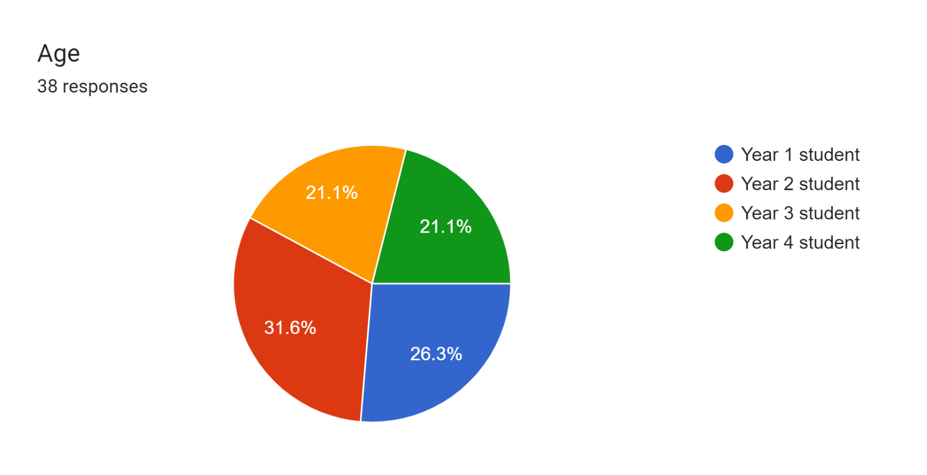
Figure 1: Distribution of the sample among academic years
Regarding the gender distribution, the data revealed that out of the 38 participants, 31 identified as female, while 3 identified as male. Additionally, 4 participants chose not to disclose their gender preference. These findings highlight the predominance of female students within the Faculty of Education – Bitola, indicating a potential gender disparity within the sample. (Figure 2)
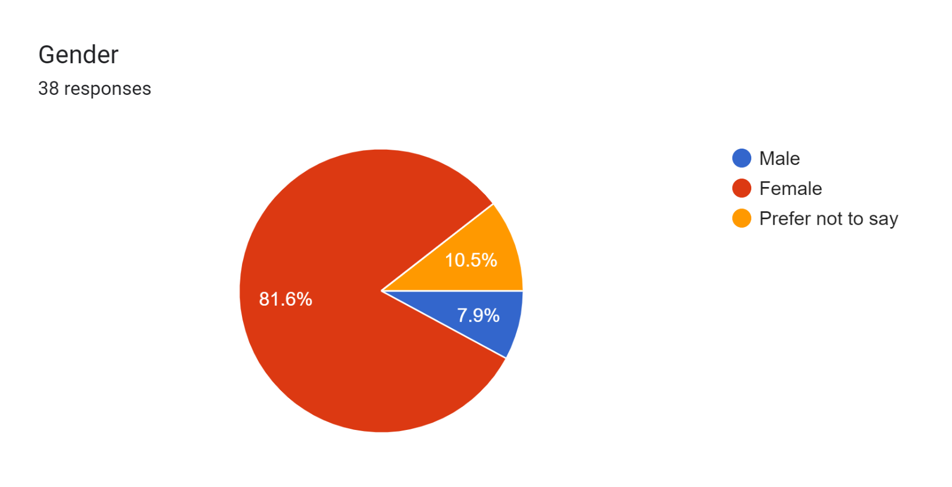
Figure 2: Gender distribution

With the gender and academic level data collected, the questionnaire then set to enquire about students’ perspectives to do with academic dishonesty and integrity. The multiple-choice question "Have you ever cheated or engaged in any type of academic dishonesty during online learning?" yielded interesting responses from the participants. Among the 38 respondents, 9 individuals admitted to cheating or engaging in academic dishonesty often, while 19 participants confessed to doing so every once in a while. Thus, over ⅔ of the students admitted to having engaged in fraudulent behavior during remote learning, whether frequently, or sporadically. These findings shed light on the prevalence of academic misconduct in the context of remote education and the prevalent need to address it.
On the other hand, 10 participants declared that they had never cheated or engaged in any form of academic dishonesty during online learning. Though this might seem like excellent news, it is important to acknowledge the potential influence of the so-called, social desirability bias. As this questionnaire was administered by their instructor, students might have felt compelled to provide socially acceptable or favorable responses to present themselves in a positive light. Though certain steps were taken to mitigate this bias (such as ensuring anonymity and confidentiality in the data collection process) it is important to acknowledge that despite the anonymity, some level of self-reporting bias or underreporting may still be present. (Figure 3)
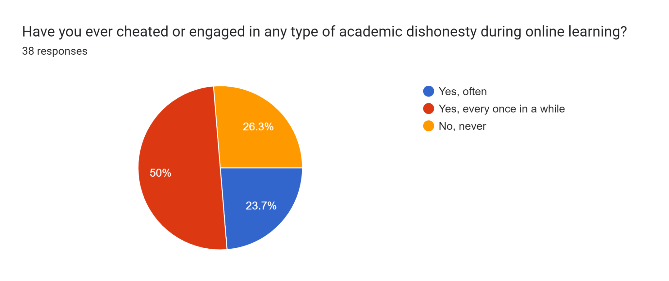
Figure 3: % of participants engaging in academic dishonesty
Interesting results were also obtained as to whether students have “witnessed or heard of someone else cheating online”. Out of the 38 respondents, a significant majority of 31 students indicated that they had witnessed or heard of someone cheating on an online exam. Conversely, 7 participants reported that they had not come across any instances of cheating. These findings suggest a high prevalence of observed cheating behaviors within the online exam setting, which is undoubtedly concerning.
Once again, it is important to note the potential social desirability bias in the responses. Participants might have been more comfortable discussing instances of academic misconduct involving "someone else" rather than admitting personal involvement. This bias might have led to a higher number of students acknowledging other students’ fraudulent behavior while downplaying their own engagement in dishonest practices. Which might mean that the number of students who actively break the rules is significantly higher than initially admitted. (Figure 4)
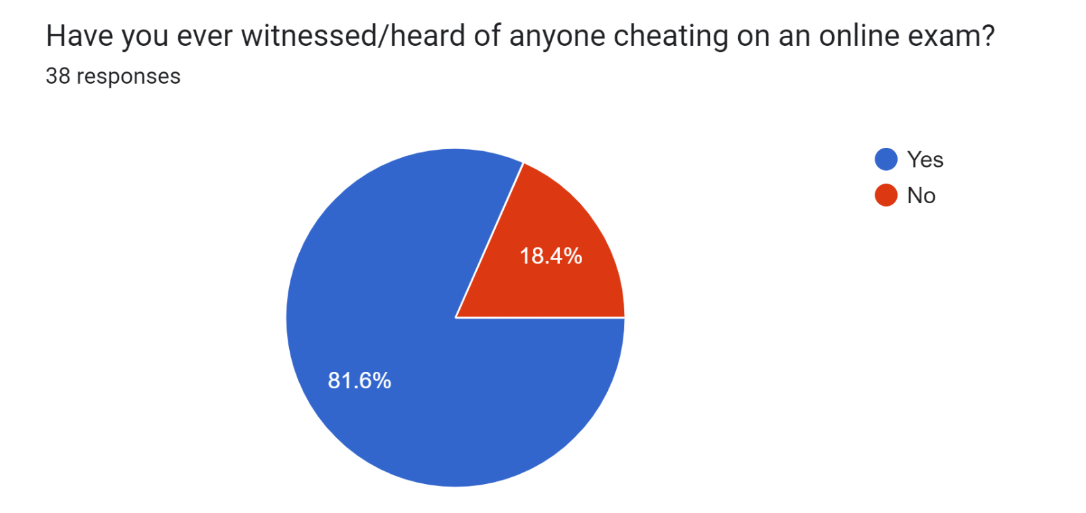
Figure 4: Observed dishonest behavior

The following select-all-that-apply question focused on the reasons why students cheat. The responses revealed a wide range of factors that contribute to dishonesty in higher education. Among the 38 participants, several motivations were identified. The most frequently selected reason was the accessibility of online resources that make cheating easier (20). Other commonly mentioned motivations included the pressure to achieve high grades and maintain a certain GPA, which was chosen by 19 respondents, the belief that cheating is a common or accepted practice among peers or in the academic culture (16), and the lack of consequences for cheating online (13). Additionally, participants identified factors such as the lack of time for completing demands on time (12) and peer pressure (2) as additional reasons behind academic dishonesty. It is noteworthy that a few respondents also provided their own unique motivations, using the “Other” option, such as not liking the professor (1) and lacking the motivation to learn (1).
These diverse motivations highlight the complex nature of cheating and academic dishonesty in online learning environments. Students may be driven by various external and internal factors that influence their decision to engage in dishonest practices. Due to the vast array of reasons for engaging in such behavior, the issue of the declining academic integrity is that much more difficult to solve. (Figure 5)
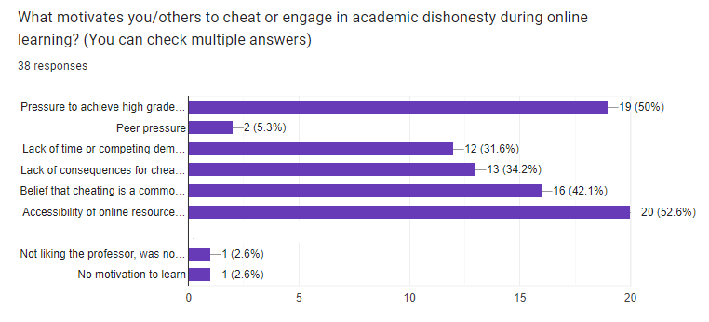
Figure 5: Reasons to engage in academic dishonesty
In order to compare the dishonest behavior in real life vs. in an online environment, the questionnaire enquired whether students think cheating is more prevalent online. Out of the 38 respondents, a significant majority of 30 stated that in their view, students cheat more during online exams compared to traditional exams. On the other hand, 8 participants expressed the belief that there is no significant difference in cheating behavior between the two modes of assessment. (Figure 6)
It is important to consider the aforementioned reasons for cheating, as they may shed light on the perceived increase in cheating during online exams. The highlighted factors above, such as the accessibility of online resources, and the belief that cheating is a common practice could contribute to the perception that online exams are more susceptible to dishonest behaviors.
However, it is crucial to note that perceptions do not necessarily reflect the actual prevalence of cheating. Future research should explore this perception further and investigate the correlation between perceived cheating rates and actual instances of academic dishonesty online and offline.
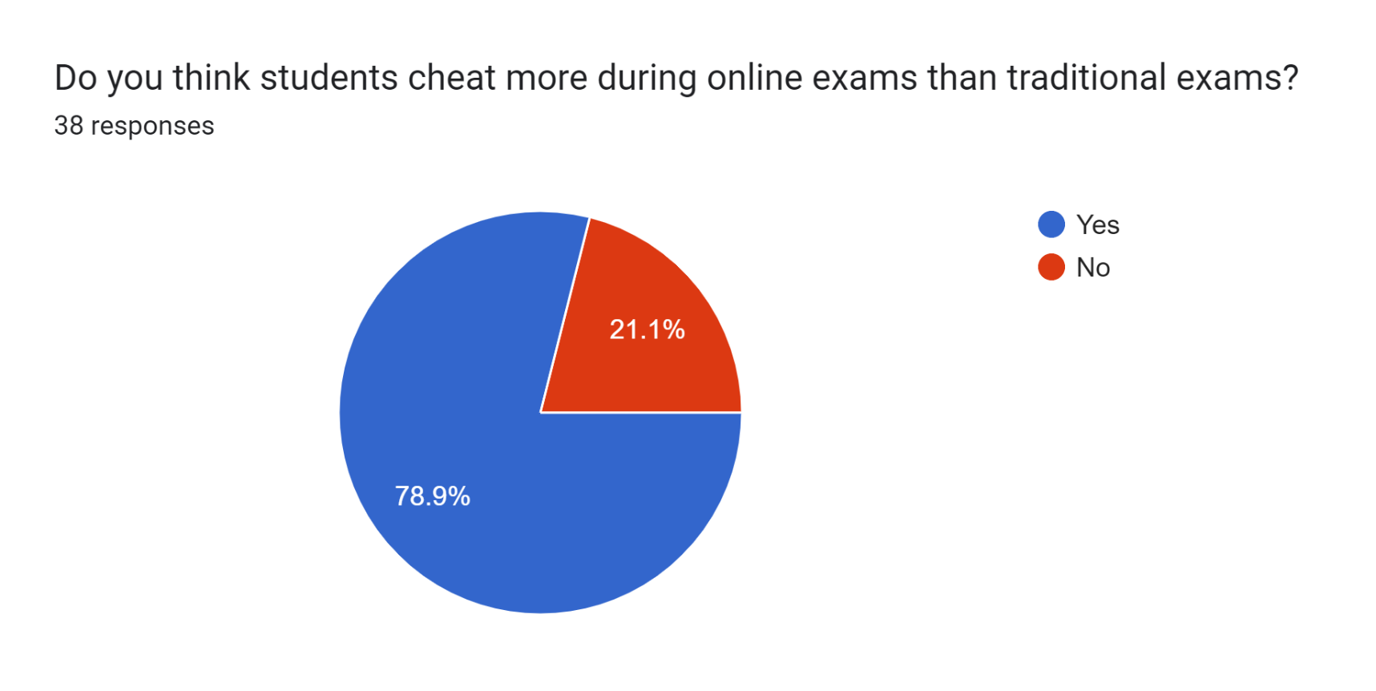

Figure 6: Cheating online vs. offline
Students’ perceptions as to the measures academic institutions have taken/should take to prevent academic misconduct are also interesting to note. Out of the 38 respondents, 17 stated that academic institutions should take stricter action against students who cheat or engage in academic dishonesty during online learning. In contrast, 21 participants believed that the existing measures in place are sufficient. (figure 7)
These responses reveal a divergence of opinions regarding the appropriate approach to addressing academic dishonesty in the online learning environment. These contrasting perspectives highlight the complexity of striking the right balance between prevention, and intervention.
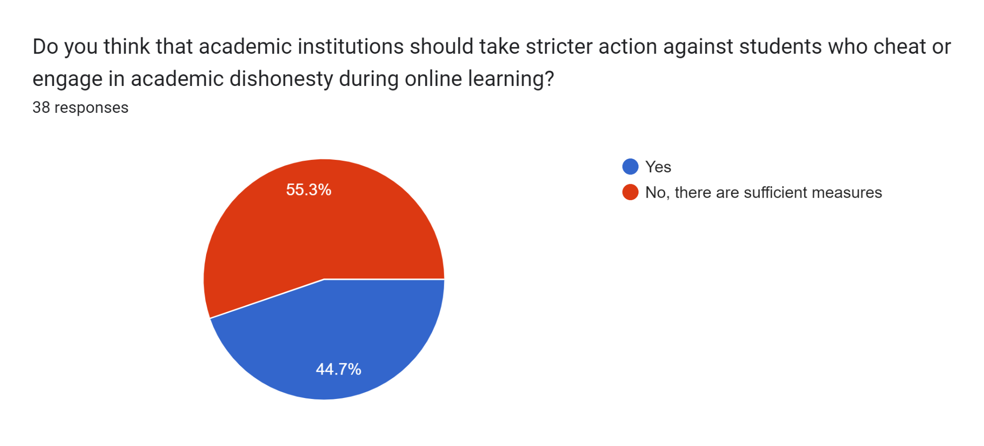
Figure 7: The appropriate approach to addressing academic dishonesty

The final part of the questionnaire aimed to collect data on students’ perception as to what constitutes as cheating in academia, understanding that not recognizing a behavior as inappropriate or fraudulent might also be one of the reasons cheating occurs at such a high rate. According to the responses, the most commonly identified forms of academic dishonesty included copying from others' work or using someone else's ideas without proper citation (25), having someone else complete an assignment or take an exam on one's behalf (25), and submitting work that has been previously submitted for another course or assignment (22). Other behaviors acknowledged as cheating or dishonesty included cooperating with others to cheat or engage in academic dishonesty (21) and using 'essay mills' or other services to complete assignments on one's behalf (18). Notably, 15 participants indicated that they consider asking professors for help, cheating. (Figure 8)
These variations in individuals' perceptions of what constitutes academic misconduct can also be seen as part of the wider issue. As stated, failing to recognize certain behaviors as problematic or not fully understanding the boundaries of academic integrity can contribute to dishonesty. To address this, institutions should provide clear guidelines, training, and awareness programs. Such measures can empower students to make informed decisions, encourage ethical behavior, and create a culture that prioritizes integrity in higher education.
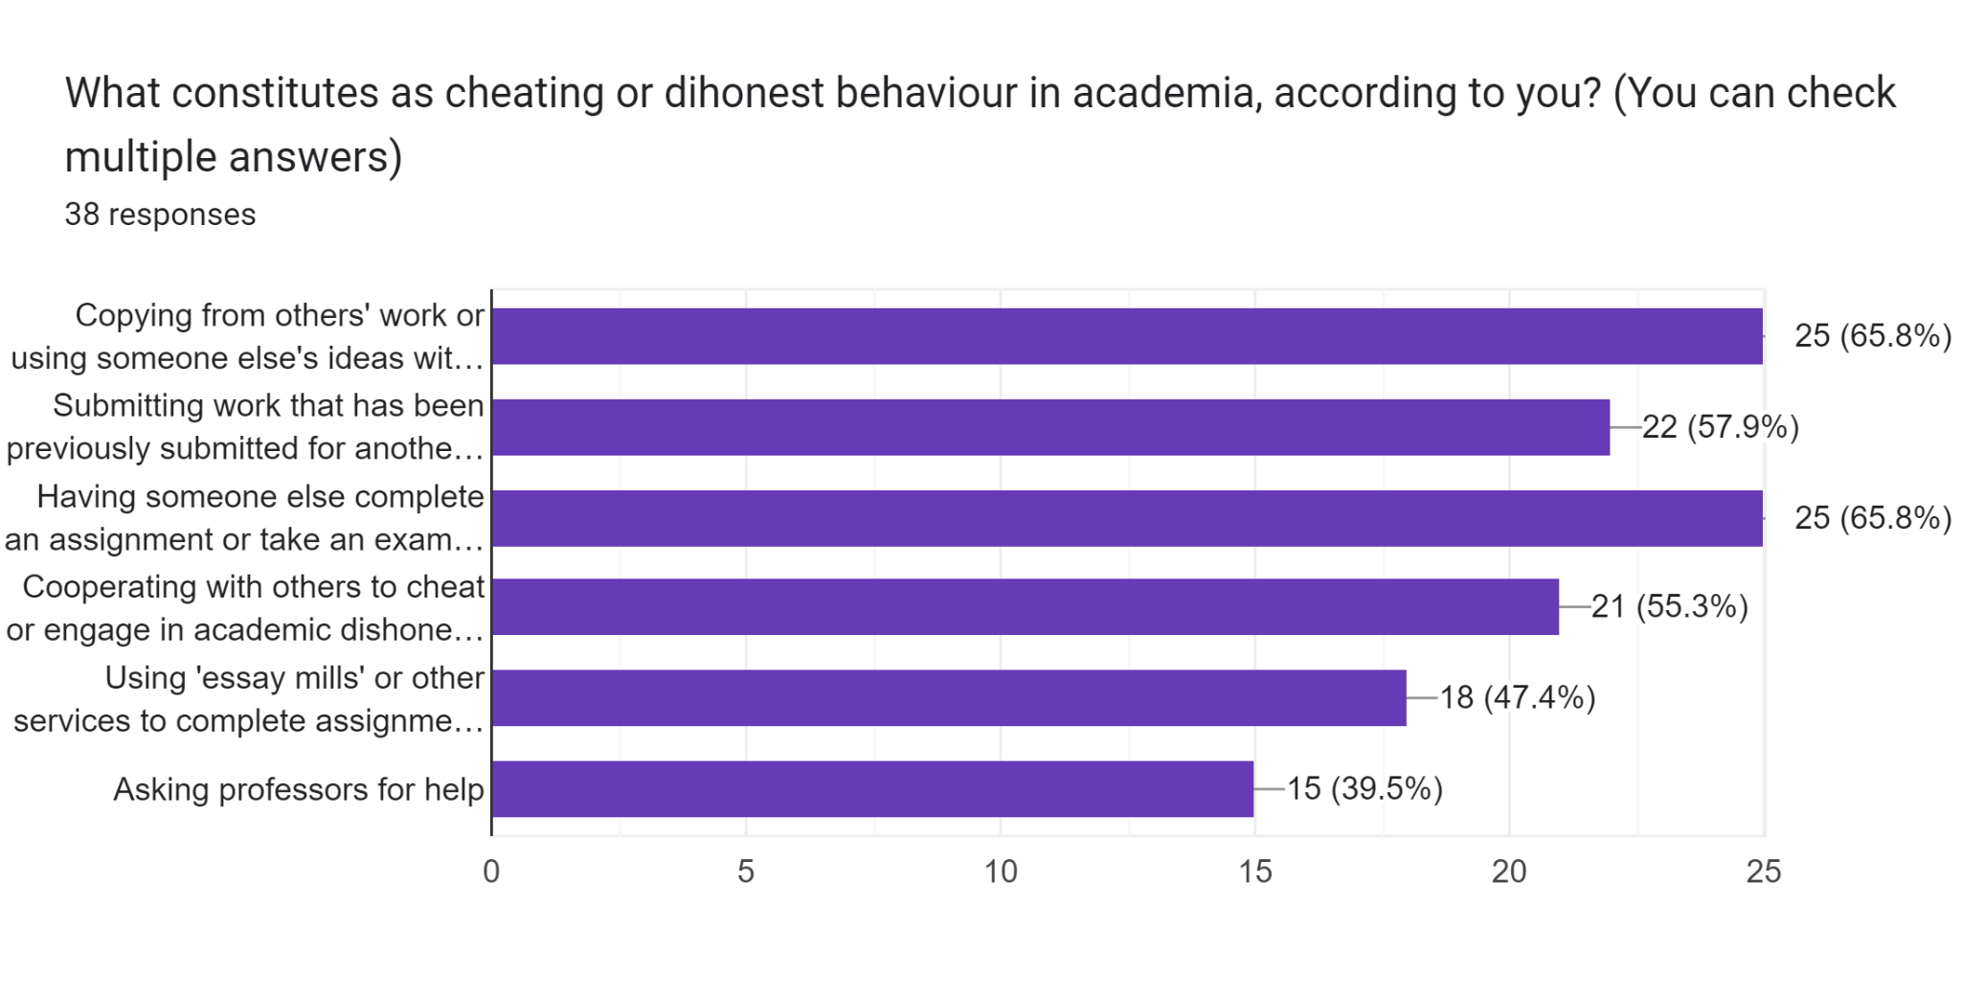
Figure 8: Students’ perception as to what constitutes as academic dishonesty

4. Conclusion
The study found that a significant number of the sample of students in higher education admit to cheating, and their reasons for doing so vary. While some students cheat out of a desire to succeed or a fear of failure, others cheat due to the ease of access to information online or a lack of understanding of what constitutes academic dishonesty. Although students’ answers must be observed and generalized cautiously due to the potential of self-reporting bias, it seems that academic dishonesty in the remote learning environment is a prominent issue that needs to be addressed carefully, due to the difficulty of striking the right balance between prevention and intervention.
These findings underscore the need for higher education institutions to prioritize academic integrity and employ effective strategies to prevent and address fraudulent behavior. In order to address the issue of academic dishonesty, higher education institutions can take several steps. Such efforts could include promoting a strong culture of integrity, providing clarity on what constitutes academic dishonesty, and implementing appropriate disciplinary measures when misconduct occurs. Moreover, they can provide support and resources to help students succeed academically without resorting to dishonest practices. By addressing the underlying motivations, enhancing awareness, and fostering a sense of personal responsibility, higher education institutions can strive to cultivate an atmosphere of trust, fairness, and ethical conduct.

Bibliography

International Center for Academic Integrity. (2019). The fundamental values of academic integrity. Retrieved from:https://academicintegrity.org/images/pdfs/20019_ICAI-Fundamental-Values_R12.pdf on 10.4.23

McCabe, D. L., & Trevino, L. K. (1993). Academic dishonesty: Honor codes and other contextual influences. Journal of Higher Education, 64(5), 522-538.

McCabe, D. L., Butterfield, K. D., & Trevino, L. K. (2012). Cheating in college: Why students do it and what educators can do about it. Johns Hopkins University Press.

McCabe, D. L., & Trevino, L. K. (1997). Individual and contextual influences on academic dishonesty: A multicampus investigation. Research in Higher Education, 38(3), 379-396.

Whitley, B. E. (1998). Factors associated with cheating among college students: A review. Research in Higher Education, 39(3), 235-274.

Pew Research Center. (2011). The digital revolution and higher education. Retrieved from: http://www.pewinternet.org/2011/08/28/the-digital-revolution-and-higher-education/ on 10.4.23

Chiang, F., et al. (2022). A systematic review of academic dishonesty in online learning environments. Journal of Computer-Assisted Learning 38(4)

Adzima, K. (2020). Examining online cheating in higher education using traditional classroom cheating as a guide. Electronic Journal of e-Learning,18(6), 476–493. https://doi.org/10.34190/jel.18.6.002

Shalevska, E. (2021). Cheating And Academic Dishonesty And Covid-19 Distance Learning. International Journal “Teacher”, 21, 18–25.

Sitel. (2023). Групно препишување во Вибер група на државната матура. Available from: https://sitel.com.mk/grupno-prepishuvanje-vo-viber-grupa-na-drzhavnata-matura

Shalevska, E. (2021). Students’ motivation during distance learning. International Journal of
Science and Research. Vol.10, No. 1. Retrieved from:
https://www.ijsr.net/get_abstract.php?paper_id=SR21126103143, on 5.6.2023

