SUSTAINABLE TRANSPORTATION SYSTEM, A CASE STUDY

Vaska Atanasova, Marija Stojanoska
PhD., Graduate traffic engineer, Faculty of Technical Sciences – University of St. Kliment Ohridski, Bitola, Macedonia,
vaska.atanasova@uklo.edu.mk, marijastojanoska3112@gmail.com

Abstract
In today's time, the risk of sustainable transport is related to the economic and social development of a given country or region. We are surrounded with transport since the moment you leave your doorstep or order your goods. It is a fundamental and human activity, interrelated with other important activities such as socializing, trading and entertainment. Any change in such activities can have a dramatic effect on transport and vice versa. As a result, the transportation industry has become one of the most important industries in the world, and in which we all directly matter. The sustainability of urban transport needs traffic solutions that will encourage the passenger car to be the second choice, and thus reduce environmental pollution and energy consumption. Sustainable urban transport, in addition to cycling and walking, includes the development of optimal public urban transport, the aim of which is quality service to users in the entire urban area, which is actually both the aim and the object of this paper. Public transportation as a type of transportation that can greatly help in building the policy for a sustainable urban transportation system. In this paper, the goals, measures and principles for building sustainable development with the application of public city transport will be presented, on a case study.
Keywords: sustainable, development, urban public transport, planning, application.
Classification JEL: Sustainability in Sciences

1. Introduction

Urbanization is a process that in the first decade of the 21st century has already passed the threshold of 50% of the population living in cities and has a trend of further growth, so it is believed that by 2050 70% of the population will live in the cities. Due to the modern way of life, many cities face the harmful impact of traffic processes reflected in autocentricity, traffic congestion, lack of parking spaces and green areas, which, in turn, all together affect the economic, ecological and health aspects of society ( environment, health and safety of citizens). Statistics from the World Health Organization indicate that motor vehicle addiction claims nearly 7 million lives a year, of which 3.3 million are the result of air pollution-related illnesses, where traffic accounts for more than 25%, and 1.3 million die in traffic accidents. The sustainability of urban transport needs traffic solutions that will encourage the passenger car to be the second choice, and thus reduce environmental pollution and energy consumption. Sustainable urban transport, in addition to cycling and walking, includes the development of optimal public city transport, whose goal is quality service to users in the entire urban area. The priority in the promotion and modernization of the public city transport is aimed at its better inclusion in the initiatives for sustainable mobility. Public city transportation is a particularly important part of urban transportation. Public city transport vehicles provide a fast, safe, cheaper, less noisy, ecological and comfortable way of transport. In addition, they cost less, take up less space, use less energy, and have a lower health impact compared to cars. Public city transport is a type of transport that can greatly help in building the policy for a sustainable urban transport system. If the public city transport offers a high quality of transport service and attracts a greater number of trips to the city, then the city would have a chance to withstand the pressure of the car and its constant need for new high-capacity traffic facilities, the negative impacts on the environment would be reduced, i.e. the quality of living in the city would increase. The main goal is to reduce the demand for transport by reducing the number of trips and the length of the trip. The organization of urban space helps in reducing the distances between places and people and as a result people travel less to get goods and services.

2. THE GOALS FOR THE DEVELOPMENT OF A SUSTAINABLE URBAN TRANSPORTS SYSTEM

The goals for the development of a sustainable urban transport system are:
¬ providing a basis for economic development and prosperity of the city,
¬ enabling the functioning of all functions of the city by ensuring accessibility and mobility,
¬ provision of a higher quality of life,
¬ enabling an efficient, inexpensive, fast, reliable, safe way for people and products to move,
¬ saving energy,
¬ protection of the environment.

2.1 Measures that are aimed at achieving the goals of sustainable urban transport

Some of the measures that are aimed at achieving the objectives of sustainable urban transport are:
¬ promotion and improvement of bicycle and pedestrian traffic
¬ support and improvement of public city transportation
¬ support of electric rail types of public city transportation
¬ advancement and improvement of the planning
¬ the management and control of traffic, that is, their integration and coordination, ¬ application of intelligent transportation systems and technologies for optimal use of the passenger car
¬ application of information systems for the purpose of rational use of transport facilities
¬ use of cleaner fuels and vehicles with an alternative ecological drive
¬ reduction of the noise of the basic network
¬ developing and coordinating integrated transport with a network of freight and logistics centers
¬ increase in traffic safety, application of the "user pays" principle, that is, fair distribution of costs in urban transport
¬ management of parking
¬ measures to calm the traffic
¬ introduction of an eco fee as a measure for a sustainable urban transport system and
¬ management of freight traffic.
In order to successfully implement initiatives for sustainable urban transport, an effective system must be established. To create a safe and efficient system for sustainable urban transport, certain guidelines and principles must be examined, such as those listed below.

2.2 Principles of sustainable transport

The following principles are set out as part of an urban mobility strategy that aims to make transport more sustainable and faster by reducing congestion and carbon emissions.
• New transport must be designed safely, with the safety of people being the top priority in transport.
• Mobility innovations must benefit every part and be accessible to everyone in society.
• Mass transportation remains fundamental as part of an efficient transportation system.
• New transport must be designed to release zero emissions and reduce emissions to meet climate change targets.
• Innovations in mobility must reduce congestion by making highly efficient use of limited road space, such as through ride sharing.
Walking, cycling and active travel must be promoted as more efficient and healthy options for short urban journeys. This would also improve the air quality and reduce congestion. Sustainable transportation is transportation that does not rely on the world's natural resources such as coal, oil, and gas. Sustainable urban transport is important because it helps to improve air quality and releases significantly less greenhouse gas emissions, which is better for the environment. Cost, connectivity, flexibility, speed and health effects are all factors that need to be considered when planning to implement sustainable urban transport schemes.

3. APPLICATION OF PUBLIC URBAN TRANSPORT AS A SUSTAINABLE TRANSPORTATION SYSTEM

During our daily life, we face various problems that directly or indirectly affect our mood and consequently affect the performance of our daily duties. The fast lifestyle, among other things, has a negative impact on our health. Thinking that driving a motor vehicle will get us to work faster every morning, we put ourselves in a situation where we face heavy traffic jams and waste our precious time. A number of studies give us an indication that people who use public transportation to work are far happier than others who use their own vehicles. Indications are that the time spent on a bus, train, tram, etc. is usefully used by travelers, so that during the trip you can complete some work duties, read a book, and even study... In addition, the pollution of the environment where we live is significantly reduced, because, compared to all world analyses, one bus that can accommodate 60 passengers actually replaces 20-30 motor vehicles, reducing the level of pollution by approx. 10 times. From an economic point of view, public transportation is far cheaper than transportation with your own vehicle. In addition to fuel consumption, parking spaces, which are expensive for daily use, as well as the smaller number of them, as a consequence of the increase in the number of vehicles, must also be considered in this segment. Passenger cars require too much space, both for movement and for rest, i.e. for parking. Cities by definition represent spaces with a high concentration of activities that produce a large number of trips. But if all trips are made by car, then physically, enough traffic areas cannot be provided for the movement of such a large number of cars on city roads. From here, the role and significance of public city transport clearly emerges. If he offers a quality service, he can transport a huge number of passengers with very little demands on areas for movement and stopping, that is, ensure high mobility of the population and availability of city functions. This results in the possibility of turning the city into a pleasant place to live, with more areas intended for greenery, housing, cultural facilities, sports fields, production facilities. The alternative to this is for the city to turn into concrete and asphalt flooded with cars and smothered in exhaust fumes and unpleasant noise. Public transport is the type of transport that has the greatest potential in solving traffic problems in cities.
This is important for our cities in Macedonia, which today mostly rely on the car as a means of transportation. The car is the favorite means of transportation for over a third of the country's residents. There are over 477,000 cars with an average age of 19.3 years on the roads all across the country. About 57 percent of them drive on diesel, and only 0.03 are electric. And while the streets and sidewalks are seemingly crowded with vehicles, we are still below the European average, where there is one car for every two inhabitants, while here we have one for every four. At the end of 2021, 559,418 vehicles were registered on the roads in Macedonia, according to the data of the State Statistics Office, it should also be mentioned that the share of kilometers driven by cars is constantly growing in our country, while the number of transported passengers in public transport is in continuous decline. In contrast to this negative situation in our country, the number of passengers transported by rail is growing in the EU member states, and the same applies to public transport in cities and the use of bicycle transport. The majority of cities in Macedonia are small cities that have introduced or are introducing public urban transport in recent years and there is a need to establish a methodology for planning such systems in accordance with the specifics here (availability of data, mentality and habits of the population, characteristics of cities and their street network etc.) In Macedonia, Skopje seems to be one of the few capital cities in which there is a limited and very poor offer of public transport. In addition to the capital, in 2014 public city transport was also introduced in Prilep. Public city transport has also been introduced in Ohrid, Kavadarci, Tetovo, Kočani, Kumanovo, Veles, but due to the bigger problems, needs and the understanding of the importance of sustainable public city transport, it is planned to introduce it in Strumica, Shtip and other smaller cities.

3.1. City Prilep, a case study

Public city transportation as a department of the Public Enterprise for Spatial and Urban Plans has been operating since April 2014. Prilep is the first city in the country to receive environmentally friendly and cheaper city transport. Part of the vehicle fleet that is used for transportation is diesel, while there are also four buses that run on methane. There are 3 bus lines in Prilep, payment is made through a card, which can be purchased at JSP Prilep, it can be topped up, and the control is carried out electronically through a monitored apartment, for people who do not have a card, payment is made with coins from 5 and 10 denars, where he receives a fiscal bill, the vehicles are equipped with video surveillance, double-winged doors, low floors, the possibility of wheelchair entry and a space intended for disabled people. The vehicles are modernly equipped, 12 meters long, double-winged, with 27 seats, with a ramp for passengers with wheelchairs, that is, they have the capacity to transport 78 passengers standing (Fig.1). The main benefit of these buses is that they do not pollute the environment, because they are Euro 6 standard.
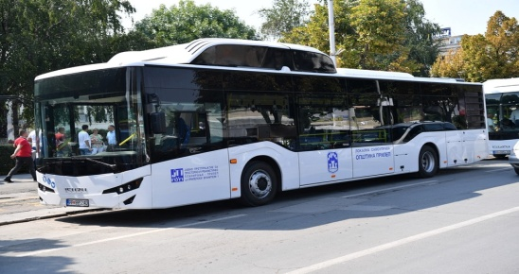
Fig.1 Bus for public transportation of passengers in Prilep (Source:https://www.gradskiprevozprilep.com/avtobuski-linii)

3.2 PTV VISION SOFTWARE

The software tool PTV VISION VISSIM, is a tool that allows simulating the currents on a set substrate. (Figure 2) shows the section that we analyze with a substrate.
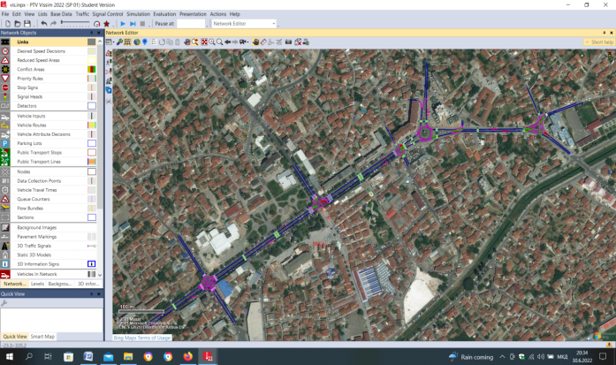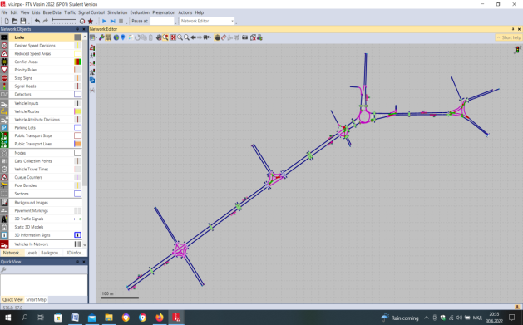
Fig.2 Shows the section that we analyze with a substrate
(Source: Created by the authors in Vissim software)
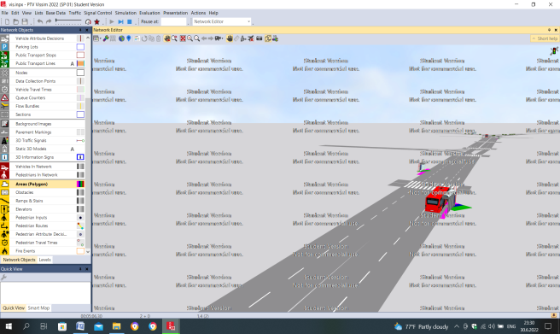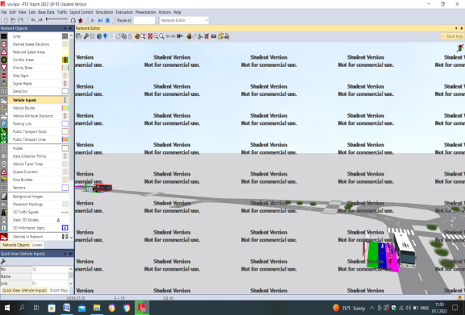
Fig.3 Entry and exit of passengers from the public city transport vehicle
(Source: Created by the authors in Vissim software)

4. CONCLUSIONS

At the same time, urban passenger and freight transport has negative impacts by leading to congestion, pollution and challenges to traffic safety. Increasingly, the movement of passengers and freight are intertwined in a zero-sum game, having to use the same finite infrastructures and urban space to meet the ever-growing demand for mobility. The results of this paper present the goals, measures, and principles for the introduction of sustainable transportation systems, including public city transportation. From this paper we can conclude that the introduction of public urban transport in the cities of Macedonia is of great importance because in addition to reducing air pollution, increasing safety, transporting a large number of passengers, they are considered to be sustainable for the environment. In this paper, a case study using the software tool PTV VISION VISSIM, for the city of Prilep, was presented, with a display of the layout route, simulation of passenger entry and exit.

REFERENCES

- https://www.studysmarter.co.uk/explanations/geography/sustainable-urban-development/sustainable-urban-transport/
- http://www.crpm.org.mk/wpcontent/uploads/2019/09/BelDokument_urbana_mobilnost.pdf
- https://www.ptvgroup.com/
- https://www.google.com/maps
- https://www.gradskiprevozprilep.com/avtobuski-linii
- https://www.studysmarter.co.uk/explanations/geography/sustainable-urban-development/sustainable-urban-transport/
- https://slocat.net/transport-targets-sustainable-development-goals/
- https://www.un.org/esa/dsd/susdevtopics/sdt_pdfs/shanghaimanual/Chapter%204%20-%20Sustainable%20urban%20transport.pdf
- https://www.sciencedirect.com/science/article/pii/S2352146516300758
- https://sutp.org/publications/10-principles-for-sustainable-urban-transport/

