Conference paper
Savings and Ethics of the Population in the Republic of Macedonia
Snezana Mojsoska1, Nikola Dujovski2 and Dance Nikolovska,*
¹ St. Kliment Ohridski University - Bitola, Faculty of Security - Skopje; smojsoska@gmail.com
² St. Kliment Ohridski University - Bitola, Faculty of Security - Skopje; ndujovski@gmail.com
³ Revenue Office - Shtip; nikolovska_dance@yahoo.com
* Correspondence: smojsoska@gmail.com; Tel.: +389-70-288-845
Academic Editor: name
Received: date; Accepted: date; Published: date
Abstract: The financial system as a subsystem of the global economic system plays an essential role in the efficient functioning of the global economy. Some of the main features of the financial sector of the Republic of Macedonia are the low degree of inter-sectoral integration and the limited intercross ownership among the separate financial segments. The aim of this paper is to prove the influence of the financial institutions on the macro economy in the Republic of Macedonia through the savings of the population correlated with the importance of knowledge of the ethics in savings. A surveying research was conducted on a statistical sample of 1250 respondents, where the analyzed data obtained with the basic statistical parameters of 7 variables were estimated measures of variability (Std. Dev., Skewness, Kurtosis and KV%). As it is obvious in the above-mentioned research, we can conclude that in Macedonia the amount of savings of the population is generally low; the respondents were mainly insufficiently acquainted with the financial conditions and the possibilities of the market and the financial institutions; people do not have any knowledge about ethics in savings in order to increase savings. In this direction, in the conclusion of this paper, some new measures for increasing of the savings in other financial institutions will also be offered.
Keywords: financial institutions; savings, ethics, measures;

1. Introduction
The development of the financial markets and institutions is of essential meaning for the process of growth of the economy and the society. There are empirical proofs that the level of financial development is a good indicator of the future rates of economic growth and the accumulation of assets and technological changes. Furthermore, the comparative analyses point out that the time intervals when the financial system was not sufficiently developed were also reflected in a serious weakening of the economic development. Lucas[1] claims that the role of the banking sector in the economic growth is overemphasized. According to Levine [2], the efficiency of the functioning of the financial institutions in the framework of the financial system has a great impact on the living standard and the well-being of each individual in the society. The financial institutions collectivize the savings of the population and allocate them within the economic agents with profitable investment possibilities, thus increasing the productive capacity of the economy. Financial institutions also enable the economic agents to postpone their current expenses into future ones (stimulating their savings). Efficient functioning of the financial system and the financial institutions and their effectuating to economies of circumference as well as at lower operational (informational and transactional) expenses in the financial market gives the possibility for acceleration of the economic growth. On the contrary, the improper functioning of the financial institutions and the financial system as their surrounding leads to insufficient mobilization of the financial means, reduction of spending, reduction of production, insufficient utilization of the available resources, reduction of employment and eventually - to decrease of the living standard.
In 2004, in the framework of their research, Rioja and Valev[3] underlined that finances accelerate the growth in the rich countries above all through increase of the growth of productivity, while in the poorer countries it is done through increase of the accumulation of the assets. In 2001, Benhabib and Spiegel[4] found that the indicators of the financial intermediation are correlated with the factors of growth of the total productivity, while the accumulation of the assets is correlated with the material and human capital. In 1998 Rousseau[5] found that the permanent reduction of the spreading of banks by 1% is related to the increase of the financial depth by 1,7% to almost 4% as well as that financial innovations deepen financial depth, which is closely related to the economic growth. Consistently with it, Levine and Zervos[6] and Bekaer, Harvey and Lundblad[7] show that financial liberalization accelerates economic growth through improvement of the allocation of the resources and the rate of investment. Rajan and Zingales[8] sublime that the more developed financial intermediaries and financial markets are, the more they facilitate the access to additional external financing of the companies and support the growth of the companies as well as the economic growth. The development of the financial sector in the transitional economies is especially important, mainly because of its influence of the rapid and successful implementation of the transitional process. In conditions of non-market economy, even though dominant, the banking sector was totally ruined, with domination of the state ownership, with high percentage of delinquent loans in relation to the total banking assets (which reflected on the price of finances in terms of interest rates with high margins as a difference between the active and the passive interest), with high bank concentration and concentration within the separate sectors and departments, with situations where the beneficiaries of the loans are also members of the supervisory and managerial bodies of the banking institutions, etc. The financial system of the Republic of Macedonia is characterized by a relatively simple structure and underdevelopment from the aspect of the type of financial institutions and the range of products and services which they offer, as well as by insufficient international integration which was one of the main factors in the global economic crisis.
In this paper we will analyze the efficiency of the financial markets; then we will point out that the development of the financial sector in the transitional economies is especially important. For the purposes to prove the savings in the financial institutions in Macedonia, a surveying research will be presented in order to set the hypothesis that the level of saving within the population of the Republic of Macedonia is at insufficiently low level. We will also show the importance of ethics in savings and point out that people are not familiar with the rules of ethics in savings.

2. Materials and Methods

For the purpose of this paper, Macedonian banks and their ethical standards were analyzed. The importance and the need of a well-functioning, developed and integrated financial system and financial institutions reflect on the enhancement of competitiveness, quality, and type of the offered financial services and instruments as well as reduction of the expenses for financial intermediation; this on the other part motivates saving in the country as a potential for further investment activity. The low level of financial intermediation, the conservativeness of the banks, and the cautious loan policy control the influence of the financial crisis in the national economy in a significant part. The banks, with participation of 88,7% in the total financial assets in 2009 and 88,5% in 2012, were dominant financial institutions in the Republic of Macedonia. Compared to these numbers, the participation of the non-deposit financial institutions in the total financial assets is 10,2% in 2009 and 10,8% in 2012. The relative insufficient development and integration and the shallowness of the financial system in Macedonia were the best protection in the times of the global economic crisis.

Ethical standards

Furthermore, awareness of the costumers of the financial institution for the ethical standards will lead to increase of the savings. All financial institutions, according to their public documents, have in common approximately 6 ethical standards. These are: transparency - transparent information both to the customers and the general public, as well as to the employees. For example, cater customers fully understand the terms of the contracts they sign with banks and engage in financial education in order to increase public awareness about the dangers of non-transparent financial offers; a culture of open communication - fair and constructive in communication with each other, a conflict at work in a professional manner, working together to find a solution; social responsibility and tolerance - giving advice based on solid foundation. Before offering loans to customers, they assess their economic and financial situation, as well as their business potential and repayment capacity in order to evade their indebtedness and allow appropriate financial services. In addition, all customers and employees treat them with respect and fair access, regardless of their origin, skin color, language, sex, or religion. Also, it is essential to make sure that requests for loans to customers are dealt with in accordance with the ethical business practices. No loans are issued to enterprises or citizens if they suspect that they use practices which are unsafe, harmful to the environment, or moral forms of exploitation of human labor and in particular of child labor; service oriented - every client should be served in a friendly, competent, and courteous manner. Employees are committed to providing excellent customer service, regardless of their background and size of their business; high professional standards - employees take personal responsibility for the quality of their work and always strive to improve professionalism; high degree of personal integrity and commitment - all employees in the financial institutions expect full commitment and honestly and sincerely carry out their duties[9].

Methods

In order to prove that savings, as well as the knowledge of people about the ethics in savings in Macedonia are at a low level, a surveying research on a random statistical sample of 1250 respondents was conducted. Thus it was proven the set hypothesis that the level of saving within the population of the Republic of Macedonia (as a dominant source of the activities of the domestic financial institutions) is at insufficiently low level and the knowledge of ethical saving is very low. Hence, the influence of the financial institutions implies a low level of economic growth and development. The questions were elaborated in the Statistical program SPSS 19 and on the place of 7 questions, 7 variables were defined (Table 1). The data from this research were elaborated by the basic descriptive statistical procedures. In the space of the descriptive statistics for each of the variables, the basic measures of central tendency and dispersion were estimated, as well as the grouping of the results in classes (frequency analysis). Analyzing the data where the basic statistical parameters of 7 variables were given, we can state that the distribution of the results in most variables is mainly in the normal margins of distribution, and certain declination from the normal distribution is related only to the variables 6 and 7 (this is due to the content of the 5th variable - it is not in favor of saving, as well as to the 7 modules of responding within the variable 6. The estimated measures of variability (Std. Dev., Skewness, Kurtosis and KV%) with only small exceptions show a relatively high degree of homogeneity in relation to the average values in each variable.

Results
Through statistical elaboration of the data we came to a result that as to the first question presented in figure 1 and related to the number of households which save, at the very beginning we can state that less than half of the households save. This is shown in the diagram in which it is obvious that 45,6 % of the respondents save, and the other 54,4 % do not save.
The purpose of the second question or the second given variable is to estimate the percentage of the savings in the total income. Through statistical elaboration of the data we came to a result which shows that 26% of the total number of respondents save from 10% to 25% of their personal income (Figure 2). The valid distribution of the percentage of the answers of people who save is as follows: 35,1% save under 10%, 57,9% save from 10% to 25%, and 7% of the respondents save from 25% to 50%. In the essence, this variable is homogenous to the previous one and supports the hypothesis that savings are at a low level.
In order to estimate the share of the respondents who save which is invested in the financial institutions and the share which they keep “under the pillow”, the variable 3 was taken into consideration (Figure 2). Here, it was stated that 31,2% of the respondents invested their saving in the financial institutions, 15,2% did not invest their saving in the financial institutions and the rest 53,6% do not possess any savings. Precisely, the valid percentage of people who save and who would invest in the financial institution is as follows: 67,2% from the respondents invest their savings in the financial institutions and 37,8% of the respondents do not invest.
The question or the variable 4 has been created with the aim to show the amount of people who are acquainted with ethics standards of banks and their behavior in cases of successful saving (whether they will invest in the financial institutions if they have knowledge of the ethics of saving which are benefits, did someone present the ethical standards of banks, etc.). Here, the valid percentage implications of the answers show that 66,7% of the respondents who do not possess savings, in case they possess they would invest it in the financial institutions if someone presented the ethics standards of financial institutions and banks, and 33,3% of them would not invest in the financial institution even in case when ethical standards are shown to them, because of their conservative views.

Figure 1 Figure 2 Figure 3
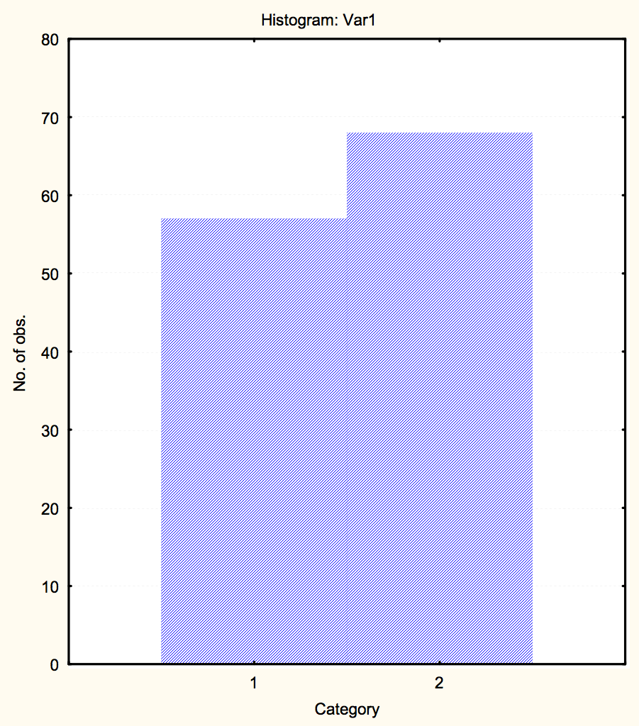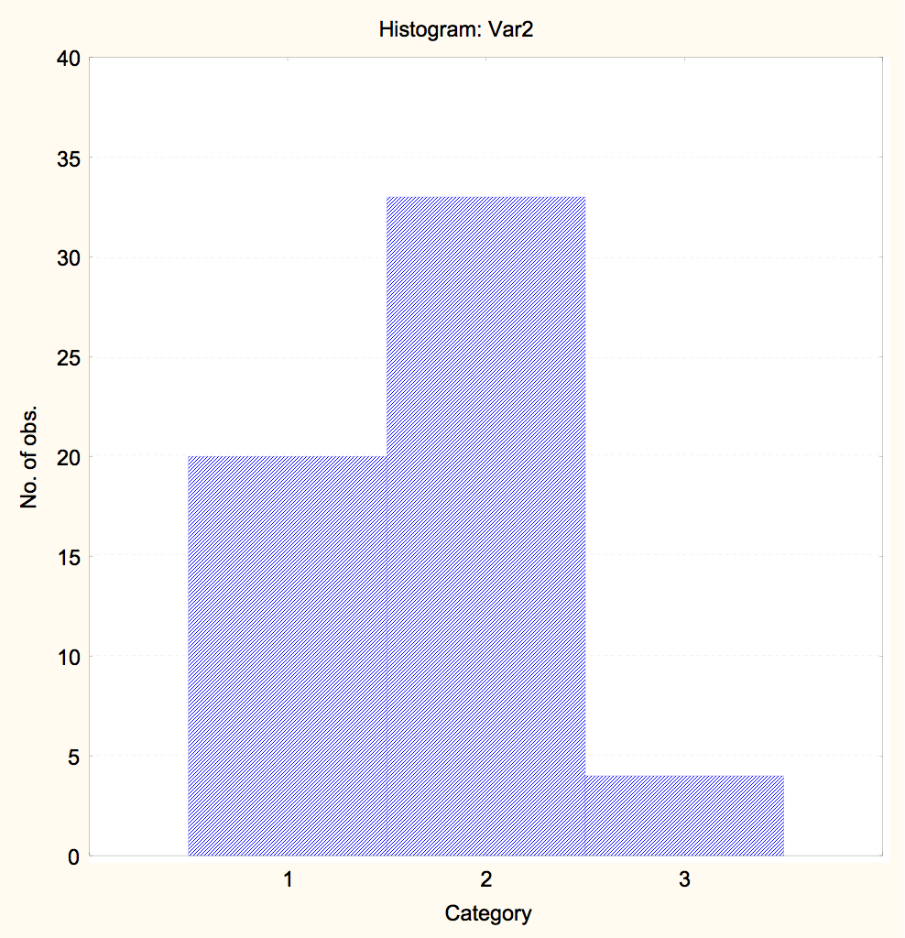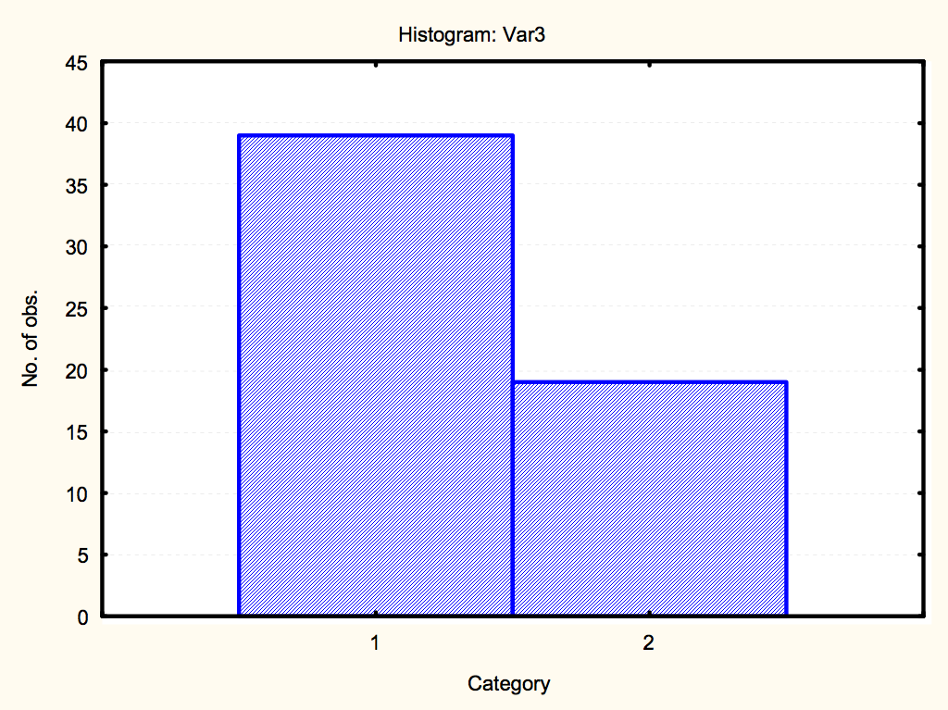
Figure 1. Percentage of households which save: 1. Households which save; 2. Households which do not save;
Figure 2. Amount of savings from the total incomes: 1. Under 10%; 2. From 10% to 25%; 3. From 25% to 50%.
Figure 3. Potential investors in the financial institutions if they are informed about the ethics in saving: 1. They would invest; 2. They would not invest.
Table 1. Frequency analyses of variables for savings in the Republic of Macedonia.
 |  |  | Valid N |  | Mean |  |  | Min |  | Max | Std.Dev. |  | Skewness |  | Kurtosis
Var1 |  | 1250 |  | 1,54 |  | 1 | 2 |  | 0,50 |  |  | -0,18 |  | -2,00
Var2 |  | 570 |  | 1,72 |  | 1 | 3 |  | 0,59 |  |  | 0,15 |  | -0,49
Var3 |  | 580 |  | 1,33 |  | 1 | 2 |  | 0,47 |  |  | 0,75 |  | -1,48
Var4 |  | 660 |  | 1,33 |  | 1 | 2 |  | 0,48 |  |  | 0,72 |  | -1,52
Var5 |  | 420 |  | 2,76 |  | 1 | 5 |  | 1,54 |  |  | -0,08 |  | -1,76
Var6 |  | 850 |  | 2,09 |  | 1 | 6 |  | 1,77 |  |  | 1,26 |  | -0,02
Var7 |  | 850 |  | 1,84 |  | 1 | 4 |  | 0,78 |  |  | 1,06 |  | 1,38

4. Discussion

The researches show that almost 96% of the activities of the Macedonian banks are related to domestic deposits, and only 3 to 4% are financed through foreign loan lines. The economic theory and analyses suggest that the economic agents with sufficient financial means (a sector which saves and creates the deposit accumulation) usually come from the sector of population, whereas in the framework of the sector of enterprises - usually dominate the financially deficient economic agents. The total amount of investments of the financial non-deposit institutions in the banks comprises only 0,6% of the total assets of the banks, whereas in the sectoral structure of the deposits, the deposits of the population strengthen their dominant position as a main source of financing of the activities of the domestic banks, and in 2010 they form up to 86,7% from the total annual growth of the deposits as it is stated in the National Bank of the Republic of Macedonia[10]. A mutual feature of the analyzed variables is that their average values are somewhat more moved towards the zone of the lower values, which defines the attitude of the respondents related to saving, i.e. the conclusion that the savings are low and the reason for this will come from the rest of the variables. The illustrated state of the variables provides a solid implication for further elaboration of the obtained results, because it gives the possibility of answering the needs of the research. In the following table and figures we will show the data of the method of grouping of the results in classes (frequency analysis) for all the applied variables.7.
On the other side, ethics in savings is a very important chain in the increase of the population that saves. Ethics insure safety saving and confidence in banks of the people who save. From the aspect of knowledge of ethics it is important to point out three goals for ethical spending and saving: 1. Ethics are standards that help determine what is good, right, and proper. 2. Ethical implies acting in a way that is good, right, and proper. 3. Ethical spending and saving is spending and saving money in a way that is reasonable or wise. The aim is to contribute not only in terms of the target groups that banks serve and the quality of the financial services they provide, but to contribute in terms of business ethics.
According to the analyses of the ethics standards of all financial institutions in Macedonia we can say that all six values or ethical principles in the financial institutions make up the backbone of the financial institutional culture and the banks; they are reflected in the Code of Conduct which transforms the Group's ethical principles into practical guidelines for all staff.

5. Conclusions
The development of the financial markets and institutions is of essential meaning for the process of growth of the economy and the society. The theory suggests that financial instruments, financial institutions, and financial markets are socially existent to reduce informational and transactional expenses in economy, which on the other part evokes increase of the rate of saving, strengthens investment decisions, technological innovations and provides a long-term growth and development. The relative underdevelopment, shallowness and insufficient integration of the financial system of the Republic of Macedonia were the best protection in the flushes of the global economic crisis. Taking into consideration the domination and the role of the banking system as a subsystem of the financial system, we underline that the conservativeness of the banks as classical loan-depositary institutions, the absence of financial instruments in their portfolios and restrain from the investment banking were strong defensive pillars against the crisis of the financial system. The resistance of the banking system in the transitional economies is due to their structural underdevelopment and the relatively low indebtedness, and Macedonian banks are a characteristic example of this phenomenon.
If we take into consideration the fact that about 96% of the bank resources come from deposits of the residents - the domestic savers, the banks are still conservative and traditional in their working. In conditions of insufficient saving this also brings to insufficiently developed financial institutions, a small loan potential and a low level of financial intermediation for servicing of the real sector, i.e. of the economic growth and development in the Republic of Macedonia.
As it can be seen from the mentioned research, we can see that in Macedonia, the amount of the savings of the population is generally small; the respondents are mainly not sufficiently acquainted with the financial conditions and the possibilities of the market as well as of the financial institutions (which leaves space for creation and implementation of educational and promotional campaigns with the aim of increasing the awareness and education of the economic agents in the sphere of conditions, possibilities, and comparative advantages for investing offered by the financial institutions and instruments, especially the non-banking. Ethics in savings is very important in the sense of increasing the population that saves; yet, people are not acquainted with the fact that banks have bank ethics that include rules for safety savings. In Macedonia, besides the low interest rates in savings, people do not have confidence in the banking system. Here, the main purpose would be modernization, development, and deepening of the financial system.
Author Contributions: S. M. gave the idea to set up variables, analysis tools and analyzed the data and the results; N.D. contributed in writing the paper, gave contribution to the analyses and collected references; D.N. performed the inquiry, collected the data and put them in the program, and also wrote a part of the paper;
Conflicts of Interest: “The authors declare no conflict of interest."

References
- Robert E. Lucas, Jr. On the mechanics of economic development. Journal of monetary economics, 1988, pp. 3-42, http://www.parisschoolofeconomics.eu/docs/darcillonthibault/lucasmechanicseconomicgrowth.pdf (25.04.2015)
- Levine Ross. Financial development and economic growth: views and agenda, Journal of economic literature, 1997, Vol. XXXV,688-726, http://pascal.iseg.utl.pt/~aafonso/eif/pdf/Levine.pdf (25.04.2016)
- Felix Rioja & Neven Valev, 2004. "Finance and the Sources of Growth at Various Stages of Economic Development", Economic Inquiry, Western Economic Association International, vol. 42(1), pp. 127-140, January
- Jess Benhabib & Mark M. Spiegel. "Human capital and technology diffusion", Working Paper Series 2003-02, Federal Reserve Bank of San Francisco
- Peter L. Rousseau; The permanent effects of innovation on financial depth: Theory and US historical evidence from unobservable components models. Journal of Monetary Economics 42, 1998; pp. 387–425
- Levine, R. and Zervos S., Stock Markets, Banks, and Economic Growth. American Economic Review, 1998
- Geert Bekaert & Campbell R. Harvey & Christian T Lundblad & Stephan Siegel. Political risk spreads. Journal of International Business Studies, Palgrave Macmillan, vol. 45(4), 2000; pp. 471-493
- Raghuram G. Rajan & Luigi Zingales, 1996. "Financial Dependence and Growth", NBER Working Papers 5758, National Bureau of Economic Research, Inc
- http://www.socialbanking.org/fileadmin/isb/Artikel_und_Studien/de_Clerck_Ethical_Banking.pdf (25.05.2015)
- Report on the financial stability in the Republic of Macedonia for 2010, National Bank of the Republic of Macedonia 2011
© 2016 by the authors; licensee MDPI, Basel, Switzerland. This article is an open access article distributed under the terms and conditions of the Creative Commons by Attribution (CC-BY) license (http://creativecommons.org/licenses/by/4.0/).

