The market as a factor for valorization of the tourist resources - the case of Macedonia
KaterinaAngelevska-Najdeska
Faculty of Tourism and Hospitality, Ohrid, Macedonia
katerina.angelevska@uklo.edu.mk
Elena Cickovska
Faculty of Tourism and Hospitality, Ohrid, Macedonia
elena.cickovska@uklo.edu.mk
Abstract. The tourist market is unique in its specificity and differs significantly from any other type of market of goods or services. However, it is still based on a combination of supply and demand as integral parts of that market. When researching and analysing the tourist supply and demand, special emphasis is placed on the attractive elements - resources, services, and prices. The attractive elements of the market or the tourist resources are objects or phenomena of natural and anthropogenic origin that attract tourists, enabling them to meet the basic tourist needs, i.e. their cultural and recreational needs. The attractiveness of resources is a very variable category under the influence of various factors, but the specificity of the objects of supply and demand in the tourist market should be especially emphasized. In the effort to achieve successful development of tourism, the movement of tourist demand is of great importance. Crucial are the factors that influence the demand and cause changes in the wishes and needs of potential tourists and their expectations for resolving those demands.The complexity of the tourist needs, which is manifested in each individual as a need for a certain combination of basic and additional services, must be satisfied with a complex tourist product, which implies temporal and spatial synchronization of attractive, communicative and receptive factors. Valorization is an integral part of market research and cannot be done independently of the research of the relationship between supply and demand, unlike some other markets of goods and services, between which an optimal degree of correspondence should be established.Since the are at a certain, this should be taken into account In the tourist valorization of resources and in tourist market research the seasonal character of the tourist trade and the spatial distance between tourist supply and demand should be taken into account.Given the specificity, complexity and heterogeneity of the tourist market and especially its spatial and temporal variability, then it is clear that it is impossible to apply a single method in researching the tourist market. Therefore, it is best to combine different methods in order to attain accurate results and a valid assessment of the dimension of the tourist demand perspective.
Key words:tourist valorization, tourist resources, tourist market, tourist offer, tourist demand

Introduction
The valorization of the tourist resources with the help of the market mechanism imposes the need to analyse the wishes and needs of the potential tourist-tourist demand on the one hand and the needs of the entities that are on the side of the tourist offer, i.e. those who participate in the creation and realization of the tourist product. Various factors influence the formation, as well as the change in the needs and desires of potential tourists. When determining the price of tourist resources, all factors that can influence its change are analysed, in order to be able to influence the demand for those resources, but also to be competitive. The future valorization of tourist resources on the market, their exploitation and preservation for future generations depends on several non-market laws, the time period of preparation and adjustment of tourist resources to create a new tourist product, as well as the formation of completely new preferences of future participants at the tourist market.
For the successful development of tourism, the continuous monitoring of the tourist demand, but also of the tourist supply is of special importance. It actually means monitoring the expected changes in the wishes, needs and expectations of modern tourists, on the one hand, but also monitoring the opportunities for their anticipation and satisfaction on the other hand.

Characteristics of the tourist market in Macedonia
The market covers the relations between supply and demand, which actually means a form of exchange of products or services mediated by money. The market is a set of entities that need certain products or services, but at the same time have the ability and authority and are willing to buy those products or services.
The tourist market, in terms of its constituent elements, does not differ from other markets of classic products, because it also has its subjects, namely:tourist demand and supply,exchange facilities (products, services) andthe price. (Milisavljević, 1998)
The tourist market is a set of supply and demand relations that are aimed at the exchange of goods and services through money and on a scale that determines the price of the goods or services. (Marković&Marković1972) However, with the functioning of these components the specifics of this market is shown.
The modern concept of the tourist market must respect the integrity and causal connection of the three basic categories of the tourism phenomenon - movement, space and consumption. (Jovicić, et al., 2005) Because, in the tourist market, supply and demand refer to both goods and services and neither is dominant, the characteristics and research of this market differ significantly from the general concept of market.
The tourist market is heterogeneous and consists of different groups of consumers, which are characterized by different needs, different purchasing power, different perception of a certain type of tourist offer and different reactions to the means of tourist propaganda.
The subject of tourist demand is not only goods or only services. These are in fact the tourist resources, which in themselves have neither the quality of goods nor the quality of services, but as attractive elements make the tourist market specific.(Lancaster&Massingham, 1997)
Resources with higher tourist value should offer better service, and thus have a higher price. However, attractiveness is not the only, and often not the most important measure of the tourist value of resources. The primacy of the attractive elements in the market structure indicates the close interrelationship of supply and demand, which is much more pronounced compared to other types of markets.
When analysing the attractiveness of resources, we should always keep in mind the fact that they should be used without utilization, i.e. we should be aware that excessive use of resources can impair their attractive properties. (Angelevska-Najdeska, 2009)
Services are part of the tourist market that are closely related to the location and characteristics of the attractive elements. Only on the tourist market there is a unification of traffic and catering services in the form of a tourist arrangement. In the tourist market it is impossible to conduct a separate research on the demand for traffic services without linking them to the demand for certain resources.
The connection of the attractive elements and the catering services is significant, and is reflected in the type, capacity and category of the accommodation facilities. Before starting the construction of certain buildings, the appropriate segment of tourist demand should be carefully studied and care should be taken to preserve the style of authentic architecture so that it can be maximally fit into the natural landscape environment, but also to not disturb the ecological balance.
In Macedonia, each city has its own specific architecture for which it is recognizable, which is a reason to take more care of its preservation. (E.g.Ohrid, Krushevo, Kratovo, Debar, etc.). For example, Ohrid is a city protected by UNESCO primarily because of its specific architecture. And that is why we must not allow what happened to the city of Dresden in Germany to happen again. Namely, due to ignoring such issues, this city is no longer under UNESCO protection. (Angelevska-Najdeska, 2006)
Prices are directly related on the one hand to the attractiveness of resources, and on the other hand to the quality of services. The relationship between resources and services is two-way. Namely, most often in the areas with attractive resources are built accommodation facilities of a higher category, and vice versa, such facilities affect the increase of the attractiveness of resources. In addition to the type of resources, the price is influenced by market factors, the distance and size of urban centres, the density of the same or different resources at a particular location and so on.
The price of the tourist product as an integral product of the tourist destination is formed according to certain criteria and under the influence of certain factors. (Bakić, 2002)
One of the specifics of price formation is that it is formed at a higher level in those destinations that are more attractive (rich in cultural and historical monuments, natural resources, etc.), and in buildings that are more modern and contemporary equipped (of a higher category). Nevertheless, when setting the price, care should be taken not to lose market competitiveness. It is also particularly important to find the most appropriate way to combine pricing policy and quality policy, which means that reducing the price should not reduce the quality of the tourist product, or vice versa by increasing its quality not to abruptly raise the price.

Characteristics and trends of the tourist demand and supply
The continuous monitoring of the trends in the tourist demand, i.e. monitoring of the expected changes in the wishes, needs and expectations of the modern tourists, and in the tourist offer, monitoring of the possibilities for their prediction and satisfaction, is necessary for the development of tourism.(Angelevska-Najdeska, 2008)

Specifics (characteristics) of the tourist demand
The basic condition that has to exist for the demand for a product or service to appear is, above all, the existence of a need. When it comes to tourist demand as a specific type of demand, in addition to the existence of the need and the readiness to address that need with a particular product or service, also free time and free cash is needed.(Milenković, 1999)
When it comes to selling a tourist product of a destination the potential consumer has to come to the destination to consume the product and it leads to the conclusion that, it is concluded that to do so one must first have enough free time and enough free funds to cover the costs of that trip and stay in the tourist destination. The fund of free time and the amount of free money depend on many factors (economic development of the country, the level of employment of the population, etc.), and are a basic and unconditional factor for tourist consumption.(Kobašić&Senečić, 1989)
When analysing the situation in Macedonia in terms of this issue, then first fact is the really high unemployment rate. This problem initiates the emergence of other subsequent problems. The part of the population that belongs to this group (of the unemployed) should have more free time, but additionally face the problem of securing financial resources. So they are burdened with meeting some other more essential needs, and the tourist needs of the ranking of this group of population are in the lower half. The working population also does not have the conditions to meet their tourist needs because the amount of free money is either very small or they do not have it at all, and they also do not have enough free time. (In Macedonia they do not have enough free days at work and do not have vacations, although they are guaranteed). When all these factors are taken into account, it is concluded that if this population wants to be included in tourism flows, then it will probably be included in domestic tourism, which has a certain positive feature, because in that way the domestic population gets a better opportunity to get to know his country. This fact should be taken into account by travel agencies when forming their offer.(Angelevska-Najdeska, 2006)

Specifics (characteristics) of the tourist demand
In order to successfully meet the different tourist needs, it is necessary to create a complex tourist product, i.e. to make temporal and spatial synchronization of attractive, communicative and receptive factors. These factors cover a wide range of elements that tourists expect to have at their disposal, so that with their choice and consumption they can achieve personal satisfaction.
The relative immutability, i.e. the consistency of the attractive factors, as well as the relatively high fixed costs for the communicative and receptive factors contribute to the relatively slower turnover of funds in this business. Thus, state intervention is not only welcome, but also necessary in order to stimulate the private sector to invest in this area, in terms of incentives in the field of credit policy to tax policy (Bakić, 2003). Amortization of the rigidity of the offer of the tourist destination, i.e. its product, can be achieved if the services are constantly and variously combined and, by introducing certain attractions that will attract the attention of tourists and increase the attractiveness of the destination. All the previously mentioned elements determine the inelasticity of the tourist offer, and are also relevant factors for strategic management of the tourist product, which, in turn, must be supported by applying a relevant strategy to the other elements for market performance.
The tourist offer is established in the tourist destination where the tourist resources are located. In order to consume the tourist product, it is necessary for the consumer-tourists to come to the tourist destination. From this fact arises the characteristic of the non-transferability of the elements of the tourist offer.
Another characteristic of the tourist offer is the inability to store services. This means that the tourist destination does not face a problem when the demand is constant, but problems are encountered when the demand is unstable or changeable.(Kobašić&Senečić,1989)
These characteristics of the tourist offer, with the previously exposed specifics of the tourist demand, prove the complexity of the tourist market, but also indicate the necessity of managing the marketing activities at both micro and macro level.
In order to take measures to create a better quality tourist offer that will adequately respond to tourism demand, a research was conducted. In the research, tourists were surveyed in order to analyse their opinion on the attractiveness of the destination and the use of tourist opportunities.
The first Figure shows the opinion of tourists about the use of tourist opportunities in Macedonia as a tourist destination.

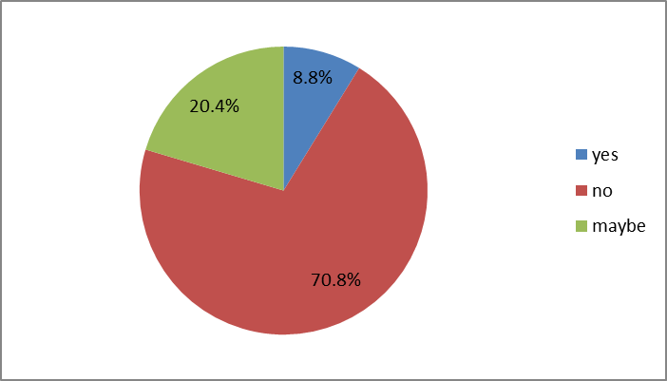
Figure 1 Perceived utilization of tourist opportunities
The results show that the percentage of respondents who think that tourism opportunities are not used at all is really high, and when we add to that percentage the number of respondents who think that tourism opportunities are not used enough, it is concluded that there is opportunity to undertake countless activities in order to take advantage of the tourist opportunities and to enrich the tourist offer.
Figure 2 shows how tourists assess the attractiveness of the space in various tourist destinations in Macedonia.
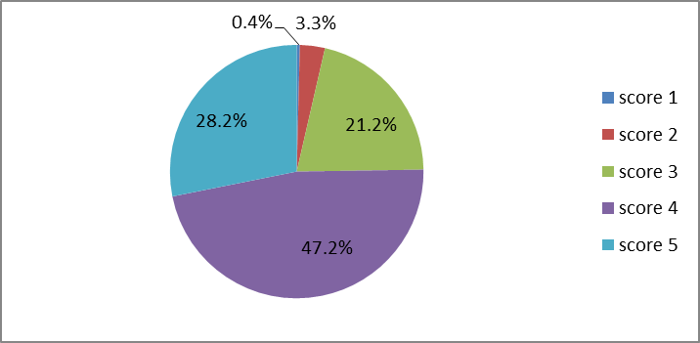
Figure 2 The attractiveness of the space where tourists stay
The results presented in the graph show that there is a large percentage of respondents who rated the attractiveness of the space with a score of 5 and a score of 4, which means that there are huge opportunities to undertake various activities that will contribute to the development of tourism and improve the position of the destination on the market.

The market as a factor for valorization of tourist resources
When the tourist market is treated as a factor for valorization of tourist resources, it can be considered locally, regionally, nationally, internationally and globally. Namely, the local market covers the excursion movements, and the world market refers to the resources that have world value, such as Paris, London, Madrid, Rome, New York, the Alps, the Mediterranean, etc. In both the local and the world market the services can be of the highest category, which means that the prices should be equal. Unlike the classic product, the product of the tourist destination, if one strives to reach the world demand, must take into account the impact of the resources on the quality, but also on the price. With increasing of the spatial distance of certain areas or segments of demand the prices of services in tourist areas increase too (due to the cost of transporting customers).
If the place of the offer is closer and more attractive, then the arrival of potential tourists is more probable, which means that the geographical location of the tourist destination and its traffic connection with the initiative spheres is of great importance. The market value of the offer, i.e. the tourist resources is directly related to the attractiveness of the resources, and inversely related to the distance to the consumer centres (tourist areas). (Angelevska-Najdeska, 2009))
When researching the tourist market, one usually comes across data that can dimension the shape and structure of demand. The tourist season as a distinct market category directly covers the supply and demand, which emphasizes the need for their combined study.
Given the fact that tourist consumers as a specific type of consumers use the resources and services that are part of the destination offer, it is logical that in market research first should be investigated the volume and structure of the offer. In that way the demand of potential tourists can also be influenced or modified. This is even more important when it comes to attractive elements that, if valorized, can be included in the tourist offer, and with the necessary investment of labour and funds should participate in the completion of certain services.(Angelevska-Najdeska, 2017)
For that purpose, the research emphasized the priorities for tourism development. Graph 3 presents the results.
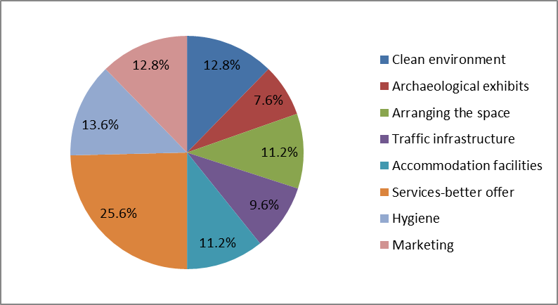
Figure 3Tourism development priorities
Figure 3 shows that the greatest attention should be paid to services, because the largest percentage of respondents believes that they are the most important for intensifying tourism development. Therefore, all activities should be taken in order to increase the range of services included in the tourist product of the destination, because it affects the increase of the quality of the tourist product on the one hand, which in turn affects the attraction of tourists and encouraging the development of tourism, on the other hand.

Impact of geographical elements and space on the formation of tourist supply and demand
The length of the road and the time spent on the trip influence the decision in which parts of the receptive zone the tourists will move. When forming the tourist demand, the attractiveness of the resources of the receptive countries or regions should first be determined and evaluated. The attractiveness increases with the improvement of the accessibility to a certain destination on the one hand, and on the other hand with the modernization of the means of transport, which in turn affects the reduction of the travel time, but also the extension of the residence time. (Milenković, 2003)
The value of the resources affects the spatial approximation or distancing of supply and demand. For example, depending on whether we are talking about international or domestic resources, we can mention the example of Disneyland, which attracts people from all over the world, and some local attractions, i.e. resources, such as the event in the village of Dolneni, or the monastery of St. Jovan Pretecha in the village of Slepche-DemirHisar, attract only the local population.
The spatial distance of supply and demand is the distance between the emitting and receptive areas. When making efforts to reduce that gap between supply and demand, the minimum travel time must be taken into account, as this is often a decisive factor in choosing a destination. The maximum time of the tourist trip is the time of departure, the trip, the optimal rest and the complete acquaintance and experience of the receptive space.
The Republic of Macedonia is a crossroad in the Balkans and is accessible by almost all means of transport, except maritime traffic. This is important because tourists make decisions based on the lowest costs (length of road, type of vehicle, length of travel, strength of attractiveness of the destination). Tourist destinations that are closer to the emitting countries have a greater attractive force than the distant ones. Macedonia is relatively close to the emitting areas, but does not have an adequate level of quality of the other conditions that are important for successful tourism development (economic development, unstable political system, level of tourist service ability). The traffic connection with the most attractive and most important tourist resources is very bad, which is one a reason more for reducing the quality of the offer. On the other hand, having in mind the fact that we should look for potential foreign tourists at a distance of about a hundred kilometres from our country, which means to consider a closer environment and neighbourhood as a potential market, we have more opportunities for different regions in the country. For example, tourists from Kosovo were very frequent this year in PopovaSapka, at Kozuv tourists from Bulgaria and Greece, in Krushevo and Pelister tourists from Albania and Greece. This information is of great importance, on one hand for directing research to tourist demand, and on the other hand for creating the tourist offer.(Angelevska-Najdeska, 2009)
Potential tourists, at the moment when they have to make a decision to choose a certain destination, often feel certain psychological constraints, as a result of the distance of the receptive countries, the unavailability and the limited choice of means of transport. These are factors that have a discouraging effect on travel decisions for those destinations. A discouraging factor is also the length of time it takes to get to that destination, as they do not want to spend part of their free time on a long trip to the desired destination. This can only be mitigated by the extremely high attractiveness of receptive areas. The high cost of travel, as a result of the length of the travel that entails additional costs for food, accommodation, fuel i.e., have also a negative impact on decision-making. Certain activities can be undertaken in order to minimize the negatives, like organizing travels that take less time, or by increasing the quality of all accompanying road conditions.
If the spatial distribution of supply and demand is of a broken nature, i.e. if the tourist resources of the destination on the one hand, and the emission centres on the other hand, are distributed in an area with a larger radius, then the costs of transporting tourists increases, which certainly has an impact on the choice of destination.
Try to provide good quality figures, as you would wish them to look when published. Do not use embedded vector graphics because of possible side effects. Use raster graphics in a resolution not less than 300 dpi. Try to balance the figure size according to information you are trying to present to reader. Allow a small percentage of figure resizing for the sake of typesetting.

Conclusion
The complexity of the tourist needs, which is manifested in each individual as a need for a certain combination of basic and additional services, must be satisfied with a complex tourist product, i.e. an offer that implies temporal and spatial synchronization of attractive, communicative and receptive factors. These factors indicate a wide range of numerous elements that tourists expect to have at their disposal, so that with their choice and consumption they can achieve personal satisfaction.
Given the fact that tourist consumers as a specific type of consumers use the resources and services in the tourist destination that are part of the offer of the destination, it is logical that in market research should first understand the volume and structure of the offer and thus can influence the modification of the demand of potential tourists.
This is even more important when it comes to attractive elements that if valorized can be included in the tourist offer, and with the necessary investment of labour and funds should participate in the completion of certain services. When researching and analysing the tourist supply and demand as integral components of the market, special emphasis is placed on the attractive elements - resources, services, but also prices.

References
Angelevska-Najdeska, K. (2006). An attempt to re-actualize Ohrid as a tourist destination-International Scientific Symposium: Tourism and the hotel industry, Opatija, Croatia.
Angelevska-Najdeska, K. (2006). Marketing management of the tourist destination as a way for its successful development - International Scientific Symposium: Contemporary Trends in Tourism, Hospitality and Gastronomy, Novi Sad, Serbia.
Angelevska-Najdeska, K. (2008). Management of the catering product life cycle as a condition for better competition priority on the tourist market, New trends in tourism and hospitality management, Opatija, Croatia
Angelevska-Najdeska, K. (2009). Valorization and management of tourist resources in function of sustainable tourism development in the Republic of Macedonia.[Unpublished doctoral dissertation. University KlimentOhridski, Bitola, Faculty of Tourism and Hospitality, Ohrid, Macedonia.
Angelevska-Najdeska, K. (2012). Rural tourism as a significant factor for tourism development in the Republic of Macedonia-(co-authored)- International Scientific Symposium: "Rural tourism: Experience, problems, prospects", Saint-Petersburg, Russia.
Angelevska-Najdeska, K. (2017): Tourist resources valorisation through the market mechanism- International Scientific Symposium: The 6th international conference on tourism and sustainable development, Timisoara, Romania
Bakić, O. (2002): Marketing management of a tourist destination, Faculty of Economics in Belgrade, CID, Belgrade, Serbia.
Bakić, O. (2003): Marketing in Tourism. Faculty of Economics in Belgrade, CID, Belgrade, Serbia.
Jovičić, D.,&Ivanović, V. (2006). Tourism and Sustainable Development in Europe: Current Situation and Perspectives, 18th Biennial International Congress, Opatija, Croatia.
Kobašić, A., Senečić, J. (1989): Marketing in tourism. Školskaknjiga, Zagreb
Lancaster, G., Massingham, L., (1997): Menadžment u marketingu, (prevod). Grmeč, Beograd.
Marković, S.,&Marković, Z. (1972).Economics of tourism.Školskaknjiga, Zagreb.
Milenković, S. (1999).Tourist activity in the market economy.VukKaradžić, Paraćin
Milenković, S. (2003), Eko-turizamkaopokretačkasnagarazvojapojedinihprostora, Međunarodninarodnisimpozium, Ruralniturizam i održivirazvojBalkana, Kragujevac.
Milisavljević, M., (1998).Marketing.Megatrend, Beograd.

