**Corruption impact on mitigation of the brain drain pressure and national economy competitiveness**

Anastas Dzurovski, Associate Professor, Faculty of law, University “St. Clemens of Ohrid”, Bitola, Macedonia

During the past four decades, the Macedonian economy has experienced fundamental changes influenced by the increasing emigration and in particular of the highly skilled workers’ emigration. Globalizing forces have reduced barriers to labor mobility across countries and economies especially for highly skilled workers. During the last few decades there has been an increase in the importance of the ‘knowledge economy’ and thus the demand for such category of workers. There is a wide consensus that impact of such a trend for developing economies is predominantly negative and multidimensional: from losing one of the major production factors through non-refundable costs for the national economy incurred during the education process of the emigrating workers to pressure on local wages increase. Combination of these factors has urged for the need of brain drain policy for workers that are motivated to emigrate. Paper will focus on corruption as a trigger for higher brain drain rates and will analyze possible outcome strategies. In particular paper will analyze the extent of which anticorruption measures can positively impact decrease of the brain drain are policies in such sector good or simply high gap among the salaries between the emigration economy and immigration economy are irreversible motivation to leave the country.

1. Corruption effects on the migration

Usually the traditional migration literature emphasizes income differentials between source and destination countries as the most important driver of migration, more recent empirical studies have shown that socio-economic and institutional conditions such as underdevelopment, demographic pressures, political instability and terrorism are also highly important push factors of international migration (e.g., [Dreher et al., 2011](http://dx.doi.org/10.1016/j.econlet.2011.05.044); Docquier and Rapoport, 2012). Corruption, as another form of institutional deficiency is intended to have a similar effect on migration. What is more, it may be particularly important to the migration decision of highly-skilled workers, i.e., it may be an important root cause of international “brain drain”.

Corruption negatively impacts the quality of and the return to education. For instance, by impairing economic growth and increasing the probability of becoming unemployed corruption reduces the workers’ expected return to human capital. Given the irreversibility of human capital investment, corruption may make it more attractive to use Hirschman’s “exit” option and migrate to another—less corrupt—country to recoup one’s individual education investment. This relationship between corruption and migration is likely to be particularly relevant to skilled workers. High skilled workers ought to be especially responsive to the prevalence of corruption because of their (irreversibly) high level of human capital investment and subsequent need for particularly high skill premiums.

While tackling on brain drain no one can confim that same cannot be mitigated through the quality of the higher educaton process. Among the else there are at least two ways that we can research on : 1. Direct emigration due the the lower quality education in the native country and direct impact of education (all three main pillars) on the economy competitiveness.

1. **Corruption in public higher education a perception or reality ?**

It has been stated that corruption affects three major aspects of education: access, equity and quality (Heyneman, 2004, 2008, 2009). Corruption in higher education hinders all three goals. The reforms that are officially still ongoing in Macedonia have made a significant contribution to fighting corruption. These reforms include: 1) access through the introduction of unified entrance critera and equity in access by assisting the financing of various ethnic minority and low-SES students through the establishment of governmental grants; 2) quality through the accreditation of higher education institutions and 3) efficiency through the restructuring of academic and administrative staff.

Corruption in higher education is difficult to define. What is considered to be corrupt behavior by some, may be considered acceptable or normal by others. For instance, insisting that a student‟s opinion mirror that of a professor is considered corrupt by some, but others consider that to be normal. What might be perceived as favoritism or nepotism in one culture might be considered as supporting family, relational or friendship ties in another. Nevertheless, certain cases from any single country might provide an example for consideration of corruption issues for other countries or regions.

Scholarly literature on corruption in higher education is relatively scarce in any country due to the specific nature of the topic.

I have undertaken the survey within the statistical sample of 100 students and 100 parents of students studying at public universities in Bitola, Skopje and Stip asking them to answer about their perception of the higher education corruption in Macedonia. The answers are :

Graph 1- Is there a corruption in higher education in Macedonia

Source: Author’s survey

Graph 2- Do you find hard to understand due to unrecognizable by you procedures within the higher education entrance procedure

Source: Author’s survey

Graph 3 Do you have personal experience of somebody within the higher education institution to ask you for a bribe or other kind of service?

Source: Author’s survey

Graph 4 : Do you have find process of passing the exams transparent enough?

Source: Author’s survey

Graph 5 : Do you think that process of employment at university is transparent enough ?

Source: Author’s survey

In accordance with the previous questions can be concluded that students and their parents traditionally think that there is a corruption on the (public) universities but only small part have direct experience on it. On the opposite they think that the university promotion process has been quite corrupted which implies that quality that they receive can be disputed.

It is obvious that perception can be and must be changed of course if corruption within higher education in public universities doesn’t take place at all. Because citizens can be whistle-blowers, they are instrumental in the fight against corruption. Disseminating knowledge and raising awareness of measures to prevent corrupt behaviour is thus a critical element in the fight against corruption. Governments can boost public awareness through campaigns and seminars or by disseminating literature and publishing reports to educate the public on ways to avoid getting involved in bribery and on the negative effects of corruption on society. In addition, the introduction of effective legal protection for whistleblowers is considered “an essential element for safeguarding the public interest, promoting a culture of public accountability and […] is proving crucial in the reporting of misconduct, fraud and corruption” (OECD,2015b). To date, Macedonia have adopted a whistleblower protection law.2 The Public Awareness Sub-Dimension assesses the economies’ policies for raising awareness and understanding of corruption. It does so through a single qualitative indicator, awareness raising. As the economies seek to attack corruption at the source, public perception and awareness-raising activities may be considered a vital component in their overall.

**3.Correlation between the corruption and brain drain in SEE countries**

Corruption significantly increases the brain-drain. Corrupt societies which channel access through patronage and corruption therefore discourage meritocracy and encourage talented people to seek recognition elsewhere. The association is highly significant, controlling for development at the level of the EU-27. That is particularly revealing considering that the EU is a common labor market. Apart from language barriers there are few obstacles to internal migration in the European Union, and seeing that some new member countries from Eastern Europe have a highly educated population but high levels of favoritism and corruption, the brain-drain is a major threat to their economic recovery. The risk is faced not only by Romania, Lithuania, Latvia and Bulgaria, but by Italy and Greece too.

Graph 6 : Corruption and brain drain within the EU 27 countries.

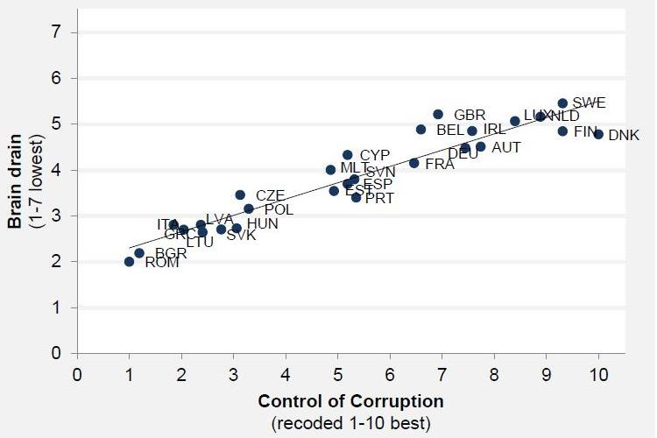

Data source: World Economic Forum, “Global Competitiveness Report 2010-2011”

Another respectable survey finds strong correlation among the corruption as well as brain drain within the EU countries. Hence it is quite obvious that Macedonia even within high economic development of the

Table 1 : Persons correlations between control of corruption and selected consequences including the brain drain

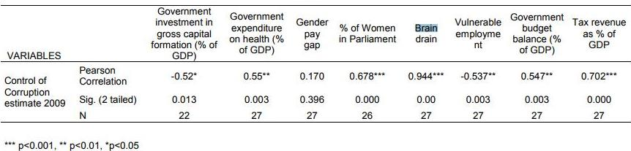

The good the bad and the ugly, controlling the corruption within the European union, Alina Mungiu Pipppidi, Hertie School of Governance, 2013

There are very few data on the migrant workers from Macedonia and in particular highly educated and skilled migrant workers. Hence precise conclusions on Macedonian case cannot be made about the extent of the brain drain. Still there are some reports that can show the level of the brain drain issue.

Graph 7: Impact of brain drain on the skilled workers shortage



Source : Emigration and its economic impact on Eastern Europe, IMF 2016

Graph 8 : Emigration of skilled workers from SEE Countries by level of education



Source : Emigration and its economic impact on Eastern Europe, IMF 2016

As shown above as of 2010, the share of emigrants from the Czech Republic, Hungary, Latvia, and Poland with tertiary education was well above the equivalent ratio in the general population (Graph 7) and has been increasing over time. For Croatia and Romania, which have already low shares of people with tertiary education in the population, the *brain drain* from emigration may have had particularly important implications for productivity. As discussed later, the prevalence of better-educated and working-age people among emigrants leaving CESEE countries has significantly reduced the supply of skilled labor and contributed to fiscal burdens arising from the higher dependency ratio.

Strong educational performance cannot be expected without sufficient resources and reforms. The main input indicator for measuring government funding of educational institutions is annual expenditure on education as a percentage of GDP. Countries invest in education to foster economic growth, enhance productivity, contribute to people’s personal and social development, and reduce social inequality. EU spends 5.3% of GDP on education and OECD countries 6.1%. The figure is lower in Serbia and fell further in 2011 to 4.8%. As for Albania, expenditure on education is even less at 3.3 % of GDP as well as below 4% for Macedonia (National Statistics Offices and Eurostat data).

**Economic growth and brain drain in Macedonia**

High rates of emigration abroad, particularly in the last four decades, is having quite negative implications on the population growth and on the demographic and socio-economic structure of the population in the country. More than one fourth (26.5%) of the total population is abroad, the implications on the total and on the natural population increase are obvious. Macedonian emigration abroad in the last two decades, (approximated at about 200,000 persons or about 10% of the total population), has a direct influence on the absolute population increase. In the period 1994-2002 the natural population decreased by 20,960 persons, as a consequence of emigration. In the same time, population development was accompanied by intensified process of demographic ageing. In the period 1994-2010, according to the more segmented demographic ageing classification25 (with seven stages), the population in the country crossed from demographic old-age threshold (fourth stage) to demographic old-age (fifth stage). This is a big change that took place in a relatively short period. The intensified process of demographic ageing could be confirmed by age dependency ratios of the young and of old population. In the same period the age dependency ratios of young population decreased from 37.4% (1994) to 24.6% (2010), while the age dependency ratios of old population increased from 12.7% and 16.5%. Usually ceonomic growths as well as competitiveness policies are based on highly educated and highly skilled workers in productive age and thus brain drain as well as emigration at all is the major inheriting factor for the competiveness policy of Macedonia even when there is a expansive part of the economic cycle.

**Meritocracy as a path towards brain drain mitigation**

It is not enough to build research institutes and engage the diaspora. Although there are different sets of measures that are to be promoted in relation with brain drain, meritocracy is one of the most interesting concepts that can be even within the short term suitable for the national public governance and overall country management system. A merit based system has to be implemented. Talented individuals, naturally, seek a quite recognizable meritocratic system which embodies fair and equal chances for everyone to achieve success on their own capabilities, and completely ignores gender , age, race or political differences. Meritocracy would allow talented Macedonians to attain success based on their own merits and will help address “social injustice”, one of the mostly documented reasons by the World Bank for underdeveloped countries high-skilled emigration (World Bank, 2013). Implementing a merit-based system would also remove the need to rely on connections and corruption; and would incentivise individuals to fulfil their potentials through fierce competition (Jomo 2004).

**Conclusion**

.

Macedonia is indeed affected by the emigration of their educated population to mainly more developed countries in Europe. Yet the brain drain has created specific shortages in the labor market, like in the field of medicine, science and research and IT. The main factor, regardless of the occupation of the emigrants that motivates people to emigrate is the significant wage differential between Eastern Europe and other more developed countries. In addition, prestige of the working place, access to the latest technology and research are also great influences. Accession to the European Union through Bulgarian passports increased the emigration rates.

Since education is essential for a knowledge-based country, it is of great importance for Macedonia to preserve their skilled manpower in order not to challenge future unsuccessful

development. Therefore, the country need to keep the pace with the rest of Europe, future research about the causes of the emigration from these countries and possible appropriate policies to prevent the brain drain is necessary. Two concepts that are to be fully implemented and closely monitored are fighting the corruption and/or corruption perception in the higher education through transparency increase as well as implementation of the meritocracy system at all the country governance levels.

**References :**

1. Dimant, E., Krieger, T. and Meierrieks, D. (2013): The effect of corruption on migration, 1985-2000. Applied Economics Letters 20, 1270-1274;
2. Dreher, A., Krieger, T. and Meierrieks, D. (2011). Hit and (they will) run: The impact of terrorism on migration. Economic Letters 113, 42-46;
3. Docquier, F., Rapoport, H. (2012). Globalization, brain drain, and development. Journal of Economic Literature 50, 681-730;
4. Jomo K. S. “The New Economic Policy and Inter-ethnic Relations in Malaysia”, Identities, Conflict and Cohesion Programme Paper Number 7, United Nations Research Institute for Social Development, Geneva, September 2004 (22pp + vii). Reprinted in Joshua Castellino [ed.] (2011). Global Minority Rights. Ashgate, Farnham, UK;
5. Emigration and its economic impact on Eastern Europe, IMF 2016;
6. The good the bad and the ugly, controlling the corruption within the European union, Alina Mungiu Pipppidi, Hertie School of Governance, 2013;
7. World Economic Forum, “Global Competitiveness Report 2010-2011”;
8. World Bank , Worldwide governance indicators, 1996-2011.