Карактеристике мобилности становника у руралним подручјима
Characteristics of the mobility of the inhabitants in rural areas
Vaska Atanasova, Marija Stojanoska
Faculty of Technical Sciences, University “St. Kliment Ohridski”, Bitola, Macedonia,
Faculty of Technical Sciences, University “St. Kliment Ohridski”, Bitola, Macedonia,

АПСТРАКТ

Мобилност обликује идентитет људи и њихов свакодневни живот. Једно од основних људских права је право кретања. Транспорт гарантује нашу мобилност и обезбеђује приступ роби и услугама. Мобилност је такође инхерентно географске природе, не само у смислу да кретања људи и објеката превазилазе простор, већ и да свеприсутност мобилности у друштву поставља важна питања о постојаности места боравка. Мање пажње је посвећено мобилности у руралним срединама. У овом раду биће разматрана мобилност становника из руралних подручја у Битољу. Узимајући у обзир различите домете кретања ван руралног подручја, потешкоће повезане са дневним потребама мобилности, као и недостатак јавног градског превоза.
Кључне речи: руралне средине, мобилност, проблеми

ABSTRACT

Mobility shapes the identity and everyday life of people. One of the fundamental human rights is the right to movement. Transport ensures our mobility and provides access to goods and services. Mobility is also inherently geographical in nature, not only in the sense that the movements of people and objects transcend space, but that the ubiquity of mobility in society raises important questions about the permanence of residence. Less attention has been paid to rural mobility. In this paper, the mobility of rural residents in Bitola will be discussed. Considering the different ranges of movement outside the rural area, the difficulties related to the daily mobility needs, as well as the lack of public urban transport.
Keywords: rural areas, mobility, problems

Introduction

Mobility has long been a critical factor in driving rural development. However, low-density areas and urban centres show a significant mobility gap. While cities are implementing a wide range of transportation options to cater to diverse user groups, adapting these solutions to rural areas presents challenges. Rural mobility is essential for fostering economic growth, improving social equity, and achieving climate goals, ensuring that rural communities are interconnected and resilient in an increasingly urbanised landscape. Rural areas are smaller settlements that differ from cities in their physiognomy, function, demographic structure of the population, and their significance. Bitola is a city in the southwestern part of North Macedonia. As of the last census, 85,164 inhabitants lived in Bitola. The city is located at the northeastern foot of Mount Baba, on which the highest peak Pelister is located, which is the third highest peak in Macedonia. This paper will analyse the mobility, the problems faced by the population living in the rural areas below Pelister, that is, the villages of Lavci and Brusnik.

General data for the city of Bitola

A city is an environment where people live, work, get educated, hang out, have fun, use various services. Bitola is a city that has developed road and rail transport. It also has public city transportation, whose lines are circular. Although the public city transport in Bitola was analysed in previous papers, we can say that the citizens are not satisfied with the current services offered by the public transport. The lines do not cover the entire area of the city, they do not move according to an exact and predetermined timetable, the vehicles are old, they are delayed. The municipality also includes 64 villages: Gjavato (Bitolsko), Bareshani, Bistrica (Bitolsko), Bratin Dol, Brusnik (Bitolsko), Bukovo, Velushina, Gabalavci, Gopeš, Gorno Egri, Graeshnica, Dihovo, Dolenci, Dolno Egri, Dolno Orizari, Dragarino, Dragožani, Dragosh, Drevenik, Zabeni, Zlokućani, Kazani, Kanino, Karamani, Kishava, Kravari, Kremenica, Krklino, Krstoar, Kukurechani, Lavci, Lažets, Lera, Lisolaj, Logovardi, Lopatitsa, Magarevo, Malovishte, Metimir, Medjitlia, Nizhepole, Novo Zmirnovo, Oblakovo, Oleveni, Optichari, Orehovo, Ostrec, Poeshevo, Porodin, Ramna, Rashtani (Bitolsko), Rotino, Swineherd, Axed, Snowy, Sredno Egri, Srpci, Staro Zmirnovo, Streževo, Trn, Trnovo, Capari, Crnobuki, Crnovec. As city citizens can satisfy their mobility needs in some way, be it by public transport, car, short distances and by bicycle and walking, this is not the case for the rural dwellers. That is why we will briefly describe two of the 64 villages that are the subject of analysis.

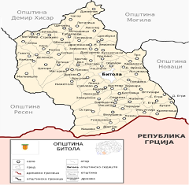

Figure 1. Municipality of Bitola with included villages

Lavci village – Municipality of Bitola

Lavci village is located near Bitola city, with tendency to quickly become a suburb of the city, due to rapid expansion of Bitola in that direction. Any place on the territory of the municipality of Bitola, taking into account the group of sub-Pelister villages on Mount Baba, whose territory rises into the mountain. Lavci is located in the southwestern part of the Bitola Plain, not far from the city of Bitola. There is an asphalt road leading to the village, which starts near the Bitola hospital. Between the village and the city, many new buildings have been erected in recent years, so it can be considered that Lavci would almost become a Bitola suburb. The village has a compact type and is divided into four neighbourhoods, Dolno, Gorno, Trajanovsko and Belkosko Maalo. The neighbourhoods are not significantly distant from each other. The village is 3.9 km away and according to the latest census, it has 291 inhabitants.

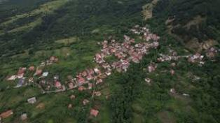

Figure 2. Lavci village – Municipality of Bitola

Brusnik village – Municipality of Bitola

Brusnik is a village in the Municipality of Bitola, located 5 km from Bitola city center. According to the legend, Brusnik was formed from the families of the neighbouring villages Lavci and Dihovo. The village is located in the central part of the territory of the Municipality of Bitola, belonging to the group of sub-Pelister villages on the Baba Mountain. Brusnik is located west of the city of Bitola, thus belonging to its rural zone. The village is located on the right side of the Dragor river. The village of Brusnik is an excellent destination for walks and cycling excursions, throughout the year and what is particularly impressive is the picturesque nature, the beautiful traditional architecture and the beautiful panoramas towards Bitola and Pelagonija. An asphalt road leads to the village, which passes through the Bitola Brusnichka settlement. Many holiday homes have been built between the village and the settlement in recent years. The village has a dense type and is divided into three neighbourhoods, Dolno, Sredno and Sop Maalo. The neighbourhoods are not significantly far from each other. Furthermore, the same are divided into smaller gender groups of houses. According to the latest census the village of Brusnik has 190 inhabitants.

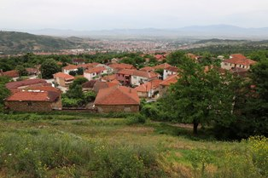
Figure 3. Brusnik village – Municipality of Bitola
Conducted research - a survey in the villages of Lavci and Brusnik

On 20.12.2024, a survey was conducted of the population in the rural areas of Lavci and Brusnik. The survey consisted of several questions, namely: gender, age, occupation, level of education, number of family members, monthly income, total number of employees in the family, number of members who travel outside the city for work, school, which means of transportation they use, what means of transportation they own, how many cars they own, motive for traveling to the city, if they had transportation on call, would they use it, how often do they travel in the city, do they have access to public city transportation services, what is the quality of the road network, are they satisfied with the mobility, if not what is the reason, problems, shortcomings, proposed solutions to improve the mobility.

From the rural area of Lavci, 73% of the respondents were female, while from Brusnik 53% were female.

In terms of gender, we had under 18, from 18 - 36, from 36 - 65 and over 65. From the village of Lavci, most of the respondents were people aged 36-65, 53% and 47% over 65 years of age. While from the village of Brusnik 53% are over 65 years old, 27% from 35-65 years old and 20% 18-36 years old.

When asked what they do from the village of Lavci, 53% of the respondents are retired, 34% unemployed and 13% employed. While from Brusnik, 60% are pensioners, 33% are employed and 7% are students.

When it comes to the level of education, we can conclude that 53% of the residents of Lavci have a secondary education, 33% primary education and 7% higher and higher education. While from Brusnik 80% secondary and 20% elementary education.

According to the number of members, in Lavci 34% have two members in the family, 20% have one member, and 13% each have three/four/six members. The situation is similar in the village of Brusnik, 40% have two members and 20% have three members.

47% of the population in Lavci and 73% of Brusnik earn a monthly income of 30-50,000 denars.
When it comes to the number of employees, the number of unemployed people in the village of Lavci is worrisome, namely 53% of the family none are employed, 10% ie 20% one or two of the family, while from Brusnik 33% neither one or two are employed, one family member 27%.

A large number of those surveyed do not have students in their family, to answer the question of what means of transport they use to get to school, while those who answered that it is mostly a car and 20% of public transport.

87% of the residents of Lavci, and 71% of the residents of Brusnik, travel to the city by car. The motive for traveling is mostly for shopping, 43%, health 34%. From the village of Brusnik, most people travel for the purpose of shopping, 26%, healthcare 20%, visiting and similar with a smaller percentage.

As we have seen before, most of the trips to the city are made by the residents by car, and when asked what means of transport you own from the village of Lavci - 87% car, 13% have no means of transport, while from Brusnik 68% car, 16% motorbike, 11% have no means of transport. While 73% of residents from Lavci and 60% from Brusnik own one car.

Since many of the population do not own any means of transport, when asked if a minibus was introduced on call, would they use it, 73% of Lavci would use it, 47% of Brusnik, 40% maybe.

Most often, the residents of Lavci travel once a day to the city, 27%, three or more times a day 20%, twice a week 20%. While from Brusnik, 20% of the residents travel once a day and once a week.

The residents of Lavci and Brusnik are not satisfied with the mobility they have towards the city, the reasons are many: not having a driver's license, health problems, low income, mostly bad infrastructure.

Chart 1. Reasons for which they are not satisfied with mobility to the city
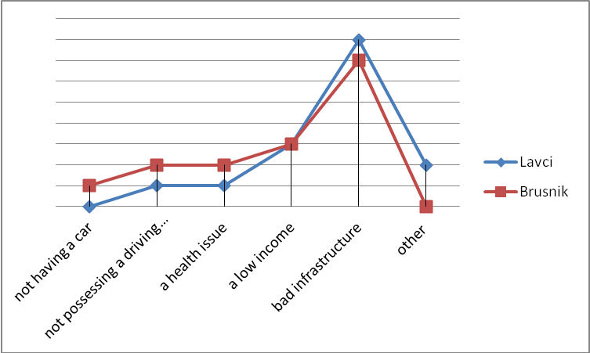

Residents of the rural areas of Lavci and Brusnik do not have access to the services of public city transportation, that is, although they are located at a short distance from the city, the lines do not cover these areas. When asked whether you have access to the services of public city transport, 100% of residents answered no.

Chart 2. What is the quality of the road network in rural areas

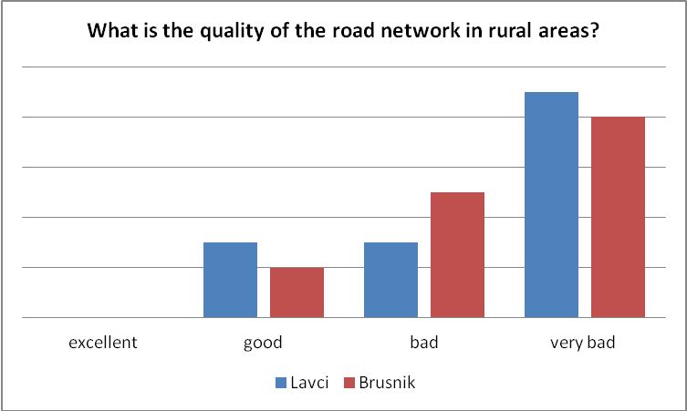

The residents of Lavci and Brusnik see the way out of this dissatisfaction in higher employment and income growth.

Chart 3. What activities should be undertaken in order to raise the standard of living of citizens and enable a better quality of life

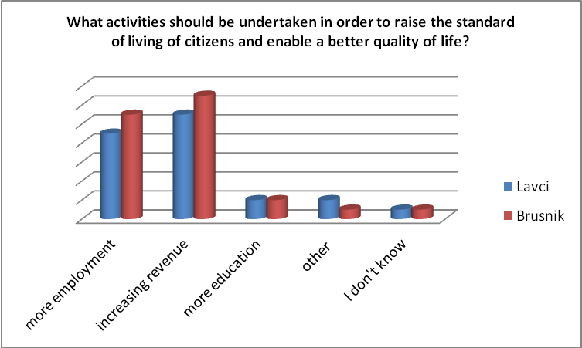

Problems that the residents of Lavci and Brusnik are facing

- There is no public city transport;
- Hard to reach places;
- Dirt roads;
- There is no bus for students.

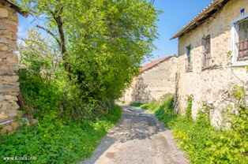

Figure 4. A picture of the poor infrastructure in the village of Brusnik

Proposal of solutions to improve living conditions and mobility in Lavci and Brusnik

- Introducing regular public city transportation;
- Introduction of school transportation, which will be for students only;
- To improve the road network, to asphalt all streets;
- Introduction of on-call public transportation;
- Higher population employment.

Mobility of the population towards the city of Bitola

From the conducted survey it can be concluded that the residents of Lavci and Brusnik most often travel to zone 2 which is closer to them and has shops, institutions, zone 8 where the hospital is, and zone 1 the central city area.

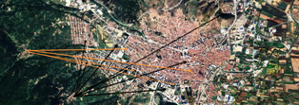

Figure 5. Mobility of the population towards the city of Bitola

Conclusion

In this paper, the subject of analysis were two rural areas in the immediate vicinity of the city of Bitola. We are talking about the rural area of Lavci, which is about 3 km away from Bitola, and Brusnik, which is about 5 km away. Bitola is a developed city with good road and railway, public city traffic is transport but not to a great extent. The rural areas although close to the urban city, forgotten by the institutions of the inhabitants are flooded with a number of problems from infrastructural to not being able to do any transportation to meet the mobility needs. From the statistical analysis, it can be said that these areas are not so populated, it is all due to the migration of the population from the countryside to the city and outside the country. There are only about 200 residents left, mostly pensioners, with one member in the family, they don't own a car, while those who do have one, and the most common reason for traveling to the city is to buy groceries or go to the doctor. They live in very difficult conditions in inaccessible terrain to their homes, there is asphalt only in the center of the village. Poor infrastructure is an obstacle to satisfying the need for mobility. Although is a small number of residents, but if offer a public transport line, it will make the movement of the population bigger. The apparent mobility gap and the digital divide perpetuate a persistent car dependency in rural regions. However, many people living in rural areas cannot drive or do not own cars, especially those belonging to vulnerable sectors of the population. Consequently, mobility in rural areas often becomes a self-perpetuating cycle where low accessibility generates greater demand for mobility, turning mobility into a source of new inequalities that feed the vicious circle of rural mobility.

References

- https://mk.wikipedia.org/
- https://www.interregeurope.eu/
- https://factual-consulting.com/rural-mobility-challenges-opportunities
- https://en.wikivoyage.org/wiki/Bitola
- https://bitola.info/mk/pelister-nacionalen-park/
- https://bitola.info/?s=lavci
- https://bitola.info/brusnik-village/
- https://bitola.info/mk/selo-brusnik/
- https://earth.google.com
- https://www.ifad.org
- https://eprints.uklo.edu.mk/id/eprint/10083/
- https://zenodo.org/records/14420466
- https://www.researchgate.net/publication/381421352_Mobility_Analysis_of_the_Peripheral_Traffic_Zones_of_the_City_of_Bitola?_tp=eyJjb250ZXh0Ijp7InBhZ2UiOiJzY2llbnRpZmljQ29udHJpYnV0aW9ucyIsInByZXZpb3VzUGFnZSI6bnVsbCwic3ViUGFnZSI6bnVsbH19
- https://www.stat.gov.mk/publikacii/2020

