9th INTERNATIONAL CONFERENCE
’’TOWARDS A HUMANE CITY‘‘
Reshaping Mobility
Novi Sad 19th and 20thOctober 2023

Atanasova Vaska,PhD.¹
E-mail: vaska.atanasova@uklo.edu.mk
Stojanoska Marija,M.Sc.²
E-mail:marijastojanoska3112@gmail.com

Krstanoski Nikola,PhD.³
E-mail: nikola.krstanoski@uklo.edu.mk
¹ Faculty of Technical Sciences – University of St. Kliment Ohridski, Bitola, Macedonia,
Makedonska Falanga 37, 7000 Bitola
²Faculty of Technical Sciences – University of St. Kliment Ohridski, Bitola, Macedonia,
Makedonska Falanga 37, 7000 Bitola
³Faculty of Technical Sciences – University of St. Kliment Ohridski, Bitola, Macedonia,
Makedonska Falanga 37, 7000 Bitola

BUS RAPID TRANSIT, POSSIBILITY FOR APPLICATION

Key Words |  | Abstract
Rapid  Bus  Passengers  Application |  | Bus Rapid Transit (BRT) is a high-quality bus-based transit system that provides fast, convenient and cost-effective mobility services.BRT achieves this through dedicated bus lanes, fast and high-frequency service, and a focus on marketing and customer service. This is a bus-based public transportation system designed to improve capacity and reliability over a conventional bus system.BRT aims to combine the capacity and speed of the train with the flexibility, lower cost and simplicity of the bus system.Fully implemented BRT systems have been proven popular with developing countries as a public transport mode that can offer high quality service comparable with LRT or even metro at lower costs.  European cities are less enthusiastic in investing into BRT systems for several reasons. Many cites already have well-developed rail public transport modes such as metro, LRT and tram. These rail systems offer good quality of service, have long tradition of usage and are well known to public, unlike BRT which is relatively new concept and often perceived with suspicion. In addition, there are cases when implementation of BRT projects become subject of political confrontationsand battlefield of politicians. Such recent example is the city of Skopje where the newly elected major has stopped the BRT project despite the fact that project documentation and project financing has been already worked out.

1. INTRODUCTION

Transportation is an essential aspect of our daily lives, affecting our mood and well-being.People who use public transport to work are often happier than those who use their own vehicles, and it also reduces environmental pollution since a bus can transport 60 passengers and replaces 20-30 cars, which is economically justified.Public transport is available for use by the general public, unlike private transport, and operates on pre-defined schedules along established routes with a charge for the journey.Public transportation includes metro, tram, rapid bus systems and regional railways.Bus Rapid Transit (BRT, BRTS) is a bus-based public transit system designed to improve capacity and reliability over conventional bus systems.Introducing a system of fast bus transportation, which enables the integration of intelligent billing systems, systems for informing passengers in real time at stations, stands, as well as in the vehicles themselves, shorter travel time, greater safety and security, good accessibility, better comfort, the use of ecological vehicles with large capacity, lower transportation costs.
2. Bus Rapid Transit
Bus Rapid Transit (BRT, BRTS) is a system of mass passenger transportation by buses. The system generally has specialized design, services and infrastructure to improve the quality of the system and mitigate the typical causes of bus delays. It does this by providing dedicated lanes, with bus routes and stations, as well as collecting fares outside the bus.BRT (Bus Rapid Transport) has several benefits, including reduced congestion, air and greenhouse gas pollution, and improved service for people in developing countries. The main advantages of BRT (Bus Rapid Transport) compared to other MRT options are its significantly lower investment cost, while its main disadvantage is its demand for space in the city .^{[1]} In many cases, when BRT (Bus Rapid Transport) is built, the road space for private vehicles is reduced, as there may not be an opportunity to expand the total road space. With its dedicated lanes, accommodating service areas, technologically advanced stations and GPS tracking systems, bus lanes and bus priority at intersections where buses can interact with other traffic, along with design features are aimed at reduce delays caused by passengers getting on or off buses or paying for tickets. ^{[2]}
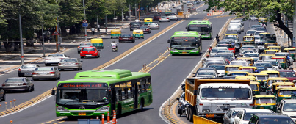
Figure 1. Bus rapid transit

- MAIN COMPONENTS OF BUS RAPID TRANSPORT
To have the application of the system for fast bus transport, we need defined routes for the movement of vehicles, adaptation of bus stops, an increase in the capacity of vehicles, services for passengers, the method of fare collection, real-time information, and the application of intelligent transport systems. These components provide us with a complete system for high-speed bus transport, which promises confidence and readiness to meet the demands of users.
3.1. Defining a vehicle movement route
Bus rapid transit lanes are the main feature, for economic reasons.The dedicated lane prevents delays of buses, ensuring greater safety and speed.^{[3][4]}
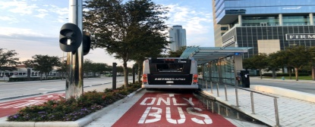
Figure 2.Physically separated route for bus rapid transport
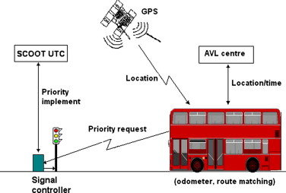
If the route passes through a traffic light intersection, priority is given to the vehicles of fast bus transport.Traffic light intersection priority techniques can generally be classified as "active" or "passive".^{[5][21]}

Figure 3.Priority of bus service at a signalized intersection
Figure 4 shows the route of high-speed bus transport that passes through a roundabout.^{[6]}
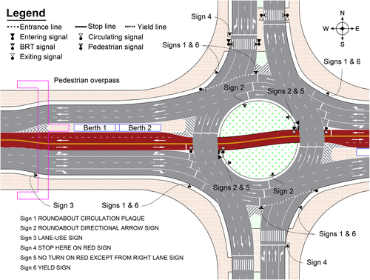
Figure 4. Bus rapid transit route through a roundabout
Exclusive bus lanes are the most impressive element of the BRT system.It is shown in figure 5.^{[7] [23]}
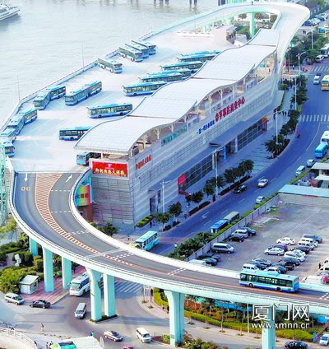
Figure 5. Elevated route for bus rapid transport

  - Adapted bus stops and stations
The most important safety feature is closed stations, regardless of whether the bus system uses outside or inside fare collection.The stands need to be well secured, lit, with urban equipment, greenery, to have enough space for all people, to have an area intended for individuals.^{[8][24]}
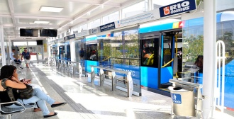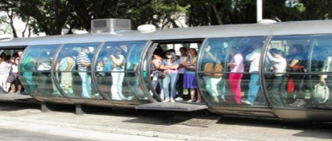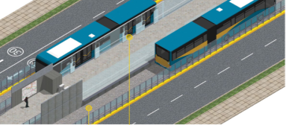
Figure 6.Bus stations and bus stops - protective fence, urban equipment

3.3.Increase in vehicle capacity
When it comes to the vehicles that will be used to transport passengers, it is essential that they accommodate more passengers than conventional bus lines, have doors on both sides, be uniquely branded and designed, electric and environmentally friendly.All over the world, articulated buses have proven to be the best option for BRT systems.Figure 7 shows a Mercedes Benz vehicle. ^{[9]}
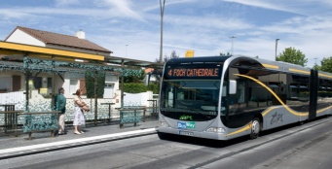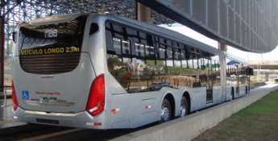
Figure 7. Vehicle for rapid bus transport
3.4 Billing system
Passengers should pay the ticket price at the station instead of on the bus, reducing the waiting time and traffic jam.BRT systems are flexible where an automatic, contactless ticketing system can operate, minimizing waiting time and the need for cash.^{[10] [25]}
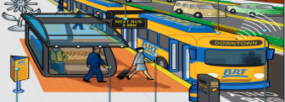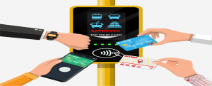
Figure 8. Billing system for bus rapid transport
3.5 Real time information
One essential element of Bus Rapid Transit (BRT) is real-time information communication.^{[11] [26]}
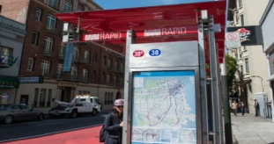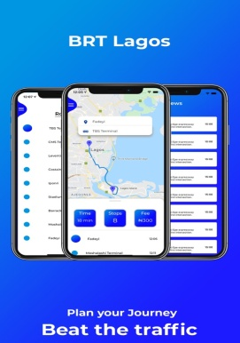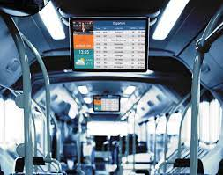
Figure 9. Real Time Information
3.6Intermodal connections and the application of intelligent transport systems
BRT lines are part of a public transport network with different modes of transport, generally well coordinated with each other.^{[12][13] [22]}
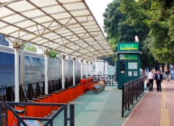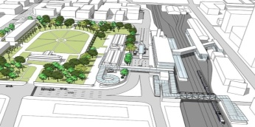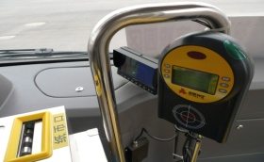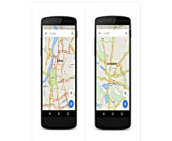
Figure 10.Intermodality between BRT, BRT and cycling, P&R system and intelligent transport system in BRT
- APPLICATION OF BUS RAPID TRANSPORT
BRT has emerged as successful public transport mode in the cities of South America during the last decades of the 20th century.Since, it has been accepted as cheaper alternative for providing higher quality of service in many, mostly developing countries, around the world. In these countries, the BRT has been recognized as public transport system that can match operational features of the LRT or even metro systems, but at considerably lower costs.
In Europe, the BRT systems are rare, often introduced with only one line in newer parts of the cities and without full features of the BRT, that is without implementation of closed type of stations(payment out of the vehicles at stations) and fully separated right-of-way over the entire length of the line.
There are several reasons for this situation. Firstly, most of the European cities have already well-developed rail public transport systems such as metro, LRT or tram systems. The rail transport systems have stronger image, long tradition and offer very good quality of service compared to the relatively new and unknown BRT systems.
Another obstacle for greater implementation of BRT in Europe is that often the public does not recognize the major operational features of BRT that makes it at least equal to LRT in terms of the service it provides. The general perception of the public seems to be that BRT is another bus system that is inferior to the features of the rail systems.
Also, there are several examples where the proposals for building BRT system has become battlefield of the confronting political parties. The political parties that oppose the introduction of BRT system use the fact that BRT is greatly unknown to the public, and overfloat the media with half-true and untrue arguments against BRT.
Such example can be found in case of Italian city of Rimini. Despite the BRT project documentation was finished in 2006 and was supported by the Italian government, the realization of the project took place between 2012 and 2017 due to long political battle and opposition form the politicians of the local government.^{[29]}
Most recent case of political battle for and against introduction of BRT can be found in the city of Skopje, North Macedonia.
Skopje is a city with about 600000 citizens. Its public transport system includes only buses that operate on congested streets without any measure to provide any type of priority for buses. Many surveys confirm that public transport in Skopje is perceived to offer bad quality of service: low commercial speed, low reliability in terms of keeping the timetables, lack of capacity on some lines, old vehicles without heating and cooling that are operated by private operators etc.
But the greatest deficiency of the transport system in Skopje is not related only to the problems of the existing bus public transport system. The size of Skopje in terms of population and area it covers, points to bigger system problem. Skopje definitely needs to introduce high-capacity, fast and ecological public transport modes, because the bus system itself is not enough to meet the increased need for higher quality public transport service.
The project for the introduction of rapid bus transport (BRT) in the City of Skopje included two lines with corridors reserved for rapid bus transport - Line 1 (east - west, from Gjorce Petrov through Centar to Novo Lisiche) with a length of 12.81 km and 21 bus stops, Line 2 from the northern station-BIH on Blvd.Kuzman JosifovskiPitu, with a length of 10.4 km with 20 bus stops.The two lines overlap in the Center.The travel time will be reduced by 50% from the current 70 minutes.A dedicated route for high-speed buses, which will be physically separated from the rest of the traffic, cuts the travel time in half, and the bus frequency of 3-4 minutes during peak traffic prevents the city congestion.The traffic priorities at intersections allows BRT buses to move without stopping through central city streets and boulevards.Frequency, accessibility, safety, comfort and speed are indicators of quality transport services that encourage citizens to use the public transport system instead of private vehicles.
Unfortunately, the BRT project documentation was finished just before the end of the mandate of the local government that supported the project, and during the campaign for the new local government elections, the BRT has found itself in the middle of political battle. The election was won by the BRT opposing political party, and the new mayor has stopped the project despite the fact that the financing was already approved and available by the EBRD.^{[30]}
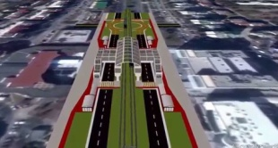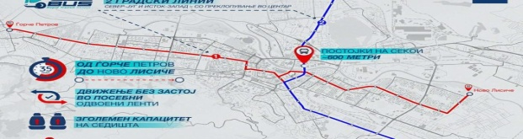
Figure 11. Project for the introduction of bus rapid transport in Skopje

- Conclusion
BRT systems that is planned with all its major operational features that guarantee high quality of service such as dedicated right-of-way, closed type od stations, ecological, higher capacity articulated od double articulated buses, intelligent fare payment and contemporary system of passenger information, have been proven to offer high quality of service that can easily match the one provided by the LRT or even metro systems at considerably lower investment costs. Therefore, BRT has become popular option mostly in developing countries.
European countries have been less enthusiastic in building BRT systems for several reasons.Most of the European cities already have well-developed rail public transport systems such as metro, LRT or trams. These rail systems offer good quality of service, they have long tradition of usage and are very well known and widely accepted by the public, unlike the BRT systems that are relatively new concept and which operational features often are unknown to general public. BRT image is plagued by the fact that the vehicles are buses, and it seems that people perceive it as another bus system that is characterized by low commercial speed, low reliability and low capacity.
In addition, there are cases when the BRT projects became subject for political battle, in which the opponent politicians misuse the fact that the concept is new for majority of the public, presenting it often falsely as public transport mode that can not meet the requirements for higher quality of service.
The latest such example is the city of Skopje, where the newly elected mayor has stopped the project despite the fact that the BRT project documentation and the project financing were already approved and available by the EBRD and the central government.
References
- https://www.acea.auto/files/20th_SAG_HR.pdf
- https://nacto.org/
- https://en.wikipedia.org/wiki/BRT_Sunway_Line
- https://www.daimler-truck.com
- https://brtguide.itdp.org/branch/master/guide/technology/fare-collection
- http://haddadinco.com/node/26
- https://www.unescap.org
- https://metenders.com
- https://www.mercedes-benz-bus.com
- https://slidetodoc.com/grtc-bus-rapid-transit-project-july-17-2015/
- https://www.peninsulabrt.com/what-is-brt/
- https://www.intelligenttransport.com
- https://www.conserve-energy-future.com
- http://www.busandcoach.travel/pt/smart_policies/bus_rapid_transit_brt.htm
- https://rsbsp.org.mk/zoshto-javen-prevoz-kampanja-na-rsbsp-i-jsp-skopje
- http://www.busandcoach.travel/en/safe/
- https://skopje.gov.mk/mk/objavi/studii/
- https://reagiraj.mk/blog/301-500
- https://makstat.stat.gov.mk/PXWeb/pxweb/mk/MakStat/MakStat__Transport__RegistriraniVozila/150_Trans_reg_voz_po_vidovi_opst_mk.px/table/tableViewLayout2/?rxid=63d13bd1-5691-4a1f-b607-4642a307515d
- https://mk.wikipedia.org/wiki/%D0%93%D1%80%D0%B0%D0%B4_%D0%A1%D0%BA%D0%BE%D0%BF%D1%98%D0%B5
- https://www.gtt.com/every-bus-get-priority-nyc-traffic-signals/
- https://www.intelligenttransport.com/transport-articles/73648/public-transport-cities-mobility/
- https://timesofindia.indiatimes.com/city/hyderabad/rs-2000-crore-elevated-bus-route-to-come-up-in-2-years-ktr/articleshow/65908094.cms
- https://www.theguardian.com/cities/2015/may/26/curitiba-brazil-brt-transport-revolution-history-cities-50-buildings
- https://brtguide.itdp.org/branch/master/guide/fare-systems/fare-system-functionality
- https://www.ctc-n.org/similar-national-plans/17696
- https://civilmedia.mk/zoshto-mladite-ne-sakaat-da-koristat-javen-prevoz/
- https://civitas.eu/cities/skopje
- https://en.wikipedia.org/wiki/Metromare
- “Conceptual design of BRT for city of Skopje – route Gjorce Petrov – Novo Lisice”, 24 ING dooel Bitola, JV Prima Engineering doo Skopje, June 2021 – Nikola Krstanoski, principal investigator

