Problems and proposed solutions for the planning of public transport in Bitola
Vaska Atanasovaª, Marija Stojanoska^{b}, Nikola Krstanoski^{c}
ª Graduate traffic engineer, PhD., Faculty of Technical Sciences – University of St. Kliment Ohridski, Bitola, 7000, Macedonia, vaska.atanasova@uklo.edu.mk
^{b} Graduate traffic engineer, M.Sc., Faculty of Technical Sciences – University of St. Kliment Ohridski, Bitola, 7000, Macedonia, marijastojanoska3112@gmail.com
^{c} Graduate traffic engineer, PhD., Faculty of Technical Sciences – University of St. Kliment Ohridski, Bitola, 7000, Macedonia, nikola.krstanoski@uklo.edu.mk

Abstract: Due to the modern way of life, many cities face the harmful impact of traffic processes reflected in autocentricity, traffic congestion, lack of parking spaces and green areas, which, in turn, all together affect the economic, ecological and health aspects of society. Public transport as a type of transport that can help a lot in building the policy for a sustainable urban transport system. If public transport offers a high quality of transport service and attracts a greater number of trips to the city, then the city would have a chance to withstand the pressure of the car and its constant need for new high-capacity traffic facilities, the negative impacts on the environment would be reduced, i.e. the quality of living in the city would increase, and in order to satisfy that goal, it is necessary to carry out constant field research, through surveys and interviews of the users of the services, in order to understand the problems they face and propose their solutions . This paper will show the problems faced by the users of public transport in Bitola and a proposal of solutions to improve services.

Key words: public transport, survey, users, Bitola.

INTRODUCTION
Bitola is the largest city center in the fertile and largest Macedonian valley of Pelagonia and the second largest city in the Republic of Macedonia.1
In the results published by the State Statistics Office for the census that was held in September 2021, the Municipality of Bitola has a population of 85 164.2
Bitola is a city that has a road and railway network.3
Public transport in Bitola is carried out by 5 licensed private operators. The current public transport service in the city's metropolitan area is represented by 5 urban lines.4
Public transportation in Bitola is carried out only by circular routes. As a consequence, the current situation is characterized by an unstable service of public transport.
Namely, using only a circular network, the frequent service is provided only in one part or in this case only in the central area of the city. At the municipal level, there are 19 lines in total, while at the city level, we have 5 urban lines.
Today, in the world, as well as in individual cities in Macedonia, due to various studies and analyses, data collection of a different nature is constantly being carried out.
Thus, the last collection and analysis of data on the transport demand in the territory of the city of Bitola was done with the study conducted in 2010.5
The problems with lack of parking places, pollution and suffocation are everyday, with the increase in the degree of motorization, the number of passengers transported by public transport is decreasing year by year. This is precisely why this survey was conducted, where the drivers and users of the service were surveyed, in order to identify problems and propose solutions to improve services.

METHODS
In this paper, one of the most commonly used methods for scientific research will be shown, which is a survey/interview.⁶ In the period from 21.01.2023 - 11.03.2023, a survey was conducted for all users of public city transport in Bitola.
The survey was made on the Google Drive - Google Forms platform. 30 questions were created that analyzed the current situation, the problems faced by the users and proposed solutions to improve the situation.⁷
The survey was distributed electronically to the students and employees of the secondary schools "Taki Daskalo" - Bitola, "Josip Broz Tito" - Bitola, "Gjorgi Naumov" - Bitola, while on 06.03.2023 the survey was conducted in a public city transport vehicle, the survey was conducted in public city transport vehicles, line 1, line 4 and line 5. The total amount of data was processed and displayed graphically, in point attachments.⁸
The questions refer to the age of the users of public city transport, gender, family size, whether they own a car, what is their occupation, how often they use public city transport, what is their most common purpose for traveling by public transport, what is the quality of public city transport today, would they use it if the quality of the service were improved, what are the reasons why they do not use the services of public city transport, if they had the opportunity to choose which means of transport they would choose to meet their mobility needs, whether the number on public transport lines are sufficient and meet the needs, whether the introduction of free public transport will increase the number of users and reduce the use of passenger cars, whether the vehicles of public city transport are delayed a lot at the charging stations, if they are introduce modern ways of collecting tickets, will the time spent at the stands be reduced, are you sufficiently informed about the timetable, are the vehicles operating with sufficient frequency, are the vehicles late, how does the driver treat the passengers, have they ever felt unsafe, whether there is a need to introduce environmentally friendly vehicles, whether they meet the needs of people with disabilities, what they are most interested in when they have to choose which means of transport they would use from the source to the destination of the journey, why they use a private car and whether they would use it if it increased the price of a parking place, which distance is the most acceptable for walking, whether the parking spaces are safe and have the appropriate information, problems and proposed solutions.

RESULTS
148 respondents took part in the electoral survey, while 167 users of the service were surveyed in a vehicle of public city transport. The data were processed and graphed.
From the conducted electronic and classic survey in a vehicle of public city transport, out of 315 respondents, 47% are users up to 18 years old, 26% from 18 to 36 years old, 16.5% are users from 36 to 65 years old, while those over 65 years old use public city transport only 10.5%. From this we can conclude that the largest number are young people who use the services of public city transport.

According to gender, the largest number of users are women 55.6%, while men are 44.4%. From the conducted survey, it was determined that the family size of the respondents is mostly four members, 45.4%, while 1.9% has one member.

Regarding car ownership, 48.9% own only one car, 27.3% more than one, while 23.8% do not have a car in the family. We can see that in graphic display, figure 1.

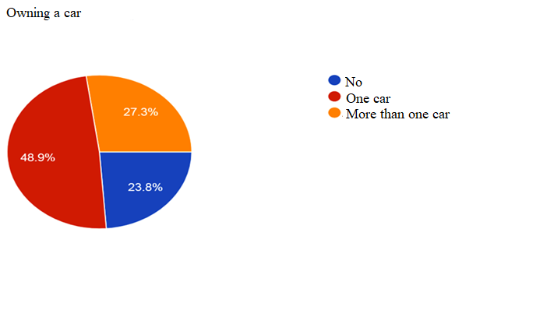
Figure 1. Owning a car
Given that the largest number of respondents were under 18 years of age, this indicates that their occupation is a pupil/student, that is, 55.6%.

The largest number of respondents regularly use public city transportation, 46.3%, about 20% of respondents often or sometimes use public city transportation, while 11.4% rarely. We can see that in graphic display, figure 2.
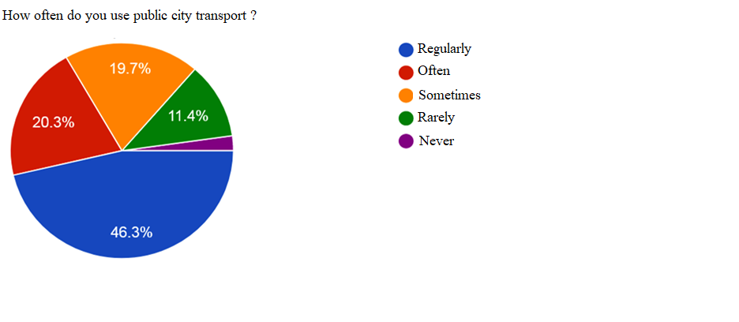
Figure 2. How often do you use public city transport

Most of the time, their purpose for traveling is to go to school/faculty, that is 52.4%. When asked what is the quality of public city transport services, 56.5% answered that it is good, a very small percentage consider it to be excellent and very good, while 54 respondents or 17.1 consider that the services are bad and 5.4% very bad.
If the services of public city transport were improved, 43.8% would use public transport more, while 33.7% would use it at the same level as now.
The biggest reason for not using public city transport is the bad and irregular timetable, i.e. 28.6%, about 22% do not use it because of too much crowding and lack of information, 5.1% think that the price of the ticket is high and that is why they do not use it. use the services.
If they had a choice, 60% would choose the car, while 18.7% would use public city transport, the percentage of using a bicycle, motorbike and electric scooter is very small. Shown in Chart 3.
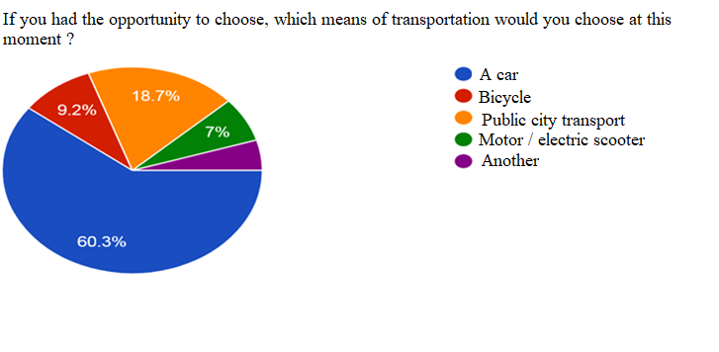
Figure 3. If you had the opportunity to choose, which means of transportation would you choose at this moment ?
The largest number of respondents believe that it is necessary to introduce other lines of public city transport, 37.8%, while 32.4% believe that they are not sufficient, while 29.5% are sufficient and meet the needs.
A huge percentage of the respondents believe that the introduction of free public city transport will increase the number of users of public city transport, namely 57.5%, also 33.7% think that it may increase, but the increase does not depend on the introduction of free transport only, but also for other secondary reasons. Chart view 4.
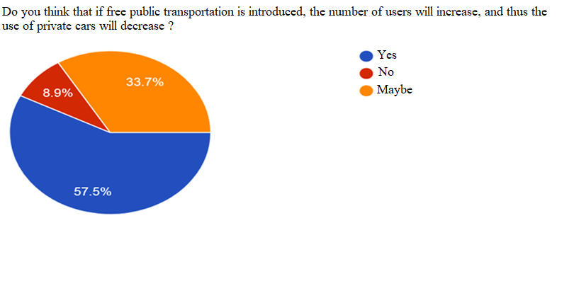
Figure 4. Do you think that if free public transportation is introduced, the number of user will increase, and thus the use of private cars will decrease ?
The respondents believe that the introduction of modern payment methods will shorten the waiting time at the stands, and 65.4%, 21.3% believe that there is no need for another method. Chart view 5.
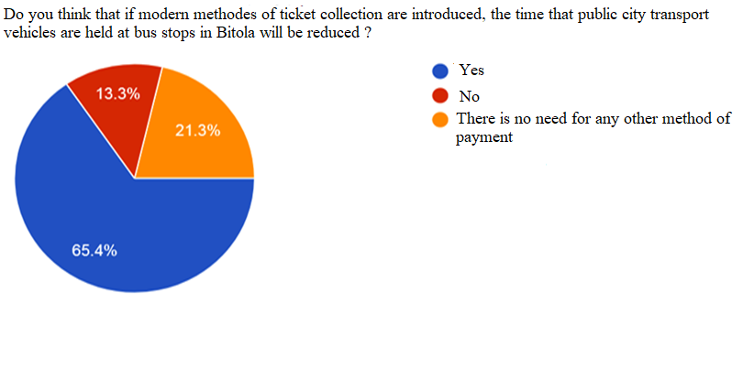
Figure 5. Do you think that if modern methods of ticket collection are introduced, the time that public city transport vehicles are held at bus stops in Bitola will be reduced?
Public city transport vehicles are not delayed much at the ticket collection stands, 56.5%, while 43.5% think they are.
Most of the time, passengers only know the timetable of the line on which they most often travel, and that is 36.2%, respondents who do not know the timetable and who believe that modern methods of information should be introduced amount to about 20%, while 25.7% know it the timetable.
Respondents believe that the frequency of public city transport vehicles should be increased, 45.4% and that they do not operate with sufficient frequency 24.4%.
The driver of public city transport always treats passengers well and very well, about 36%. Sometimes public city transport vehicles are late at stops 58.1%.
The introduction of environmentally friendly vehicles is of great need and 93% of the respondents consider this to be the case. Chart view 6.
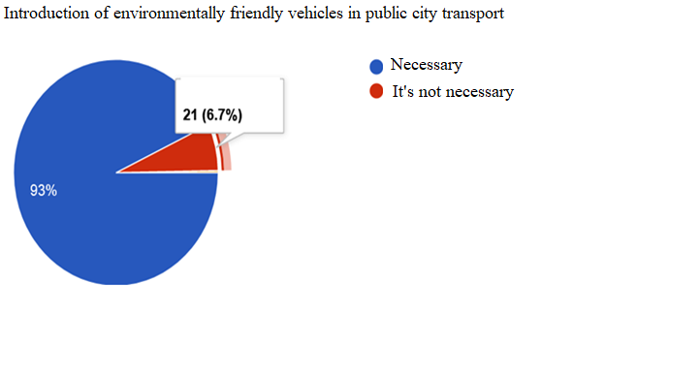
Figure 6. Introduction of environmentally friendly vehicles in public city transport
Safety in public city transport vehicles is at a sufficient level and 64% of respondents never once felt threatened.
Public city transport does not meet the needs of users with certain disabilities 50%, partially 39%.
When asked if they had to arrive from the Faculty of Pedagogy to the Faculty of Technology, about 39% would do so by public city transport, 33% by car, while 23% would walk.
The most acceptable distance that citizens choose to walk is 2 km, and 60%, while 30.6% would walk up to 5 km.
When it comes to the question of what they pay attention to when they have to choose public city transport as a means of mobility, we have a variety of answers and they are most interested in the total travel time from the source to the destination of the trip 35%, the ticket price affects 21 % of the respondents, the distances from the stand to the final destination affect 18% of the respondents, while 14% the distance to the source of the trip to the stand. Chart 7 view.
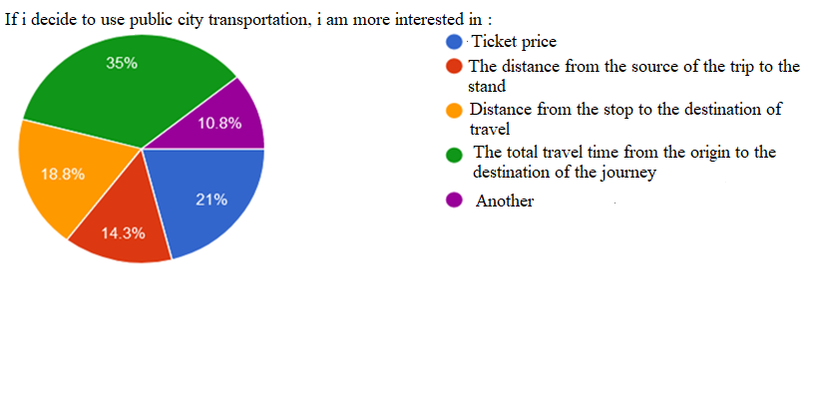
Figure 7. If I decide to use public city transportation, I am more interested in
If the price of a parking space doubles, it will contribute to the opportunity for users to think about whether they would use the car again for mobility, 33.8%, of the total number of surveys, 29.3% will replace the car with public city transport, and 22% again i'd use the car. Chart 8.
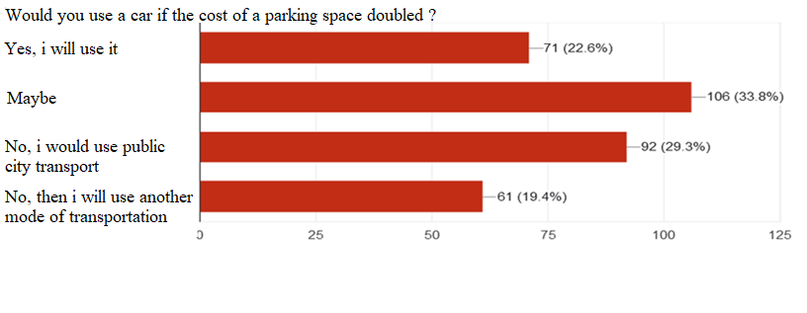
Figure 8. Would you use a car if the cost of a parking space doubled?
There is a huge percentage of respondents who think that the stands are not safe, are not well marked and do not have the necessary information, that is, partially, 78.6%.

DISCUSSION
Problems with public city transportation in Bitola:
- Absence of the operation of coordinated timetables;
- Competition between private carriers, movement before timetable, theft of passengers of other carriers;
- High costs, small number of passengers transported, cancellation of lines; ¬ Problems with an integrated policy for urban transport;
- Problem with taxi transport - unregistered (wild) carriers who are illegal competition, simply steal the passengers who are waiting for the services from the public city transport;
- Illegal parking of other road users blocks the movement of public city transport vehicles, thereby causing delays, loss of regularity and accuracy;
- Malfunctioning of the inspectorate and traffic police;
- The vehicles (small number of buses, poor hygiene, old fleet that often breaks down, loud noise, harmful emissions, small number of seats, air conditioning, too crowded, not low-floor, which makes entry/exit difficult for the elderly and with a disability, small children, bad smell, )
- Train staff (rude behavior with passengers, eating food while driving the bus, smoking cigarettes, talking to passengers, braking suddenly, )
- Timetable (frequent delays, the timetable is not followed, a small number of lines, cancelled, no transport in the late hours, certain stops are skipped, low frequency of vehicles, )
- Collection (collection of students, high price of the ticket, bad system of collection, collection in hand, )
- Information (non-existence of a system to inform the passengers that the public transport vehicle will be late, will not come at all, there is no button in the public transport vehicle with which the passenger would inform the driver that there are passengers to exit at the next stop)
- Security (due to illegal parking, passengers enter/exit from outside the parking lot, as their security is at a low level).

conclusion
As a conclusion from the conducted survey, we can say that there are a large number of ways and opportunities to solve the problems related to public city transportation in Bitola. By solving them and improving the situation, it will contribute to the completion of a sustainable urban city, where mobility with public city transport will be at the top of the pyramid, and problems with automobile traffic will be minimized. Attached is a proposal for solutions to improve the services of public city transportation:
- To follow the experiences and positive sides of European countries;
- Constantly analyzing, conducting surveys and investigations that will allow us to perceive the needs of the users from year to year;
- Introduction of new lines that will provide better service in more remote and unconnected places with public service, lines in the late hours and on weekends;
- Introduction of quality systems for tracking the vehicles of public city transport at any moment in a given location, and thus improving the availability of the vehicles for accurate and timely information about where the vehicle is and when it will arrive at our location;
- Information about the train schedule at the stands, internet platform;
- Modern ways of collecting tickets;
- To use modern, low-floor, safe, environmentally friendly, noise-free, air-conditioned, clean and with a greater number of seats, double-decker buses;
- Introducing stricter measures and restrictions for private traffic in order to direct passengers to use public transportation;
- Free public city transportation, a special bus for students;
- Accuracy and regularity of the buses;
- Seat belts for passengers, prohibition of the intake of vegetables, etc.
- Continuous maintenance of cleanliness and hygiene in the vehicles;

REFERENCES
- https://mk.wikipedia.org/wiki/%D0%91%D0%B8%D1%82%D0%BE%D0%BB%D0%B0
- https://www.stat.gov.mk/
- https://www.bitola.gov.mk/
- https://www.bitola.gov.mk/wordpress/wp-content/uploads/2021/04/%D0%92%D0%BE%D0%B7%D0%BD%D0%B8-%D1%80%D0%B5%D0%B4%D0%BE%D0%B2%D0%B8-2021.pdf
- https://www.temjournal.com/content/61/TemJournalFebruary2017_53_63.pdf
- https://mk.wikipedia.org/wiki/%D0%90%D0%BD%D0%BA%D0%B5%D1%82%D0%B0
- https://docs.google.com/forms/d/e/1FAIpQLScv1gSMdXhNTKNANnODlSpW1HHpWGtJZGwJOj-0lreCCEVWuw/viewform
- https://mk.wikipedia.org/wiki/%D0%9A%D0%B0%D1%82%D0%B5%D0%B3%D0%BE%D1%80%D0%B8%D1%98%D0%B0:%D0%A1%D1%80%D0%B5%D0%B4%D0%BD%D0%B8_%D1%83%D1%87%D0%B8%D0%BB%D0%B8%D1%88%D1%82%D0%B0_%D0%B2%D0%BE_%D0%91%D0%B8%D1%82%D0%BE%D0%BB%D0%B0

