A Survey of Machine Learning Techniques Used in Recommender Systems

¹ Nora PireciSejdiu, ² Blagoj Ristevski and ³ Ilija Jolevski
University "St. Kliment Ohridski" – Bitola
Faculty of Information and Communication Technologies – Bitola, Republic of Macedonia
{¹pireci.nora, ² blagoj.ristevski, ³ ilija.jolevski}@uklo.edu.mk

Abstract - The amount of data on the internet is increasing every day, and this is leading to information overload. Recommendation systems have been very efficient by significantly improving information retrieval in data mining. Machine learning techniques have been used to improve the performance of recommendation systems, which are typically trained to maximize user satisfaction and increase sales in business companies. This paper deals with the research of machine learning techniques, which are used in recommendation systems in different fields improving performance.
Keywords – recommender systems, content-based filtering, collaborative filtering, hybrid filtering, machine learning techniques, decision tree, naïve Bayes, k-nearest neighbor, neural networks, support vector machines.

Introduction
The rapid increase in the amount of information in digital technologies has created a challenge for users in accessing relevant documents. Recommender systems (RS) are information filtering systems that deal with the problem of information overload by filtering vital information fragment out of a large amount of dynamically generated information according to the user’s preferences, interest, or observed behavior about an item. Recommender systems are beneficial to both service providers and users [21]. Many Researchers and organizations use data mining to extract useful knowledge regarding their needs. Data mining covers many techniques such as classification, clustering, regression, association rules, summarization, time series analysis etc. Each technique has some algorithms like classification has decision trees, naïve Bayes, neural networks etc., while clustering has k-means etc. [8] [26] [27] [28].
Recommender Systems propose useful and interesting items to users in order to increase both seller’s profit and the buyer’s satisfaction. They contribute to the commercial success of many online ventures such as Amazon or NetFlix and are a very active research area. Examples of recommended items include movies, web pages, books, news items and more. Often an RS attempts to predict the rating a user will give to items 170 based on her past ratings and the ratings of other (similar) users [12]. Due to the explosion of e-commerce, recommender systems are rapidly becoming a core tool to accelerate cross-selling and strengthen customer loyalty. There are two prevalent approaches for building recommender systems – content-based recommending and collaborative filtering (CF). The CF algorithm is one of the most common recommender system algorithms. This study focuses on improving the performance of recommender systems by using data mining techniques [19]. To improve the quality of recommendations, machine learning techniques are used in recommendation systems. The most popular techniques are decision tree classifier, naïve Bayes, k-nearest neighbor, neural network and support vector machines.
This paper surveys the application of machine learning techniques in recommendation systems based on existing literature where recommendation systems have been proven to improve the process and quality of decision making depending on the technique used.
The rest of the paper is structured as follows. Section II describes the recommendation systems. The commonly used machine learning techniques are described in Section III. The subsequent section depicts the related work and compares the obtained results when different techniques are used. Concluding remarks are highlighted in the last section.

Recommendation Systems
The explosive growth in the amount of available digital technologies and information and the number of visitors to the Internet has created a potential challenge of information overload which hinders timely access to items of interest on the Internet. Recommender systems are beneficial to both service providers and users. They reduce transaction costs of finding and selecting items in an online shopping environment. Recommendation systems have also proved to improve the decision making process and quality [21].
The use of efficient and accurate recommendation techniques is very important for a system that will provide a good and useful recommendation to its individual users. This explains the importance of understanding the features and potentials of different recommendation techniques. Figure 1 shows the anatomy of different recommendation filtering techniques [21].
Methods that use the former are referred to as collaborative filtering methods, whereas methods that use the latter are referred to as content-based recommender methods.
Note that content-based systems also use the rating matrices in most cases, although the model is usually focused on the ratings of a single user rather than those of all users. In knowledge-based recommender systems, the recommendations are based on explicitly specified user requirements. Instead of using historical rating or buying data, external knowledge bases and constraints are used to create the recommendation. Some recommender systems combine these different aspects to create hybrid systems. Hybrid systems can combine the strengths of various types of recommender systems to create techniques that can perform more robustly in a wide variety of settings. In the following, we will discuss these basic models briefly, and also provide pointers to the relevant chapters in the book where they are discussed [2].

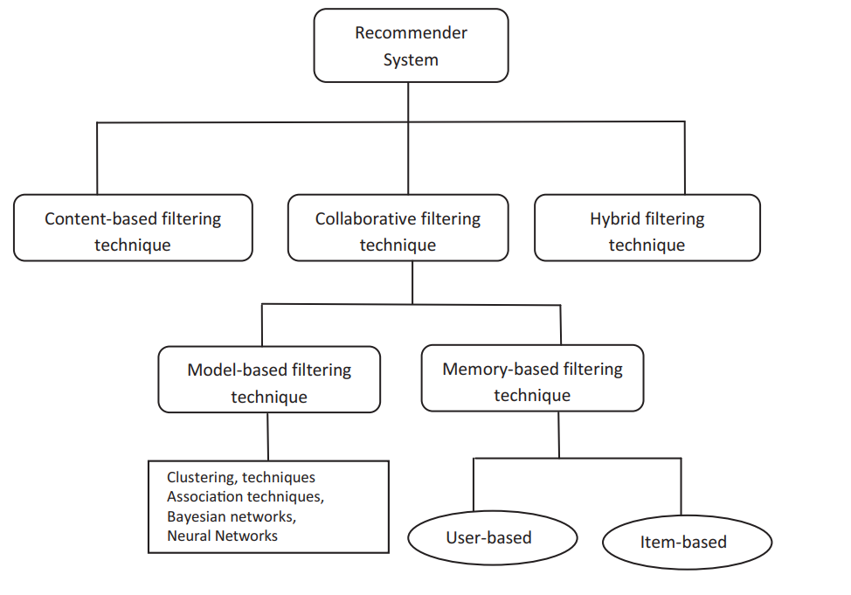
- Recommendation techniques.

Content-based filtering
In content-based recommender systems, the content plays a primary role in the recommendation process, in which the ratings of users and the attribute descriptions of items are leveraged in order to make predictions. The basic idea is that user interests can be modeled based on the properties (or attributes) of the items they have rated or accessed in the past [2]. Content-based systems examine the properties of the items recommended. As shown in Figure 2 [25] content-based recommenders rely on the fact that a user is interested in items similar to those he liked (purchased, searched, browsed, etc.) in the past.
They entail the description of items that may be recommended, the creation of a profile describing the types of items the user likes, and a strategy that compares
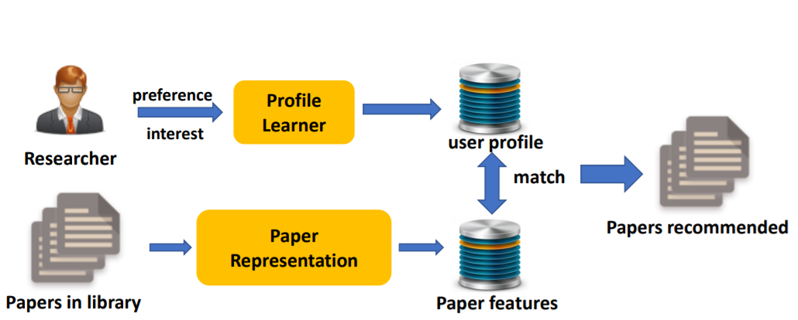
- Content-based system for a paper recommendation.
item and user profiles to determine what to recommend [17]. Content-based recommendation systems may be used in a variety of domains ranging from recommending web pages, news articles, restaurants, television programs, and items for sale.

Collaborative filtering
Collaborative filtering (CF) is a popular recommendation algorithm that bases its predictions and recommendations on the ratings or behavior of other users in the system [13]. Collaborative filtering is also referred to as social filtering as it filters information by using the recommendations of other people. Collaborative filtering recommender systems recommend items by identifying other users with similar tastes and use their opinions for a recommendation. Collaborative filtering explores techniques for matching people with similar interests and making recommendations on this basis [16]. The term “collaborative filtering” refers to the use of ratings from multiple users in a collaborative way to predict missing ratings. In practice, recommender systems can be more complex and data-rich, with a wide variety of auxiliary data types [2]. Collaborative filtering systems focus on the relationship between users and items as illustrated in Figure 3 [25]. The similarity of items is determined by the similarity of the ratings of those items by the users who have rated both items [1]. There are two types of methods that are commonly used in collaborative filtering, which are referred to as memory-based methods and model-based methods.
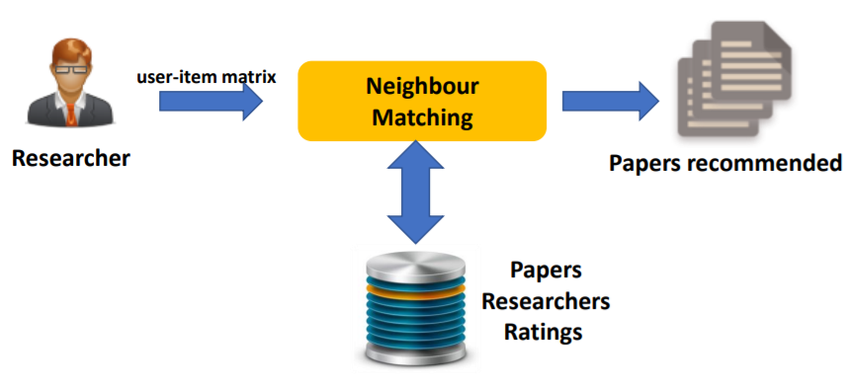
- Collaborative filtering system for a paper recommendation.

Hybrid filtering
Hybrid filtering, in many cases where a wider variety of inputs is available, one has the flexibility of using different types of recommender systems for the same task. In such cases, many opportunities exist for hybridization, where the various aspects from different types of systems are combined to achieve the best of all worlds. Hybrid recommender systems are close to the field of ensemble analysis, in which the power of multiple types of machine learning algorithms is combined to create a more robust model. Ensemble-based recommender systems can combine not only the power of multiple data sources, but they are also able to improve the effectiveness of a particular class of recommender systems (e.g., collaborative systems) by combining multiple models of the same type as shown in Figure 4 [25]. This scenario is not very different from that of ensemble analysis in the field of data classification.
The hybrid method of recommendation is also employed in many applications, such as the temporal purchase patterns derived from sequential pattern analysis (SPA) [4]. The hybrid method of recommendation is also employed in many applications, such as the temporal purchase patterns derived from sequential pattern analysis (SPA). On one hand, these applications derived implicit ratings that can be used in online transaction data for collaborative filtering. On the other hand, these applications used temporal purchase patterns to eliminate the harmful effect on recommendation services through SPA [17].
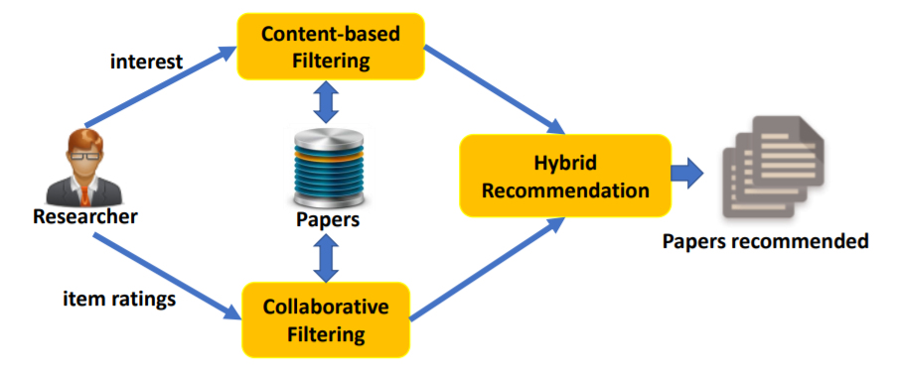

- Content-based system for a paper recommendation.

Machine Learning Techniques
Many algorithms are today classified as “machine learning”. All algorithms for the analysis of data are designed to produce a useful summary of the data, from which decisions are made. However, algorithms called “machine learning” not only summarize our data; they are perceived as learning a model or classifier from the data and thus discover something about data that will be seen in the future. Machine learning enthusiasts often speak of clustering with the neologism “unsupervised learning”; the term unsupervised refers to the fact that the input data does not tell the clustering algorithm what the clusters should be [27] [28]. In supervised machine learning the available data includes information about the correct way to classify at least some of the data. The data classified already is called the training set [1].
Machine learning is a method of data analysis that automates analytical model building. It is a branch of artificial intelligence based on the idea that systems can learn from data, identify patterns and make decisions with minimal human intervention [13].
There are many different types of classification tasks in machine learning and specialized approaches to modeling but the most popular Machine Learning techniques are:
- Decision trees have been previously used as a model-based approach for recommender systems. The use of decision trees for building recommendation models offers several benefits, such as efficiency and interpretability and flexibility in handling a variety of input data types (ratings, demographic, contextual, etc.) [12]. The general idea of the algorithm Tree structure that has been widely used is to represent classification models. Most decision tree induction algorithms are based on a greedy top-down recursive partitioning strategy for tree growth. They use different variants of impurity measures, like; information gain, gain ratio, and distance-based measures to select an input attribute to be associated with an internal node [6]. Decision Trees are classifiers on a target attribute or class in the form of a tree structure. The observations or items to classify are composed of attributes and their target value. The nodes of the tree can be: a) decision nodes, in these nodes a single attribute-value is tested to determine to which branch of the sub-tree applies or b) leaf nodes that indicate the value of the target attribute [22].
- Another very popular linear classification algorithm is naïve Bayes. It has been applied to text categorization with reasonable performance, although the performance is significantly worse than that achieved by regularized linear classifiers such as support vector machines. It is also very suitable for online updating, which could be important in practice [7]. One can treat the items as features and users as instances in order to infer the missing entries with a classification model [2]. Naïve Bayesian classifiers assume that there are no dependencies amongst attributes. This assumption is called class conditional independence. It is made to simplify the computations involved and, hence is called "naive" [3].
- K-nearest neighbor algorithm is one of the simplest non-parametric lazy algorithms called "Closest Point Search" is a mechanism that is used to identify the unknown data point based on the nearest neighbor whose value is already known. It is easy to understand but has incredible work in fields and practice especially in classification. It does not use training data to do generalization, that and in the best case, it makes a decision based on the entire training data set [6]. The k-nearest neighbor algorithm (k-NN) is a method to classify an object based on the majority class amongst its k-nearest neighbors. k-NN algorithm usually uses the Euclidean or the Manhattan distance. However, any other distance such as the Chebyshev norm or the Mahalanobis distance can also be used [3].
- A neural network is a set of connected input and output units in which each connection has a weight associated with it. Neural network learning is also referred to as connectionist learning due to the connections between units. It involves a long training process that requires a number of parameters for the classification of categories. A backpropagation neural network is a multilayer, feed-forward neural network consisting of the input layer, a hidden layer and an output layer. The neurons present in the hidden layer and output layer have biases, which are connected from units whose activation function is always 1. The bias term also acts as weights [9]. Artificial neural networks (ANNs) are also usually applied to traffic prediction problems because of their advantages, such as their capability to work with multi-dimensional data, implementation flexibility, generalizability, and strong forecasting power [23].
- Support Vector Machines (SVMs) are one of the most theoretically well-motivated and practically most effective classification algorithms in modern machine learning [24]. Support Vector Machines (SVM) improves upon perceptrons by finding a separating hyperplane that not only separates the positive and negative points but does so in a way that maximizes the margin – the distance perpendicular to the hyperplane to the nearest points. The points that lie exactly at this minimum distance are the support vectors. Alternatively, the SVM can be designed to allow points that are too close to the hyperplane, or even on the wrong side of the hyperplane, but minimize the error due to such misplaced points

Related Works
Due to the extensive use of computers, smartphones and high-speed Internet, people are now using the web for social contacts, business correspondence, e-marketing, e-commerce, e-surveys, etc. [2]. In recent years, recommendation systems have changed the way of communication between both websites and users. The recommendation system sorts through massive amounts of data to identify the interest of users and makes the information search easier [20].
The application of machine learning techniques in recommender systems has shown very good results and has significantly improved the performance of recommender systems. This is evidenced in related works that have been done so far. In the following, we can see the application of machine learning techniques in different areas of recommendation systems
In paper [3] the authors used naïve Bayes, decision Tree, and k-Nearest Neighbor algorithms to propose a new method to search alternative designs in an energy simulation. Their experiment shows that the decision tree has the fastest classification time followed by naïve Bayes and k-nearest neighbor. Based on the Precision, Recall, F-measure, Accuracy, and AUC value, the performance of naïve Bayes is the best.
In the paper [10] authors compared machine learning methods depending very much on the characteristics of a particular data set and the requirements of the respective business domain. This case study provides an assessment of the predictive performance of different classification methods for campaign management. The evaluation of data mining methods for marketing campaigns has special requirements. Whereas, typically the overall performance is an important selection criterion, for campaign management it is more important to select the technique which performs best on the first few quantiles. The C4.5 decision tree inducer in WEKA produced good results, in particular for the first few percentiles of the Gain Curve. K-nearest neighbor (k-NN) methods provided good results only after irrelevant attributes were removed from the data set. There are a number of useful extensions one can perform in addition to the steps described in this paper.
In [12] a new method for decision tree-based recommender systems is proposed. The proposed method includes two new major innovations. First, the Decision Tree produces lists of recommended items at its leaf nodes, instead of single items. The second major contribution of the paper is the splitting method for constructing the decision tree. Splitting is based on a new criterion - the least probable intersection size. The proposed decision-tree-based recommendation system was evaluated on a large sample of the MovieLens dataset and is shown to outperform the quality of recommendations produced by the well-known information gain splitting criterion.
In this research work [13] a movie recommender system is built using the k-means clustering and k-nearest neighbor algorithms using The MovieLens dataset. The proposed work deals with the introduction of various concepts related to machine learning and recommendation system. In this work, various tools and techniques have been used to build recommender systems. It is seen that after implementing the system in the python programming language the root mean square error (RMSE) value of the proposed technique is better than the existing technique. It is also seen that the RMSE value of the proposed system is achieving the same value as the existing technique but with less no of clusters.
In paper [14] a comparison has been performed between different collaborative filtering algorithms to assess their performance. They evaluated k-nearest neighbor (k-NN), Slope One, co-clustering and non-negative matrix factorization (NMF) algorithms. k-NN algorithm is representative of the memory-based collaborative filtering approach (both user-based and item-based). The other three algorithms, on the other hand, are under the model-based collaborative filtering approach. They used the MovieLens dataset based on six evaluation metrics and resulted that the k-NN algorithm for item-based collaborative filtering outperformed all other algorithms examined in this paper.
In [5] authors propose a Bayesian methodology for recommender systems that incorporates user ratings, user features, and item features in a single unified framework. The key advantage of this approach is that it can use all the available information in a unified, coherent model.
In paper [15], a collaborative filtering based recommender system is improved by the ask-to-rate technique to solve the cold start problem. This paper determines the optimal number of neighbors in the item-based collaborative filtering k-NN algorithm after the login of the new user to the recommender system. After implementing the new user signup process framework, the results indicate that an optimal number of neighbors for the new user is 5 to 15 following the used standard dataset. If the number of neighbors is considered greater than 15, more neighbors with negative similarity will be involved in calculating the item rate prediction for the new user, reducing the accuracy of recommendations. If the number of neighbors is considered less than 5, no neighbors may be found for the user. In these conditions, it is proposed that the k value is not constant for everyone, and only positive neighbors for each user are considered, k or number of the new user's neighbors is determined by an experimental evaluation.
Paper [11] evaluates the performance of ten different recurrent neural networks (RNN) structures on the task of generating recommendations using written reviews. The RNN structures they studied include well know implementations such as multi-stacked bi-directional Gated Recurrent Unit (GRU) and Long Short-Term Memory (LSTM) as well as the novel implementation of attention-based RNN structure. The attention-based structures are not only among the best models in terms of prediction accuracy, they also assign an attention weight to each word in the review.
A unique switching hybrid recommendation approach is proposed in [18] by combining a naïve Bayes classification approach with collaborative filtering. Experimental results on two different data sets have shown that the proposed algorithm is scalable and provide better performance–in terms of accuracy and coverage–than other algorithms while at the same time eliminating some recorded problems with the recommender systems.

Conclusion
This survey focused on the existing literature and explored the application of machine learning techniques in recommender systems. Based on our research and in previous works as well as recent ones, it is well known that no algorithm can perform and give satisfactory results in all areas of use. Some algorithms may perform very well in a given field but in a specific field, another algorithm may perform better.
The biggest challenge of recommender systems is the so-called Cold Start problem, and it continues to be one of the key areas of current and future research.

References
- Jure Leskovec, Anand Rajaraman , Jeffrey D. Ullman, “ Mining of Massive Datasets”, Chapter 9, (2010)
- Charu C. Aggarwa. “Recommender Systems: The Textbook”. Springer International Publishing Switzerland, (2016)
- Ahmad Ashari, Iman Paryudi, A Min Tjoa, “Performance Comparison between Naïve Bayes, Decision Tree and k-Nearest Neighbor in Searching Alternative Design in an Energy Simulation Tool”. International Journal of Advanced Computer Science and Applications, Vol. 4, No. 11, (2013)
- Shouxian Wei, Xiaolin Zheng, Deren Chen, Chaochao Chen, “A hybrid approach for movie recommendation via tags and ratings”. Electronic Commerce Research and Applications, Volume 18, Pages 83-94, (2016)
- M. Condliff, D. Lewis, D. Madigan and C. Posse, "Bayesian Mixed-Effects Models for Recommender Systems", Proc. ACM SIGIR '99 Workshop Recommender Systems: Algorithms and Evaluation, (1999)
- Delveen Luqman Abd AL-Nabi, Shereen Shukri Ahmed, “Survey on Classification Algorithms for Data Mining: (Comparison and Evaluation)”. Computer Engineering and Intelligent Systems www.iiste.org ISSN 2222-1719 (Paper) ISSN 2222-2863 (Online) Vol.4, No.8, (2013)
- T. Zhang, S.I. Vijay, “Recommender systems using linear classifiers”. Journal of Machine Learning Research 2, pp. 313-334, (2002)
- M Mohanapriya, J Lekha, “Comparative study between decision tree and knn of data mining classification technique”. Second National Conference on Computational Intelligence, (2018)
- Anuradha Patra, Divakar Singh, “A Survey Report on Text Classification with Different Term Weighing Methods and Comparison between Classification Algorithms”. International Journal of Computer Applications (0975 – 8887) Volume 75– No.7, (2013)
- Bichler, Martin and Kiss, Christine, "A Comparison of Logistic Regression, k-Nearest Neighbor, and Decision Tree Induction for Campaign Management". AMCIS 2004 Proceedings. 230, (2004)
- David Zhan Liu, Gurbir Singh, “A Recurrent Neural Network Based Recommendation System”. Technical Report: Stanford University, (2016)
- Amir Gershman, Amnon Meisels, Karl-Heinz Luke, Lior Rokach, Alon Schclar, Arnon Sturm, “A Decision Tree Based Recommender System”. 10th International Conferenceon Innovative Internet Community Systems (I2CS) – Jubilee Edition 2010 –. Bonn: Gesellschaft für Informatik e.V. (S. 170-179), (2010)
- Rishabh Ahuja, Arun Solanki, Anand Nayyar, “Movie Recommender System Using K-Means Clustering AND K-Nearest Neighbor”. 9th International Conference on Cloud Computing, Data Science & Engineering (Confluence), (2019)
- Maryam Al-Ghamdi, Hanan Elazhary, Aalaa Mojahed, “Evaluation of Collaborative Filtering for Recommender Systems”. (IJACSA) International Journal of Advanced Computer Science and Applications, Vol. 12, No. 3, (2021)
- A.Mojdeh Bahadorpour, B.Behzad Soleimani Neysiani, C.Mohammad Nadimi Shahraki, “Determining Optimal Number of Neighbors in Item-based kNN Collaborative Filtering Algorithm for Learning Preferences of New Users”. ISSN: 2180 – 1843 e-ISSN: 2289-8131 Vol. 9 No. 3, (2017)
- Sayali D. Jadhav, H. P. Channe, “Efficient Recommendation System Using Decision Tree Classifier and Collaborative Filtering”. International Research Journal of Engineering and Technology (IRJET) e-ISSN: 2395 -0056 Volume: 03 Issue: 08, (2016)
- Iván Cantador, Desmond Elliott, Joemon M. Jose, “A Case Study of Exploiting Decision Trees for an Industrial Recommender System”. European Commission under contracts FP6-027122-SALERO, FP6-033715-MIAUCE, and FP6-045032 SEMEDIA, (2009)
- M Ghazanfar, A Prugel-Bennett “An Improved Switching Hybrid Recommender System Using Naive Bayes Classifier and Collaborative Filtering”. Proceedings of the International MultiConference of Engineers and Computer Scientists, IMECS, Vol. 1, (2010)
- Min SH., Han I. “Recommender Systems Using Support Vector Machines”. In: Lowe D., Gaedke M. (eds) Web Engineering. ICWE 2005. Lecture Notes in Computer Science, vol 3579. Springer, Berlin, Heidelberg, (2005)
- Paritosh Nagarnaik, A.Thomas, “Survey on Recommendation System Methods”. IEEE sponsored 2nd International Conference on Eletronics and Communication System, (2015)
- F.O. Isinkaye, Y.O. Folajimi, B.A. Ojokoh, “Recommendation systems: Principles, methods and evaluation”. Egyptian Informatics Journal, Volume 16, Pages 261-273, (2015)
- Maizan Mat Amin, Jannifer Yep Ai Lan , Mokhairi Makhtar1 , Abd Rasid Mamat, ”A Decision Tree Based Recommender System for Backpackers Accommodations”. International Journal of Engineering & Technology, 7 (2.15) 45-48, (2018)
- Xiaolei Ma, Zhuang Dai, Zhengbing He, Jihui Ma, Yong Wang and Yunpeng Wang, “Learning Traffic as Images: A deep convolutional neural network for large-scale transportation network speed prediction”. Special Issue Sensors for Transportation, (2017)
- Mehryar Mohri, Afshin Rostamizadeh, and Ameet Talwalkar, “Foundations of Machine Learning”. Massachusetts Institute of Technology, (2012)
- Xiaomei Bai, Ivan Lee, Xiangjie Kong, Feng Xia, “Scientific Paper Recommendation: A Survey” IEEE Access PP(99):1-1, (2019).
- Beyene, Solomon Shiferaw, Tianyi Ling, Blagoj Ristevski, and Ming Chen. "A novel riboswitch classification based on imbalanced sequences achieved by machine learning." PLoS computational biology 16, no. 7 (2020): e1007760.
- Ristevski, Blagoj, Suzana Loshkovska, Sasho Dzeroski, and Ivica Slavkov. "A comparison of validation indices for evaluation of clustering results of DNA microarray data." In 2008 2nd International Conference on Bioinformatics and Biomedical Engineering, pp. 587-591. IEEE, 2008.
- Ristevski, Blagoj, and Suzana Loskovska. "Bayesian networks application for representation and structure learning of gene regulatory networks." In 2009 12th International Conference on Computers and Information Technology, pp. 609-613. IEEE, 2009.

