Analysis of local curricula in the field of tourism and entrepreneurship in the Republic of Macedonia

This project is co-financed by the European Union and the National Fund of participating countries

TABLE OF CONTENTS

INTRODUCTION 2
METHODOLOGY 2
OVERVIEW OF STRATEGIC DOCUMENTS 3
ASSESSMENT OF THE CURRICULA IN THE FIELD OF TOURISM, HOSPITALITY AND ENTREPRENEURSHIP 14
SWOT ANALYSIS 31
CONCLUSION 32
REFERENCES 33

The Study is originally developed in English by the Faculty of Tourism and Hospitality - Ohrid

Research Team:
Naume Marinoski, PhD
Cvetko Andreeski, PhD
Michael Risteski, MSc

INTRODUCTION

The aim of this part of the project is determining the characteristics of curricula in the field of tourism as well as pointing out their improvement and expansion with new contents. This has the function of improving human potentials, entrepreneurial spirit and tourism enterprises in general. The modified and expanded programs provide not only improved portfolios for the management, but also for the employees in tourism and hospitality enterprises in Kicevo.
The survey concerned two areas of interest:
А. Collection of data, processing and analysis of information in order to evaluate curricula in the field of tourism at all levels of education.
Б. Collection of data, processing and analysis of information in order to assess the educational needs of the young population in relation to tourism, at all levels of such education, including secondary, higher and master studies
This analysis has enabled us comparatively to understand the positive processes in the field of education in the determined region. This will lead to the creation of optimal curricula that will include the experiences of different areas in the process of improving the schoolchildren’s and students’ knowledge in the field of tourism.

METHODOLOGY

The research methodology covers two levels. The first level refers to secondary research activities. As part of this type of research, an analysis of published studies in the field of tourism will be undertaken. Secondary research activities will also allow for situational awareness for the curricula on a local and national level. Secondary research will provide insights in the most relevant course programs included in the curricula.
The primary research was conducted by using a standardized questionnaire. It was carried out in the Municipality of Kicevo on a sample of 200 stakeholders. The primary research is based on determined hypotheses that are related to situational assumptions. In the research through the views and opinions of the stakeholders, specific shortcomings in this area were determined and the perceptions of future improvements in the field of tourism and hospitality were defined.
The processing of the primary data is being conducted by using statistical software SPSS (Statistical package for social science), as one of the most used methods for such purposes.

OVERVIEW OF STRATEGIC DOCUMENTS

The strategy for the development of education in the Republic of Macedonia provides general improvement directions in which the field of entrepreneurship in tourism and hospitality is also incorporated. This document defines the main goals and objectives as follows: "The goals and tasks defined in the Strategy derive from the most significant challenges of the education system that are identified through thorough analysis of the situation in each subsector. They are also in line with the objectives defined by the key documents related to the accession processes that are signed by the EU and the Republic of Macedonia and adopted by the Government." The Indicative strategic document of 2015-2020 sets out the following objectives in education, employment and social policy sector: "Reducing high rate of unemployment; increasing labor market participation, especially for youngsters and women; increasing access to quality education and training; harmonizing with the demand for skills; establishing a modern and flexible system for social protection. The results that have to be achieved include:
- A more inclusive and more efficient labor market;
- Improved harmonization between the demand and offer of skills;
- Modernizing the system of social protection;
- A higher number of statistical indicators for the policy makers;
- Improved pre-school, mandatory education (primary and secondary) and higher education.
This document is based on IPA II support (IPP II). On the basis of this we can conclude that the intention of the Republic of Macedonia is to monitor the contemporary processes in this sector.
The strategy for tourism development puts special importance on education. The current situation based on this document is interpreted as follows:
“While several activities have been undertaken at the national level for improving the development of tourism and marketing knowledge, together with relevant institutions, on the local or regional level there is often a lack of specific knowledge on the characteristics and mechanisms of the tourism. This is due to the lack of professional organizational structures in tourism at the local or regional level.
There have also been positive developments in the tourism sector for education, over the last few years, and the number of universities offering higher education in the field of tourism has increased to six. Unlike this, the secondary tourism education still has no good reputation in Macedonia, and as a result, the much-needed young professionals that want to work in the tourism industry are not created.
Also, the service quality in accommodation facilities and tourist attractions must be improved as well; for example, many unskilled workers are engaged without proper training or education". In this document, the following recommendations for the development of education in the field of tourism are given: "One of the main tasks of each government is to support and continuously improve tourism knowledge and the quality of services in the country. In the concrete case of Macedonia, improvement should be in the following areas:
- Increasing the development of tourism and knowledge by the responsible ministry and the Agency for Promotion and Support of Tourism of the Republic of Macedonia
- Starting initiatives on the local / regional level
- Improving the quality of tourism education
- Initializing training programs for tourism employees
The analysis covered the Law on Tourism and the Law on Catering Industry of the Republic of Macedonia. The Law on Tourism does not provide compulsory education in the field of tourism and hospitality in order to manage travel agencies as a basic intermediary factor in tourism. Any person who has completed higher education can perform this type of management. The only certification required by this Law is the certificate for managing travel agencies with a passed exam, issued by authorized higher institutions that educate such personnel. Tourist agency agents also do not have to have such specialized education. This in a way devalues ​​the educational process. In the Law on catering, the situation is similar.
This Law also prescribes the conditions for performing tourist-guiding services. This is covered as informal education. This type of certification is also performed by higher education institutions in the field of tourism. Problems in this area arise in the part of the practical training of tourist guides because the legislator did not foresee such obligatory activities.
Education of staff in the field of tourism is being conducted in 12 specialized secondary schools of this type

Table no. 1. Representation of curricula in secondary schools in the Republic of Macedonia
No. | School | City | Capacity (Number of students)
 | MUNICIPAL SECONDARY SCHOOL “ACO RUSKOVSKI” | Berovo | 68
 | SPECIALIZED SECONDARY SCHOOL “KOLE NEDELKOVSKI” | Veles | 34
 | MUNICIPAL SECONDARY SCHOOL “JOSIF JOSIFOVSKI” | Gevgelija | 136
 | MUNICIPAL SECONDARY SCHOOL “MITKO PENDZUKLISKI” | Kratovo | 34
 | MUNICIPAL SECONDARY SCHOOL “GJORCHE PETROV” | Kriva Palanka | 34
 | MUNICIPAL SECONDARY SCHOOL “NAUM NAUMOVSKI - BORCE” | Krushevo | 102
 | MUNICIPAL SECONDARY SCHOOL “ST. NAUM OHRIDSKI” | Mak. Brod | 68
 | MUNICIPAL CATERING – TOURISM SCHOOL “VANCO PITOSHESKI” | Ohrid | 272
 | MUNICIPAL SECONDARY SCHOOL OF THE CITY OF SKOPJE “LAZAR TANEV” | Skopje | 442
 | MUNICIPAL SECONDARY SCHOOL “NIKO NESTOR” | Skopje | 34
 | SPECIALIZED MUNICIPAL SECONDARY SCHOOL УЧИЛИШТЕ “MOSHA PIJADE” | Tetovo | 136
 | MUNICIPAL SECONDARY SCHOOL KOLE NEHTENIN” | Shtip | 34
 | Total |  | 1394

The table overview shows that the total capacity for enrollment in secondary-catering schools in the Republic of Macedonia is 1394. They are deployed in a total of 12 schools. The location of schools from this education profile is favorable because they are located in all planning regions of the Republic of Macedonia. The analysis shows that the closest schools to the municipality of Kicevo are the schools in Makedonski Brod and Ohrid with a capacity of 68 and 272 students, respectively. This is a positive connotation for the development of the human resources in the field of tourism and hospitality in the municipality of Kichevo. The only disadvantage is that there is no such school in the city of Kichevo. However, in favor of the positive opportunities, the Republic of Macedonia is a territorially small state, so the availability of all secondary schools from this profile is relatively close to Kichevo

In higher education, studies in this field exist at the following universities:

Table no. 2. Representation of curricula in universities and faculties in the Republic of Macedonia
No. | University | Faculty | Study program (Curriculum)
 | University “St. Kliment Ohridski” - Bitola | Faculty of Tourism and Hospitality | - Tourism  - Hotel – Restaurant management  - Gastronomy, nutrition and dietetics  - Management in Service Sector
 | University „Goce Delcev“ - Shtip | Faculty of Tourism and Business Logistics  Faculty of Economy | - Tourism  - Hotel – restaurant department  - Gastronomy, nutrition and dietetics  - Management and entrepreneurship
 | University „Sts. Cyril and Methodius“ - Skopje | Faculty of Natural Sciences and Mathematics – Skopje  Faculty of Economy - Skopje | - Tourism  - Entrepreneurship
 | University for Tourism and Management - Skopje | Faculty of Tourism  Faculty of Entrepreneurial Business | - Tourism  - Entrepreneurship
 | State University - Tetovo | Faculty of Economy | - Tourism
 | MIT University - Skopje | Faculty of Tourism Management  Faculty of Economy | - Tourism  - Rural Tourism  - Eco - tourism  - Gastronomy  - Management

The table overview shows that tourism and hospitality are represented in most of the universities in the Republic of Macedonia. This means that there is a good potential for improving staffing in the area of entrepreneurship of this sector. In the last 10 years the total number of faculties in the field of tourism and hospitality and entrepreneurship has and entrepreneurship has grown to a total number of 10. The number of curricula of this character amounts to a total of 18. This speaks of the relatively well-defined dimension of the conditions for staffing from the higher education point of view.
The analysis of curricula in higher education shows the following representation of course programs. They are differentiated according to type, as general - educational, professional, skills acquisition programs and course programs in the field of entrepreneurship as well as elective course programs.
The group of general – educational course programs incorporates the following tourism disciplines: Foreign Language, Cultural Heritage, Accounting and Foreign Language 2.
In Gastronomy, nutrition and dietetics: Foreign Language and Foreign Language 2.
In Hotel – restaurant management: Foreign Language and Foreign Language 2.
In Management in Service Sector: Sociology, Administrative Law, Business Psychology, Foreign Language, Accounting, Foreign Language 2 and Cultural Heritage

The group of professional course programs covers the following:
In Tourism: Fundamentals of Law and Tourism Law, Sociology of Tourism, Fundamentals of Tourism, Tourism Psychology, Economics and organization of tourism, Hotel Business, Management of Tourism and Hospitality, Fundamentals of goods and food sciences, Promotion activities in tourism, International Tourism, Tourism Geography, Marketing in Tourism, Tour operators, Information Systems in Tourism, Sustainable tourism development, Politics for tourism development and Graduate thesis.
In Gastronomy, nutrition and dietetics: Economics of hospitality and tourism, Fundamentals of goods and food sciences, Fundamentals of Law and Tourism Law, Microbiology of food and beverages, Gastronomy tourism, Standardization in tourism and hospitality, Nutrition, Management Information Systems in Hospitality, Dietetics, Management of food production in hospitality and Graduate thesis.
In Hotel – restaurant management: Fundamentals of Law and Tourism Law, Economics of hospitality and tourism, Hotel Business, Psychology in hospitality, Fundamentals of goods and food sciences, Accounting, Nutrition, Marketing in hospitality, Promotion activities in tourism, Hotel entertainment, Management Information Systems in Hospitality and Graduate thesis.
In Management in Service Sector: Economics of service sector, Marketing of services, Logistics systems, Promotion activities in service sector, Propaganda in service sector, Operation of travel agencies, Financing promotion activities and Graduate thesis.

The group of skill acquisition programs covers the following courses:
In Tourism: Practical work.
In Gastronomy, nutrition and dietetics: Fundamentals of the art of cooking, Economics and techniques of serving, Practical classes, National cuisine, Sensor analysis of food, Bar and bar operation.
In Hotel – restaurant management: Techniques of serving and cooking, Practical classes, Fundamentals of the art of cooking, Bar and bar operation and Catering.
In Management in Service Sector: Practical classes, Contemporary technologies and media for promotion and Techniques for measuring propaganda efficiency.

In the field of entrepreneurship the following course programs are included:
In Tourism: Management of tourism and hospitality, Business planning in tourism and Entrepreneurship.
In Gastronomy, nutrition and dietetics: Restaurant management, Business communication and Entrepreneurship.
In Hotel – restaurant management: Restaurant management, Management of tourism and hospitality, Business planning in service sector and Entrepreneurship.
In Management in Service Sector: Management in service sector, Management of human resources in service sector, Event management and Strategies for integrated market communication.
Electiveness is present in all curricula of this kind, and the representation is the same for all (14 courses).

Table no. 3. Structure of course programs within the curricula in the field of tourism, hospitality and entrepreneurship
Type of course programs | Tourism | Gastronomy, nutrition and dietetics | Hotel – restaurant management | Management in service sector | Total
General - educational | 4 | 3 | 3 | 8 | 18
Professional | 17 | 11 | 12 | 8 | 48
Skill acquisition programs | 4 | 10 | 8 | 6 | 28
Course program in the field of entrepreneurship | 3 | 3 | 4 | 4 | 14
Elective | 14 | 14 | 14 | 13 | 55
Total | 42 | 41 | 41 | 39 | 163

The table overview is presented in the form of graphs in continuation.

Graph no. 1 – Total representation of types of course programs in higher education in the field of tourism, hospitality and entrepreneurship
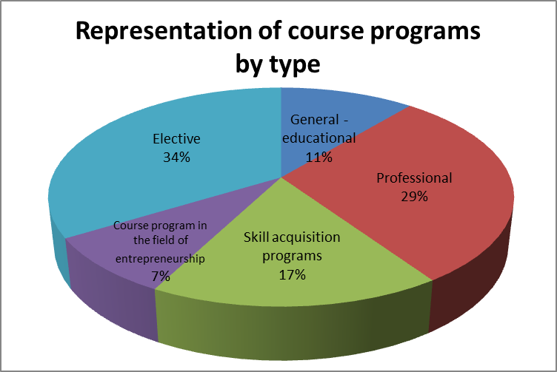
From the graph no. 1 it can be seen that there is a high level of electiveness that can be accepted as a positive circumstance because it enables directing the affinities of the candidates studying in the field of tourism and hospitality, as well as in entrepreneurship. The presence of professional disciplines, disciplines for acquiring skills and entrepreneurship courses is at a relatively high level. It is also characteristic that general - educational course programs are represented in a measure that provides academic knowledge of a general nature that can be used in the conduct of labor relations.

Graph no. 2 – Representation of types of course programs in the study program of Tourism
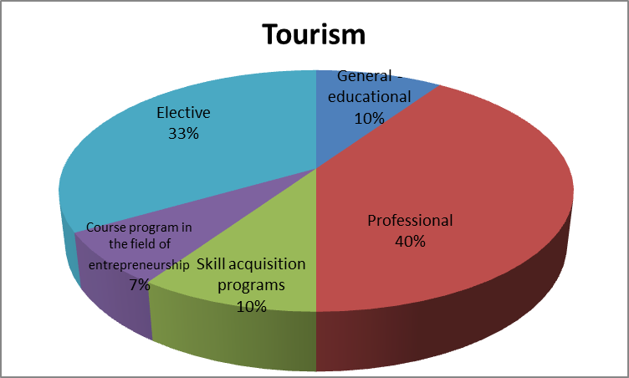

In this profile of studies, it is noticeable that professionalism and competence are dominant. This can be concluded from such representation, as well as from the electiveness and the ability to acquire skills. It can only be noted that the percentage of subject disciplines in the field of entrepreneurship that have to be promoted is relatively low.

Graph no. 3 – Representation of types of course programs in the study program of Gastronomy, nutrition and dietetics
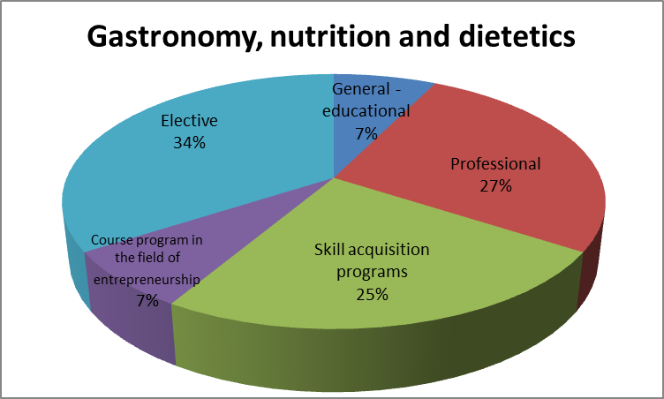
The profile of gastronomy, nutrition and dietetics is characterized by high electiveness, the presence of professional disciplines and skills acquisition programs. Also in this regard, course programs in the field of entrepreneurship, as well as general - educational disciplines are the least represented. Therefore, it is necessary to promote this conjuncture in favor of entrepreneurship.

Graph no. 4 – Representation of types of course programs in the study program of Hotel-restaurant management
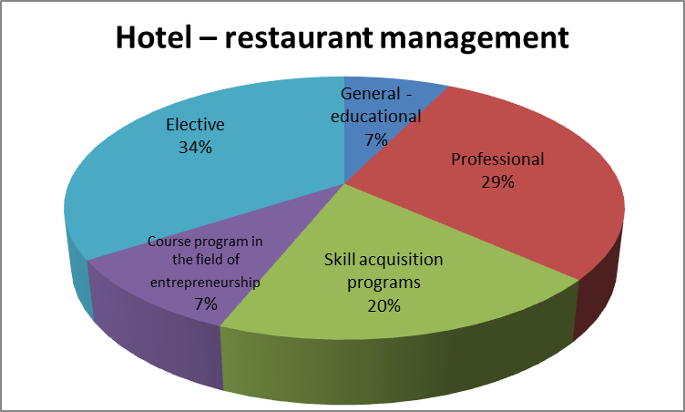

In the study program of hotel - restaurant management, electiveness is prevalent. There is a high level of professionalism as well as the presence of skills acquisition programs. The representation of the disciplines in the field of entrepreneurship is higher here than the general - educational subject programs which supports the validity of the structure of this study program.

Graph no. 5 – Representation of types of course programs in the study program of Management in service sector
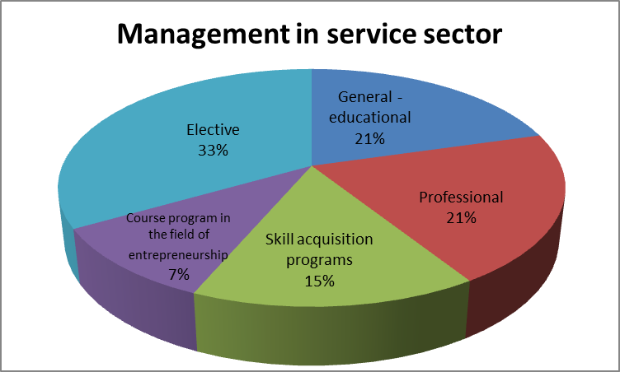

There are similar parameters of the study program of Management in service sector like the ones in Hotel - restaurant management. It is characteristic that it has high electiveness, high level of professionalism and general education. Also in this case, the presence of subject disciplines in the field of entrepreneurship is lagging behind, which is in contradiction with the very vocation of the program of management in service sector.

The analysis of second cycle of studies in these areas shows similar characteristics as in the structure of the first cycle of studies. This suggests that the envisaged advancements in the first cycle of studies at the faculties of this profile should also be applied in the second cycle of studies.

The analysis of curricula in secondary schools shows that they conform at the national level. Accordingly, this can be applied to all secondary schools that train staff in the field of tourism, hospitality and entrepreneurship.

Table no. 4. Representation of lecturing by courses and types of teaching in the educational profiles of hospitality – tourism profession in secondary education
Education profile
Programs, fields and type of lecturing |  | Hotel-tourist technician | Hospitality technician | Hospitality technician for rural tourism | Chef | Waiter | Total
General education | Common courses | 10 | 10 | 10 | 9 | 9 | 54
 | Courses in the function of the profession | 2 | 2 | 2
Professional education | Mutual courses for the profession | 5 | 5 | 5 | 7 | 7 | 51
 | Courses characteristic for an educational profile | 5 | 6 | 11
Practical teaching |  | 1 | 1 | 1 | 1 | 1 | 5
Optional courses |  | 2 | 2 | 2 | 0 | 0 | 6
Total |  | 25 | 26 | 31 | 17 | 17 | 116

In the structure of general education for the educational profile of hotel - tourist technician as common courses are included the following: Macedonian language and literature, First foreign language, Business, Informatics, History, History of Macedonia, Civic education, Sport and Sports Activities, Music and Arts
Courses in the function of the profession are the following: Mathematics and Second foreign language.
In professional education, common courses for a profession are the following: Fundamentals of hospitality and tourism, Tourism geography, Psychology, Hygiene and Culture of behavior, while courses typical for the educational profile are the following: Operation of travel agencies, Hotel operations, Tourism economics, Marketing and Cultural - historical heritage.
This profile includes practical teaching as part of the practical training, as well as school holidays practical work.
Optional courses are the following: Second foreign language and Mathematics
The hospitality technician profile has the same structure as the profile of hotel – restaurant technician. Only this profile differs for its courses that are characteristic for the educational profile, which are the following disciplines: Serving in hospitality, Cooking art, Economy of tourism, Marketing, Cultural - historical heritage of the Republic of Macedonia and Food and Beverages.

The profile of hospitality technician for rural tourism has the same structure and differs for its courses that are characteristic for the educational profile. These courses cover 11 disciplines: Alternative types of tourism, National gastronomy, Natural rarities in the Republic of Macedonia, Crop and livestock production, Organization of accommodation and lodging services, Hunting tourism, Religious tourism, Tourism management, Tourism economics, Marketing and Cultural - historical heritage.

The chef's educational profile is a three-year program that differs from the program of four years. The general education covers the following disciplines: Macedonian language and literature, First foreign language, History, Informatics, Mathematics, Geography, Biology, Arts and Sports and sports activities.
The professional theoretical education covers the following: Fundamentals of hospitality and tourism operations, Hygiene and ecology, Cooking art, Food and beverages, Psychology and communications, Decoration in cooking art and Fundamentals of serving. There is also practical teaching and school holiday practical work in this program.

The profile of waiter does not show differences in terms of its general - educational disciplines. The following disciplines are encompassed in professional theoretical education: Fundamentals of hospitality and tourism, Hygiene and ecology, Second foreign language, Hospitality serving, Food and beverages, Psychology and communications and Fundamentals of the art of cooking.

Graph no. 6 – Percentage of teaching types in secondary education from the field of hospitality and tourism
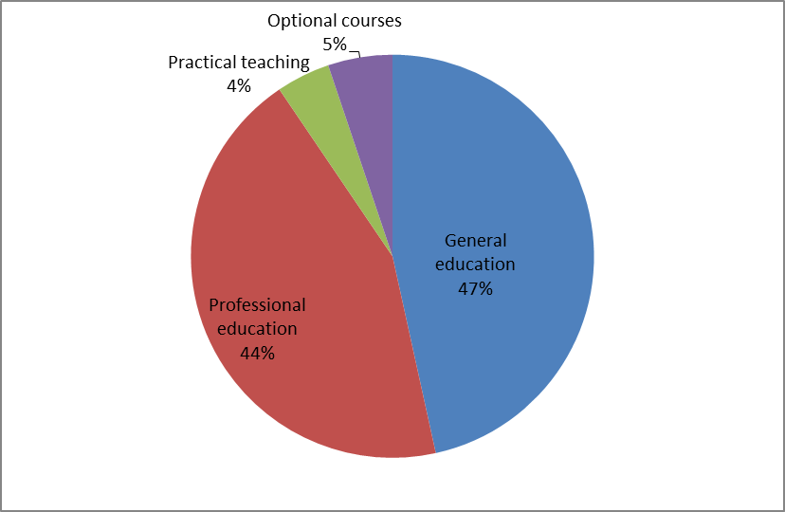

As seen in the graph above it can be concluded that the lowest representation has the practical teaching (4%), while the largest representation has general education (47%). This means that it is necessary to improve this program in terms of practical education activities. It should be noted that these relations are alleviated because of the existence of school holiday practical work, lasting a total of 20 days. However, it is obvious that the prevalence of general education can not fully meet the needs of the tourism and hospitality sector. It is therefore necessary to reduce the participation of the general education while increasing the practical training and professional education.

ASSESSMENT OF THE CURRICULA IN THE FIELD OF TOURISM, HOSPITALITY AND ENTREPRENEURSHIP

In order to get an assessment of the curricula in the field of tourism, hospitality and entrepreneurship, we used the primary research. In this context, we constructed a questionnaire. We conducted the questionnaire on a total of 210 respondents aged 18 to 30. This population encompassed 190 students and 20 managers in the hospitality and tourism sector in Kicevo.

Table no. 5 - What is your field(s) of education (according to the Frascati classification)
 |  | Frequency | Percent | Valid Percent | Cumulative Percent
Valid | Tourism | 90 | 42,9 | 42,9 | 42,9
 | Other social fields | 90 | 42,9 | 42,9 | 85,7
 | Technical - technological sciences | 10 | 4,8 | 4,8 | 90,5
 | Medical sciences and public health | 20 | 9,5 | 9,5 | 100,0
 | Total | 210 | 100,0 | 100,0

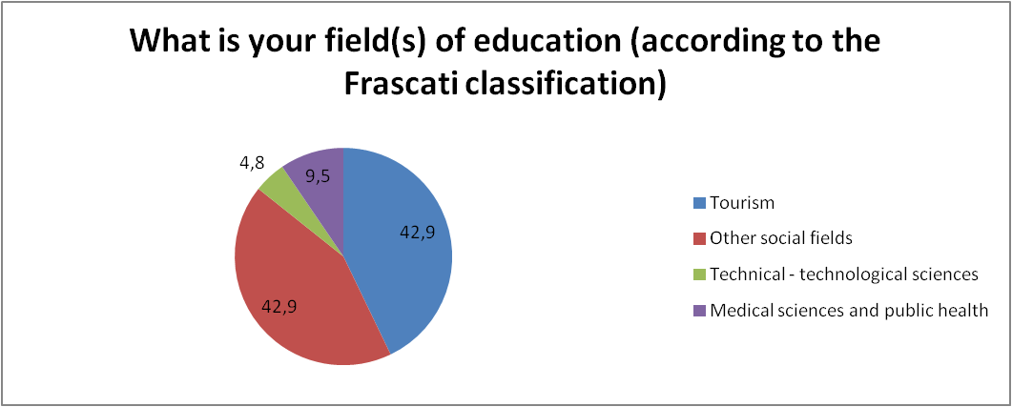

The first question concerns the type of education completed according to the classification of fields and areas of education. Expectedly, 42.9% of the respondents are from the field of tourism, and an additional 42.9% are from other social fields. This means that the staff that is part of this research is from the appropriate area of expertise and their recommendations will be valid.

Table no. 6 - Determine the representation of employees with education in tourism and hospitality and entrepreneurship in this sector in Kicevo
 |  | Frequency | Percent | Valid Percent | Cumulative Percent
Valid | up to 20% | 90 | 42,9 | 42,9 | 42,9
 | from 21 to 50% | 40 | 19,0 | 19,0 | 61,9
 | from 51% to 70% | 70 | 33,3 | 33,3 | 95,2
 | More than 70% | 10 | 4,8 | 4,8 | 100,0
 | Total | 210 | 100,0 | 100,0

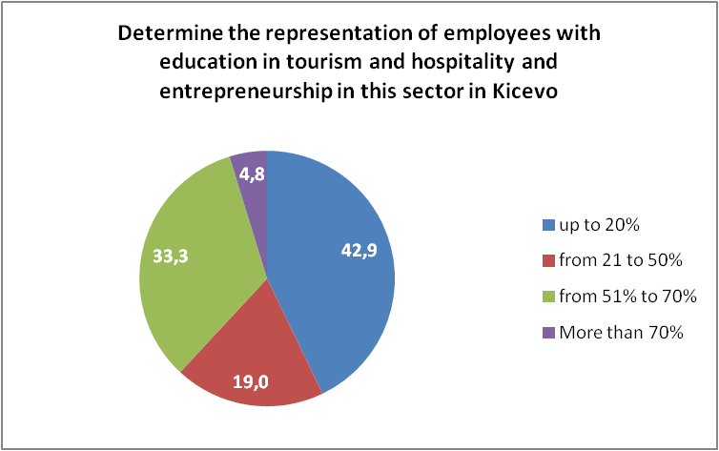

Although the majority of the respondents are from the field of tourism and social sciences, most of the answers say that up to 20% of the employees are from this sector. In second place according to representation is the answer that between 51% and 70% of employees are from the field of tourism.

Table no. 7 - What is your opinion on the quality and suitability of curricula in secondary education in the field of tourism and hospitality
 |  | Frequency | Percent | Valid Percent | Cumulative Percent
Valid | Totally appropriate | 80 | 38,1 | 38,1 | 38,1
 | Appropriate to a greater extent | 110 | 52,4 | 52,4 | 90,5
 | Slightly appropriate | 20 | 9,5 | 9,5 | 100,0
 | Total | 210 | 100,0 | 100,0

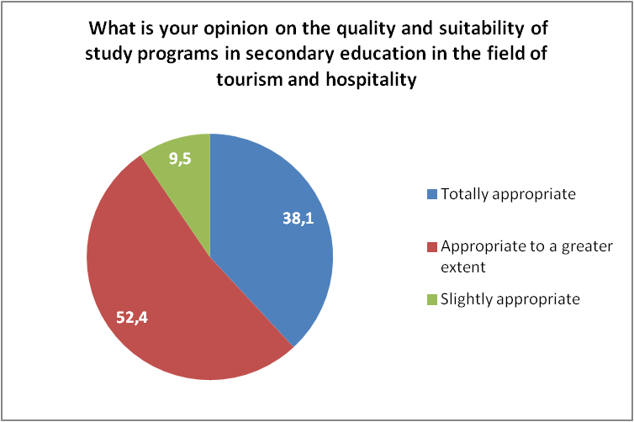

The third question relates to the appropriateness of curricula in secondary schools. The answer to this question is significant, given that all state secondary schools in the field of tourism and hospitality operate under the same curriculum. According to the results, the majority of the respondents (52.4%) have answered that the programs are "Appropriate to a greater extent". The answer is "Totally appropriate" with a share of 38.1%. These answers indicate the adequacy of curricula in the field of tourism and hospitality in secondary education.

Table no. 8 - What is your opinion on the quality and suitability of curricula in higher education in the field of tourism and hospitality
 |  | Frequency | Percent | Valid Percent | Cumulative Percent
Valid | Totally appropriate | 110 | 52,4 | 52,4 | 52,4
 | Appropriate to a greater extent | 100 | 47,6 | 47,6 | 100,0
 | Total | 210 | 100,0 | 100,0

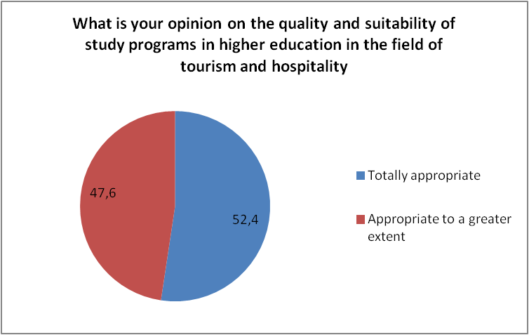

The fourth question relates to the quality and appropriateness of curricula in higher education. Although the respondents were given four answers to choose from: “Totally appropriate”, “Appropriate to a greater extent”, “Slightly appropriate” and “Not appropriate at all”, they selected only the first two answers. That means there is not one negative answer. More than 50% of the respondents opted for the answer " Totally appropriate ". This confirms that the curricula in the field of tourism and hospitality in higher education are appropriate for the profession being studied.

Table no. 9 - What is your opinion on the quality and suitability of curricula in master studies in the field of tourism and hospitality
 |  | Frequency | Percent | Valid Percent | Cumulative Percent
Valid | Totally appropriate | 150 | 71,4 | 71,4 | 71,4
 | Appropriate to a greater extent | 60 | 28,6 | 28,6 | 100,0
 | Total | 210 | 100,0 | 100,0

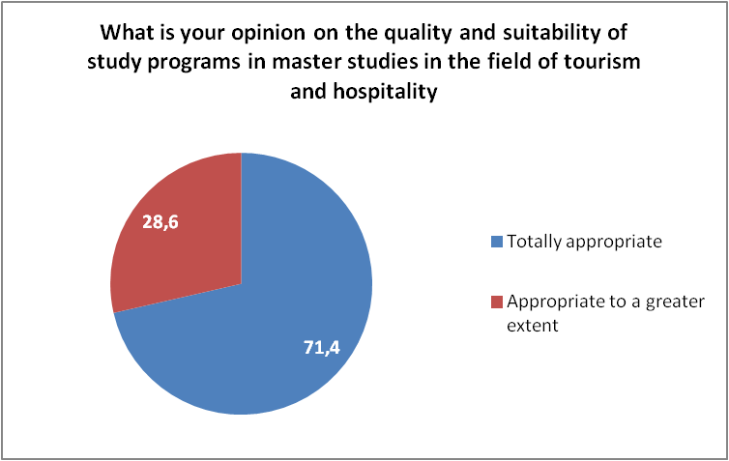

The fifth question concerns the appropriateness of curricula in the postgraduate (master) studies in the field of tourism. Also for this question the respondents chose the first two answers, like the previous question, with the difference that 71.4% gave the best answer "Totally appropriate". Thus, the respondents believe that the curricula at the master studies are completely suitable for the field.

The following questions relate to the assessment of certain aspects of the curricula in the field of tourism.
The sixth question examines the prevalence of practical teaching in education in the field of tourism. For this question the employees in companies from the field of tourism and hospitality can respond appropriately because the students conduct their practical training in these companies. The results are given below:

Table no. 10 - Evaluate the prevalence of practical training in education in the field of tourism
 |  | Frequency | Percent | Valid Percent | Cumulative Percent
Valid | Excellent | 80 | 38,1 | 38,1 | 38,1
 | Very good | 70 | 33,3 | 33,3 | 71,4
 | Good | 60 | 28,6 | 28,6 | 100,0
 | Total | 210 | 100,0 | 100,0

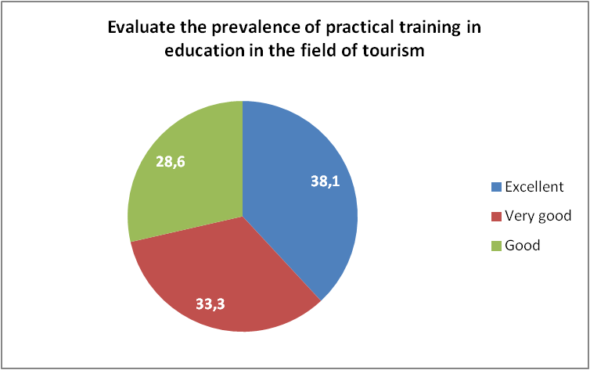

Although there were a total of five possible answers to choose from (from Excellent to Insufficient), the respondents chose the top 3 answers "Excellent", "Very Good" and "Good". The answers were in the largest part “Excellent”, provided by the majority of the respondents (38.1%). This shows that practical teaching is mostly prevalent in education.

Table no. 11 - Evaluate the prevalence of professional disciplines in the curricula of secondary schools in the field of tourism and hospitality
 |  | Frequency | Percent | Valid Percent | Cumulative Percent
Valid | Excellent | 100 | 47,6 | 47,6 | 47,6
 | Very good | 90 | 42,9 | 42,9 | 90,5
 | Good | 20 | 9,5 | 9,5 | 100,0
 | Total | 210 | 100,0 | 100,0

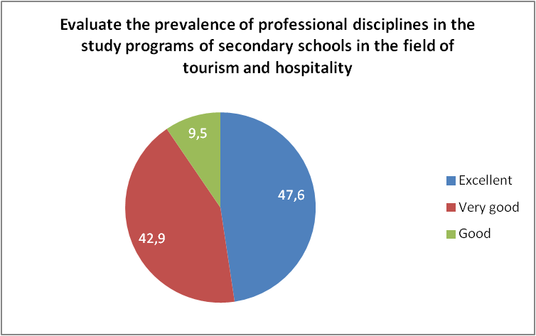

Also for the seventh question "Evaluate the prevalence of professional disciplines in the study curricula of secondary schools in the field of tourism and hospitality", the respondents chose the top three answers. The majority of them chose the answer "Excellent". Thus, it can be concluded that the professional disciplines are sufficiently prevalent in the curricula in secondary schools.

Table no. 12 - Evaluate the prevalence of professional disciplines in the curricula of faculties in the field of tourism and hospitality
 |  | Frequency | Percent | Valid Percent | Cumulative Percent
Valid | Excellent | 140 | 66,7 | 66,7 | 66,7
 | Very good | 70 | 33,3 | 33,3 | 100,0
 | Total | 210 | 100,0 | 100,0

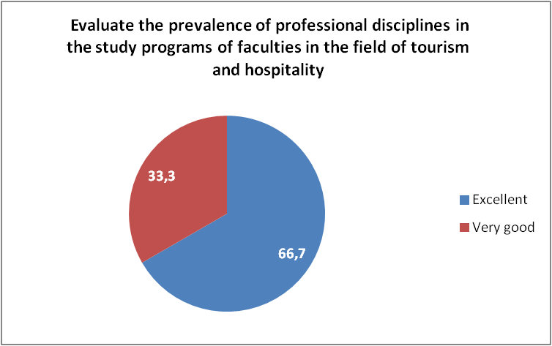

The assessment of the prevalence of professional disciplines in the curricula at the faculties in the field of tourism and hospitality is even higher. Respondents chose only the top two options "Excellent" and "Very good".

Table no. 13 - What do you think about introducing modern disciplines like ICT, ecology, modern gastronomic skills
 |  | Frequency | Percent | Valid Percent | Cumulative Percent
Valid | Excellent | 110 | 52,4 | 52,4 | 52,4
 | Very good | 100 | 47,6 | 47,6 | 100,0
 | Total | 210 | 100,0 | 100,0

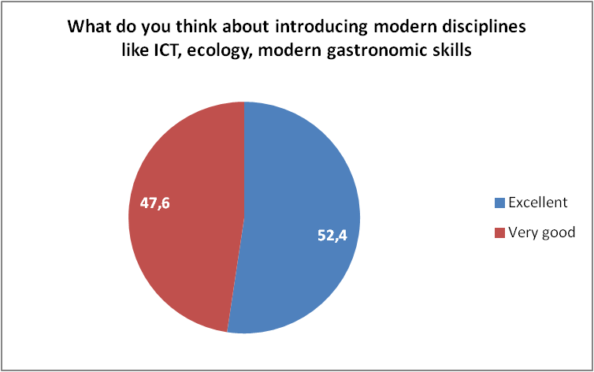

The eighth question relates to the prevalence of contemporary disciplines in the curricula of the faculties in the field of tourism and hospitality. The assessment of the respondents was also very positive for this question. Many of the contemporary disciplines are already part of the curricula in the field of tourism. The respondents chose the top two answers "Excellent" and "Very good".

Table no. 14 - What is your opinion on the prevalence of foreign languages in the curricula
 |  | Frequency | Percent | Valid Percent | Cumulative Percent
Valid | Sufficiently prevalent | 60 | 28,6 | 28,6 | 28,6
 | Insufficiently prevalent | 150 | 71,4 | 71,4 | 100,0
 | Total | 210 | 100,0 | 100,0

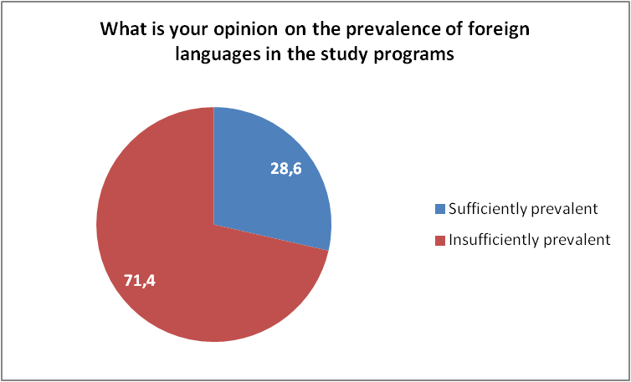

For the ninth question about the prevalence of foreign languages in the curricula, the respondents in a greater extend expressed negative views. They believe that foreign languages are insufficiently prevalent in education in the field of tourism. The following two questions are related to this issue.

Table no. 15 - What is your opinion on how many foreign languages should be taught in high school in the field of tourism and hospitality
 |  | Frequency | Percent | Valid Percent | Cumulative Percent
Valid | 2 | 80 | 38,1 | 38,1 | 38,1
 | 3 | 130 | 61,9 | 61,9 | 100,0
 | Total | 210 | 100,0 | 100,0

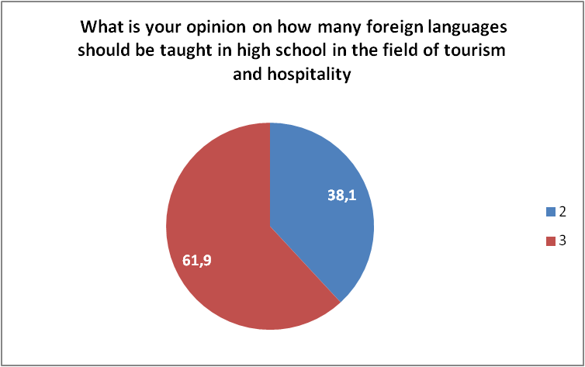

The majority of the respondents answered that in secondary education related to the field of tourism and hospitality, three languages should be taught. This is not the case in the current programs. No respondent provided an answer for the option “1”. The conclusion is that employees in companies in the field of tourism and hospitality need to know more foreign languages in order to be successful in their work

Table no. 16 - What is your opinion on how many foreign languages should be taught at the faculties from the field of tourism and hospitality
 |  | Frequency | Percent | Valid Percent | Cumulative Percent
Valid | 2 | 40 | 19,0 | 19,0 | 19,0
 | 3 | 170 | 81,0 | 81,0 | 100,0
 | Total | 210 | 100,0 | 100,0

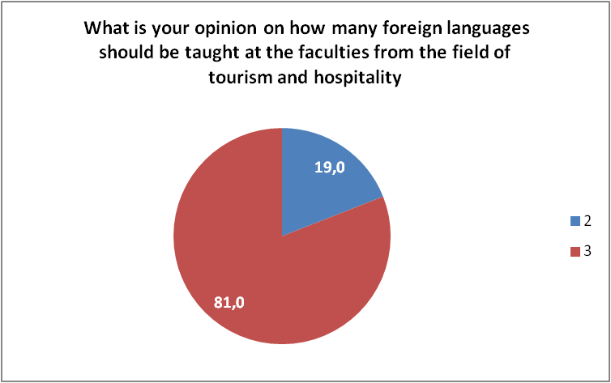

The obtained results for the eleventh question about the number of foreign languages that students at the faculties should study are similar to the previous question. More than 80% of the respondents chose the answer “3”. Their opinion is that students should study at least three foreign languages during. This opinion should be taken into account when creating curricula in the field of tourism.

Table no. 17 - Do you think that general cultural disciplines should be more prevalent in the curricula
 |  | Frequency | Percent | Valid Percent | Cumulative Percent
Valid | Sufficiently prevalent | 120 | 57,1 | 57,1 | 57,1
 | Insufficiently prevalent | 70 | 33,3 | 33,3 | 90,5
 | No prevalent at all | 20 | 9,5 | 9,5 | 100,0
 | Total | 210 | 100,0 | 100,0

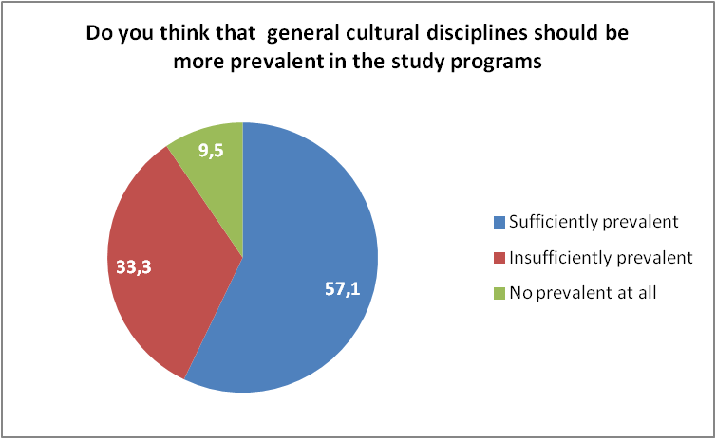

The 12th question "Do you think that general cultural disciplines should be more prevalent in the curricula", the majority of the respondents (57.1%) answered that these disciplines are sufficiently prevalent. Studying culture is an important part of the knowledge that students acquire in the curricula related to tourism.

Table no. 18 - Your opinion about introducing multiple disciplines from the field of professional education
 |  | Frequency | Percent | Valid Percent | Cumulative Percent
Valid | Sufficiently prevalent | 140 | 66,7 | 66,7 | 66,7
 | Insufficiently prevalent | 70 | 33,3 | 33,3 | 100,0
 | Total | 210 | 100,0 | 100,0

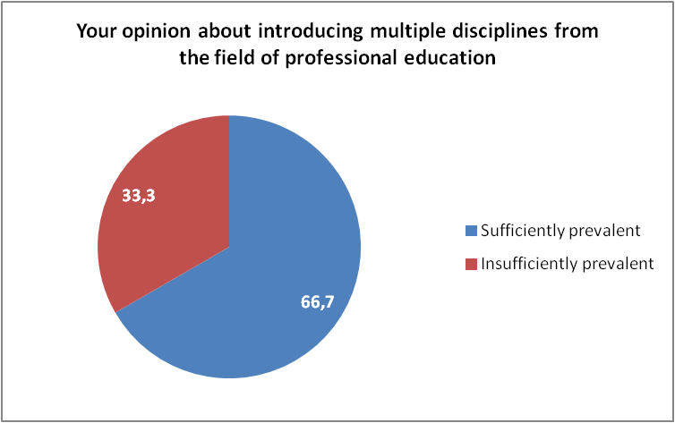

The 13th question "What is your opinion about introducing multiple disciplines from the field of professional education (techniques and skills for carrying out the work process)". Two-thirds of the respondents believe that these disciplines are sufficiently represented in the process of education.

Table no. 19 - Your opinion about the use of modern didactic means in teaching
 |  | Frequency | Percent | Valid Percent | Cumulative Percent
Valid | Sufficiently prevalent | 150 | 71,4 | 71,4 | 71,4
 | Insufficiently prevalent | 60 | 28,6 | 28,6 | 100,0
 | Total | 210 | 100,0 | 100,0

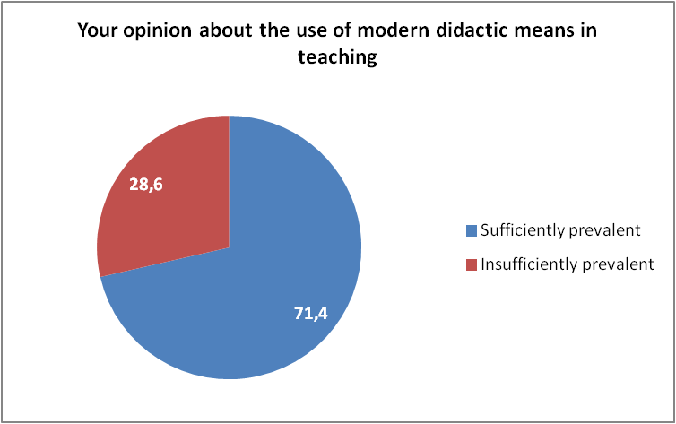

From the responses for the 14th question, it can be concluded that the modern didactic means are sufficiently prevalent in education in the field of tourism and hospitality. More than 70% of the respondents answered that the modern didactic means are sufficiently prevalent in education.

Table no. 20 - Your opinion about the interactivity during lectures in high schools
 |  | Frequency | Percent | Valid Percent | Cumulative Percent
Valid | Sufficiently prevalent | 100 | 47,6 | 47,6 | 47,6
 | Insufficiently prevalent | 80 | 38,1 | 38,1 | 85,7
 | No prevalent at all | 30 | 14,3 | 14,3 | 100,0
 | Total | 210 | 100,0 | 100,0

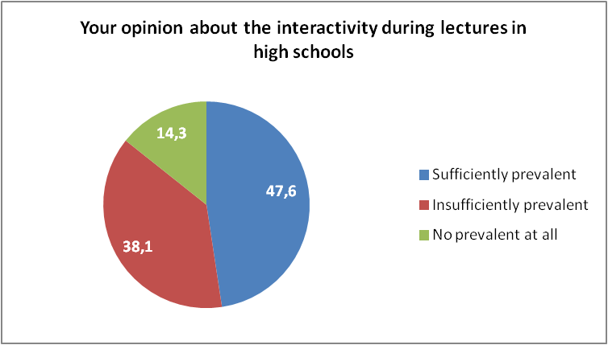

The last, 15th question was about the interactivity during lectures in secondary schools. The majority of the respondents answered that interactivity is sufficiently prevalent, but more than 30% answered that they are insufficiently prevalent (38.1%). A large portion of the respondents (14.3%) believe that interactivity is not prevalent at all. There is the possibility to improve interactivity during classes in this field. Project-oriented education is still a challenge for our secondary schools, as well as the encouraging of critical thinking throughout education.

SWOT ANALYSIS

STRENGTHS | WEAKNESSES
- Respondents mostly belong to tourism and social sciences  - The quality of the study programs in secondary education is satisfactory, while in higher education (graduate and master studies) they have the highest level of appropriateness  - The prevalence of practical teaching and professional disciplines in secondary and higher education in the field of tourism, hospitality and entrepreneurship is excellent and very good  - General cultural disciplines are sufficiently prevalent in the curricula  - Modern didactic means are sufficiently represented in teaching at all levels  - Young people have a positive opinion about the curricula in terms of easier involvement in work processes | - The employees in hospitality - tourism enterprises have a certain education in the field of tourism and hospitality, but their prevalence is relatively low  - Insufficient prevalence of interactivity during lectures in secondary and higher education  - Curricula should be further improved to the requirements of companies in the tourism and hospitality sector  - Practical training should be introduced on a higher level in the process of education
OPPORTUNITIES | THREATS
- There is a positive opinion regarding the introduction of modern disciplines, such as ICT, ecology, modern gastronomic skills etc., in the process of education  - The number of foreign languages that need to be taught opportunity should be at least 3 which is the optimum  - The main and key components of tourism are a part of the curricula, they should just be adapted and built up  - Legislation and strategic documents have a positive connotation towards education in tourism, hospitality and entrepreneurship  - The harmonization of curricula at different levels allows for continuity in the process of education  - Young population can participate in non-formal education and advance their knowledge and skills in the field of tourism, hospitality and entrepreneurship  - Young people can use different pre-accession funds of the European Union in the field of education through the implementation of identified projects for this purpose (IPA, INTERREG, IPARD and others)  - Different funds for young entrepreneurs  - Use of perquisites and subsidies in the field of employment as measures of the Government of the Republic of Macedonia  - The harmonization of curricula with the needs of enterprises in the field of tourism and hospitality allows for a greater efficiency in employment in this sector  - Entrepreneurs have an active attitude in the creation of curricula in secondary and higher education in this profession  - Modern approaches to education and the use of didactic means and standards will lead to harmonization between education and contemporary market trends  - Legislation is a good framework for implementing the strategic goals in education and tourism sector in the Republic of Macedonia | - Foreign languages are not sufficiently prevalent in the curricula at all levels in the field of tourism, hospitality and entrepreneurship  - The current demographic situation leads to emigration, ageing of the population and depopulation of small settlements in the country  - The lasting dependence of young people on their parents and family decrease their own initiative  - Insufficient number of organized campaigns that point out the benefits for businesses’ start-up in the field of tourism and hospitality  - Low level of balanced economic development in Macedonia, especially in rural areas  - Administrative procedures in using funds for starting-up business activities  - Insufficient prevalence of innovations in terms of using the own acquired knowledge in the field of tourism and hospitality

CONCLUSION

The analysis of the local curricula in the field of tourism, hospitality and entrepreneurship in the Republic of Macedonia has shown that this is an issue related to the connection of these two interactive areas. They influence the overall development of the country and especially in the development of enterprises in underdeveloped areas, such as the municipality of Kichevo. The strategic documents in the Republic of Macedonia contain a positive impact on the prioritization of education in the field of tourism and hospitality. Enterprises in these domains provide not only individual prosperity, but also total development of the society. Legislation is a positive framework for these processes. Considering the dynamics of education and the acquisition of new knowledge, there is an appropriate approach in adapting the legislation in order to improve the conditions for tourism and hospitality management.
The prevalence of high schools in the country is balanced, thus enabling the acquisition of knowledge in different areas. The total number of schools corresponds to the education needs. Higher education of the first and second cycle of studies has similar characteristics. The curricula are adapted to the needs of enterprises; however, further improvements are needed in this regard. This refers especially to entrepreneurship and the start-up of new businesses in the tourism and hospitality sector. The harmonization of curricula at different levels ensures a continuous educational process. In the country there is also informal education in the field of tourism and hospitality, which allows for the introducing of retraining, advanced training activities and lifelong education. However, this part of the process of education should also be improved.
The structure of practical teaching, professional disciplines and school-holiday practical work are the basic paradigm in the promotion of the quality of education in this domain, since they allow for an easier employment and more efficient working processes that have entrepreneurial character.
The adoption of modern approaches in the creation of curricula will contribute to reaching the levels that are present in the education of EU countries.

REFERENCES

- Curricula of first and second cycles of studies at the Faculty of Tourism and Hospitality – Ohrid, 2018
- Korunovski S., Marinoski N., Andreeski C., Risteski M. (2012) Preparation, presentation and dissemination of a strategy for sustainable tourism development, Center for Education and Networking in Tourism – CENET, European Union External Actions
- Law on Catering of the Republic of Macedonia
- Law on Tourism of the Republic of Macedonia
- Ministry of Education and Science, official website: http://www.mon.gov.mk/index.php
- National Strategy for Tourism in the Republic of Macedonia (2015-2020)
- State Statistical Office of the Republic of Macedonia, official website: http://www.stat.gov.mk/
- Curricula and courses of secondary schools in the Republic of Macedonia
- Sub-strategy for tourism development of the South-West Planning Region, 2015

National Strategy for Tourism in the Republic of Macedonia
Ibid

