OTTOMAN HERITAGE TOURISM FLOWS IN MACEDONIA

Ivanka Nestoroska; Biljana Petrevska ; Petar Namicev

Abstract

Five centuries of Ottoman oppression in Macedonia has left deep traces as a real mixture of cultures and religions. The remnants of that turbulent time are noticeable today in more than 150 different cultural relicts dispersed over the whole territory, out of which more than half may be valorized in tourism manner. Yet, currently only some 20 original sites are on the list for tour visiting. The aim of the research is to investigate presence of current and potential tourism heritage flows based upon cultural heritage in Macedonia dating from the Ottoman period. This is done by employing the Saint Gallen Destination Management model which enables reconstruction of strategic visitors’ flow. The qualitative data analysis is derived by conducting interviews with local tourist guides. Based on findings, the study produced maps on the current Ottoman heritage tourism routes thus enabling better understanding of their shape. Furthermore, several new routes are identified as strategic visitors’ flows, which may enhance further tourism development of the country. Finally, the study recommends design and development of an Ottoman heritage tourism product within the frames of cultural tourism development at regional, or even national level.

Key Words: Ottoman heritage sites, Strategic visitors flows, Tourism

JEL classification: L83, Z32

Introduction
Cultural tourism supported by heritage sites, is one of the leading motives in tourism industry resulting in development of specific tourism products (Bond et al., 2015; Dinis & Krakover, 2015). The heritage sites are often destined to be leading or supporting spots on the tourism course generally being designed for specific groups of tourists and visitors (Moscardo & Pearce, 1999). Heritage is a rasing tourism product that provides tourists with experiences based on the (in)tangible remains of the past. This resulted in inevitable relationship between the cultural heritage and tourism (Fonseca & Ramos, 2012; Garrod & Fyall, 2000; Loulanski & Loulanski, 2011).
Despite the growing interest for sightseeing heritage dating from the Ottoman period, empirical investigation of tourist practices is missing. There are limited studies that treat Ottoman Empire and in this line the Ottoman heritage sites (OHS) from a tourism approach. Nance (2007) suggests a facilitated access model to describe how local people make and have made use of tourism when being related to the Ottoman heritage. Alp (2009) argues the perception of a comprehensive cultural heritage of the Ottoman period (14-20 century) in the Balkans noting it as a common heritage for all nations in the Balkans. Davis (2013) explores the representation of the Ottoman heritage in Israel by elaborating the case of the Hammam al-Pasha as a tourist attraction. Luke (2013) elaborates the rehabilitation of the Islamic heritage in the Balkans by putting different shade that preservation of cultural heritage projects demonstrate symbolic power of cultural sovereignty. Arslan and Polat (2015) discuss the Ottoman Empire’s first attempt to establish hotels in Istanbul by examining the earliest related documents.
While studies that refer to OHS may be found, those that put a respect to the demand flow investigation are rather limited. The Saint Gallen Destination Management (SGDM) model (Beritelli et al., 2015; Beritelli & Laesser, 2017) is based on the territorial concept in the first line by explaining how the land is managed for tourism by creating various flows. The importance of the land through which all visitors flow implies understanding the destination as a place with very dynamic tourism demand (Gunn, 1997).
Generally, this study aims in exploring the current Ottoman heritage flows (OHF), even though following the experiential approach, light is shed on the possibilities for developing new strategic visitors’ flows (SVF) that may enhance tourism development based on OHS. Macedonia represents a suitable testing ground for investigation since it is rich with cultural heritage dating from the Ottoman period. With the exception of Petrevska and Namicev (2017) who argue the possibilities for reanimating the Ottoman heritage on local level in Macedonia, no academic studies have so far been carried out with such comprehensive approach like this research explores. Besides its contribution to the literature as a pioneer study in Macedonia’s academic work, the study has practical significance since it recommends design of new routes as important component of tourism supply. It praises that local, regional and national authorities should induce more proactive attitude among tourism policy makers, which is easily manageable if changing the perception.
After the introduction, section two provides a background material on the presence of OHS in Macedonia. Section three addresses the research methodology, followed by a summary of the findings and discussion. Section four presents the main conclusions and recommendations for developing new tourism routes based upon the already identified new cultural flows. The final section covers the limitations with future work that may be addressed in new research.
Background material
Five centuries of Ottoman oppression in Macedonia has left deep traces as a real mixture of cultures and religions. Unlike the darkness of the medieval Byzantine time, the Ottoman Empire brought the erotic and narcotic scent of the Orient. Each historic period, particularly the Ottoman rule (1392-1912) left footprints on tradition, mentality, language and peoples culture. Ottoman architecture and style meant a significant structural changes of the town. For the practice of the Muslim religion, they built a large variety of new types of buildings. The bazaar became the economic center of each town, surrounded with public buildings, such as hamams, bedestens, karavanseray and other facilities, some of them being concentrated around the mosques. Bridges were part of the transport system, aqueducts for water supply, and clock towers completed the architectural panorama. The architecture the best reflected the ottoman spirit, which was drawn from both Islamic and Christian artistic tradition. The main characteristic features of Ottoman architecture and art was expressed through decoration of buildings, mosques and hamams, with arabesques, laceria (decoration sheme), Islamic calligraphy, tile revetment and some fresco paintings.
The remnants of that turbulent time are noticeable today in more than 150 different cultural relicts being dispersed all over the whole territory of Macedonia. More than half of them (around 80) may be valorized in tourism manner. Yet, less than half of that eighty cultural assets are on the list for tour visiting. According to the significance of the buildings, the extent of their preservation and accessibility to the public, today there are only 33 significant OHS in Macedonia with specific features (Pavlov & Petkova, 2008). Such presence stands as great potential for creating tourist product that may contribute to differentiation and diversification of cultural tourism supply in Macedonia.
Research methodology
The study has two primary aims: (i) To investigate presence of current Ottoman heritage tourist flows by interviewing tourist guides; and (ii) To detect new tourism Ottoman heritage flows by applying the SGDM model. Addressing these research aims is of potential contribution to a better understanding of the nature of visitation patterns to sites related to cultural assets belonging to others, in this case dating from the Ottoman period.
A total of 15 interviews were conducted in the period April-May 2017. The target group consisted of local tourist guides that guide in Turkish language, specific tours arranged for tourists from Turkey. Specifically, they are hired by tourist agencies, which already have prepared tour programs that need to be accomplished by the tourist guides. During the interview procedure, full notes were taken, upon which a qualitative data analysis was conducted encompassing two steps: (1) Concise summarization; and (2) Compilation of themes. Information obtained from the interviews was summarized into items, and those items with similar meanings were categorized in order to draw conclusions. Prior to entering the field survey, an interview protocol was prepared which presented a six-step guideline framework. The protocol incorporated the following parts: Introduction; Description of the guided itinerary; Experiential judgement; Tourism route decisions; Ex-facto justification; and Interviewees data. The summarized figures on respondents’ profile are presented in Table 1.
Table 1. Interviewee data
Item | Average/Prevailing
Age: between 23-56 years | 33 years
Gender: 13 male (87%)  2 female (13%) | Male
Nationality: Turks (100%) | Turks
Time for interviewing: 10-25 min | 16 min
The second data source incorporated a consultation of secondary sources in terms of review of literature, such as historical data as well as materials that directly or indirectly deal with Ottoman history and OHS in Macedonia. In this line, the study adopts the deductive methodology anchored in grounded theory of Michalos (1969). Several procedures, different methods and tools were applied enabling triangulation and validation of gathered data (Yin, 2003).
So, a comprehensive review of OHS in Macedonia was done. By applying a regional approach, an inventory list of all sites dating from Ottoman period dispersed over eight regions in Macedonia was created. That extended inventory list consisted of: 59 mosques, 12 bridges, 20 clock towers/towers, 16 hamams, 4 bedestens, 6 inns/hans, 12 turbe, 1 konak, 5 public buildings, 3 tekke, 5 bazaars, 1 magaza and 1 medrese. After a rapid assessment of inventoried OHS that may be valorized for tourism purposes, a new summarized list was made, this time encompassing total of: 26 mosques, 9 bridges, 13 clock towers/towers, 9 hamams, 3 bedestens, 4 inns/hans, 3 turbe, 2 konak, 3 public buildings, 2 tekke, 5 bazaars, 1 magaza and 1 fortress. As noted earlier, the study applied the SGDM model, upon which several SVF are mapped. This model allows better understanding of specific tourist flows and arranges effective planning of future tourism development. This enables a complex multidisciplinary approach, which empowers to better understand the broad context.
Findings and discussion
The findings were analyzed in two stages. In the first stage, upon the gathered data of all sources, particularly after the interview material, by applying the SGDM model, the SVF are mapped, thus marking the first Ottoman heritage routes (OHR) in Macedonia. In the second stage, following the experiential approach, new OHR are mapped covering other parts of Macedonia, thus identifying new possibilities for enhancing tourism development of Macedonia.
Figure 1. SVF for Macedonia
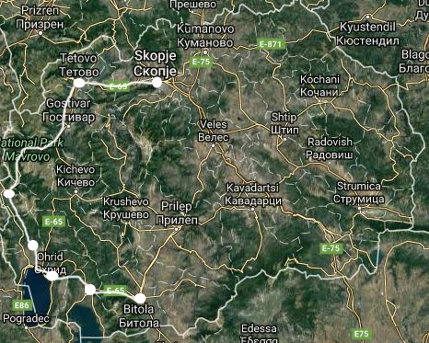
Source: Own illustrations, graphics ©2017 Google maps
Figure 1 presents the map of SVF on OHS for Macedonia, based upon interviewees’ responses. Namely, tourist guides were asked to describe the routes they are guiding by identifying the system heads i.e. the main supply elements in terms of a space. So, six system heads were identified, which resulted in Figure 2, representing separate maps for each supply element of Skopje, Tetovo, Centar Župa (village Kodžadžik), Ohrid, Resen and Bitola.
Figure 2. Separate maps on SVF on Ottoman Herritage
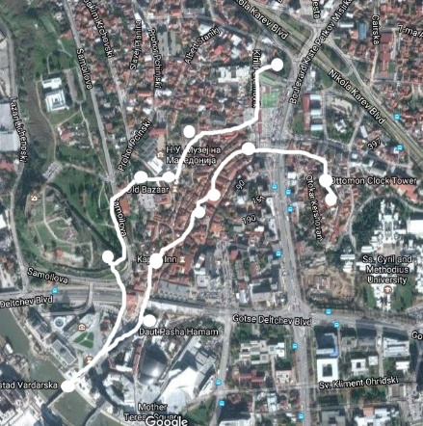 | 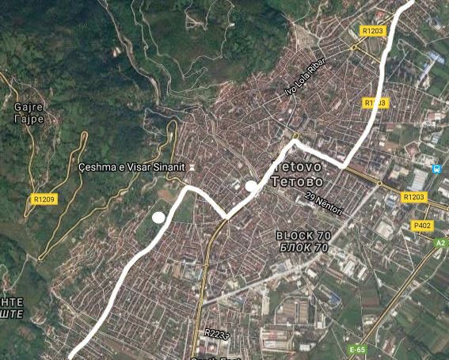
- Skopje | - Tetovo
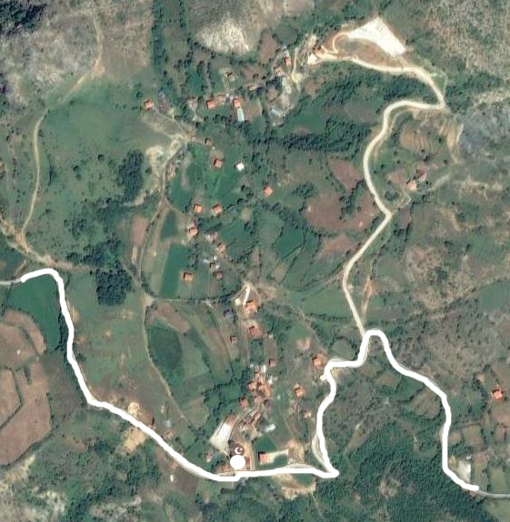 | 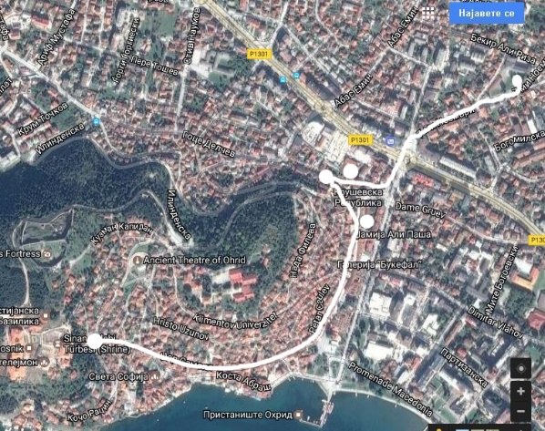
- Centar Župa (Kodžadžik) | - Ohrid
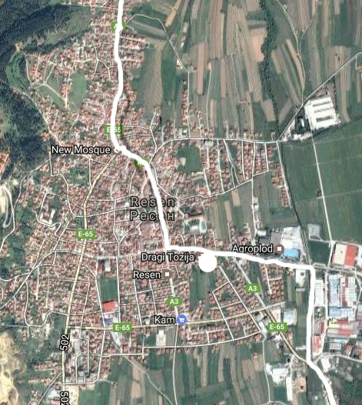 | 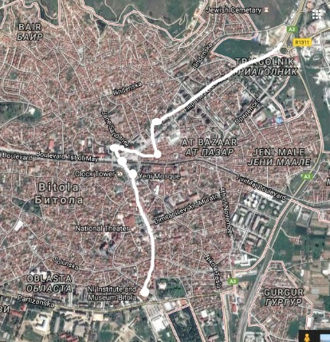
- Resen | - Bitola
Source: Own illustrations, graphics ©2017 Google maps
Figure 2a represents the OHR that covers Skopje. Particularly the old part of Skope has impressive architectural monuments being restored and rebuilt many times, and today, beside the status of monuments of culture, have a new purpose in the cultural life of Macedonia. The OHR in Skopje includes: Gazi Isa Bey mosque, Kuršumli An, Bedesten, Mustafa Paša mosque, Skopje Fortress, Stone Bridge, Išak Beg mosque, Daut Paša Hammam, Bit Pazar, Kapan An, Čifte Hammam, Suli An, Bazaar, Murat mosque (with Clock Tower). Figure 2b represents the OHR for Tetovo which has remarkable Ottoman cultural heritage. It includes: Alaca mosque and Harabati Baba Tekke. Recently, the itineraries are expended with a route in Centar Župa (Debar) by visiting the Memorial Museum in the village Kodžadžik where Hafiz Ahmet Efendi, the grandfather of Mustafa Kemal Ataturk was born (Figure 2c). Figure 2d presents the OHR for Ohrid, where besides non-Ottoman heritage sites, tourists visit Hadži Turgut Mosque, Tekke of the Helveti, old Bazaar, Ali Paša mosque and Tomb of Sinan Čelebi. Resen is a small city and besides the Niyazi Bey Sarai, it offers no other sites dating from the Ottoman period (Figure 2e). Before leaving Macedonia, just before the border with Greece, the last OHR is done covering Bitola (Figure 2f). It includes: Haydar Kadi Mosque, Bazaar, Isak Čelabi mosque, Bedesten, Jeni Mosque and the City museum (Mustafa Kemal Ataturk section).
Generally, the Turkish tourists visit Macedonia on round tours, spending only 2-3 days. Based upon official statistics (State Statistical Office, various years), a constant rise during 2000-2016 in terms of tourists and overnights is noted. This is supported with the facts that in 2016, the number of tourists increased for almost 16 times, from 6,700 in 2000 to 105,738, while the overnights increased for almost 9 times, from 17,037 in 2000 to 152,748. When comparing 2015 and 2016, the number of tourists increased for 14,881 (or 16%) from 2015 (90,857) to 2016 (105,738), while the number of overnights increased for 17,493 (or 13%) from 2015 (135,255) to 2016 (152,748). When analyzing the average length of stay for 2000-2016, it is 1.9 days, whereas the highest is registered in 2000 (2.5 days) and the lowest in 2016 (1.4 days), which represents a notable decrease of 43%. Even more, when comparing the average length of stay of tourists coming from Turkey for 2015 and 2016, a decrease of almost 3% is noted. This supports the thesis argued later in the study, that new routes and itineraries need to be introduced thus extending the visit of tourists coming from Turkey.
Furthermore, based upon the experiential judgement, the local tourist guides were asked for a pragmatic opinion on the targeted tour they are guiding. The intention was to diagnose from their experience, if the tour is sufficient, needs to be extended, or is not needed at all. One-third of the respondents (33.3%) replied that the tour is sufficient, stating that it meets the interest of the Turkish visitors with no need of extension having in mind that the itinerary is previously arranged by the travel agencies and has very tight time limit. On the other hand, two-thirds of the respondents (66.7%) replied that the targeted tours need extension by including other OHS in different parts of Macedonia, and also by including non-Ottoman heritage sites that are along the current itinerary.
Having in mind that Macedonia is rich on cultural sites dating from Ottoman history, along with the findings from the inventory list of OHS that may be valorized for tourism purposes, following the experiential approach, new strategic visitors flows (NSFV) were mapped. Moreover, during the interviews, an ex-facto justification was done. This means that the respondents were asked to identify the challenges of the route, by whom and why. This assisted in perceiving the potentials of new flows based on OHS in Macedonia encompassing Štip, Kratovo and Kuklica, all three located in East Macedonia (Figure 3).
Figure 3. NSVF for Macedonia
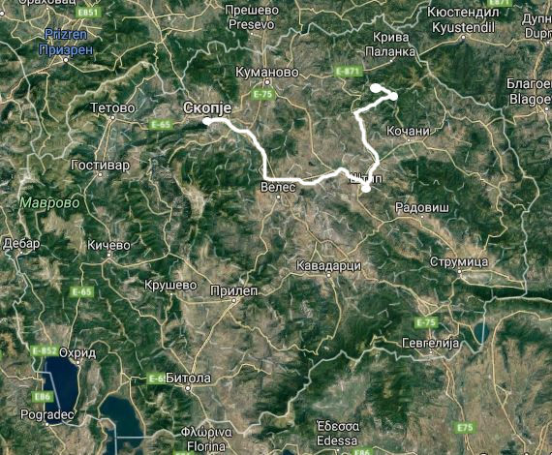
Source: Own illustrations, graphics ©2017 Google maps
Based on Figure 3, new separate maps are created, thus offering three NSVF in East Macedonia (Figure 4). Figure 4a presents a new OHR for Štip, which encompasses five OHS: Sultan’s bridge Emir Ćučuk, Clock Tower, Husamedin Paša Mosque, Kadin Aga Mosque and the Bedesten. Yet, the route may be expanded with other points of interest from Štip, like the Museum of the town Štip whereas the exhibition from the Ottoman period is presented, or a short walk to the Štip Fortress known as Isar dating from the early middle ages, and simultaneously to taste Turkish meals and desserts prepared in “Macedonian way”.
Figure 4b presents a map of a NSVF identified for Kratovo. It is characterized with typical old city architecture with many towers and bridges dating from the Ottoman period, along with the impressive natural attraction in the near vicinity. The new suggested route may encompass the following OHS: Emin Bay tower, Smićeva tower, Zlatkova tower, Grofčanski bridge, Ćaršiski bridge, Radin bridge and Prepiroven bridge. This route may be additionally expanded with a new SVF for the ‘Stone Dolls’ in Kuklica (Figure 4c) which has an outstanding legend that may be used for tourism purposes.
The private tourism initiatives, the support of local and central government, as well as the good transport communication, serve as a solid base for introducing the suggested NSVF. Hence, one may add a new content to the current modest tourism supply, particularly covering the East Macedonia.
Figure 4. Separate maps on NSVF on Ottoman Heritage
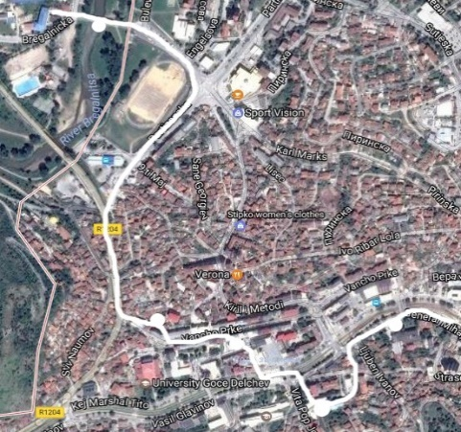 | 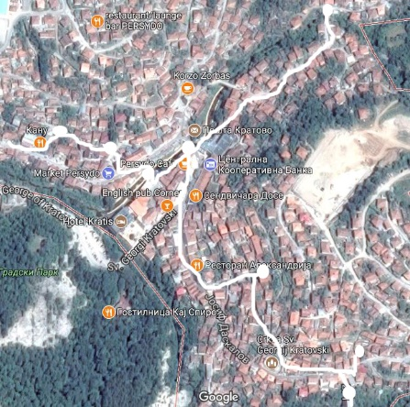
a) Štip | b) Kratovo
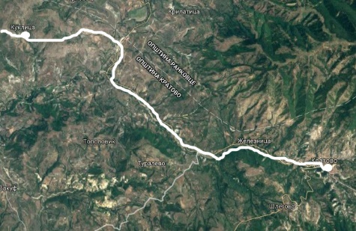
c) Kuklica
Source: Own illustrations, graphics ©2017 Google maps
Conclusion and recommendations
The primary objective of this study is to provide evidence on current Ottoman heritage tourism routes thus enabling better understanding of their shape, along with identification of several new strategic visitors’ flows. The selected test ground for the flow analysis was the cultural heritage in Macedonia dating from the Ottoman period. The research indicated that, despite to the rich and diversified structure of Ottoman cultural heritage, yet there is an evident concentration in the west part of the country. Besides Skopje and Ohrid, which encompass the vast majority of tourist arrivals and overnights of tourists from Turkey, Tetovo, Centar Zupa (Kodžadžik), Resen and Bitola are part of the current OHR.
Furthermore, the study revealed possibilities for development of three new routes associated with Ottoman cultural heritage: Štip, Kratovo and Kuklica, all located in East Macedonia. This may contribute to diversification of supply and dispersion of visitor flows to regions that are not sufficiently promoted thus leading to sustainable tourism development. Yet, not all sampled OHS have attractive location, but they all possess uniqueness, esthetic, architectural, historic and educational value. They are all evocative sites related to many legends, myths and stories, thus been completely suitable to be presented as tourism products and part of a tourist route. This is also supported by the activity noted in the annual Program for Promotion and Support of Tourism for 2017 prepared by the national Agency for Promotion and Support of Tourism of the Republic of Macedonia, where it is foreseen to prepare a “Guide through the Ottoman landmarks” as a promotional activity for a specific target group (Official Gazette, 2016: 207).
A motive that has surfaced during the interviews, without being a part of the protocol, was the presence of non-Ottoman heritage sites, which also provoke interest among tourists from Turkey. Some of the interviewees have mentioned these ties as motives for extending the tour by including non-Ottoman sites.
Based on the fieldwork findings, the paper recommends some future actions in the line of enhancing the modest development of cultural tourism in Macedonia associated with OHS:
- To develop and conduct activities for visitors and tourists by observing the OHS as parts of a past local culture;
- To create a balance between the protection of the OHS and tourism flows in the line of achieving sustainability;
- To design and develop an Ottoman heritage tourism product, but not only as a separate local product, but rather as a regional, or even national product; and
- To promote a tailor-made thematic tourist routes that may contribute to creating autochthonous and competitive tourism supply for better positioning on tourism market.
Limitations and future work
The research was limited by several factors that can also serve as productive starting points for future work. In the first line, when applying the SGDM model, the SVF were mapped only based on tour guides as informants presenting a relatively small sample of interviewers. Therefore, the future work may focus on expanding the list of informants with experts from tourism business or other segments of tourism market in Macedonia.
Practically, some future work may recommend developing Ottoman heritage tourism product as a national rather than just a local or a regional product. Such program may be beneficial towards strengthening the national economy, increasing visitors’ consumption, creating employment, as well as increasing the awareness of residents on the OHS which they possess. Notwithstanding the difficulties involved in identifying the current and potential visitors’ flows in Macedonia, this study enables better understanding of the current shape of the OHR on local and regional level. Overall, the research generates useful findings and points to valuable directions for further work. Simultaneously, it offers introduction of new routes that may boost the modest tourism development in the country.
References
- Alp, S. (2009). The universe of the material cultural heritage of the Ottoman period in the Balkans. Milli Folklor, Vol. 84, pp. 151-161.
- Arslan, A. & Polat, H.A. (2015). The Ottoman Empire’s first attempt to establish hotels in Istanbul: The Ottoman Imperial Hotels Company. Tourism Management, Vol. 51, pp. 103-111.
- Beritelli, P., Reinhold, S., Laesser, C., & Bieger, T. (2015). The St. Gallen model for destination management. St. Gallen: IMP-HSG.
- Beritelli, P. & Leasser, C. (2017). The Dynamics of Destinations and Tourism Development, In: Fesenmaier & Xiang (Eds): Design Science in Tourism, Tourism on the Verge, DOI:10.1007/978-3-319-42773-7_13, pp. 195-214.
- Bond, N., Packer, J. & Ballantyne, R. (2015). Exploring visitor experiences, activities and benefits at three religious tourism sites. International Journal of Tourism Research, Vol. 17(5), pp. 471-481.
- Davis, C. M. (2013). Conserving “The Ottoman(s)” at an Israeli World Heritage Site. Archaeologies – Journal of the World Archeological Congress, Vol. 9(2), pp. 320-343.
- Dinis, A. & Krakover, S. (2015). Niche tourism in small peripheral towns: The case of Jewish heritage in Belmonte, Portugal. Journal of Tourism Planning and Development, DOI:10.1080/21568316.2015.1114014.
- Fonseca, F. P. & Ramos, R. A. R. (2012). Heritage tourism in peripheral areas: Development strategies and constraints. Tourism Geographies, Vol. 14(3), pp. 467-493.
- Garrod, B. & Fyall, A. (2000). Managing heritage tourism. Annals of Tourism Research, Vol. 27(3), pp. 682-708.
- Gunn, C. A. (1997). Vacationscape: Developing tourist areas (3rd ed.). New York: Routledge.
- Loulanski, T. & Loulanski, V. (2011). The sustainable integration of cultural heritage and tourism: a meta-study. Journal of Sustainable Tourism, Vol. 19(7), pp. 837-862.
- Luke, C. (2013). Cultural sovereignty in the Balkans and Turkey: The politics of preservation and rehabilitation. Journal of Social Archeology, Vol. 13(3), pp. 350-370.
- Michalos, A. C. (1969). Principles of Logic. Prentice Hall, Englewood Cliffs.
- Moscardo, G. & Pearce, P. L. (1999). Understanding ethic tourists. Annals of Tourism Research, Vol. 26(2), pp. 416-434.
- Nance, S. (2007). A facilitated access model and Ottoman Empire tourism. Annals of Tourism Research, Vol. 34(4), pp. 1056-1077.
- Official Gazette of the Republic of Macedonia No. 192 from 17.10.2016.
- Pavlov, Z. & Petkova, R. (2008). Macedonian Cultural heritage: Ottoman monuments, Office in Venice, UNESCO.
- Petrevska, B. & Namicev, P. (2017). Reanimating Ottoman heritage sites: assessment of Stip, Conference proceedings from the International conference Geobalcanica, Skopje, Macedonia, 20-21 May, 2017, 169-176.
- State Statistical Office of the Republic of Macedonia. (various years). Statistical Yearbooks for various years, Skopje, Macedonia.
- Yin, R. (2003). Case study research (3rd ed.). Beverly Hills, CA: Sage.

Ivanka Nestoroska, PhD. Full professor, Faculty of Tourism and Hospitality - Ohrid, St. Clement Ohridski University - Bitola, ivanka.nestoroska@uklo.edu.mk
Biljana Petrevska, PhD. Associate professor, Faculty of Tourism and Business Logistics, Goce Delcev University - Stip, biljana.petrevska@ugd.edu.mk
Petar Namicev, PhD. Associate professor, Academy of Art, Goce Delcev University - Stip, petar.namicev@ugd.edu.mk

